Workforce Census Guide – 2023

Note: If you view the online version of this guidance you can access the guidance videos - Workforce Census Guide - 2023

Preparing for this census
See this article for your key census dates: Workforce Census help and guidance
Then follow this article to see what’s new this census, and how to prepare your data to minimise errors before you run a Dry Run: Preparing for the Workforce census
- Make sure you have the right permissions to be able to access the census and edit data
- Prepare your data for the census, including filling in any gaps, mistakes and duplicates
- Make sure you’re recording data in line with DfE guidance by taking a look at what is new for this year’s censuses
Download and print the Workforce Census Preparation Checklist before doing a Dry Run.

Running your census

Completing the data check
You’ll need to resolve some of the errors that the DfE will flag up on your Census page before you can generate a Dry Run.
To navigate to your Census page on Arbor go to School > Data > Export > Data Returns. Here you will see a list of the different censuses for the academic year to date.
If you have recently joined Arbor and this is your first time doing the census in Arbor then you will still see a list of all the Census return dates for the academic year but these will not contain any Census return data relating to your school.
The date on the left-hand side of the page is the official census day and the date in italics to the right-hand side of the screen is the deadline date for submission to the DfE. Please be aware that some Local Authorities may want you to return your census to them before this date.
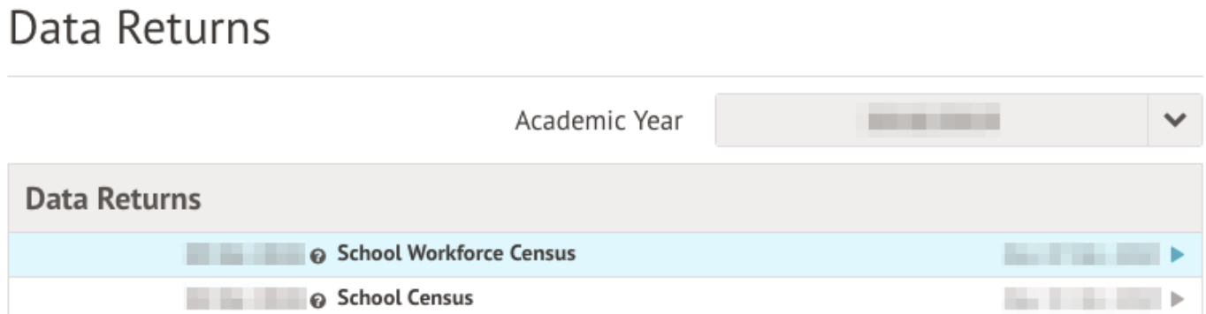

Select the workforce census, and click Fix errors in the slide over.
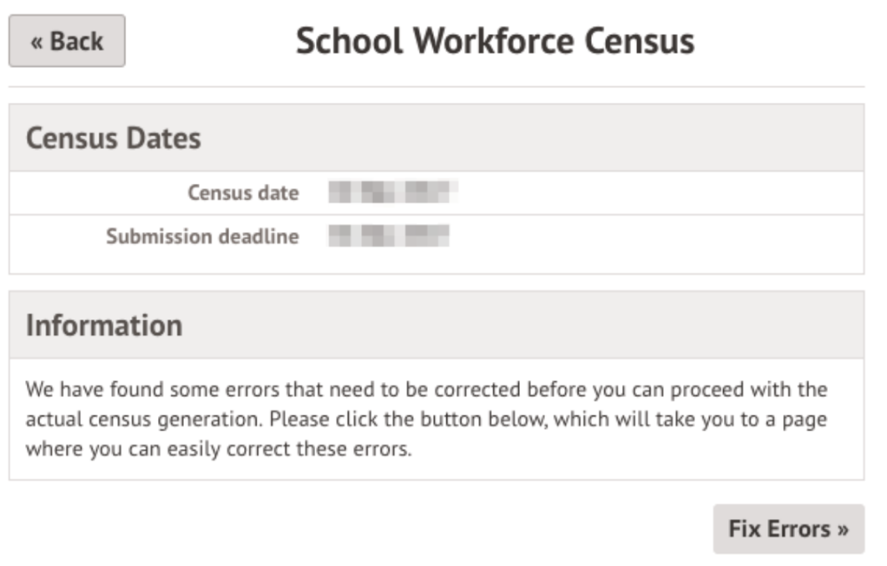

You’ll likely see errors you need to resolve before proceeding. If you have lots of errors around missing positions, click the button in the banner to go straight to the Positions page and add them in bulk. See our guide on positions for more details.
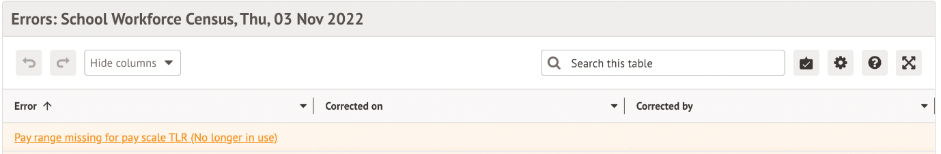

To resolve an error, click on each error to add in the required information.
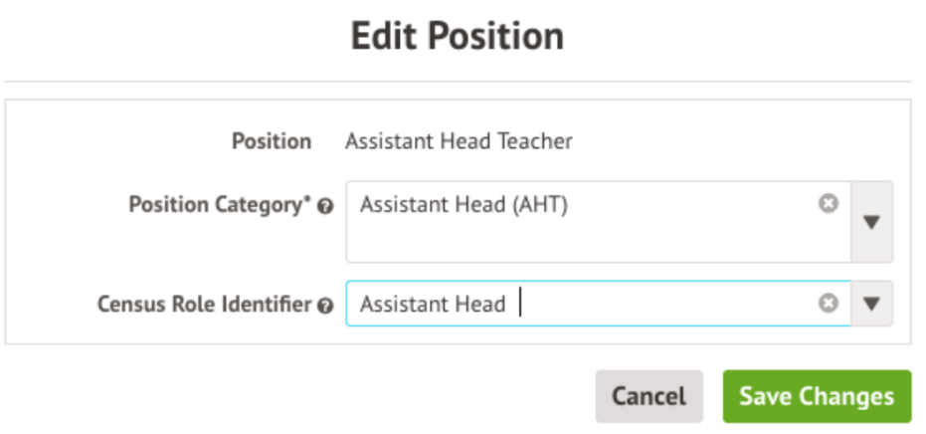

Work through all the errors on the page until all the rows show green text, then go back to School > Data > Export > Data Returns.
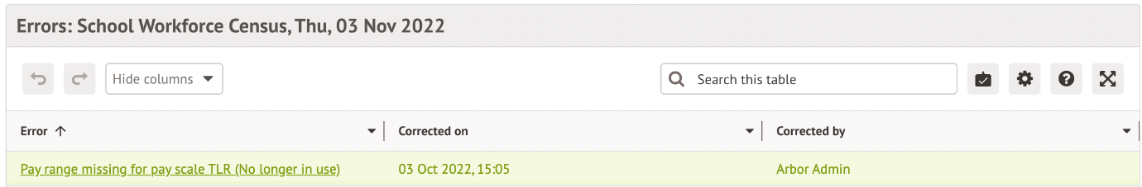

Generating a Dry Run
Once you’ve completed the Data check you’ll be able to generate a Dry Run. Go to School > Data > Export > Data Returns. Select the Workforce Census and click the Generate Dry Run button in the slide over.
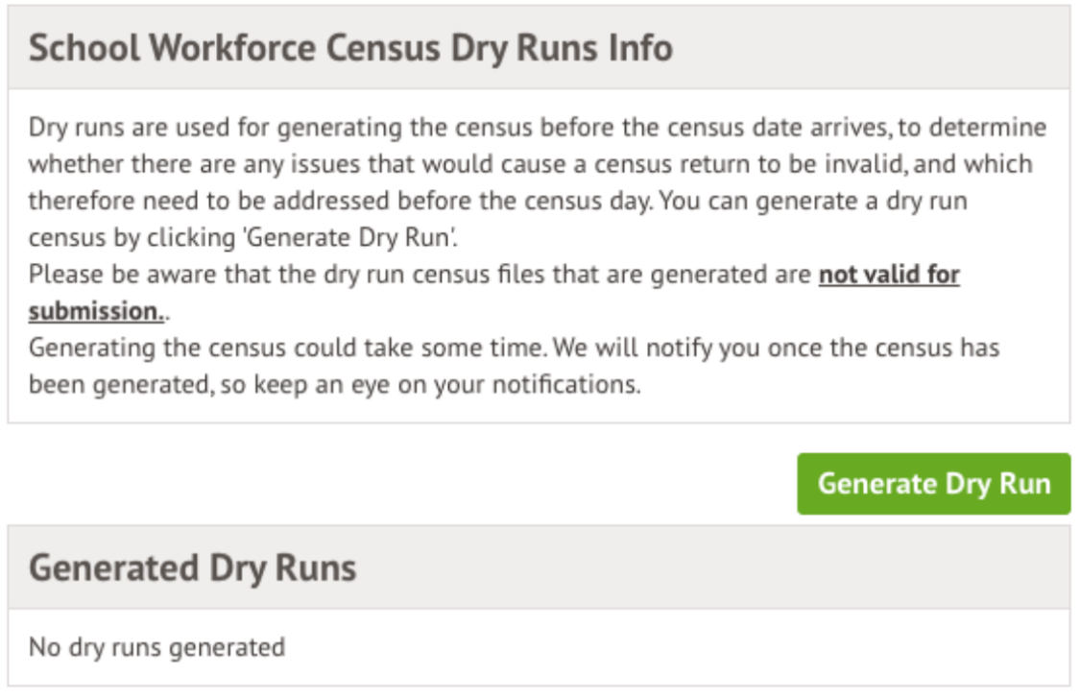
You’ll be taken back to the Data Returns page.
Once the Census has been generated, you will get a notification in the speech bubble in the top right-hand corner of your screen letting you know that the Census generation is complete.
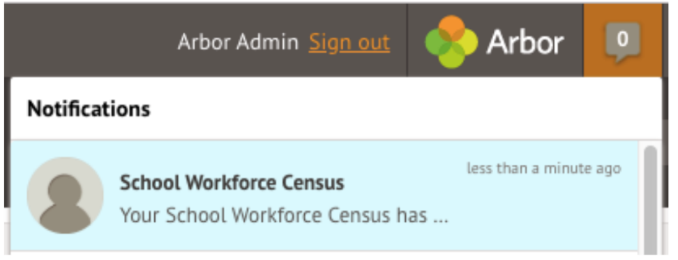
Click the notification or click into the generated dry run to access the census.
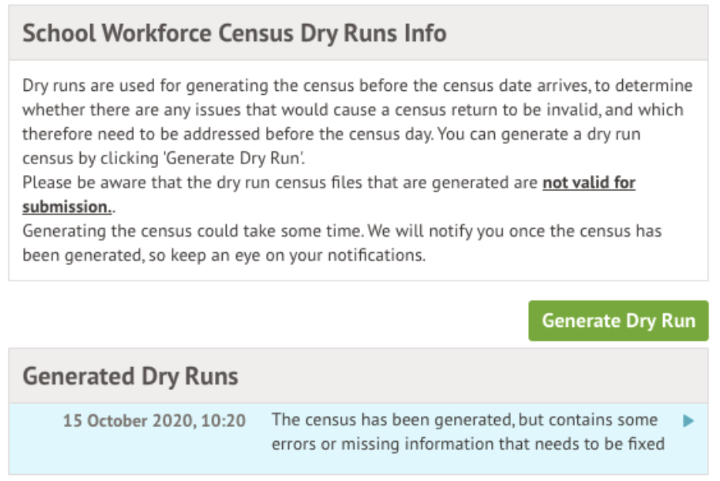

You can then work on your errors (see the next section on how to do this). To regenerate your Dry Run after resolving errors, just click the orange button on the right-hand side of your page.

Generating the Census on or after Census day
You will be able to generate your Census from the same Census Overview page that you have been using to generate your Dry Runs - School > Data > Export > Data Returns > Select Census.
On the right-hand side of the page, click the orange Generate Census button.

Once the Census has been generated, you will get a notification in the speech bubble in the top right-hand corner of your screen letting you know that the Census generation is complete. Click the notification to access the census.

Alternatively, you can select Fix Errors in the slide over to jump right to resolving errors in your most recently generated census. We recommend regenerating your census to clear any errors regarding the information you have input for census day.
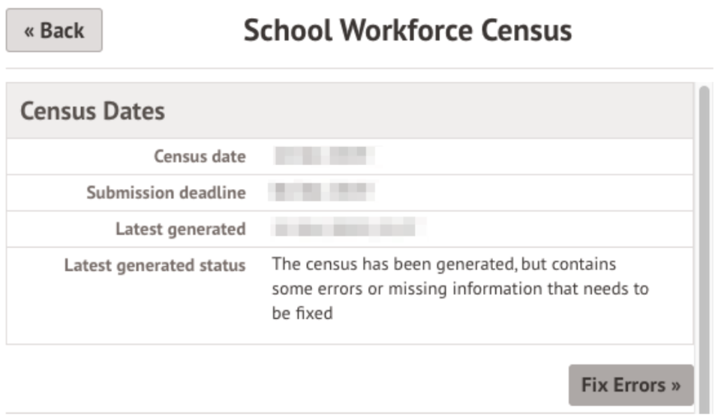

Solving Errors or Queries
Once your Census or Dry Run has been generated you’ll see errors and queries that need to be resolved. The Dry Run allows you to start working on these before census day and prepare all your information in advance of the actual Census.
All errors must be resolved during Dry Run or census, but some queries can be left unresolved if you have a valid reason why this information flagging the query is correct. When submitting your census, an explanation as to why that query exists should also be submitted to COLLECT. You can use the DfE’s COLLECT guides for help with what explanations to submit.
To view and amend errors/queries you need to have generated a Dry Run Census or Census. Go to School > Data > Export > Data Returns and select the date of the Census.
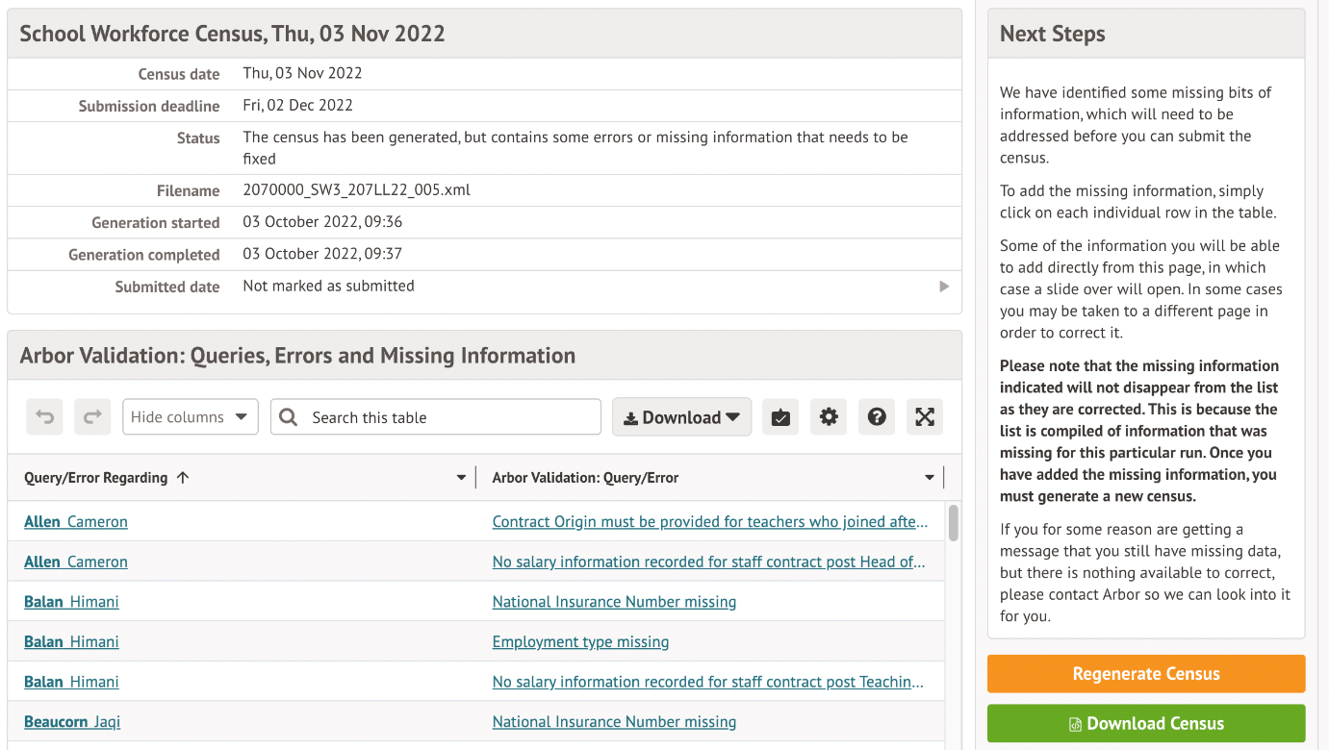

You will be taken to your most recently generated Census where you can resolve your errors and queries.
Top Tip: We recommend that you work through your errors and queries in batches and then regenerate after resolving a few to minimise time spent waiting for regeneration. Remember, the errors will only disappear after you’ve regenerated your census!

What’s the difference between Arbor and DfE errors?
Resolve your Arbor Errors first. This will usually clear one or more DfE errors at the same time.
When you click on an Arbor error, a slide over will open where you can enter the right information.
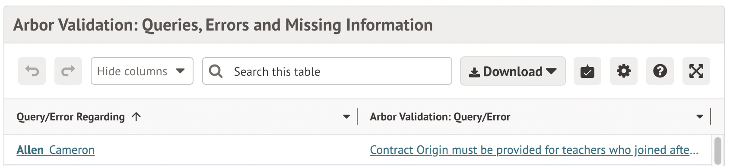

Once you have resolved as many Arbor errors as you can, start resolving your DfE errors.
Some DfE errors are clickable, and you’ll be taken to a page where you can make amendments to resolve the error such as the Staff profile. We’re unable to open a slide over to resolve the error directly from the census, as the list of errors for the DfE can change each year, and errors often have multiple methods to resolve them.
All DfE errors will have a specific error code supplied by the DfE that you can use to find more information. To find out more about what certain error codes mean and how to fix them, head over to our Workforce Census Help Articles where you can find detailed steps on how to address some of the most common errors and queries.
Top Tip: Always regenerate your Census before leaving the Census pages to ensure that any work you have done is saved and recorded.
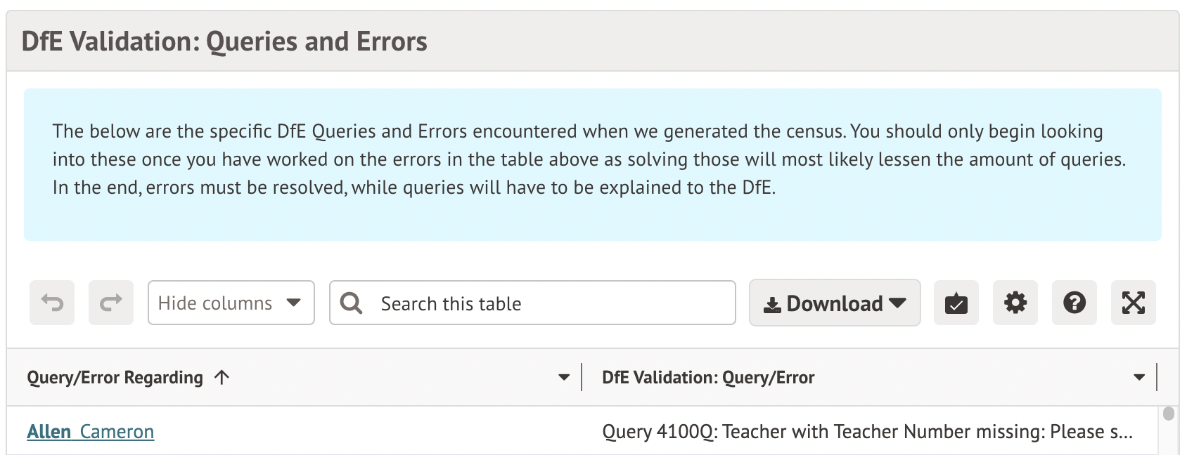

How to resolve errors
Errors will remain in the list until you regenerate the Census. Errors will only clear on each successful regeneration. We recommend that you do not regenerate the Census upon clearing each error as waiting for each regeneration would take up a lot of time - instead, resolve your errors in batches.
In the example, you can see this staff member has an Arbor error flagged as NI number missing.
As you can click Arbor errors, click on the box beside their name and a slide over will appear where you can enter the information. Then click the green button and move on to the next error.
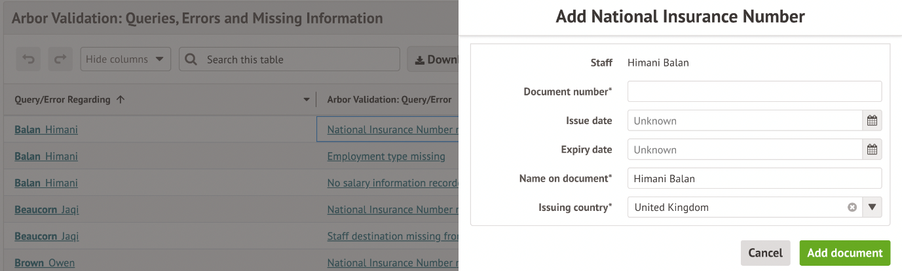

Further details you need to fill in on the census
As well as working through errors and queries, there is some census-specific information you need to input into the census pages itself.
Go to School > Data > Export > Data Returns > Select Census. Click the SWF Census button.
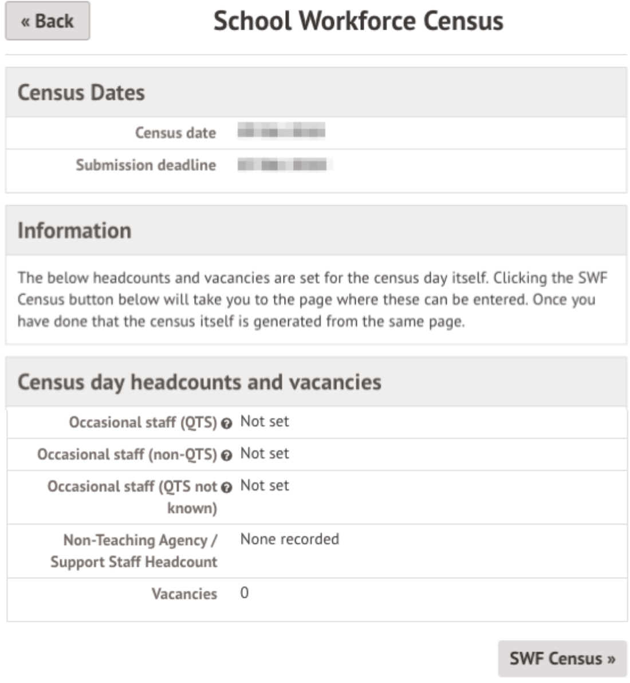

Senior Leadership Team (SLT)
Select Senior Leadership Team (SLT) from the left-hand menu. Here you can see a list of all staff included in the workforce census at your school.
By default, whether they are logged as Senior Leadership Team (SLT) depends on their Position Category (aka Post) as of census day. In the output census, anyone with one of these Position Categories will be set as Senior Leadership Team (SLT):
- Head Teacher (HDT)
- Deputy Head (DHT)
- Executive Head Teacher (EXH)
- Assistant Head (AHT)
- Leadership – Non-Teacher (LNT)
When a staff member has more than one position (because they have more than one current contract):
- If one or more of their Positions is classed as Senior Leadership Team, the default will be that they are output as SLT is True.
- If none of their Positions are classed as Senior Leadership Team, the default will be that they are output as SLT is False.
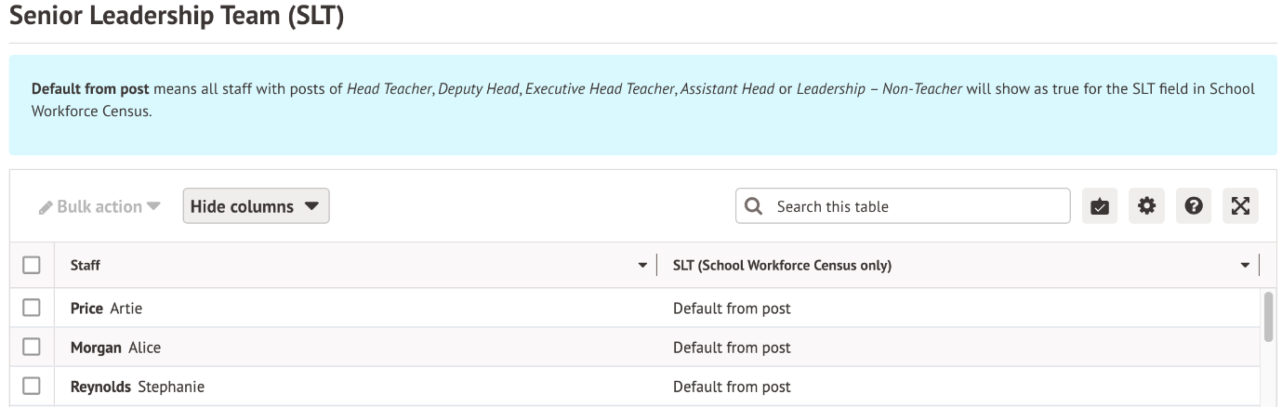

We recommend inputting this section manually. This will not affect the HR information elsewhere in Arbor.
To manually set this, tick all the staff that are SLT, click the Bulk Action button, and select Set SLT to Yes.
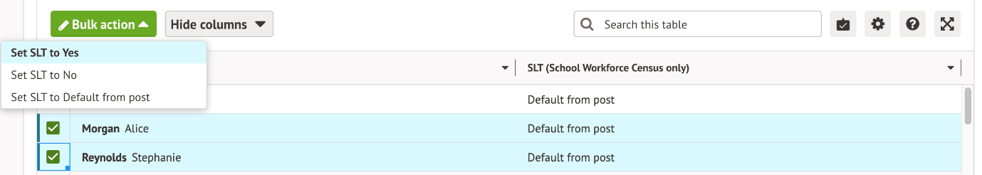

Repeat this for No.
When you have completed selecting the right choices, they should all say Yes or No.
Make sure to regenerate your census for the changes to be applied.
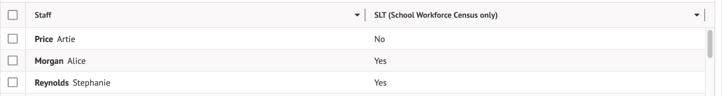

On the day staffing information
You must add in some additional information on your staffing as it is on Census day from the Census Overview page.
On census day, you’ll need to follow the instructions in this article: On-the-day Workforce Census errors - Errors 7100, 7110, 7111, 7112 and 7210 and Query 7240Q
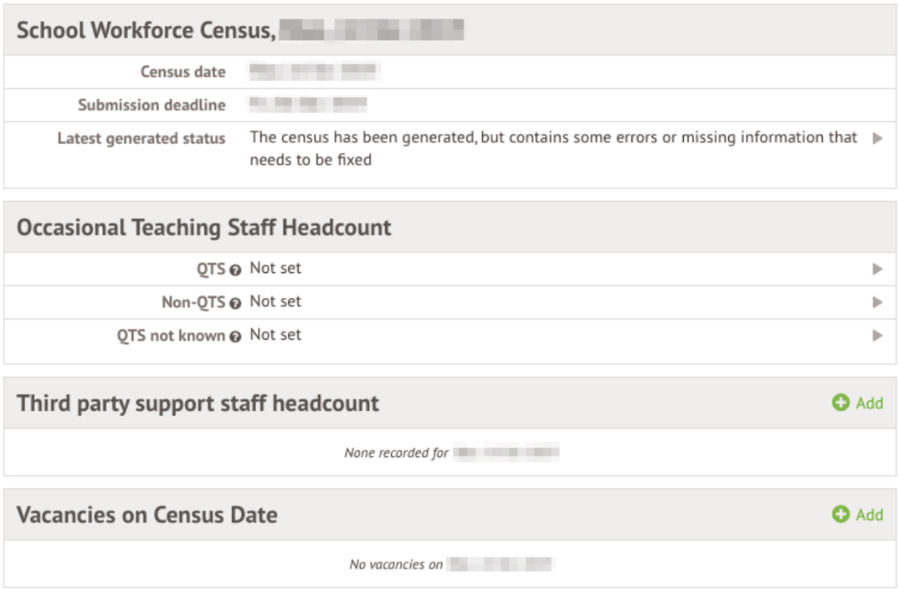

Submitting the census
Follow this article to see how to check, complete and submit your census: Submitting a Census
- You can either choose to view your Census summary live on your Arbor dashboard using the DfE Census Summary Inspection or download it in PDF format using the Download DfE Summary.
- Then download and submit your census file to COLLECT or to your LA.
Then download and print out the Workforce Census Completion Checklist to help ensure you’ve completed it correctly.
You can also mark the census as complete in Arbor to remove our banners: Can I remove the census banners on My Homepage?

