Uploading Pupil Premium Recipient Records
Table of Contents
Introduction 1
Downloading Pupil Premium file from Get Information About Pupils (GIAP) 2
If you do not have a file to update 4

Introduction
You can upload and tag the official recipients of the Pupil Premium each financial year, taken from the Official DfE files received from GIAP.
As Pupil Premium Recipient status is allocated from the DfE after each Census, the GIAP Report is correct unless any revisions are made in which case you can reimport the report from them or await the new data from the DfE after your next Census. This will allow you to see the "Pupil Premium Recipient" tag on their student profile.
Firstly, make sure that you have downloaded the file from GIAP and that this is saved on your computer before you start.

Downloading Pupil Premium file from Get Information About Pupils (GIAP)
Click in the link to Navigate to DfE Sign-in
Select Get Information About Pupils (GIAP), when you first login you will see How To Use GIAP screen, click continue. You will the be required to read and confirm you have rean and understood the conditions, then click next. The How To Use GIAP screen will pop up again, click continue.
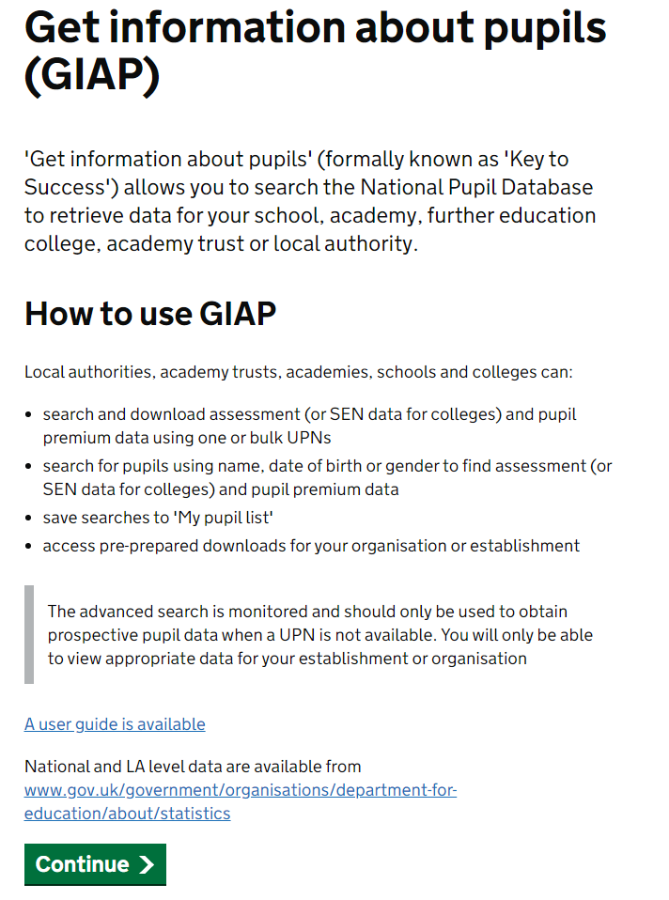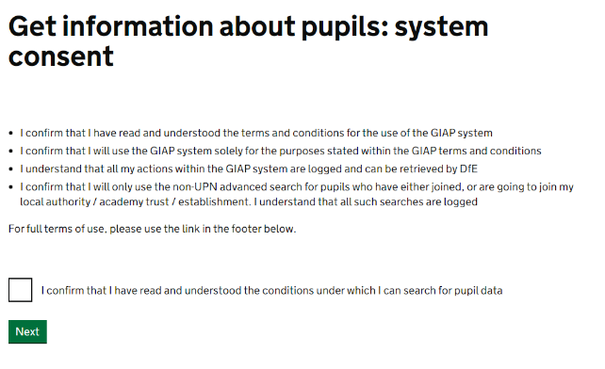
Navigate to Data Downloads area to the top of the screen.
Once you have clicked on Data Downloads you will see your schools Pre-prepared downloads
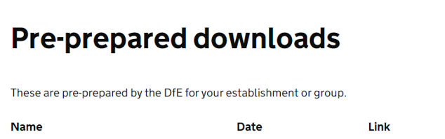
Select the Pupil Premium file which is called ‘pp2223_xxxxxxx_1’, from the menu and click to download. The x’s will represent your schools DfE number.
NOTE: The screenshots have not been updated and are for reference only
NOTE: It is important that when you are saving the file, that it is saved to a secure location, rather than somewhere public such as the desktop, as the file contains UPNs and information that can indicate a pupil’s vulnerability e.g. in care with local authority.

Once you have downloaded your file go to Student > All Students > Bulk Update > Pupil Premium Recipients. Click the green add button and select your file to upload.
Student’s records will not be updated until you have clicked on the confirm upload button
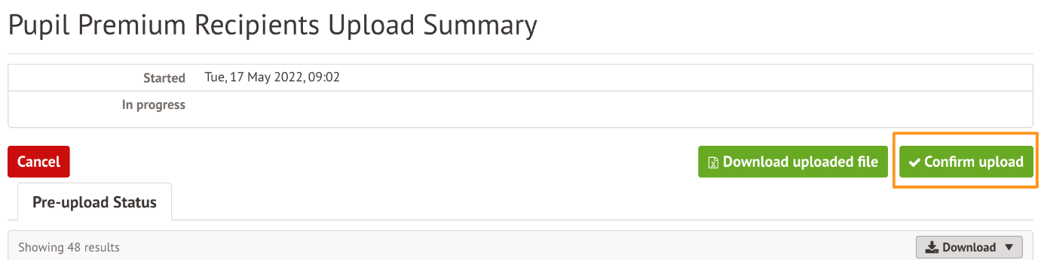

If you do not have a file to update
If you have changed school name and you don’t see your Pupil Premium download file, you can use the service to search for pupil premium students. Navigate to Student > All Students > Bulk Update > Pupil Premium Recipients, on the right hand side you will see instructions explaining how to use GIAP to download and search for students.

Click on the green Show UPN List to get a list of all UPN's of students currently enrolled in your school.
Don't worry if your report from GIAP has students in last year's year groups or forms! This is because GIAP works within the financial year and the forms on this report are from when the report was generated. When you put this information in Arbor it will add the information to the correct children and they will remain within their correct form in Arbor.
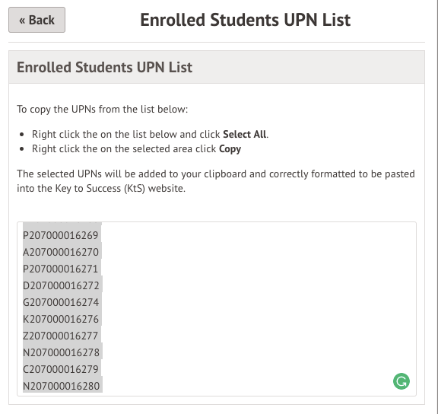

Once you have the file click +Add button. This will open a slide over where you can upload your file. Once you have browsed and added the file from your computer, click on the green 'Upload' button to continue.
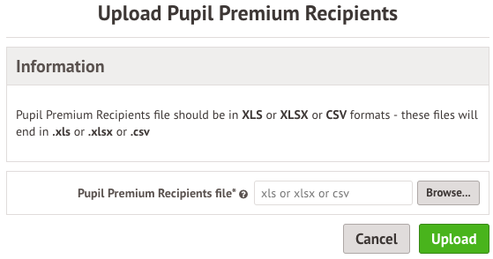

This will then generate a list of all the students in the file you uploaded. To create the Pupil Premium Recipient, records click on the green Confirm upload button. Until you have confirmed the upload, students will not be marked as Pupil Premium Recipients in Arbor.

