SIMS School Report

Information for Schools

SIMS School Report

The School Report provides an instant overview of your school, based on the latest
data held in SIMS. The report gives School Leadership and Governors an insight into areas of strength and weakness, and helps to inform their decisions. The report can be exported
to a number of formats including Excel.

To run this report, follow the route Reports / School Report

The following screen will be displayed:

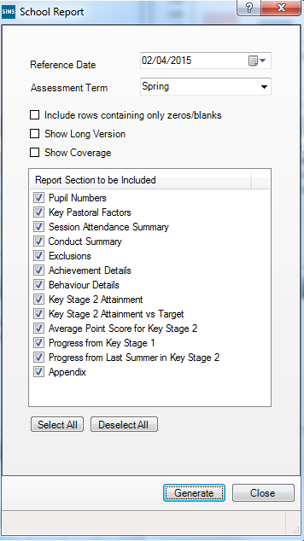

- Reference Date
The reference date for the report defaults to today’s date, however this can be changed if required by clicking on the drop down arrow next to the date field.
- Assessment Term
The current Term for which Assessment data is to be collected

- Include rows containing only zeros/blanks
Ensure that you tick the “Include rows containing only zeros/blanks” check box to ensure that all information is captured within the report.
- Show Long Version
By placing the tick the “Show Long Version” check box, the report outputs will show detailed breakdown of your Attendance Statistical Information. If you do not tick this box, the report will display a summary of Attendance data only.
- Show Coverage check box
Tick the “Show Coverage” check box, to ensure that all data is contained within the report.

The report defaults to having the selection ticks in all areas of the report, which can be selected\deselected as required
Although this report has filter selections for Assessment, it is only useful for schools who use the Capita SIMS Assessment sheets, and not customised Assessment sheets. If you use customised Assessment sheets, and with the move to Assessment without levels, this Assessment area will not produce meaningful data, so can be disregarded for the purpose of this School Report. If this report is further developed in a future SIMS release, to contain the functionality to manipulate customised Assessment data into the report, we will advise you accordingly.
Therefore, when running this report, deselect the following check boxes:

Primary
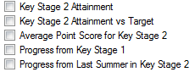

Click the Generate button to run the report. The report will output your school data as shown in the sample tables below:

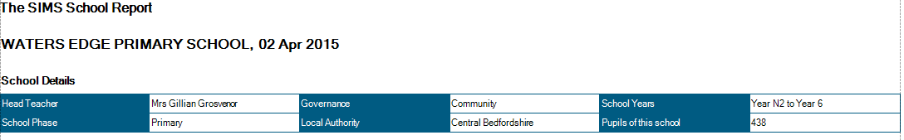

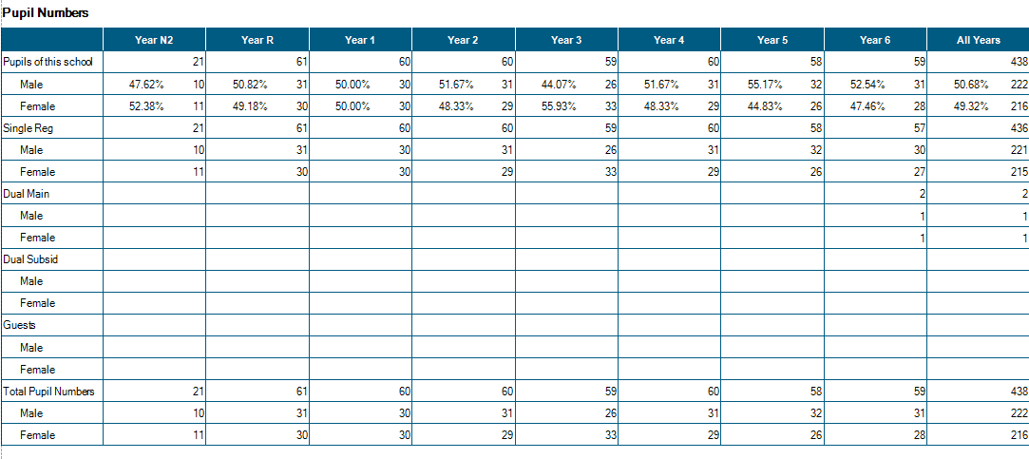

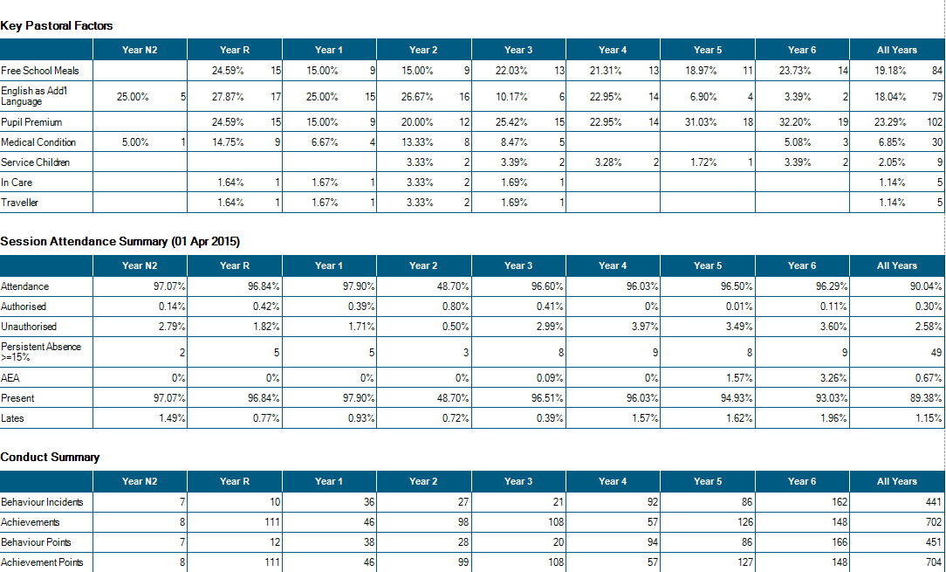

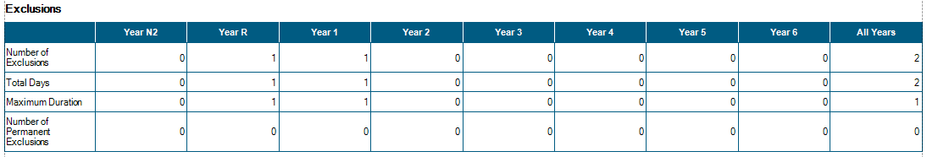

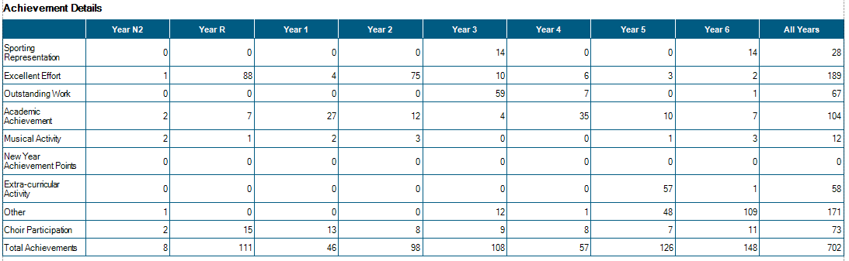

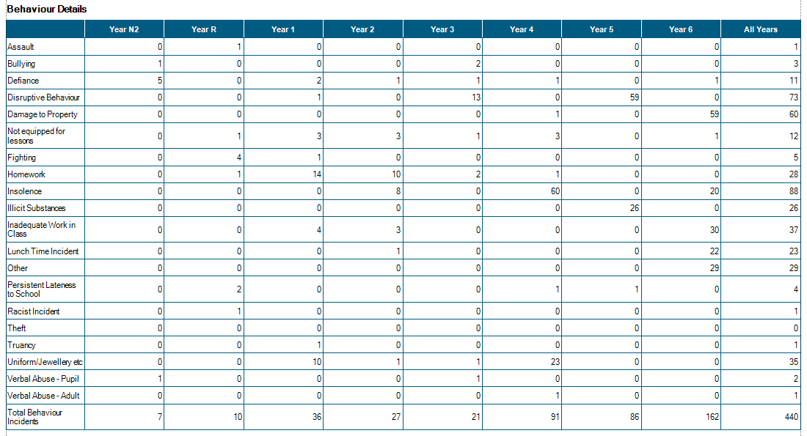

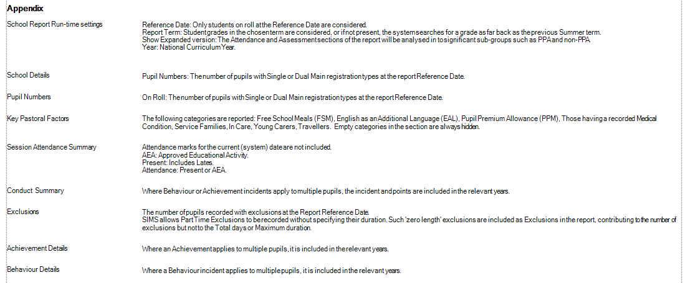

Exporting the SIMS Report

The information in the SIMS School report can also be exported to Excel if required or e emailed to colleagues. To do this, generate the report, and then click on the Export Document Icon arrow on the tool bar at the top of the report:

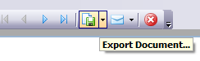

Note: (ensure that you click on the drop down arrow beside the Export Icon, or the report will default to be output to a PDF document)

Select the XLS file type:

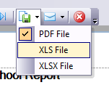

The following screen will be displayed:

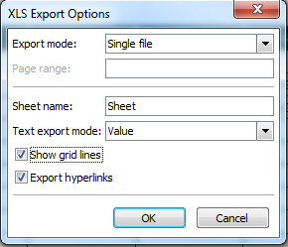

Tick the “Show grid lines” check box, and then click on OK.

The following screen will be displayed:

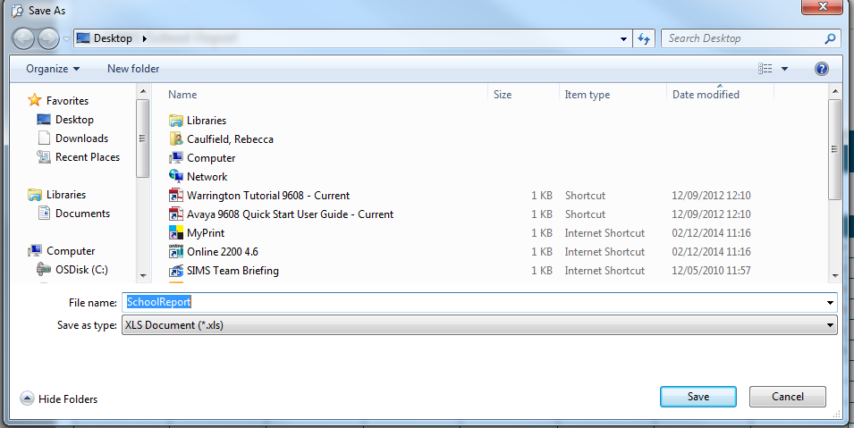

Give the report a title in the File Name box, and browse to the destination where you would like to save the report, and then click Save.

The following screen will appear. Select either Yes to view the file immediately, or No if you would like to go back to where you saved the report, in order to view it at a later time.

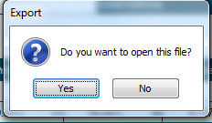

E Mailing the School Report
You may wish to E mail the school report to the Head teacher of Chair of Governors

Select the envelop icon and select the file type required

You will then be presented with the following screen
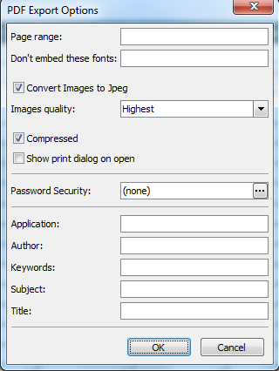
Password Security Option

If you leave all the boxes blank, the report will generate in full as the default output.
[Grab your reader’s attention with a great quote from the document or use this space to emphasize a key point. To place this text box anywhere on the page, just drag it.]

If you are emailing the report to an external e mail e.g. The Chair of Governors, you may wish to add a password to the document. This can be done by clicking on the Password Security button

You will then be presented with the following screen
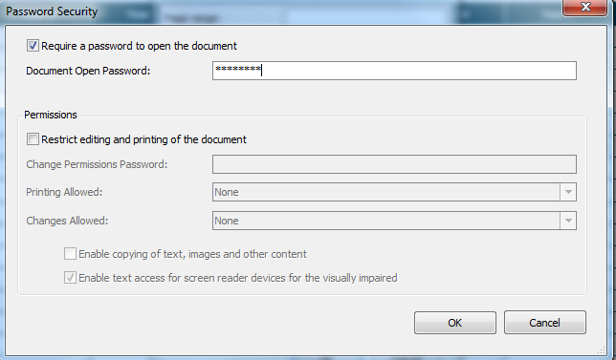
Place a tick in the Requires Password to open the document check box and enter the password

Click on OK when complete

The following screen will be displayed:

Give the report a title in the File Name box, and browse to the destination where you would like to save the report, and then click Save.

You will then be taken straight to a new e mail with the school report attached

