SIMS Hints and Tips
Guidance Notes for Primary Schools

Contents

Introduction…………………………………………………………………………………………………………….2
Shortcuts………………………………………………………………………………………………………………….3
Filtering Key Performance Indicators within a Mark Sheet……………………………………….5
Easy Reporting through the Student List Menu ………………………………………………… …...7
School Report ……………………………………………………………………………………… ………………...9
Configure homepage to show Key Performance Information within SIMS………… … .11
School Diary – Editing and Displaying on the Home Screen……………………………….……17
Import of CTF Causes a Duplicate Pupil Record ……………………………………..………………18
CTF import – Updating an Existing Pupil/Student’s Data…………………………………………20
Bulk Update of Student Profile Data……………………………………………………………………….21
Change Enrolment Status…………………………………………………………………………………….…23
Printing Attendance Letters……………………………………………………………………………………24

Introduction
Working in a busy school office environment it can be difficult to find the time to fit even the easiest of tasks in so we are hoping that these hints and tips will help simplify some of the common tasks in SIMS to save you some valuable time completing the never ending to do list!

Shortcuts – show on left hand side on the home screen to allow quicker access to most used applications

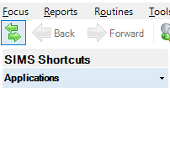

- Underneath the Focus button click on the green arrows to display the ‘shortcut’ panel

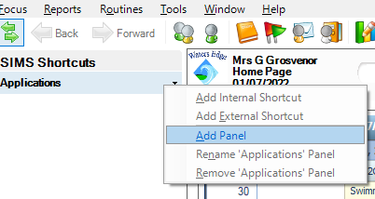

2. Right click Applications and ‘Add Panel’

3. Click on the small black down arrow
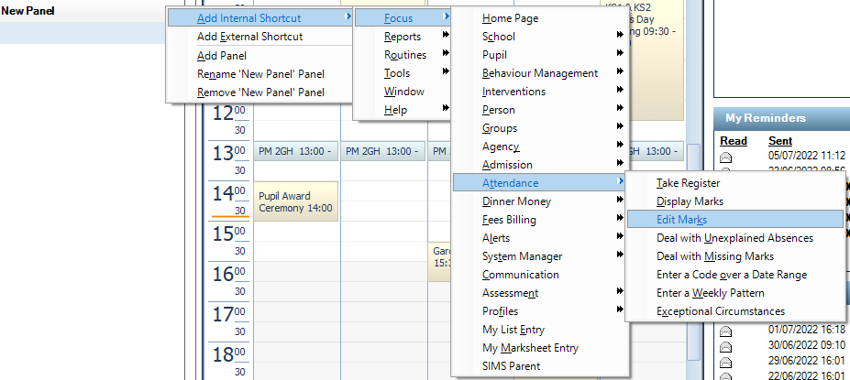

4. Here you can choose which shortcut you would like to add in SIMS
In this example we are going to add a shortcut for ‘Edit Marks’ – Hover over Add Internal Shortcut>Focus>Attendance>Edit Marks

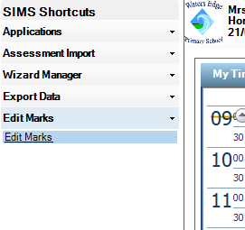

5.Edit Marks appears in your shortcut list
If you hover over ‘Edit Marks’ a hand icon will appear – click and it will take you through to the edit marks screen – please see below:

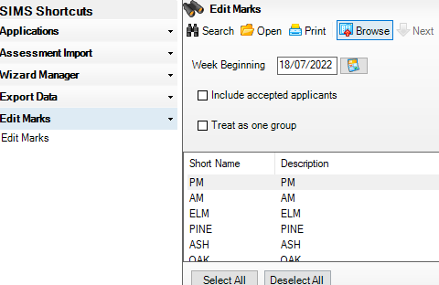

Filtering Key Performance Indicators within a Mark Sheet
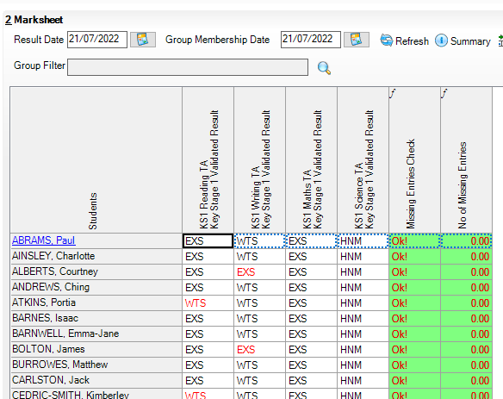

1. By clicking on the ‘Students’ box on the top left corner of the marksheet you can change the alphabetical order of students

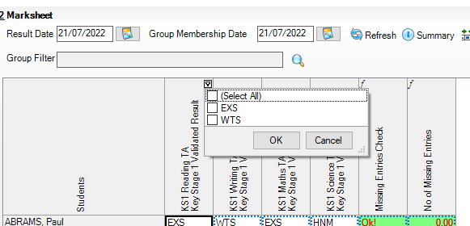
2.You can also filter each column by the grade in that cell by clicking top right on the and ticking the grade that you want to display

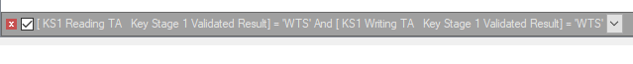
3. To return to default and show all grades in column click on the red x that is displayed under the marksheet

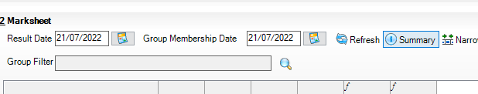

4.Click on ‘Summary’ button after calculating the results to view the ‘Total’ and the ‘Number of Results’. A ‘Median’ figure is displayed in a specific row as well as a ‘Median Grade’ row. Click the red x to return to default marksheet

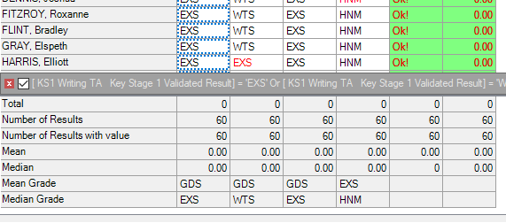

Easy Basic Reporting through the Student List Menu – easier than designing a report!

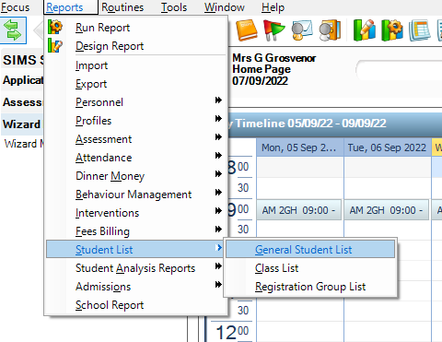
1.Click on Reports > Student List > General Student List

Which will bring you to a list of all your pupils in alphabetical order:
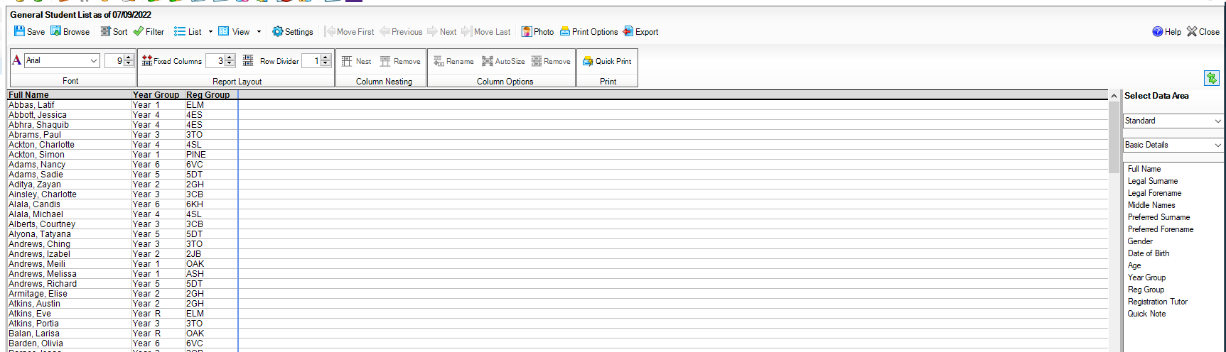
On the right-hand side, you will see the below menu:
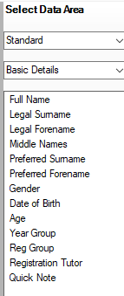
2.If you leave ‘Basic Details’ selected on the right hand side you can click and drag whichever field in the menu underneath you need such as ‘Full Name’ into the white space on the left of the menu (columns) and so on and so forth – in the example below I have selected ‘Full Name’, ‘Date of Birth’ and ‘Year group’ and dragged each field into the white space – you will see below how it populates the grid automatically – example on the next page

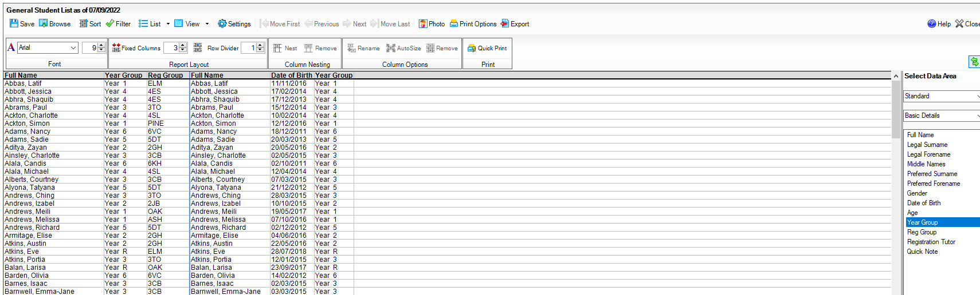

From there you can then save, filter, sort, print or export this information into an excel spreadsheet or html document:
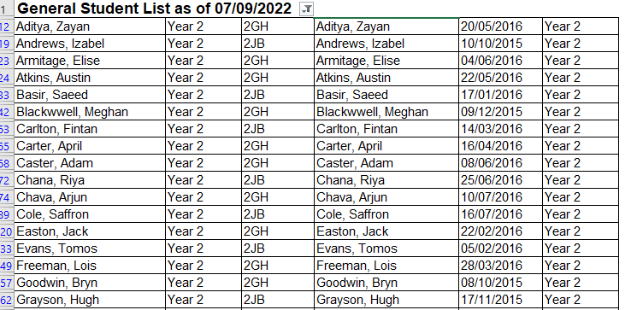

If you wish to include more information from the pupil record such as UPN, click on the right-hand side ‘Basic Details’ drop-down menu to show this menu and repeat the process:
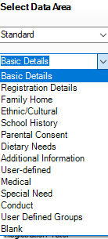
3.Each selection brings up the data entered onto the pupil record which you can click and drag into columns and add to your report.
(You can export the report to Excel and/or save the report in Student List for future use saved under Reports>General Student List>click Browse button in top left>select saved report)

School Report – Useful for Attendance Data Statistics and Session Attendance Summary
You can customise the SIMS school report output by including or excluding specific measures that you are interested in. All the pastoral factors are shown as a total number of pupils as well as a percentage breakdown. This is an excellent report to provide information for Senior Leadership and Governors
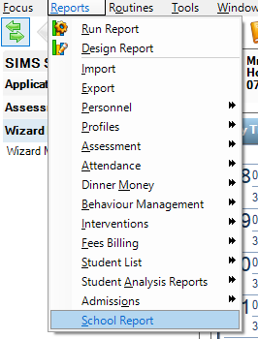

1.Click on Reports > School Report

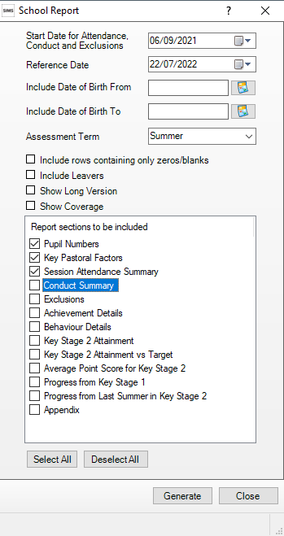
2. In the next box you can choose your criteria for the report – if you want to change the date to last years for example you must change the ‘Reference Date’ FIRST then it will allow you to change the start date

3. Put a tick in ‘Show Long Version’ to include a more in-depth comparison analysis

4.. In the ‘Report sections to be included’ box tick which information you want to be included on the report – here we are focusing on ‘Pupil Numbers’, ‘Key Pastoral Factors’ and ‘Session Attendance Summary’ so leaving the other options unticked – then click ‘Generate’

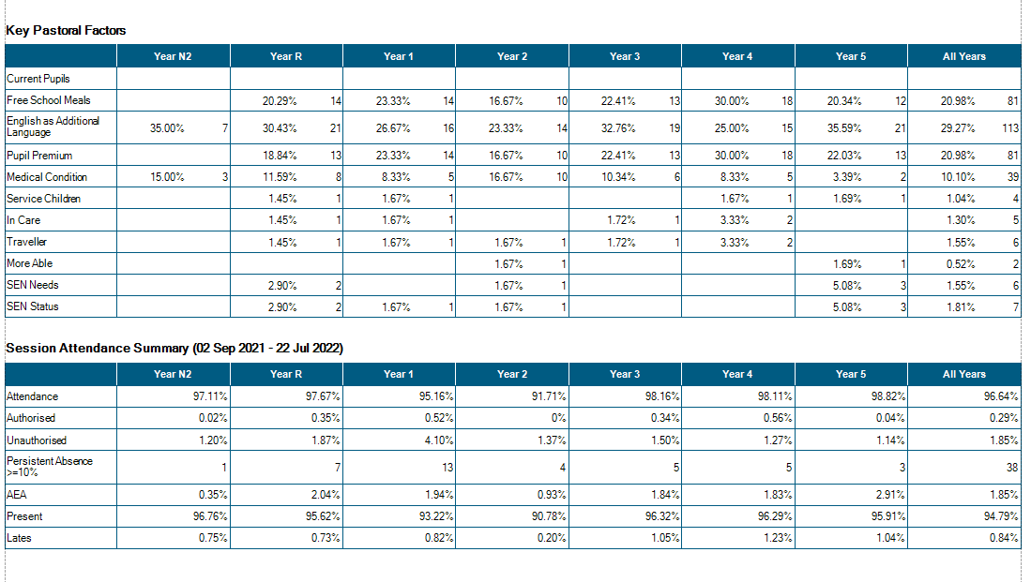
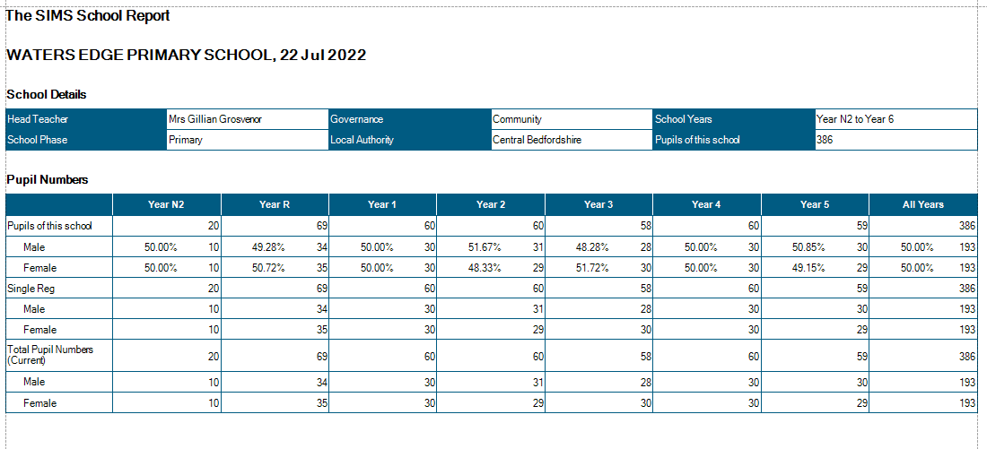
- Opens in preview on taskbar if you hover over your SIMS icon with your mouse

- This School Report breaks data down into percentages for each Year Group between the dates specified

- Particularly useful for Attendance trends and Key Pastoral Factors such as Free School Meals and Pupil Premium data

- If selected it can also give you Session Attendance Summary data for each Year Group and Persistent Absences to compare between Key Pastoral Factors

- Handy to have in one report rather than creating multiple reports off SIMS (useful for Governor’s meetings)

Configure Homepage to show Key Performance Information within SIMS

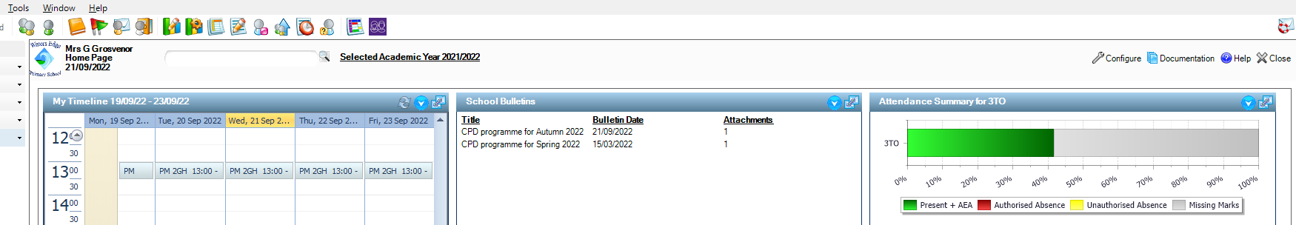

1. Go onto the homepage of SIMS – in the top right-hand corner click on the picture of the spanner with ‘Configure’ you will be presented with the following screen:

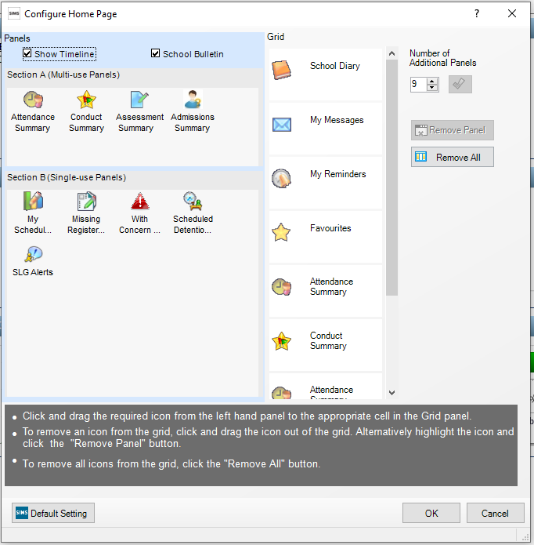
2. Follow the instructions on screen to display various items on your home page – Using ‘Section A’ panels you can use these more than once for example you can have multiple ‘Attendance Summary’ selected
‘Section B’ are only single use panels – so you can only use these once

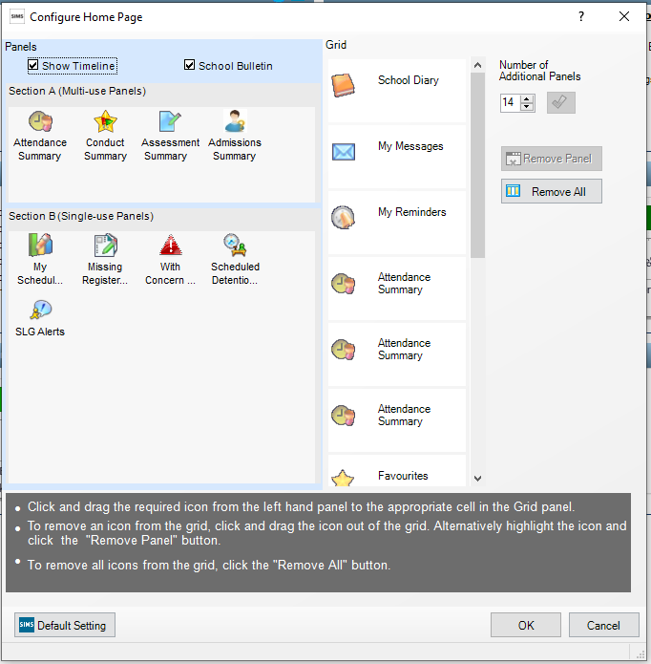
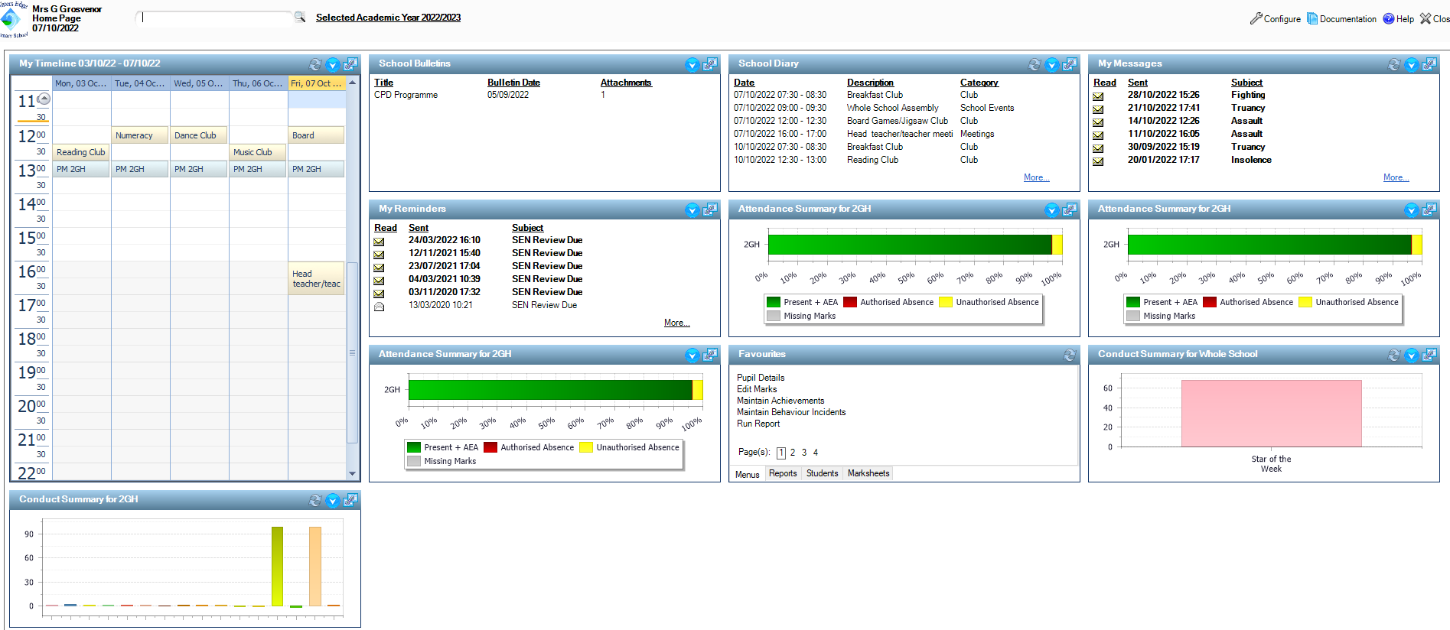

3. Looking at the panel above I have selected to show ‘School Diary’, ‘My Messages’, ‘My Reminders’, ‘Attendance Summary’ x 2, ‘Favourites’ and ‘Conduct Summary’.
Your home page will look like below with all the panels showing that you have selected:

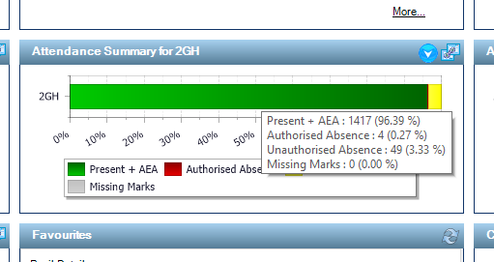
4. Each panel is interactive – here we are looking at ‘Attendance Summary for 2GH’– if you hover your mouse over the green bar, you can see the ‘Present + AEA’, ‘Authorised Absence’, ‘Unauthorised Absence’ and ‘Missing Marks’ percentages for 2GH

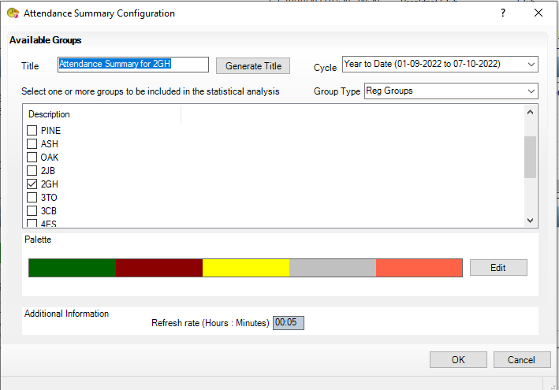
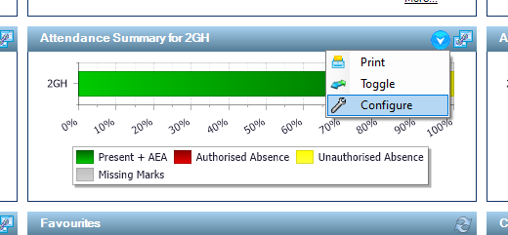
5. If you click on the downwards blue and white arrow and select ‘Configure’ you can then change the Year/Reg group etc and configure the colours, title etc – this will change what shows on your home screen

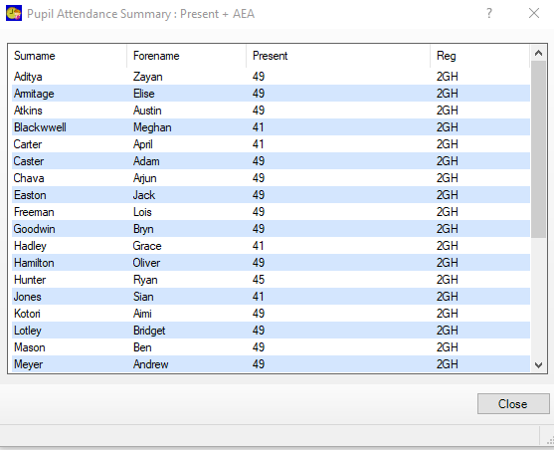
6. If you double click the green bar in the panel on your home page a list of pupil names will pop up which will display pupils ‘Pupil Attendance Summary: Present + AEA’

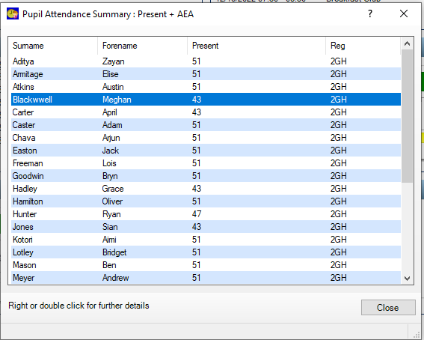
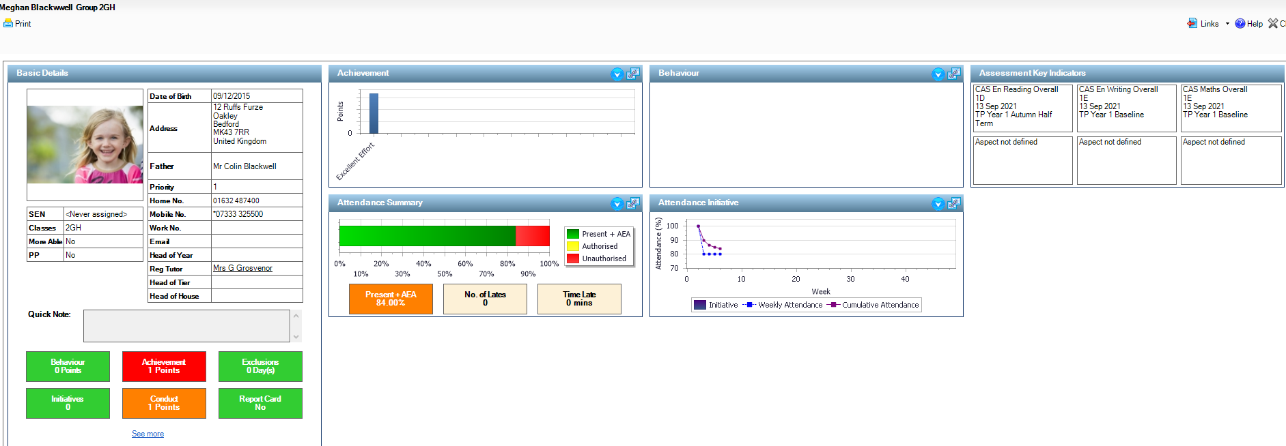
8. If you click on ‘Present + AEA’ you will be taken to the ‘Student Marks’ screen below to drill down into attendance further:
7. Double clicking on a pupil’s name will bring up the below screen with ‘Basic Details’, ‘Achievement’, ‘Behaviour’, ‘Assessment Key Indicators’, ‘Attendance Summary’ and ‘Attendance Initiative’

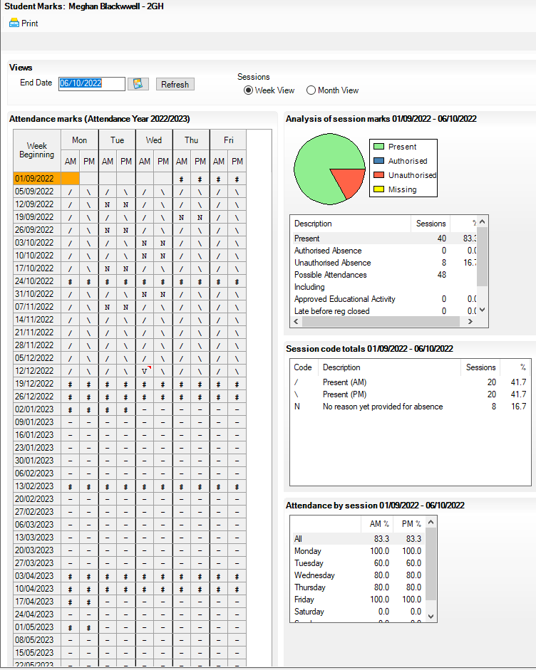

9. Student Marks – can change end date to show attendance marks from the start of the year to the date you have selected – option to print

10. If you click on icon at the top right of the panel you will be presented with the below screen– hovering over each of the pupil’s green lines will display their individual percentages and if you double click the green bar it takes you into the pupil’s details screen again (See point 8) Click close to come out of these screens and return to homepage
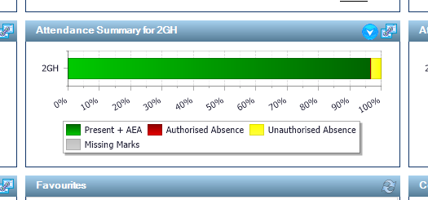

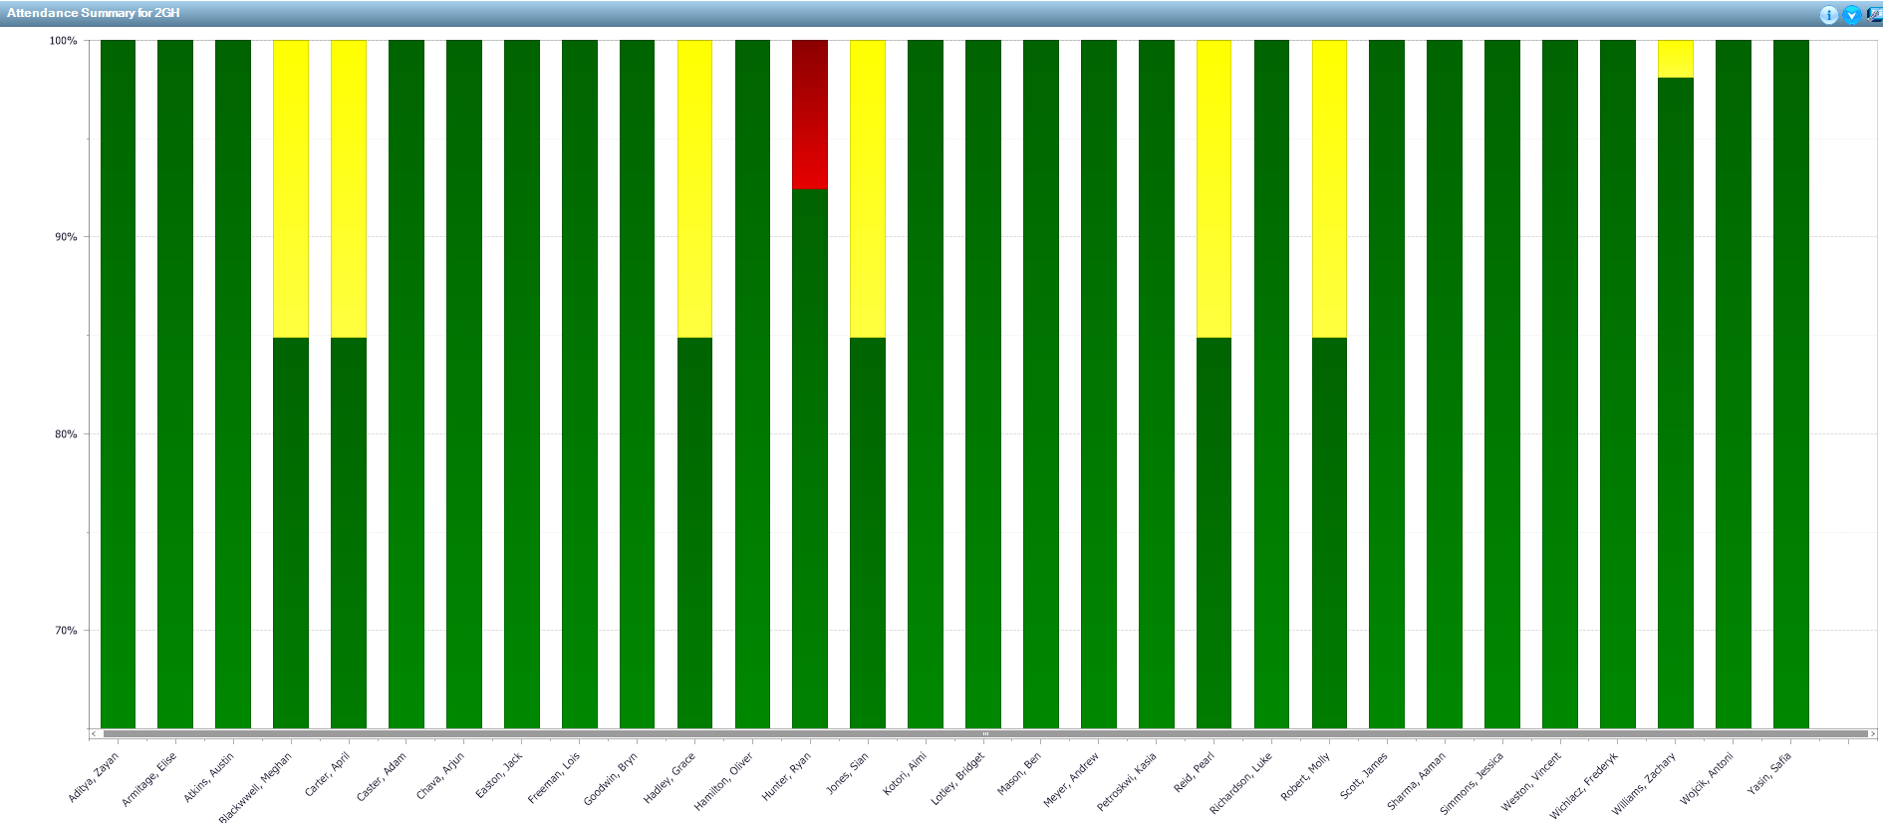

School Diary – Editing and Displaying on the Home Screen

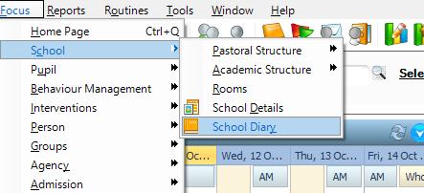
1.Go to Focus>School>School Diary

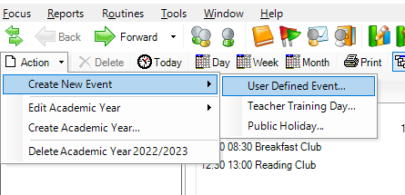
2. Click Action>Create New Event>User Defined Event to create an entry in the diary

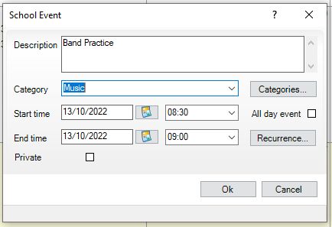
3. Here I have created an event for ‘Band Practice’ and added in a ‘Music’ Category by clicking on ‘Categories’ and ‘Add’

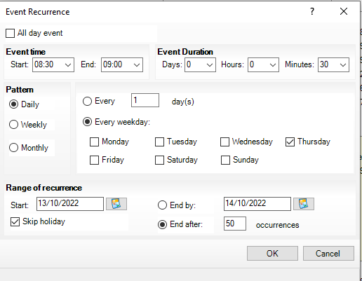

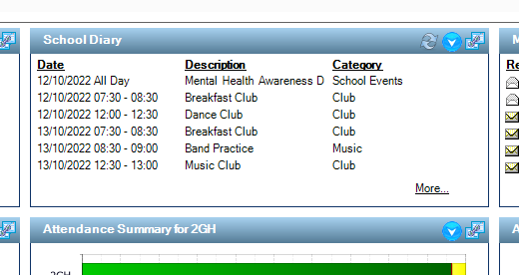
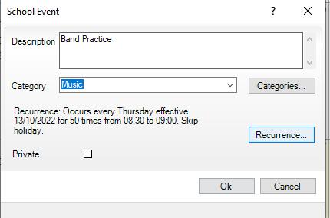
4. You can set the recurrence for the event – here I have selected every Thursday 8.30-9.00 with skip holidays selected

5. You will then see this event on your homepage under ‘School Diary’ by clicking you can select print to print off a weeks’ worth of events for the office or staff

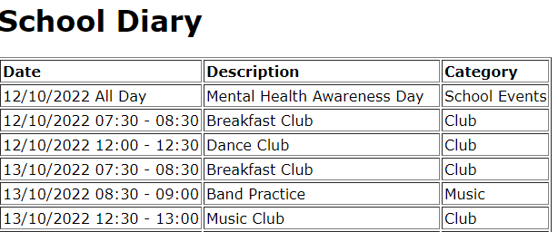

Import of CTF Causes a Duplicate Pupil Record

- This can happen when the data you have entered into SIMS does not match exactly what is on the CTF
- SIMS matches 5 pieces of information: forename, surname, date of birth, UPN and gender
- If any of this information differs, SIMS will think that the student on the CTF is a new student
- You may also receive a message that the UPN already exists as this happens when SIMS is able to match the UPN against an existing student but at least one of the other 5 pieces of information is different
- If you have created a duplicate pupil and need to delete, follow the below steps (NB: it would be preferable to delete the pupil before any data is added. It is still possible to delete the pupil with data but will take you longer in the long run)

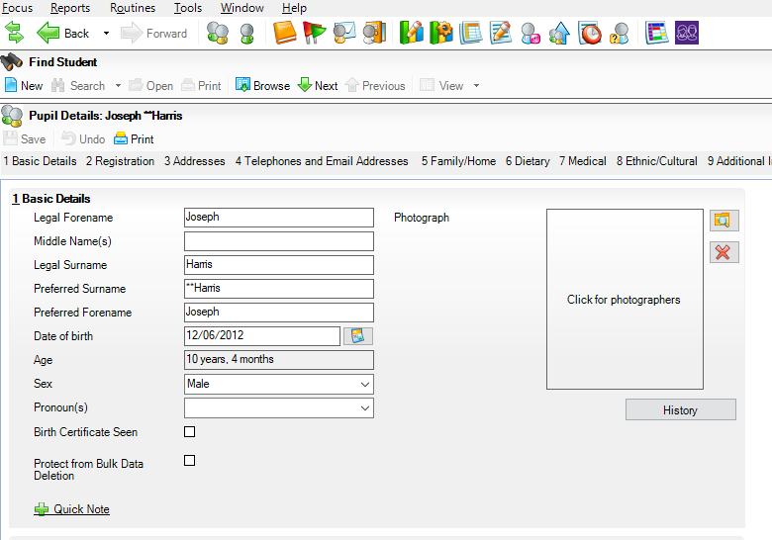

1. Find the pupil you want to delete using the browse section and add ** in front of the Surname (when you search for the pupil you will see the ** and know that is the correct pupil to delete)

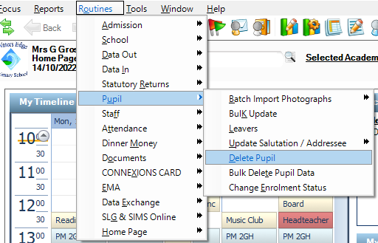

2. Click Routines>Pupil>Delete Pupil

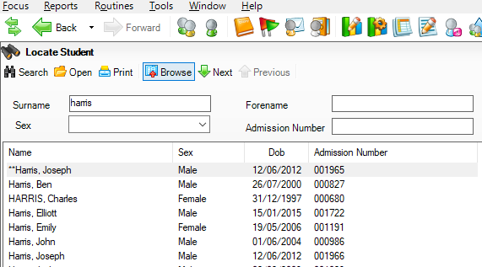
3 Search for the pupil’s surname and the pupil will show with the ** in front of the Surname. Click on the pupil’s name and click the yellow folder ‘Open’

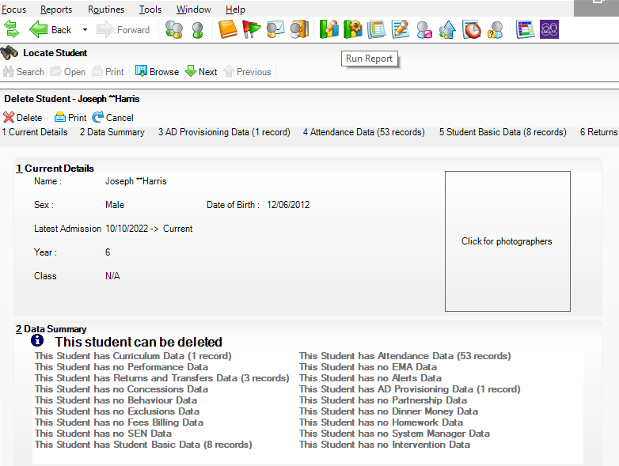
4. A message will come up saying whether you can delete or must address any data issues. Click ‘Delete’
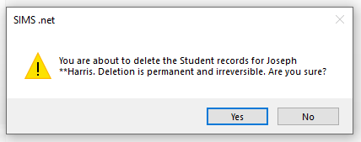
5. Say ‘Yes’ to the prompt

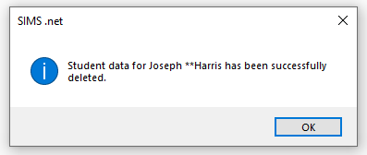
6. Click 'OK’

CTF import – Updating an Existing Pupil/Student’s Data

To avoid creating a duplicate student when importing a CTF for a pupil whose data has been partially added into SIMS follow this route:
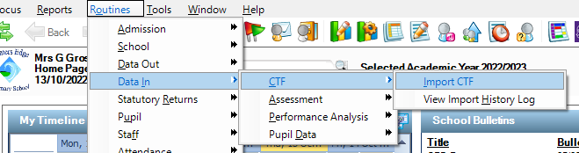
1. Click Routines>Data In>CTF>Import CTF

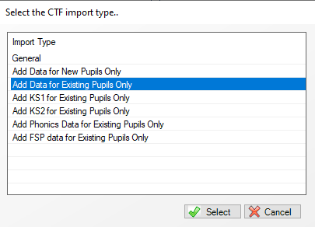
2. Click ‘Add Data for Existing Pupils Only’ and ‘Select’

The CTF will then only match to the student if the five pieces of information mentioned above match in the CTF and the Pupil Records and will not create a duplicate pupil

Bulk Update for Pupil Data – Easy Way to Update Multiple Pupil Records

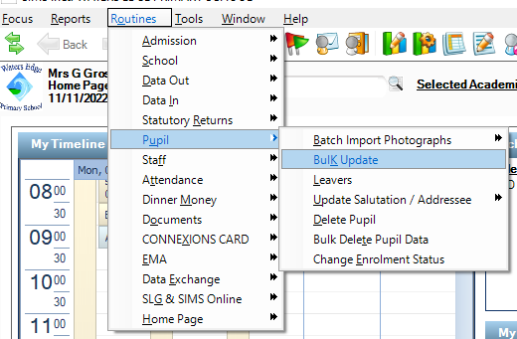

1. Click Routines>Pupil>Bulk Update

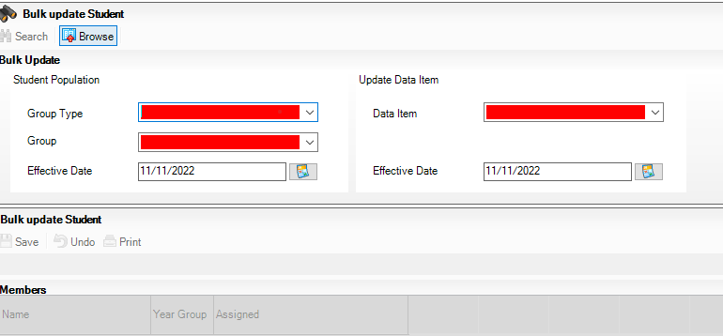
2. You will be presented with the Bulk update Student screen

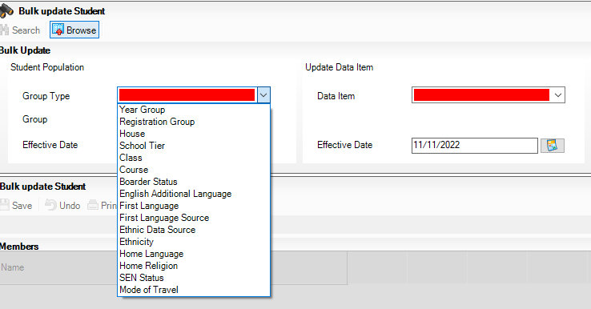
3. Select ‘Group Type’ here I selected ‘Year Group’

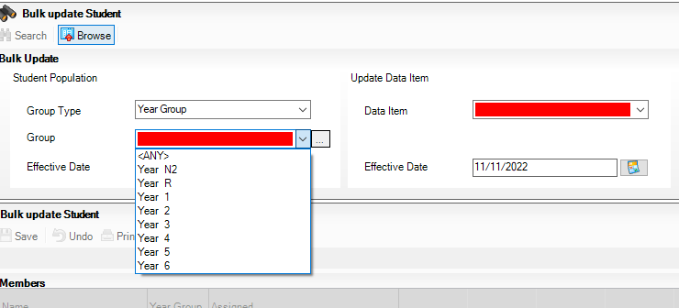
4. Select ‘Group’ here I selected ‘Year R’ and enter a date into the ‘Effective Date’ field below the ‘Group’ drop down menu

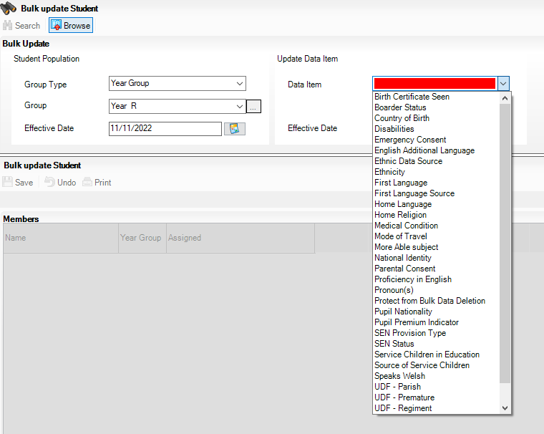

5. Here I have selected ‘Ethnicity’ as I want to bulk update from Admission Forms – once selected click ‘Search’ (you can choose various options from this list to bulk update such as ‘First Language’, ‘Medical Condition’, ‘SEN Status’ or even update ‘User Defined Fields’)

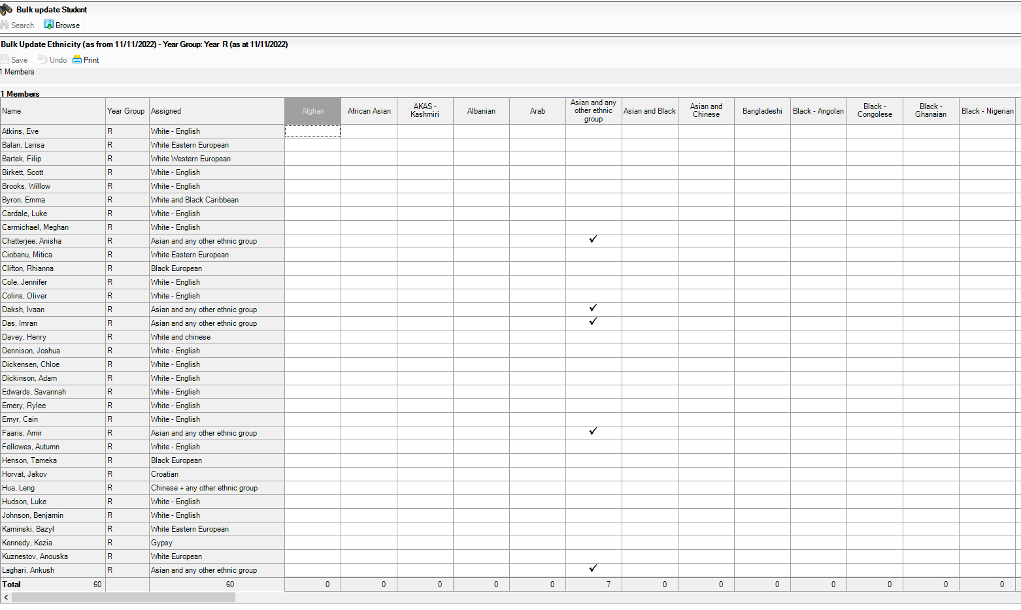
6. This screen will populate with pupils’ names and ethnicity they are currently assigned to – to change or add to the pupil record find the correct Ethnicity – enter a tick and click save – this will then show as updated on the pupil record

Change Enrolment Status

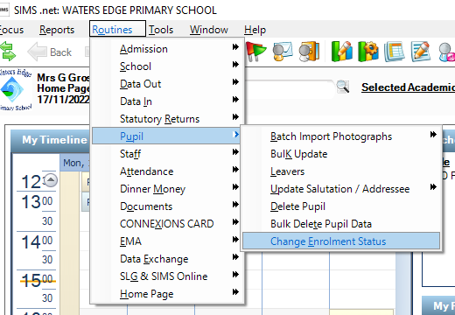
1. Click Routines>Pupil>Change Enrolment Status

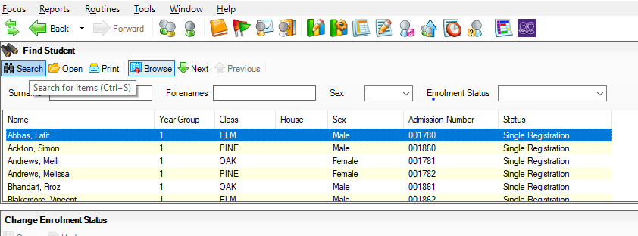
2. Click ‘Search’ to bring up pupils or alternatively can enter surname, forename, sex, or enrolment status to find pupil

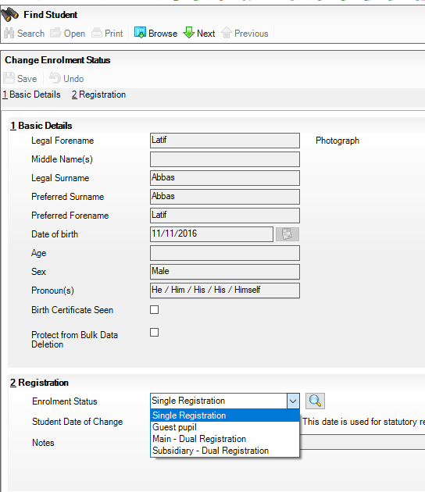
3. Open the pupil record you want to change and select drop down menu in Section 2 Registration ‘Enrolment Status’ and choose the status you want and save

Printing Attendance Letters

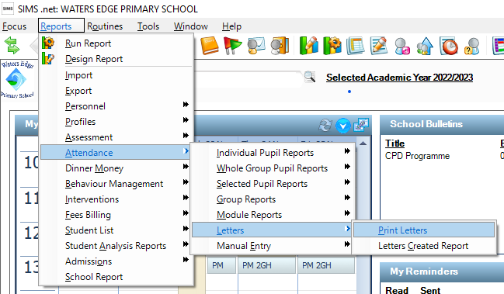
1. Click Reports>Attendance>Letters>Print Letters

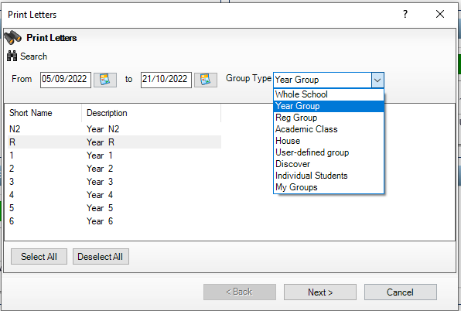
2. Change the from and to dates to show which attendance period you want the letters for and select the drop-down menu for ‘Group Type’ here I have selected ‘Year Group’ however you can select any of the other options – for example individual students

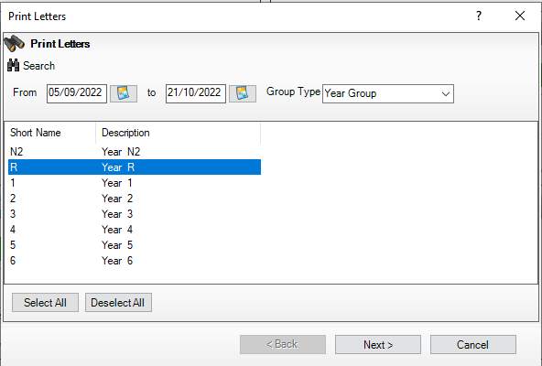
3. Here I selected ‘Year R’ – click ‘Next’

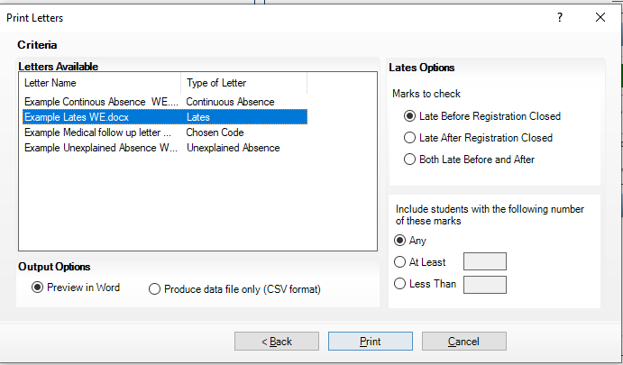

4. For this example I have selected ‘Example Lates WE.docx’ – click Print at the bottom which previews in Word and will be open in the taskbar at the bottom of the screen (example of this is shown in point 6)

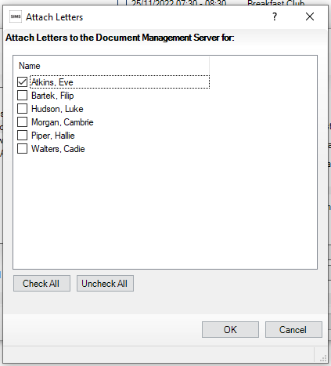
5. The ‘Attach Letters to the Document Management Server’ box comes up – select the letters you want saving onto the Pupils Record (shows in Linked Documents) by ticking the pupil’s name – here I have selected Eve Atkins – click ‘OK’. (NB If you do not wish for this to show in the pupil record under linked documents do not tick the pupil’s name and click cancel – this will not affect the letters in word – they will still be on your task bar)
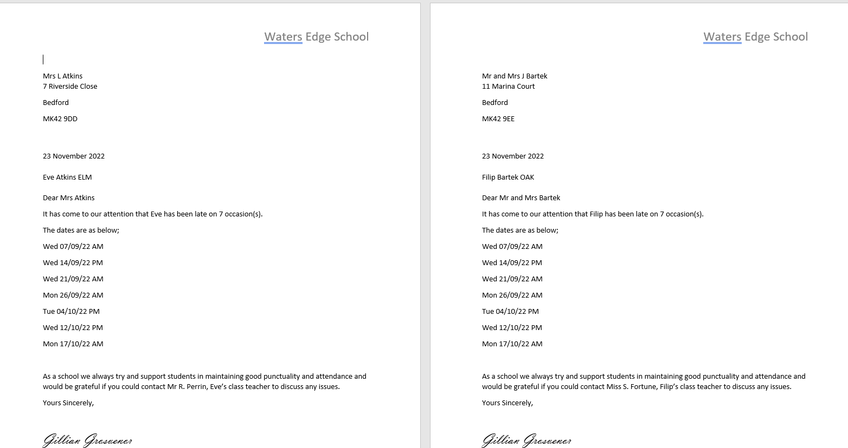

6. Above are examples of the letters that will be produced and open on your task bar addressed to the Parent – you can either print or save these to a location on your PC

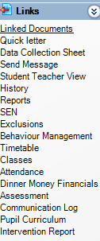
7. Looking at the Pupil Record navigate to the right-hand side ‘Links’ and ‘Linked Documents’ this is where the late letter will be stored for future reference

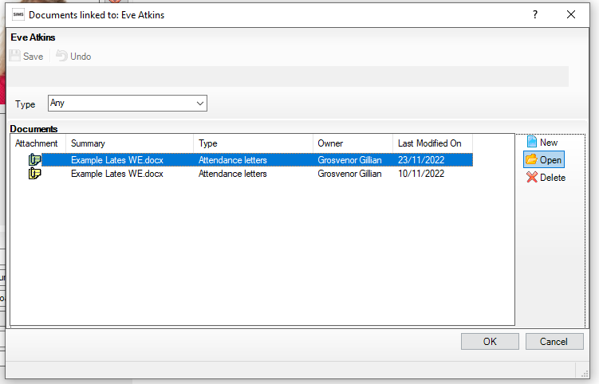
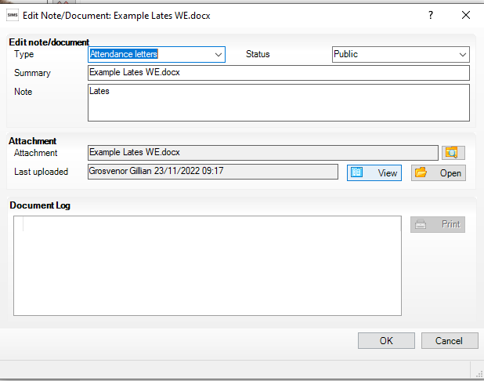
9. Click on ‘Open’ and the late letter will open in Word as shown on the next page
8. Click on ‘Example lates WE.docx’ for the date you want to view and then ‘Open’
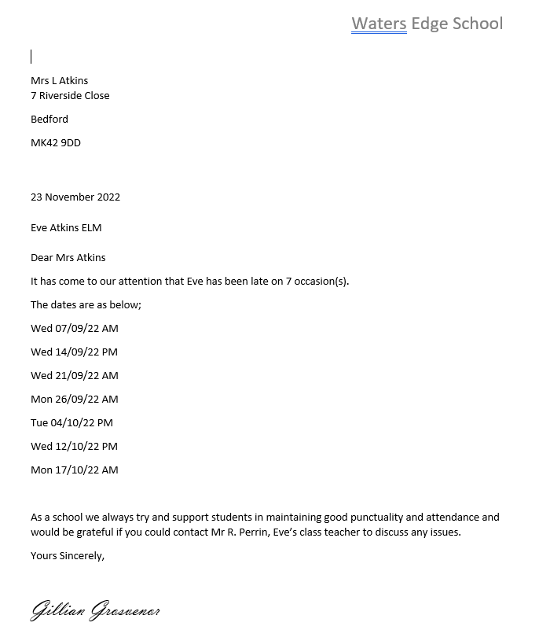

10. To create a report to tell you what letters you have created and when click Reports>Attendance>Letters>Letters Created Report

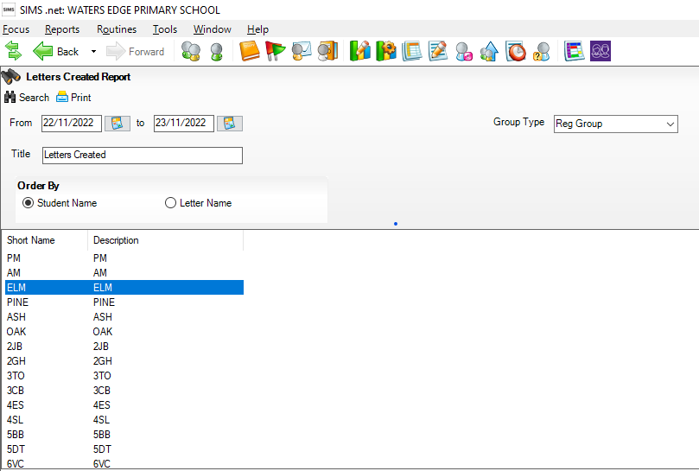

11. Here I have selected the dates from and to I want to view and the ‘Reg Group’

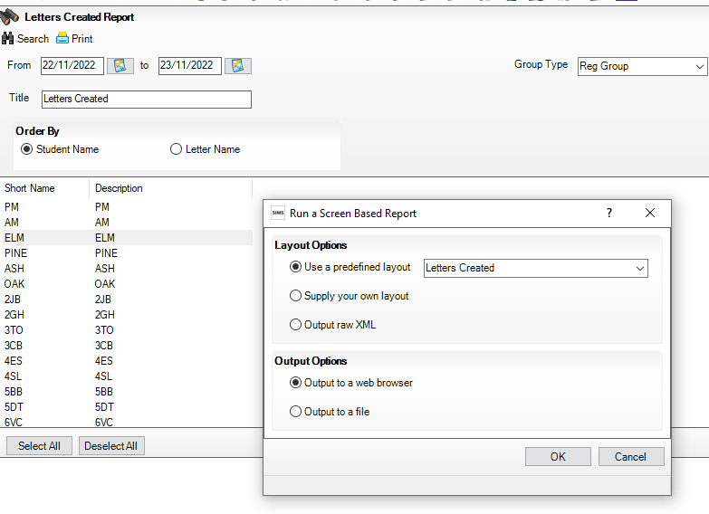
12. Click ‘Search’ and ‘Print’ click ‘OK’

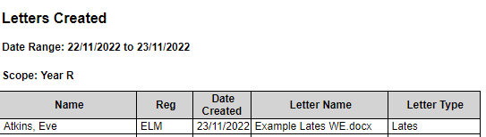

13. The report above opens in another screen for you to print or save detailing which letter was printed, when and to which child

