Guidance for Completing and Submitting

Year 1 Phonics Test Results for Year 2 Students in the 2020 Autumn Term

Contents
Page
Introduction 3

Importing the Assessment Wizards for the Year 1
Phonics Screening Check for Year 2 students 4

Using the Year 2 Phonics Screening Wizard 2019 for the Year 2 Pupils 7

In the 2020 Autumn Term

Correcting a Mark Entered Incorrectly 10

Previewing, Uploading and Exporting Reports 11

Uploading Reports 12

Exporting the Results in a CTF 12

Introduction

Cancellation of the phonics screening check in June 2020 means incoming year 2 pupils did not take the check in year 1. In the 2020/21 academic year only, it is statutory for schools to administer a past version of the phonics screening check to year 2 pupils during the second half of the 2020 autumn term and return results to the LA.

Year 2 pupils who meet the expected standard in phonics in the autumn check will not be required to complete any further statutory assessments in phonics. Year 2 pupils who do not meet the expected standard in the autumn check will be expected to take the statutory check in June 2021, alongside year 1 pupils.

Year 3 pupils, who were due to take the statutory check in June 2020 (when they were in year 2), are not formally required to take the autumn check. Schools are expected to maintain a programme of support for these pupils but do not need to return phonics data for year 3 pupils to the LA.

Administration

Schools must administer a past version of the phonics screening check to year 2 pupils. Schools have flexibility to decide when they administer the check within the second half of the 2020 autumn term (between the October half term and Christmas).

Pupils in the same cohort can take the check on different days. If a pupil is absent when the rest of the cohort takes the check, schools can administer the check to the pupil at any point up until the end of the 2020 autumn term. Any pupil who is absent from school for this entire period should be recorded as ‘A’ (absent) in the results data. This pupil would then be eligible to take the statutory check in June 2021.

IMPORTANT: The DfE would like the data to be recorded with a result date when the check is actually completed – not back dated to May / June 2020 when it would normally have been carried out. So please ensure the Result Date in the Marksheet is set appropriately for the second half of the autumn term when keying in results.

Important Dates

Date | Action
Friday 23 October | Schools should order braille versions of the 2017, 2018 or 2019 phonics screening check, if required.
Second half of the 2020 autumn term | Schools must administer a past version of the phonics screening check to year 2 pupils.
By the end of the 2020 autumn term | Schools must submit phonics results for their year 2 pupils to the LA.
22 January 2021 | Deadline for LAs to submit phonics data to DfE, via COLLECT.

Importing the Assessment Wizards for the Year 1 & 2 Phonics Screening Check
- Select Routines | Data In | Assessment | Import
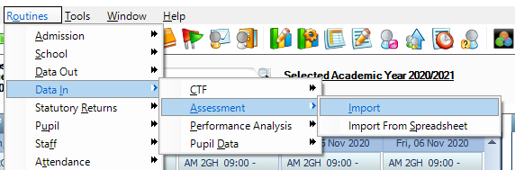

NOTE: If it is the first time you are running the wizard this year you may get the graphic below, click on yes to update your system.

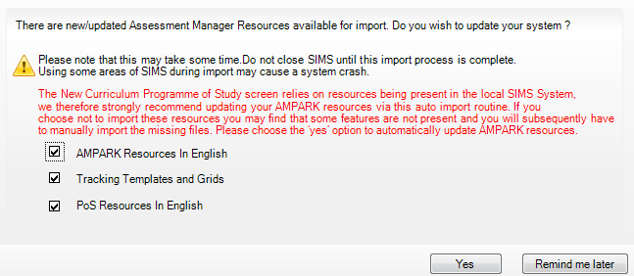
- Select the file to import by clicking the Field browser (magnifying glass) button.
- Select C:\Program Files\SIMS\SIMS .net\AMPA\England Primary (and Middle Deemed Primary)\Assessment Manager.
NOTE: Path May be C:\Program Files (x86)\SIMS\SIMS .net\AMPA\England Primary (and Middle Deemed Primary)\Assessment Manager, depending on your school setup.

- Select the Phonics Screening Year 1 2020 wizard. 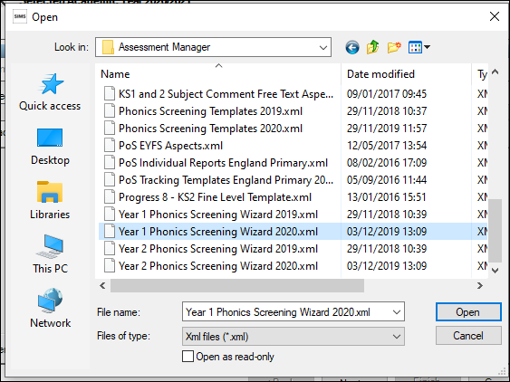
- Click the Open button to display the screen shown in the following graphic

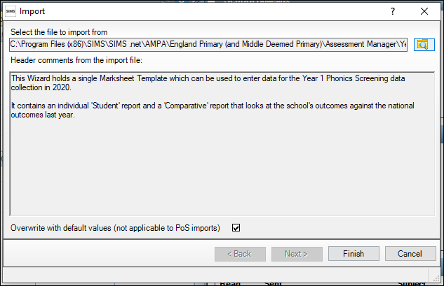

- Click the Finish button, then click the Yes button when asked ‘Do you want to proceed?’
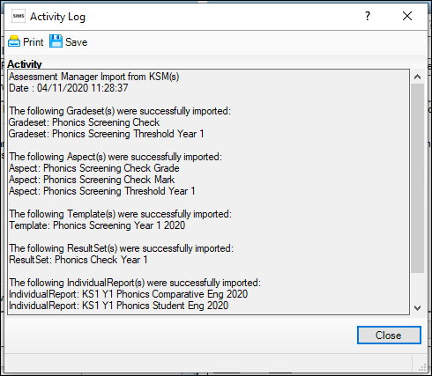

- An activity log shows what has been imported.

The Year 1 phonics screening check 2020 wizard has been imported to use in the next stage.

- Repeat this process to import the Year 2 Phonics Screening Wizard 2020.

Using the Year 1 Phonics Screening Wizard 2020 for Year 2 Pupils in the 2020 Autumn Term
- Select Tools | Performance | Assessment | Wizard Manager.
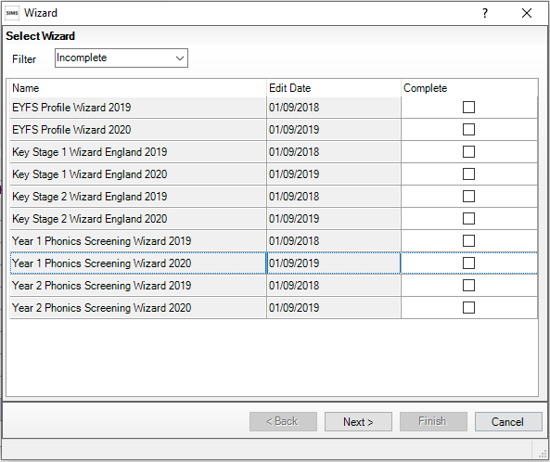
- Leave the filter on Incomplete and click the screening wizard which is going to be worked with – in this case Year 1 Phonics Screening Wizard 2020.
- Click the Next button.
- From the Select Group screen, click the Field Browser button to display the Group Selector dialog.
- Click the + next to Year Group to expand the list and select Year 2.
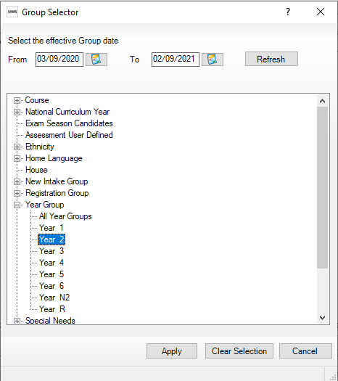
Expand the Year Group, select the Year 2 group and click Apply

- Click Next on the following screen.
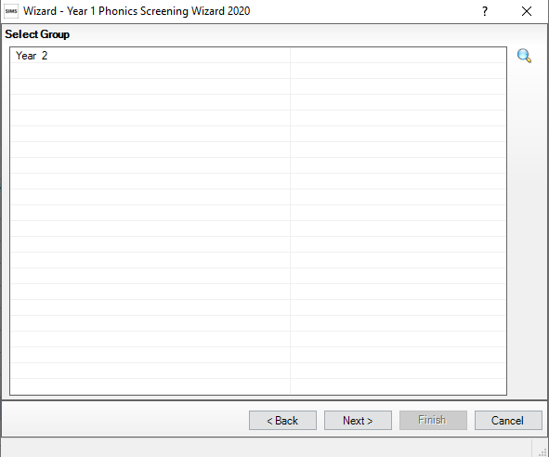
- The following screen will now been presented.
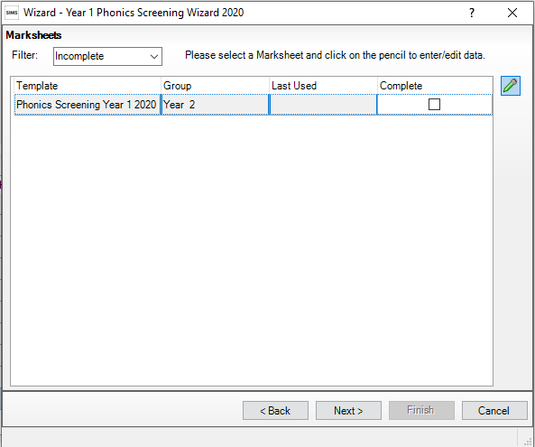
Highlight the Phonics Screening Year 1 line and click on the green pencil button to open the marksheet.
- A marksheet with the Year 2 pupils is displayed and columns relating to the assessments that need to be entered. 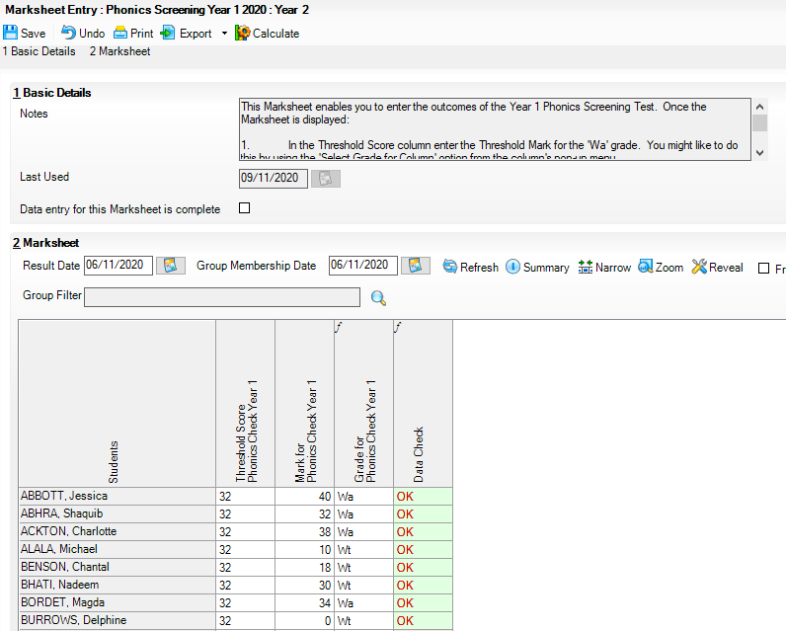
- Enter a value out of 40 into the Mark for Phonics Check Year 1 column.
IMPORTANT: The DfE would like the data to be recorded with a result date when the check is actually completed – not back dated to May / June 2020 when it would normally have been carried out. So please ensure the Result Date in the Marksheet is set appropriately for the second half of the autumn term when keying in results.
- Click Save to save the marks.
- DfE guidance says that you do not need to submit a threshold score, we advise you enter the same threshold mark for the 2019 test which is 32. If you do not enter a value in the Threshold Score Column, when you come to save you will see an exclamation in the Data Check column, this is expected. Data must be submitted for all year 2 pupils who are eligible to take the check, use the following codes:
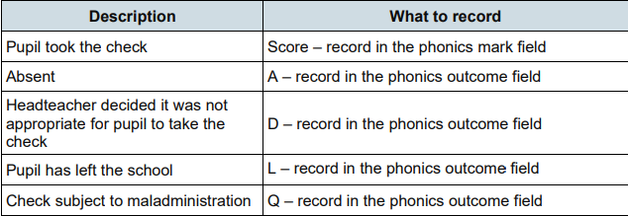

Note: Where a zero is entered an assumption is made that a pupil has been assessed and has genuinely achieved a score of 0.
Correcting a Mark Entered Incorrectly
If a mistake is corrected and the result has been saved, this cannot be deleted from the cell and saved again.
- To remove an incorrect score out of 40 or grade entered by mistake, right-click the cell with the wrong result and select View/Edit Result History.
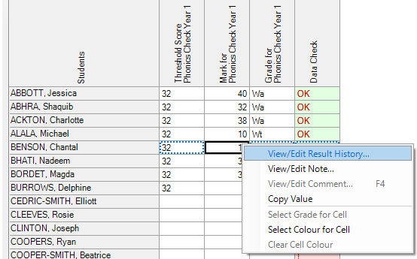
- Highlight the incorrect result and click the red cross on the right. Click the Yes button when asked to delete this. Click the Close button to close the View/Edit Result History screen. Then enter the correct mark out of 40.
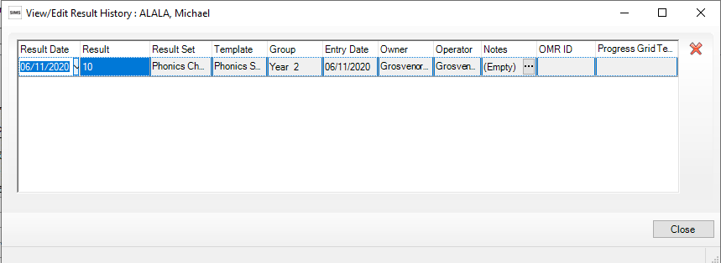
- Click the Calculate button so that the calculations are based on the most recent result. Then save the whole marksheet again.
- Exit the marksheet by clicking the Close button. This will revert back to the screen from where the marksheet was originally selected.
- The marksheet can be printed by clicking the Print button.

Previewing, Uploading and Exporting Reports
Once all the phonics screening results have been entered on the marksheets for year 2 pupils, reports can be produced.
- Select Tools | Performance | Assessment | Wizard Manager.
- Select the Year 1 Phonics Screening Wizard 2020 as required, then click the Next button.
- The group selection may be left as it is. Click the Next button until the Individual Report Format screen appears.
- Tick the box to select the students and highlight the KS1 Y1 Phonics Student Eng 2020 Individual Report Format
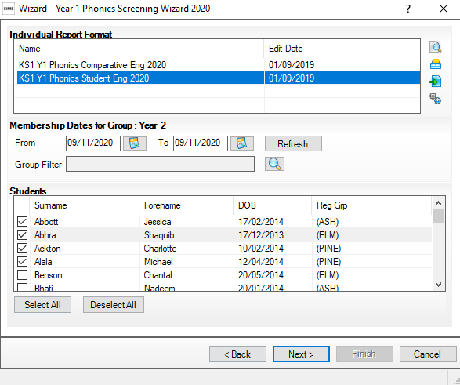
- You can now preview, upload or export the reports.
- Previewing the report will display the report seen below.
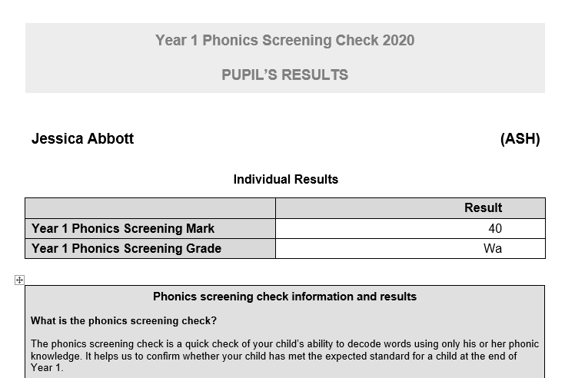

Uploading Reports
A copy of each pupil’s report can be saved in the document server. This can then be viewed at any time which will save having to print a second copy to keep with the pupil’s records.
- Once reports have been generated they can be uploaded, either individually or by selecting all pupils and clicking the Upload Report button.
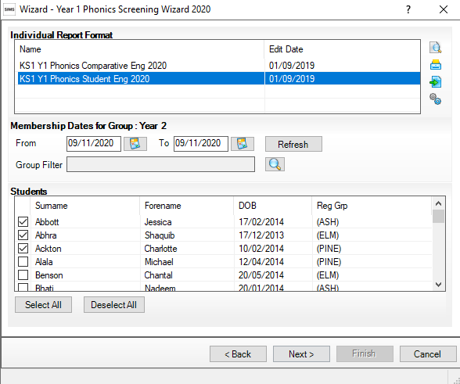
Click this button to export reports to a folder.
Click this button to upload reports to a students Linked Documents
- To view the uploaded copy, open the Pupil Details screen for the relevant pupil and select Linked Documents in the Links panel on the right. The report will open as read-only.
- Click the Close button to close the wizard

Exporting the Results in a CTF
NOTE: You must first upgrade to SIMS Autumn Release 7.196 before exporting result s to the LA
- Results for Year 2 pupils should be exported to your LA via a CTF file, by the end of the 2020 autumn term.*Please check your local LA guidance for submission deadlines*
- Select Routines | Data Out | CTF | Export CTF.
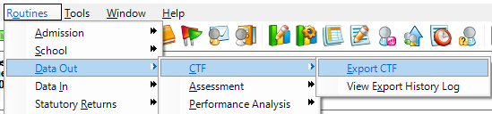
- Select the CTF export type of Phonics Test Results (for Autumn Term 2020 Screening Check only). The CTF will contain export files including only phonics test data plus the pupil UPN, surname, forename, DOB and gender.
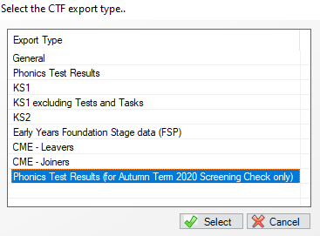
- If you have chosen a CTF export type of Phonics Test Results (for Autumn Term 2020 Screening Check only), the data to be exported panel will not be visible. On the students’ panel, click on the Year Grp column heading to order by the year and select the relevant Year 2 pupils.
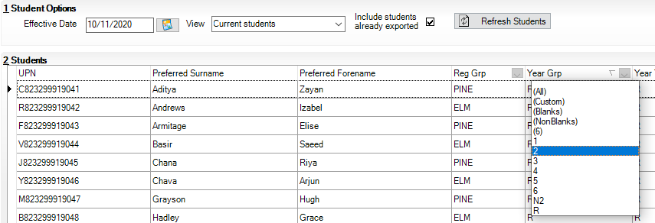
- Once the relevant pupils have been selected, choose your LA in the Destination LA/Other column. If click on a students name then press and hold ctrl on the keyboard followed by A, all students will be selected. Release the A but continue to hold ctrl and select the Destination LA/Other, it will now input this selection for all students.
- Click the Export button. A CTF will be created and placed in the normal export directory. It will contains the letters PHO (e.g. 3532999_PHO_353LLLL_002) which will indicate to the LA that this is your Phonics Test Results return.
- Upload the file to the LA in the normal way via S2S or in the normal way.

