Imagine stepping into the classroom and your tablet knows which lesson you’re taking and shows the name and picture of all pupils in that class. Mark a pupil late and it shows by how many minutes.
The new SIMS Teacher app makes everyday classroom tasks, like taking the register, simple.
So you can focus on inspiring your pupils.
- Seamless updates with SIMS in real-time
- Easy class registration
- Record achievement & behaviour
- View pupil details
- Pupil & teacher search
- Integrated assessment marksheets
- Works in school or ‘on-the-go’ out on the
school playing fields or school day trip
- Coming soon…SIMS Dinner Money integration
Registration made simple
Quickly record present, absent, late marks or school defined codes with a few simple taps so that you can get back to your class. If you need to mark a pupil late, the app automatically indicates the current number of minutes past the class start time.

www.capita-sims.co.uk/teacherapp
NEW
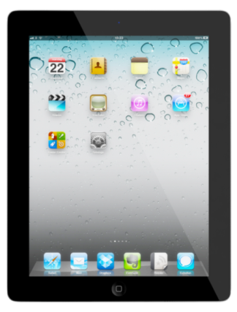
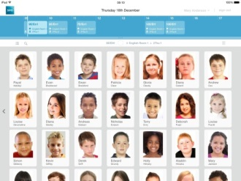
Viewing pupil details
See an overview of each pupil in class or on-the-go. View emergency contact information, any relevant medical and dietary information, and see at-a-glance any behaviour or achievement points.

New
Recording achievement or behaviour points
Recording achievement or behaviour information
for a pupil or group of pupils either in class or
on-the-go is quick and simple.
Assessment marksheets made simple
Recording assessment marks, grades and comments has never been easier with assessment marksheets in the SIMS Teacher app.
All of the data used by the SIMS Teacher app is encrypted and secure. With real-time access to timetables and pupil information, the SIMS Teacher app gives teachers more time to do what they do best...to teach and inspire pupils.
If you would like further information on the Capita Sims Teacher App. Please do not hesitate to contact us on 0161 684 2320 or email info@pennineeducation.co.uk

