- Contents
01| Introduction 1
Overview 1
How has the School Workforce Census Changed since Last Year? 2
Where to Find More Information 3
Where to find School Workforce Specific Information 3
Steps to Producing the School Workforce Census 3
02| Preparing for the School Workforce Census 5
Applying the School Workforce Census Licence 5
Setting SIMS Permissions 5
Permissions Required to Run and Edit the Return 5
Permissions Required to Import a Revised Fileset 5
Where to find More Information about Permissions 6
What Version of SIMS is Required? 6
Why Carry Out a Dry Run? 6
03| Producing the School Workforce Census 7
Creating a New School Workforce Census 7
Configuring the Census Folder 8
Specifying the Security Message for Reports 9
Checking the School Workforce Census Details 9
About the School Workforce Census Settings 11
Calculating Details 11
Editing School Information 12
Editing Base Pay Details 14
Editing Curriculum Details 16
Recording the Vacancies on Census Day 17
Editing Occasional Teachers Information 18
Recording Agency/Third Party Support Staff 19
04| Completing the School Workforce Census 21
Creating and Validating the School Workforce Census 21
Resolving Validation Errors and Queries 23
Producing Detail Reports 24
Generating Detail Reports 29
Printing a Report from your Web Browser 30
Transferring Report Data to a Spreadsheet 31
Deleting Temporary Web Browser Files 31
Producing the Summary Report 31
Generating the Summary Report 31
Editing an Unauthorised Return 32
Authorising the School Workforce Census 32
Submitting the Return 34
Retrieving Authorised Census Return Files 34
Copying a Return 35
Deleting an Unauthorised Return 36
Index 39

Introduction
Overview 1
How has the School Workforce Census Changed since Last Year? 2
Where to Find More Information 3
Steps to Producing the School Workforce Census 3

Overview
The School Workforce Census Return is required to be run by English schools in the maintained sector. These include Pupil Referral Units, Community, Foundation, Voluntary Aided and Voluntary Controlled schools, as well as Academies and Free Schools. This year the return takes place on Thursday 5 November 2020.
This handbook provides the information required by all schools to complete and run the School Workforce Census 2020 Return in SIMS.
NOTE: The contents of the graphics in this handbook (dates, names, etc.) are examples only of what you might expect to see when using SIMS to produce the School Workforce Census.
Data Items Collected in the Return
The following staff member data items are collected:
- Staff details
- Contract details (including the employment start date for the period of employment that applies to each contract)
- Service Agreement details for agency teachers (including the employment start date for the period of employment that applies to each service agreement)
- Payment details for categories of staff
Additional payment data is collected for non-teaching school leaders as well as teachers and teaching assistants. Additional payment data for other support staff is no longer required.
- Curriculum details for teachers and teaching assistants in the timetable cycle in which the census falls (Secondary and All-Through schools only)
The following school level data items are collected:
- Vacancies
- Occasional teachers
The return collects staff data for both teachers and support staff.
- Teachers and Support Staff with contracts:
- who are employed by the school via a current contract that has lasted for 28 days or more on 05/11/2020
or
- who are have been employed by the school via a contract for 28 days or more during the period 01/09/2019 to 05/11/2020 inclusive
or
- who are have been employed by the school via a permanent contract or via a contract with a contract end date at least 27 days after the contract start date.
- Teachers with service agreements (agency teachers):
- who are employed by the school via a current service agreement with a third party on 05/11/2020
or
- who have been employed by the school via a service agreement for 28 days or more during the period 01/09/2019 to 05/11/2020 inclusive.

How has the School Workforce Census Changed since Last Year?
The School Workforce Census 2020 Return includes the following changes.

Reducing Burdens
- Please note that in order to reduce burdens on schools as this difficult time, the DfE will be removing the following data from the return file on upload to COLLECT.

The absence module
The qualifications module
The third party support staff module
The ‘vacancy subject’ and ‘vacancy tenure’ fields
The ‘date of last pay review’ field
The DfE will be modify its school validation and summary report to exclude any reference to this data

Key Dates for the School Workforce Census
Routines | Statutory Returns | School Workforce Census
Census date: 05/11/2020
Absence collected from 01/09/2019 to 31/08/2020 – NOT COLLECTED IN THE 2020 SWC
Continuous contracts collected from 01/09/2019 to 05/11/2020.

New Staff Category – Leadership Non-Teacher
A separate category is now used to determine which data items are reported for Leadership Non-Teacher staff (SWC Post of Leadership - Non Teacher). Staff with an SWC Post of Leadership - Non Teacher are no longer included in the Other Support Staff category.
The staff category Leadership Non-Teachers has been included in the report criteria header of a number of the SWC reports.

Changes to Data Items Collected for the Other Contracted Support Staff Category
The Additional Payment category and the Additional Payment Amount are no longer collected for Other Support Staff (SWC Post of OSP).
QTS, QTLS, EYTS are now collected for Other Contracted Support Staff who have an SWC Post of AVT (Advisory Teachers).

Where to Find More Information
Online help can be accessed by pressing F1 or clicking the applicable Help button in SIMS.
A wide range of documentation is available from the SIMS Documentation Centre, including handbooks, quick reference sheets and tutorials. Click the Documentation button located on the top right-hand side of the SIMS Home Page, select the required category and then select the document you require.

Where to find School Workforce Specific Information
In addition to this handbook, a preparation guide that outlines how to prepare your data for the School Workforce Census is available from the SIMS Documentation Centre.
The School Workforce Census 2020 guidance information provided by the DfE is available on the DfE website (http://www.gov.uk/guidance/school-workforce-census).

Steps to Producing the School Workforce Census
The process of producing the School Workforce Census can be separated into a number of steps, some of which might need to be repeated to eliminate validation errors and queries.
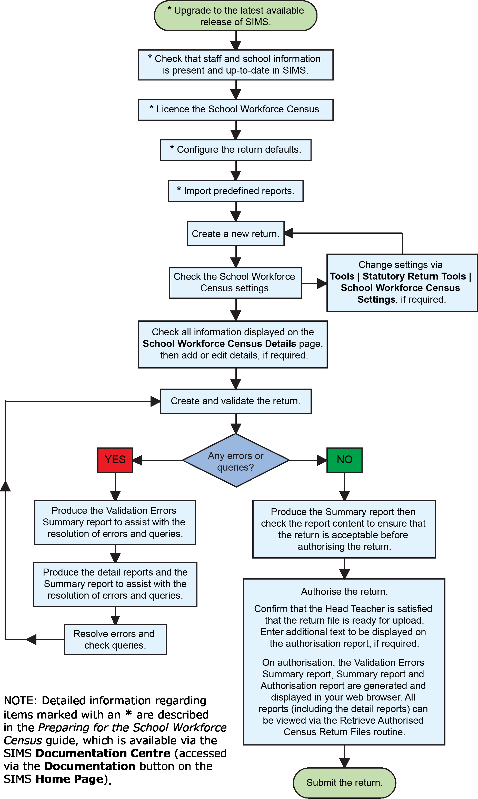

Preparing for the School Workforce Census
Applying the School Workforce Census License 5
Setting SIMS Permissions 5
What Version of SIMS is Required? 6
Why Carry Out a Dry Run? 6

Applying the School Workforce Census Licence
Applicable to schools using SIMS Personnel in read/write mode
A patch is available from SOLUS (Patch ID 11118) to license the SIMS School Workforce Census functionality.
The patch needs to be applied only once. If you have applied the patch in the past, it is not necessary to re-apply it for this year's return.

Setting SIMS Permissions
The following permissions are applicable to users who deal with returns.

Permissions Required to Run and Edit the Return
To run and edit the School Workforce Census, you must be a member of both of the following user groups in System Manager:
- Returns Manager
- Personnel Officer.
Having these permissions also enables you to correct data related to vacancies, staff and any curriculum information (if applicable) that fails validation.

Permissions Required to Import a Revised Fileset
The Import Fileset functionality enables updates to the Validation Errors Summary and the Summary report (derived from files supplied by the Statutory Body), and detail reports (provided by SIMS) to be imported into SIMS between SIMS releases.
To use the Import Fileset functionality (via Tools | Setups | Import Fileset), you must be a member of one of the following user groups in System Manager:
- Returns Manager
- System Manager.
For more information about the Import Fileset functionality, please refer to the applicable preparation guide, which is available via the SIMS Documentation Centre. Click the Documentation button located on the top right-hand side of the SIMS Home Page.

Where to find More Information about Permissions
Please contact your System Administrator/Manager if you are not sure whether you have the required permissions. For more information, please refer to the Managing SIMS Users, Groups and Databases handbook.
An Excel spreadsheet describing the numerous permissions available in SIMS is available on the Capita Software Support Portal (https://support.capitasoftware.com/csm?id=kb_article_view&sysparm_article=KB0039224).

What Version of SIMS is Required?
To run the return, you must have the SIMS 2020 Summer Release (7.194) or later installed.
To check which version of SIMS is installed, open SIMS and then select Help | About SIMS. A dialog similar to the one shown in the following graphic is displayed.
The version should read 7.194 or later.
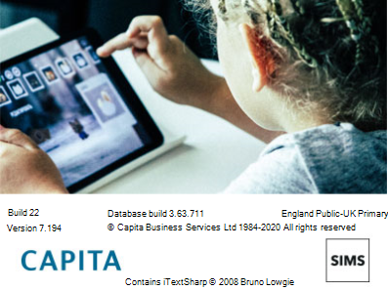

Why Carry Out a Dry Run?
Once the SIMS 2020 Summer Release (7.194) has been installed, you can carry out one or more dry runs of the School Workforce Census. It is advisable to do this as early as possible, even if you know that your data has not yet been fully prepared or checked. The purpose of the dry run is to produce the Validation Errors Summary, which details the corrections that need to be made to your data.

Additional Resources:
Preparing for the School Workforce Census 2020 Return guide

More Information:
Creating and Validating the School Workforce Census on page 21
Producing Detail Reports on page 24

Producing the School Workforce Census
Creating a New School Workforce Census 7
Checking the School Workforce Census Details 9
Calculating Details 11
Editing School Information 12
Editing Base Pay Details 14
Editing Curriculum Details 16
Recording the Vacancies on Census Day 17
Editing Occasional Teachers Information 18
Recording Agency/Third Party Support Staff 19

Creating a New School Workforce Census
Before creating a new School Workforce Census return, ensure that all staff and school information is present and accurate in SIMS.
It is possible to create more than one test return, i.e. dry runs. This enables you to check that all data required for the return exists and is up-to-date. Information can then be added or updated, if necessary, before running the final return. Any unwanted returns can be deleted, provided they have not been authorised.
- Select Routines | Statutory Returns | School Workforce Census to load the School Workforce Census validation and reporting files.
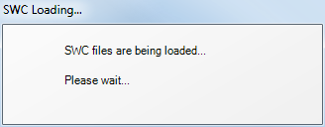
When the files are loaded, the School Workforce Census browser is displayed. The Fileset ID is displayed in the browser header (for information purposes only).
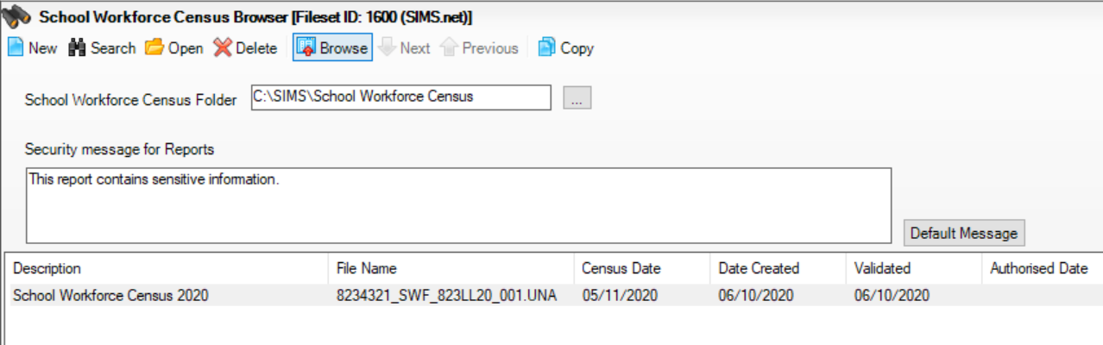
- Ensure that the School Workforce Census Folder is selected correctly and that the required Security message for Reports is specified, as described in the following sections.

Configuring the Census Folder
Before creating a return, the folder in which the return file will be saved must be specified.
IMPORTANT NOTES: Due to the sensitive nature of some of the data stored in SIMS, careful consideration must be given when specifying the location of any folder into which you save sensitive data, e.g. census returns, imported and exported CTFs, etc.
You should be mindful of your school’s responsibilities with respect to information security. Consider which users have access to the chosen folder, especially if the folder is shared on a server. Please refer to the government website for more information about securing your information (https://www.gov.uk/service-manual/technology/securing-your-information). If you are in any doubt, you should consult with your IT Security Officer before proceeding.
The General Data Protection Regulation (GDPR), which replaces the Data Protection Act 1998, is a directive for certain safeguards regarding the use of personal data. It is important that schools process all data (not just the data collected for the school census) in accordance with the full requirements of the GDPR.
Further information on the GDPR can be found on the Guide to the General Data protection Regulations (GDPR) page of the Information Commissioners Office (ICO) website (https://ico.org.uk/for-organisations/guide-to-the-general-data-protection-regulation-gdpr).
- In the School Workforce Census Folder field, enter the location of the folder where the return files are to be stored.
Alternatively, click the Browse button to display the Browse For Folder dialog.
Browse button
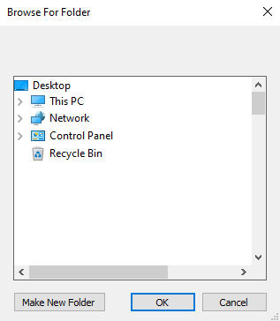
- Navigate to the location of the required folder and highlight it. If a suitable folder does not exist, click the Make New Folder button, then enter a suitable name for the new folder.
IMPORTANT NOTE: If you are changing the location of the folder, ensure that authorised personnel only have access to the new folder, as the folder will contain sensitive data. For more information, please see the important note at the beginning of this section.
- Click the OK button.
A message dialog requests confirmation that you want to continue.
- Click the OK button to select or create the folder and return to the browser, where the new folder name is displayed.
- Ensure that the Security Message for Reports is appropriate for your school.

Specifying the Security Message for Reports
The Security message for Reports field displays the text that will be included in the header of each report.
The default text (This report contains sensitive information) can be edited, if required. Clicking the Default Message button reverts the amended text to the original default text.
When the security message and census folder are specified, a new return can be created. Click the New button to display the School Workforce Census Details page.

Checking the School Workforce Census Details
The School Workforce Census Details panel displays key collection dates for the return. These dates are read-only and cannot be edited.
Census Date: 05/11/2020
Absence Start Date: 01/09/2019 – NOT COLLECTED IN 2020 SWC
Absence End Date: 31/08/2020 - NOT COLLECTED IN 2020 SWC
Continuous Contracts Start Date: 01/09/2019
Continuous Contracts End Date: 05/11/2020.
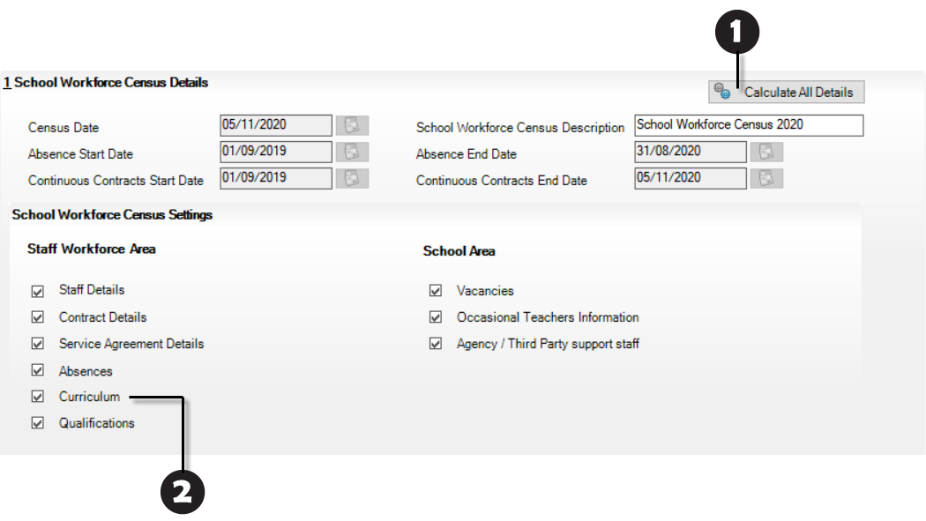

The Calculate All Details button is displayed in certain circumstances only (please see Calculating Details on page 11).
The Curriculum option is displayed for Secondary and All-Through schools only.
By default, the return Description is displayed as School Workforce Census 2020. The description can be edited, if required. This can be particularly useful when attempting to distinguish between dry runs and actual returns.
NOTES about the Calculate All Details button:
In all non-Secondary/All-Through schools (including Pupil Referral Units), this button is used to calculate pay details. If the Allow editing of Base Pay check box is deselected (via Tools | Statutory Returns Tools | School Workforce Census Settings) the button is not required and is therefore not displayed.
In Secondary and All-Through schools this button is used to calculate curriculum details for teachers and teaching assistants. Pay details are also calculated provided that the Allow editing of Base Pay check box has been selected via Tools | Statutory Returns Tools | School Workforce Census Settings.
If applicable click the Calculate All Details button to extract the data held in SIMS then populate the applicable panels on the School Workforce Census Details page.

About the School Workforce Census Settings
The School Workforce Census Settings panel displays a read-only list of all possible data items that can be collected in the return. A selected check box indicates that the associated data item is collected.
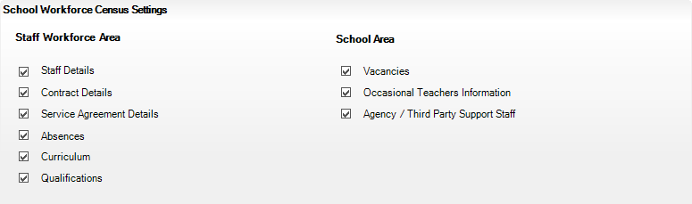
NOTE: The Curriculum check box is displayed for Secondary and All-Through schools only, indicating whether curriculum details for teachers and teaching assistants will be included in the return.
An option to Allow editing of Base Pay before the pay details are collected is also available. If selected the Pay Details panel is displayed on the School Workforce Census Details page when creating the return. This panel displays the calculated values of Base Pay for each school workforce member of staff. The values can be edited, if required.
Changes to the settings may be required if:
- your school does not record contract/service agreements because these are provided by your Local Authority. Some Local Authorities may supply contract details from an HR/Payroll system.
- SIMS Personnel is not used to record contract/service agreements but they are recorded in a different system.
- the editing of Base Pay is required before the pay details are collected for the return.
The Returns Manager can change the School Workforce Census settings via Tools | Statutory Return Tools | School Workforce Census Settings. These settings are preserved when SIMS is upgraded but can be edited, if required.

Additional Resources:
The Changing the School Workforce Census Settings section in the Preparing for the School Workforce Census 2020 Return guide.

Calculating Details
The Calculate All Details routine extracts the required information from SIMS and displays the results in the applicable panels on the School Workforce Census Details page. This routine does not populate the Vacancies on Census Day, Occasional Teachers on Census Day and Agency/Third Party support staff panels.
NOTES about the Calculate All Details button: In all non-Secondary/All-Through schools including Pupil Referral Units, this button is used to calculate pay details. If the Allow editing of Base Pay check box is deselected (via Tools | Statutory Returns Tools | School Workforce Census Settings) the button is not required and is therefore not displayed.
In Secondary and All-Through schools this button is used to calculate curriculum details for teachers and teaching assistants. Pay details are also calculated provided the Allow editing of Base Pay check box has been selected via Tools | Statutory Returns Tools | School Workforce Census Settings.
If the Calculate All Details button is displayed, you must calculate all details at least once for each return.
- Click the Calculate All Details button located in the School Workforce Census Details panel.
A warning is displayed explaining that any data previously collected or edited will be overwritten.
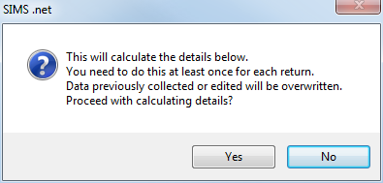
- Click the Yes button to calculate the details (and overwrite any data collected or edited previously).
Progress is reported on the Status Bar at the bottom of the screen. When complete, the applicable panel(s) is populated with the data extracted from SIMS.
- The return can be saved at any point by clicking the Save button.
WARNING: If you use the Calculate All Details routine again, any manual changes that have been made in the calculated panels are overwritten and must be re-entered.

Editing School Information
The School Information panel displays read-only information that has been recorded on the School Details page of SIMS (Focus | School | School Details).
The Previous Name and Date Name Changed, Previous Estab Number and Earliest DOA (date of admission), Previous URN and Date Number Changed fields are displayed for all schools. However, the fields are populated only if the information is relevant to your school, e.g. your school has converted to an Academy, and has been entered on the School Details page.
The School Information should always be checked.
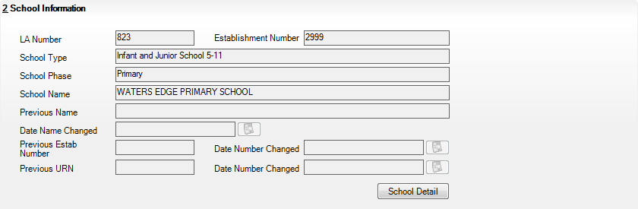
- If any details are missing or incorrect, click the School Detail button to display the School Detail dialog, where information applicable to your school is displayed.
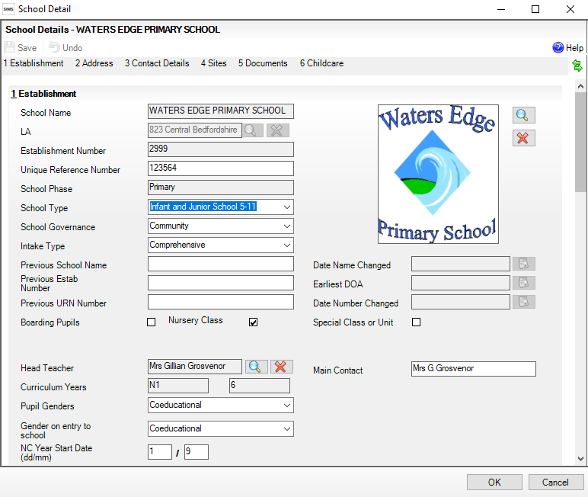
- Add or amend the school details, selecting from the drop-down lists, where applicable.
NOTE: The Establishment Number and the School Phase cannot be edited. If the information displayed is incorrect, please contact your Local Support Unit.
Information for Academies:
Academies should ensure that the following information is recorded, if applicable:
- The School Type and School Governance.
Select Academies from the applicable drop-down lists.
- The school’s Previous Name and Date Name Changed.
- The Previous Estab Number and Earliest DOA (date of admission).
If the establishment number (DfE number) has changed for sponsor-led Academies, historical information is not collected and the earliest date of admission is reported as the date the DfE number changed. This date is collected in the School Census return.
- The Previous URN Number and Date Number Changed.
IMPORTANT NOTE: These data items must be entered for all Academies because the date the URN changed is interpreted as the date the Academy opened. If this date is not entered, some of the historical information from before that date will be included in the School Workforce Census incorrectly, e.g. a member of staff who left before the Academy opened.
- Click the Save button, then click the OK button to return to the School Workforce Census Details page, where the updated details are displayed.

Editing Base Pay Details
Base pay is the pre-tax annual salary of a member of staff as at census day. It does not include the annual amount of any additional payments or allowances. In other words it is the annual salary that will be earned, based on the salary rate at the census date.
Base pay is not collected for staff paid by a daily rate.
IMPORTANT NOTE: The Pay Details panel is visible only if your Returns Manager has selected the Allow editing of Base Pay check box via Tools | Statutory Returns Tools | School workforce Census Settings.
The pay details are retrieved/calculated from SIMS Personnel and displayed in the Pay Details panel, where the base pay can be edited, if required, e.g. Academies that do not use the National Pay Scales might need to edit the pay details.
The base pay value recorded in SIMS Personnel is collected in the School Workforce Census, unless the value is edited in the Pay Details panel. If the value is edited, the new value is collected instead.
- For existing pay scales, base pay is still reported as the pay award amount on census day.
- For converted or new pay ranges, base pay is reported as the actual salary on census day.
The panel is populated when the Calculate All Details button is clicked (please see Calculating Details on page 11).
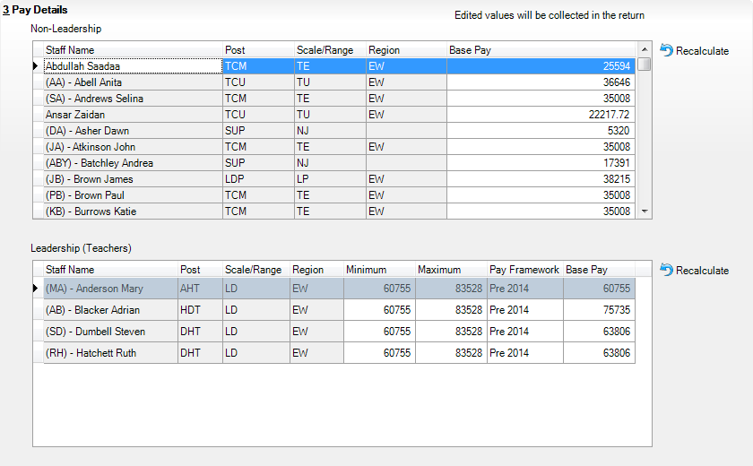
NOTES: It is possible for a staff member's name to be displayed twice, e.g. a classroom assistant who is also a playground assistant would be displayed twice in the Non-Leadership panel.
Regional pay range (Region) is no longer collected for the return but is displayed for information purposes only.

Non-Leadership
The Base Pay (retrieved from SIMS Personnel) can be edited, if required.
Base pay does not include benefits, bonuses or any other reward from the employer.

Leadership
- The Minimum and Maximum pay range (calculated from SIMS Personnel) can be edited, if required.
Each leadership teacher has a basic salary range within which they can expect to be paid while they remain in the same post at the same school.
- The Pay Framework, under which the Leadership teachers are paid, is calculated from SIMS Personnel but can be edited, if required. Select from the drop-down list:
- Pre 2014 framework (for contracts with a start date before 01/09/2014).
- 2014 framework (for contracts with a start date from 01/09/2014).
- The Base Pay (retrieved from SIMS Personnel) can be edited, if required.

Recalculate
If you wish to recalculate all pay details in the Pay Details panel for either Non-Leadership or Leadership teachers, click the adjacent Recalculate button.
IMPORTANT NOTE: Clicking the Recalculate button recalculates all pay details for teachers, teaching assistants and support staff. All information previously saved or edited is lost when performing this routine.

Additional Resources:
Changing the School Workforce Census Setting section of the Preparing for the School Workforce Census 2020 Return handbook

Editing Curriculum Details
Applicable to Secondary and All-Through Schools only
NOTES: To minimise the manual correcting of staff details, you may wish to run the Create and Validate routine before editing the Curriculum for Teachers and Teaching Assistants panel (please see Creating and Validating the School Workforce Census on page 21).
The Curriculum for Teachers and Teaching Assistants panel is only populated if the timetable has been transferred from Nova-T into the relevant academic year in SIMS and if the subject codes have been mapped to DfE subjects. For more information, please refer to the Preparing for the School Workforce Census 2020 Return handbook.
Records can be added manually to this list. For example, some staff may teach outside of the normal timetable, e.g. special support units, and will not be included here.
Please note that the description of the method used to calculate the hours is based on the DfE specification.
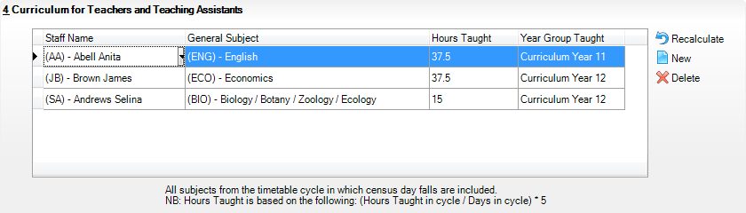
- Click the New button to display an additional row in the Curriculum for Teachers and Teaching Assistants panel.
- Click the Staff Name cell, then select the required member of staff from the drop-down list.
IMPORTANT NOTE: When a member of staff has been recorded in SIMS as a teacher or teaching assistant, SIMS must be restarted for their name to be available for selection from the Staff Name drop-down list.
- Click the General Subject cell, then select the required subject, e.g. (ENG) - English, from the drop-down list.
NOTE: The subject codes displayed are the DfE subject codes, not the school’s timetable subject codes.
- Enter the number of Hours Taught.
NOTE: Records are required on hours per National Curriculum Year group basis.
- Click the Year Group Taught cell, then select the required National Curriculum Year from the drop-down list.
To permanently delete a manually entered record that is no longer required, highlight the line and then click the Delete button.
Records displayed in the Curriculum for Teachers and Teaching Assistants panel that are held in SIMS can be deleted temporarily but are displayed again when the Recalculate or Calculate All Details button is clicked.

Recording the Vacancies on Census Day
The Vacancies on Census Day panel enables you to add any current job vacancies for all teachers (qualified and unqualified) that exist in your school. This information is not stored in SIMS so it must be added manually.
In a Local Authority Maintained school, a teacher vacancy is one where the applicant is expected to have either Qualified Teacher Status (QTS) or to be an Overseas Trained Teacher.
In Academies and Free Schools, QTS is not required for teaching posts but these schools must return data on teaching post vacancies, which if they occurred in a Local Authority Maintained school, would be filled by teachers with QTS or those who were Overseas Trained Teachers.
Each QTS (permanent or a contract of one or more terms) that is vacant or temporarily filled on census day must be recorded. A vacant or temporarily-filled post is defined as one that fulfils any of the following criteria:
- The vacant post is not covered.
- The post is covered temporarily by other staff within the school.
- The post is covered by a teacher on a contract of less than one term.
- The post is covered by a teacher on a contract of between one and three terms (except if the incumbent is on recognised long-term absence, such as maternity leave).
The following posts should be included:
- Posts that the school has tried to fill but have not been filled on census day.
- Posts where an appointment has been made but the appointee is not in the post on census day.
- Posts for all types of teachers, from classroom teachers to head teachers.
IMPORTANT NOTE: Posts that will become vacant after census day (e.g. where a teacher has resigned but is serving notice) should not be included.
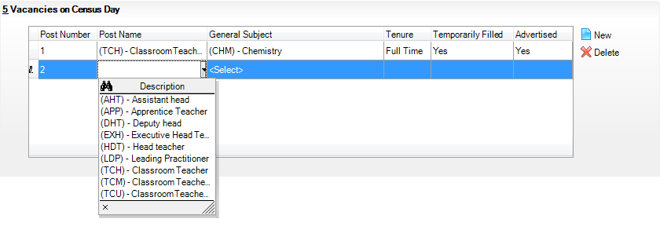
- Click the New button to add a new vacancy.
The Post Number is read-only and increments automatically when vacancies are added to the list.
- Click the Post Name cell then select the required description from the drop-down list, e.g. (LDP) - Leading Practitioner.
- Click the General Subject cell then select the required description from the drop-down list, e.g. (PRI) - Primary Curriculum, (CHM) - Chemistry, etc. depending on the school phase. NOT COLLECTED IN 2020 SWC BUT REQUIRED TO SAVE RECORD
- Indicate the Tenure of the vacancy by clicking the cell and selecting Full Time or Part Time from the drop-down list. NOT COLLECTED IN 2020 SWC BUT REQUIRED TO SAVE RECORD
- Indicate whether the vacancy has been Temporarily Filled, by clicking the cell then selecting Yes or No from the drop-down list.
- Indicate whether the post has been Advertised, by clicking the cell then selecting Yes or No from the drop-down list.
NOTE: The record can be saved only if all of the data has been entered.
To delete a vacancy, highlight the record then click the Delete button.

Editing Occasional Teachers Information
An example of an Occasional Teacher is a supply teacher who is in school on census day but is not in regular service (i.e. less than 28 days).
The Occasional Teachers on Census Day panel enables you to enter the number of occasional teachers in the following categories:
- Number of Occasional Teachers With QTS
- Number of Occasional Teachers Without QTS
- Number of Occasional Teachers Where QTS is Not Known.
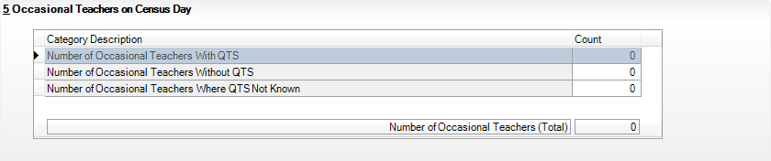
The Number of Occasional Teachers (Total) is read-only but updates automatically as the Count column is completed.

Recording Agency/Third Party Support Staff –
NOT COLLECTED IN THE 2020 SWC
Schools are required to provide the number of occasional support staff who are not directly employed by the school/LA on census day. These members of staff are likely to be employed through an agency/third party company, for example food services staff working for a catering company or occasional staff who work for an agency.
The Agency/Third Party support staff panel enables you to record the number of positions in your school that are filled by agency/third party support staff on census day.
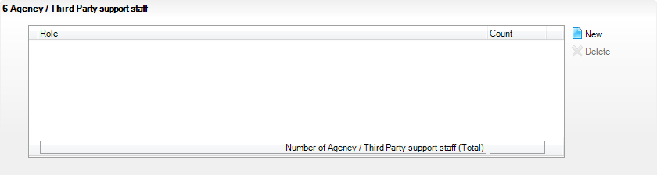
- Click the New button to display the Role Chooser dialog.
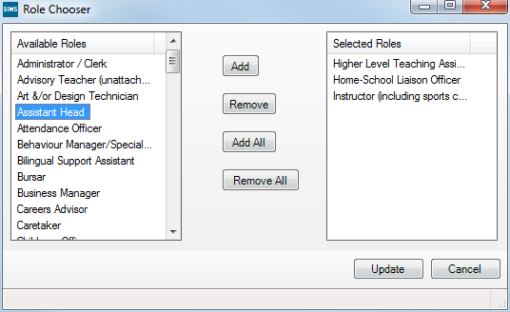
- Highlight the relevant position(s) in the Available Roles panel then click the Add button to move them into the Selected Roles panel.
Alternatively, click the Add All button to move all the Available Roles into the Selected Roles panel then Remove any roles not required.
If you wish to make your selections again, click the Remove All button to clear the Selected Roles panel and repopulate the Available Roles panel.
- When the required roles have been selected, click the Update button to return to the Agency/Third Party support staff panel, where the selected Roles are displayed.
- In the Count column, enter the number of third party staff who fill each of the roles.
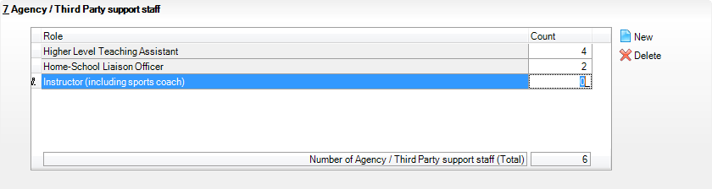
The Number of Agency/Third Party support staff (Total) is read-only but updates automatically as the Count column is completed.

Completing the School Workforce Census
Creating and Validating the School Workforce Census 21
Resolving Validation Errors and Queries 23
Producing Detail Reports 24
Generating Detail Reports 29
Printing a Report from your Web Browser 30
Transferring Report Data to a Spreadsheet 31
Deleting Temporary Web Browser Files 31
Producing the Summary Report 31
Editing an Unauthorised Return 32
Authorising the School Workforce Census 32
Submitting the Return 34
Retrieving Authorised Census Return Files 34
Copying a Return 35
Deleting an Unauthorised Return 36

Creating and Validating the School Workforce Census
A School Workforce Census Return must be validated and authorised before it can be uploaded to the DfE COLLECT data collection website or sent to your LA, depending on the instructions you have been given.
Validating the return creates an unauthorised School Workforce Census Return file, which is then validated against a set of DfE rules. Once the validation is complete, a list of errors and queries is displayed.
An error is caused by either missing or inaccurate data, whilst a query highlights data that is unusual or not as expected, e.g. staff member's age falling outside the expected range.
When the return has been validated, detail reports can be produced as an aid to resolving any issues (please see Producing Detail Reports on page 24).
- Select Routines | Statutory Returns | School Workforce Census to display the School Workforce Census browser.
- Search for then double-click the required return to display the School Workforce Census Details page.
- Click the Create & Validate button to start the Create and Validate process, which might take some time depending on the number of staff at your school.
If the value for historical spot allowances has not been specified, the Historical Allowances dialog is displayed. For your historical spot allowances to show correctly, you must indicate whether they have been entered as an actual or an annual amount.
- Click the OK button to close the Historical Allowances dialog.
- Select Tools | Setups | Employment Parameters to display the Employment Parameters page.
- In the Historical Spot Allowance Type panel, select either the Actual or Annual radio button.
- Actual - for example, if you wanted to report a Spot Allowance of £100 it is calculated as follows:
Actual allowance x pay factor, e.g. £100 x 1 = £100
- Annual - for example, if you wanted to report a Spot Allowance of £100 it is calculated as follows:
((Annual allowance x pay factor)/12) x applicable months, e.g. £1200 x 1 ÷ 12 x 1 = £100
- Click the Save button.
- Return to the School Workforce Census Details page and then click the Create & Validate button again.
- Run the Workforce Member Allowances Details report and then check the data in the following columns:
- SWC Additional Payment Amount (the value collected in the return)
- Allowance Annual Amount
- Applicable Months.
If a hyphen (-) only is displayed in the Allowance Annual Amount and Applicable Months columns, this is an indication that the SWC Additional Payment Amount is a spot allowance that has been entered as an actual amount.
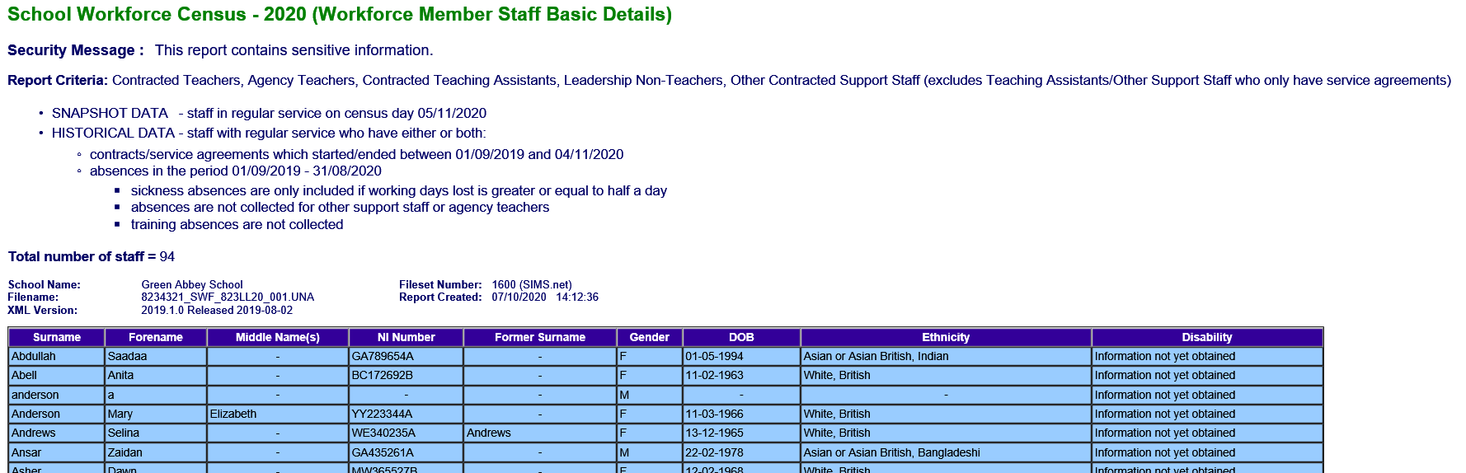
Historical spot allowances recorded before the SIMS 2017 Spring Release:
- Actual - if the historical spot allowance type is specified as actual, the School Workforce Census additional payment amount is the actual amount.
- Annual - if the historical spot allowance type is specified as annual, the School Workforce Census additional payment amount is derived from (annual allowance x pay factor)/12) x applicable months.

Resolving Validation Errors and Queries
After creating the return file and validating the data, any errors and queries found are listed in the Validation Errors Summary panel at the bottom of the School Workforce Census Details page.
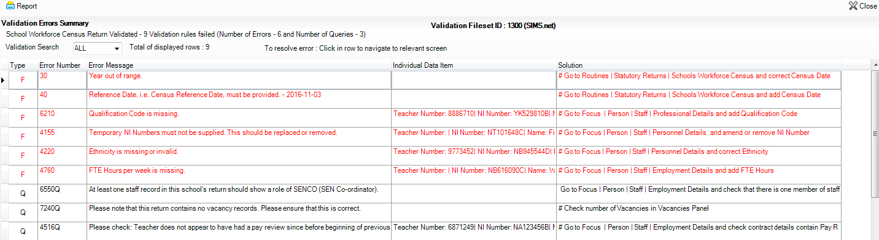
The Validation Errors Summary panel header displays the number of errors and queries found during the Create and Validate process. The Validation Fileset ID, which indicates the version of the DfE fileset currently in use, is also shown (for information purposes only).
Details about the errors and queries that have been found are displayed in the following columns.

Column | Description
Type | Displays the type of validation rule.  Failure (F displayed in red) indicates an error, which must be corrected.  Query (Q displayed in black) indicates that there are unusual data conditions. These should be checked and corrected, if necessary.
Error Number | Displays the error or query number.
Error Message | Displays the text of the error or query message.
Individual Data Item | Displays the specific record containing the error.
Solution | Provides a suggestion on how the error can be corrected or the query checked. Many solutions have a hyperlink (indicated by a #) to the applicable areas of SIMS.

TIP: Using the Solution hyperlink
When the pointer is hovered over an error or query row, it changes to a hand if a hyperlink is available to the area of SIMS where the problem can be checked.
A hyperlink is also indicated by a hash symbol (#) preceding the Solution text.
Click the required hyperlink to display the specific area in SIMS where the record(s) can be checked/corrected.
To assist in the viewing of any errors and queries:
- Use the Validation Search to display the required error or query you want to view. This is achieved by selecting ALL, ERRORS, QUERIES or the required number from the drop-down list.
- When ALL errors and queries are selected, the errors are displayed at the top of the list by default. Use the scroll bar located at the right-hand side of the panel to view all items.
- When the pointer is hovered over an Error Message, Individual Data Item or Solution cell, hover help displays the entire content of that cell.
- Change the order of the summary by clicking the appropriate column heading. If required, change the width of the columns by dragging the dividing line between the column headings until the required size is achieved.
- View a summary of errors/queries by clicking the Report button, located at the top left-hand side of the Validation Errors Summary panel. The summary is displayed in your web browser, from where it can be printed or transferred to a spreadsheet, if required (please see Transferring Report Data to a Spreadsheet on page 31).
The errors and queries are displayed until they are resolved and the Create and Validate process is run again.
Resolve as many errors and check as many queries as possible then revalidate the return details. Continue to resolve failures and revalidate the return as many times as necessary.
NOTE: All errors must be resolved and all queries must be investigated unless specific instructions to the contrary are received from your LA.
If at any point you wish to hide the list of error and queries, click the Close button located at the top right-hand side of the Validation Errors Summary panel. The list is displayed again when the Create and Validate process is run.

Producing Detail Reports
Detail Reports can be used to check the data stored in SIMS, which is used to generate the School Workforce Census Return. The reports can be produced as soon as the return has been validated.
Each detail report header displays the Security Message that was defined in the School Workforce Census browser, the Report Criteria and the Total number of staff in the report.
IMPORTANT NOTE: It is recommended that, after viewing statutory returns reports, you delete any temporary web browser files to ensure that any cached data (i.e. data stored on your machine, which enables high-speed access to previously viewed data) is removed.
Also shown at the top of the report is the School Name, the Fileset Number, the Filename, the Report Created date and the XML Version.
The following reports are currently available.

Workforce Member Basic Details Report
Report Criteria: Contracted Teachers, Agency Teachers, Contracted Teaching Assistants, Other Contracted Support Staff (excludes Teaching Assistants/Other Support Staff who only have service agreements).
- Snapshot Data – staff in regular service on census day (05/11/2020).
- Historical Data – staff with regular service who have either or both:
- contracts/service agreements which started/ended between 01/09/2019 and 05/11/2020.
- absences in the period 01/09/2019 to 31/08/2020
- sickness absences are only included if working days lost is greater or equal to half a day
- absences are not collected for other support staff or agency teachers
- training absences are not collected.
The following information is displayed in the report: surname, forename, middle name(s), National Insurance number, former surname, gender, date of birth, ethnicity and disability.

Workforce Member Area Details Report
Report Criteria: Contracted Teachers, Agency Teachers, Contracted Teaching Assistants, Other Contracted Support Staff (excludes Teaching Assistants/Other Support Staff who only have service agreements).
- Snapshot Data – staff in regular service on census day (05/11/2020).
- Historical Data – staff with regular service who have either or both:
- contracts/service agreements which started/ended between 01/09/2019 and 05/11/2020.
- absences in the period 01/09/2019 to 31/08/2020.
- sickness absences are only included if working days lost is greater or equal to half a day
- absences are not collected for other support staff or agency teachers
- training absences are not collected.
√ = data is included for this area.
Χ = data not included.
– = data not available/not applicable.
The following information is displayed in the report:
- Personal data: surname, forename, National Insurance number.
- Snapshot data on census day: SWC post, contracts, pay related, service agreements and qualifications.
- Historical data: SWC post, contracts, service agreements and absence.

Workforce Member Professional Details Report
Report Criteria: Contracted Teachers, Agency Teachers, Contracted Teaching Assistants, Other Contracted Support Staff (excludes Teaching Assistants/Other Support Staff who only have service agreements).
- Snapshot Data – staff in regular service on census day (05/11/2020).
- Historical Data – staff with regular service who have either or both:
- contracts/service agreements which started/ended between 01/09/2019 and 05/11/2020.
- absences in the period 01/09/2019 to 31/08/2020
- sickness absences are only included if working days lost is greater or equal to half a day
- absences are not collected for other support staff or agency teachers
- training absences are not collected.
The following information is displayed in the report: surname, forename, National Insurance number, teacher number, qualified teacher (QT) status, qualified teacher learning and skills (QTLS) status, early years teacher (EYT) status, higher level teaching assistant (HLTA) status and qualified teacher status (QTS) route, e.g. overseas trained teacher programme.

Workforce Member Contract/Service Agreement Details Report
Report Criteria: Contracted Teachers, Agency Teachers, Contracted Teaching Assistants, Other Contracted Support Staff (excludes Teaching Assistants/Other Support Staff who only have service agreements).
Snapshot Data – staff in regular service on census day (05/11/2020) with current contracts/service agreements.
Historical Data – staff with regular service and contracts/service agreements which started/ended between 01/09/2019 and 05/11/2020.
The following information is displayed in the report: surname, forename, National Insurance number, contract/service agreement type, start date, end date, post, contract/service agreement latest pay review date, school arrival date, destination, reason for leaving, origin, e.g. Break for family reasons, hours per week, full time equivalent (FTE) hours, weeks per year and role, e.g. Midday Supervisor.

Workforce Member Payment Details Report
Report Criteria: Contracted Teachers, Agency Teachers, Contracted Teaching Assistants, Other Contracted Support Staff (excludes Teaching Assistants/Other Support Staff who only have service agreements).
Snapshot Data – staff in regular service on census day (05/11/2020) with payment details.
The total number of staff, staff with leadership posts and staff with non-leadership posts are displayed at the top of the report.
Information for Leadership and Non-Leadership staff is displayed in two separate tables:
- Member Payment Details for staff with Leadership posts
Surname, forename, gender, National Insurance number, contract/service agreement type, post, role, scale/range, minimum, maximum, framework, base pay (excluding allowances), safeguarded salary, additional payment type, additional payment amount and daily rate.
- Member Payment Details for staff with Non-Leadership posts
Surname, forename, gender, National Insurance number, contract/service agreement type, post, role, scale/range, base pay (excluding allowances), safeguarded salary, additional payment type, additional payment amount and daily rate.

Workforce Member Pay Details Comparison Report
NOTE: This report is available only if the Allow editing of Base Pay option is selected (via Tools | Statutory Returns Tools | School Workforce Census Settings).
Report Criteria: Contracted Teachers, Agency Teachers, Contracted Teaching Assistants, Other Contracted Support Staff (excludes Teaching Assistants/Other Support Staff who only have service agreements).
Snapshot Data – staff in regular service on census day (05/11/2020) with payment details that have been edited.
The report compares the base pay recorded in School Workforce Census with that recorded in SIMS Personnel.
The following information is displayed in the report: surname, forename, National Insurance number, contract/service agreement type, post, role, base pay reported in the School Workforce Census and base pay recorded in SIMS Personnel.

Workforce Member Allowance Details Report
Report Criteria: Contracted Teachers, Agency Teachers, Contracted Teaching Assistants, Other Contracted Support Staff (excludes Teaching Assistants/Other Support Staff who only have service agreements).
- Snapshot Data – staff in regular service on census day (05/11/2020) with allowances.
- Permanent and temporary allowances – SWC additional payment amount is derived from ((Annual allowance x pay factor)/12) x applicable months.
- Spot allowances – the SWC additional payment amount is actual amount.
- Historical spot allowances recorded before the SIMS 2016 Spring release:
- Actual – if historical spot allowance type is set as Actual, the SWC additional payment amount is the actual amount.
- Annual – if historical spot allowance type is set as Annual, the SWC additional payment amount is derived from (Annual allowance x pay factor)/12) x applicable months.
- For agency teachers not on daily rate, SWC base pay and SWC additional payment amount are derived directly from the service agreement.
- Payment date is assumed to be the 28th of the month.
The following information is displayed in the report: surname, forename, National Insurance number, contract/service agreement type, e.g. permanent, post, role, additional payment type, start date, end date, SWC additional payment amount, allowance annual amount, allowance pay factor and applicable months.

Workforce Member Curriculum Details Report
Applicable to Secondary and All-Through schools only
Report Criteria: Contracted Teachers, Agency Teachers, Contracted Teaching Assistants (excludes Teaching Assistants who only have service agreements and Other Support Staff).
Snapshot Data – staff in regular service on census day (05/11/2020) with curriculum information.
The following information is displayed in the report: surname, forename, National Insurance number, subject, hours taught and year group taught.

Workforce Member Qualification Details Report
NOT COLLECTED IN 2020 SWC
Report Criteria: Contracted Teachers, Agency Teachers, Contracted Teaching Assistants, Other Contracted Support Staff (excludes Teaching Assistants/Other Support Staff who only have service agreements).
Snapshot Data – staff in regular service on census day (05/11/2020) with qualification information.
The following information is displayed in the report: surname, forename, National Insurance number, qualification, class of degree, first subject and second subject.

Workforce Member Absence Details Report
NOT COLLECTED IN THE 2020 SWC
Report Criteria: Contracted Teachers, Contracted Teaching Assistants (excludes Teaching Assistants who only have service agreements and Agency Teachers and Other Support Staff).
Historical Data – staff with regular service and absence in the period 01/09/2019 to 31/08/2020.
- Sickness absences are only included if working days lost is greater or equal to half a day.
- Absences are not collected for other support staff or agency teachers.
- Training absences are not collected.
The following information is displayed in the report: surname, forename, National Insurance number, first day of absence, last day of absence, working days lost and absence category, e.g. maternity/paternity leave.

Generating Detail Reports
To run a single detail report, select the required report from the Detail Report drop-down list located at the top of the School Workforce Census Details page.
NOTE: The Workforce Member Curriculum Details report is applicable to Secondary and All-Through schools only.
Example of the Detail Report drop-down list:
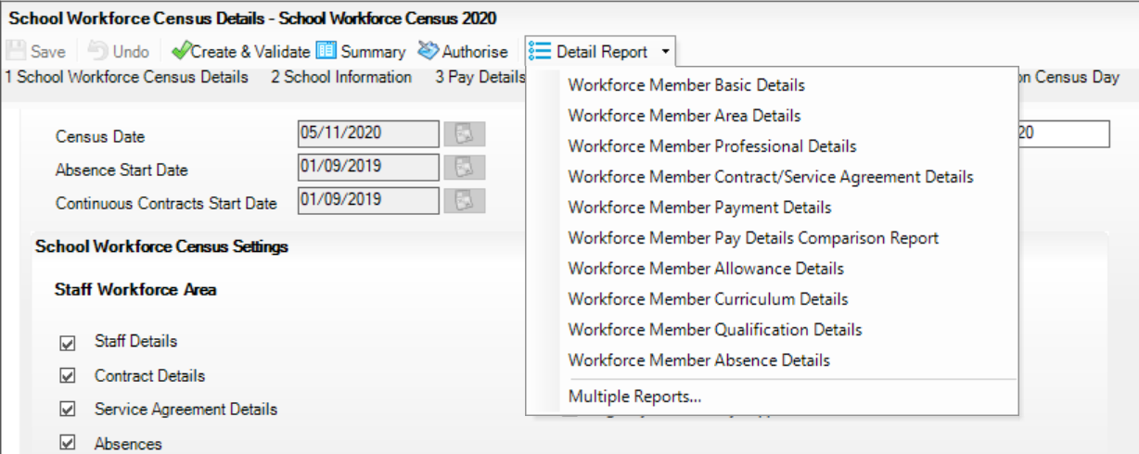
The selected report is generated automatically and displayed in your web browser.
To run several detail reports, select Multiple Reports from the bottom of the Detail Report drop-down list to display the Detail Reports dialog.
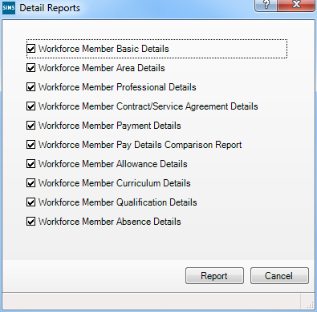
By default, all detail reports are selected. If any reports are not required, deselect the associated check box. Click the Report button to generate the selected reports.
The reports are displayed in your web browser, from where the data can be printed or transferred to a spreadsheet, such as Microsoft® Excel, if required.
The reports are saved automatically in the folder specified in the School Workforce Census browser. For guidance on navigating to files on your local workstation when you are working in a Hosted environment, please contact your System Manager or Local Support Unit.
Each report is saved with a filename that is made up of the following data fields separated by underscores (‘_’):
<LACode><SchoolNumber>_<SurveyType>_<LACode><LL><Year>_ <SerialNumber>_<name of the report>_detail_report.html
For example: 8232999_SWF_823LL20_001_Basic_Details.html.
Example of a Workforce Member Basic Details report:
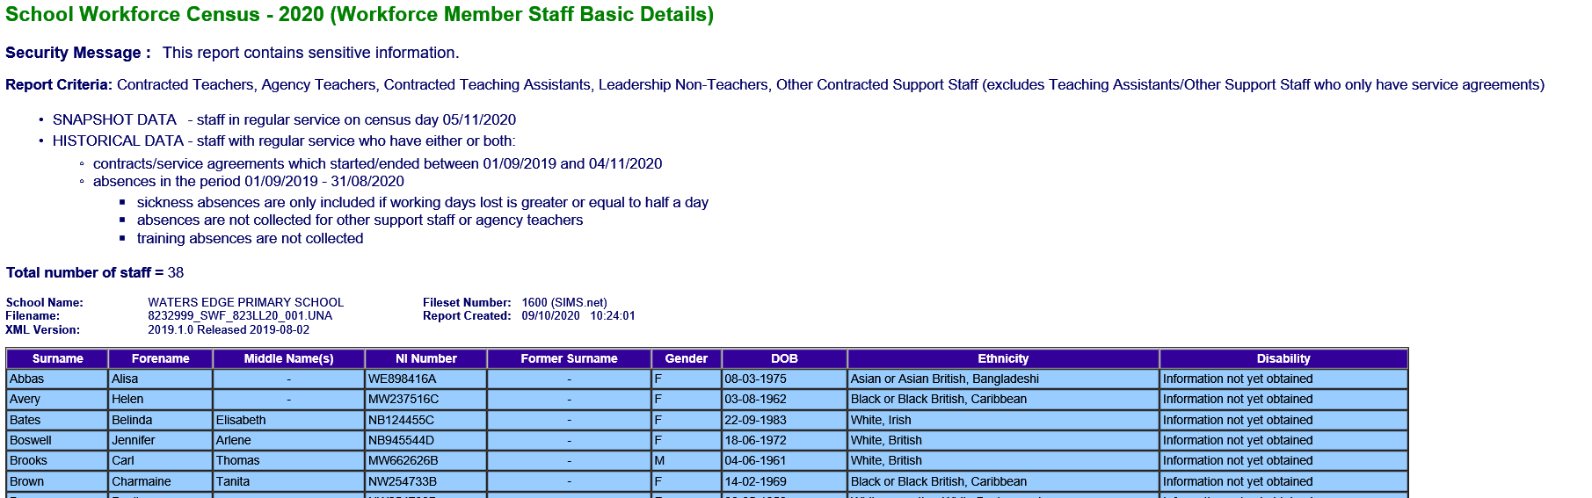

Printing a Report from your Web Browser
IMPORTANT NOTE: Any printed reports containing information that could identify a person (e.g. their name, address, UPN, National Insurance number, etc.) should be used for validation purposes only and should not be retained. The Security Message (displayed at the top of each report) can be customised to include, for example, instructions for the destruction of the printed reports.
- With the generated report displayed in your web browser, select the Print option (Ctrl+P) to display the Print dialog.
- Ensure that the print settings are correct then click the Print button.
- Click the Close button on the top right-hand corner of the web page to close the report and return to the census page.

Transferring Report Data to a Spreadsheet
Transferring a report to a spreadsheet application enables the data to be sorted, the column order to be changed, etc.
With the generated report displayed in your web browser, right-click the report and then select the required option, e.g. Export to Microsoft Excel, from the drop-down list.
IMPORTANT NOTE: The spreadsheet contains the same level of sensitive information as the original HTML report from which the information was transferred. Therefore, the spreadsheet file must be saved to a folder with the same level of security.

Deleting Temporary Web Browser Files
It is recommended that, after viewing statutory returns reports, you delete any temporary web browser files to ensure that any cached data (i.e. data stored on your machine, which enables high-speed access to previously viewed data) is removed.
This prevents the information, e.g. copies of web pages that are stored in the local cache for faster viewing, remaining on the hard disk of the PC in the temporary directory, where they are not secure because they can still be accessed.
When this process is performed, all temporary files (including any Statutory Returns reports files) that the browser has cached are deleted.
To clear the cache, open your web browser, then clear the browsing data history via Settings. For more information, please refer to the documentation applicable to the web browser you are using.

Producing the Summary Report
The Summary report enables the school staff, who are involved in the return's preparation, to assess the accuracy and completeness of the return data. It should then be passed to the Head Teacher for their review.
NOTE: When the return is authorised, the Summary report is automatically generated and displayed in your web browser.

Generating the Summary Report
The Summary report enables the accuracy and completeness of the return to be assessed by the school staff involved in preparing the return, including the Head Teacher, who is required to check the data before authorising the return.
The Summary report can be run at any time after the return is created and validated.
To run the report, click the Summary button located at the top of the School Workforce Census Details page. The report is displayed automatically in your web browser, from where the data can be printed or transferred to a spreadsheet, such as Microsoft® Excel, if required.
The report is saved automatically in the folder specified in the School Workforce Census browser, e.g. S:\School Workforce Census. For guidance on navigating to files on your local workstation when you are working in a Hosted environment, please contact your System Manager or Local Support Unit.
The report is saved with a filename that is made up of the following data fields separated by underscores (‘_’):
<LACode><SchoolNumber>_<SurveyType>_<LACode><LL><Year>_ <SerialNumber>_<name of the report>_Summary_Report.html
For example: 8232999_SWF_823LL20_001_Summary_Report.html.

Editing an Unauthorised Return
The return details, e.g. Description, School Information, etc. can be edited via the Census Return Details page at any time prior to authorisation.
IMPORTANT NOTE: An authorised return cannot be edited. If changes are required to an authorised return, use the Copy facility to produce a duplicate return (with a unique description) in which the changes can be made.
- Select Routines | Statutory Returns | School Workforce Census to display the browser.
- Ensure that the Census Folder and the Security message for Reports are correct, then click the Search button to display any previously created returns. Unauthorised return files can be recognised by their .UNA suffix.
- Double-click the required return. Alternatively, highlight the required return, then click the Open button to display the Census Return Details page.
- Edit the return details as required.
- Click the Create & Validate button to display the Validation Errors Summary panel.
- Run the detail reports and Summary report and then use the information they provide to assist with resolving errors and queries.
- Repeat the editing and Create & Validate process again, if necessary.
- Click the Save button.

More Information:
Configuring the Census Folder on page 8
Specifying the Security Message for Reports on page 9
Producing the Summary Report on page 31

Authorising the School Workforce Census
A School Workforce Census must be authorised before it can be uploaded to the DfE COLLECT data collection website or sent to your LA, depending on the instructions you have been given. Before authorising the return, you should ensure that all the information displayed on the School Workforce Census Details page is correct and does not require further editing. This is best achieved by reviewing the Summary and detail reports.
- Click the Authorise button located at the top of the Schools Workforce Census Details page.
A message advising you that the return cannot be edited once it is authorised is displayed.
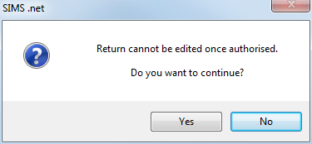
- Click the Yes button to continue or the No button to return to SIMS where edits can be made.
If you choose to continue, the Head teacher authorisation dialog is displayed.
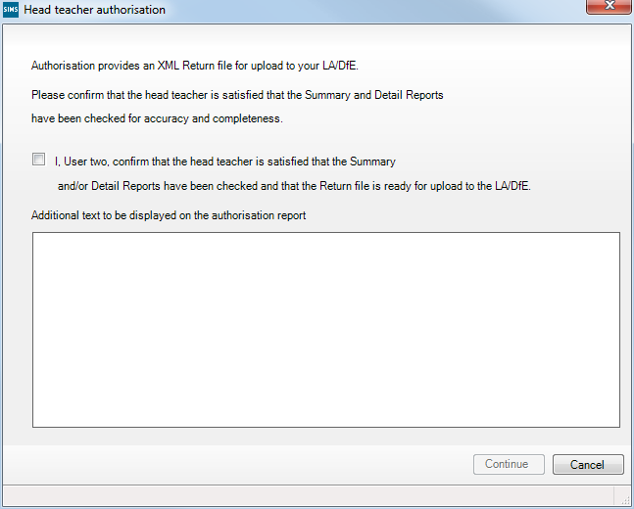
- Enter any additional text to be displayed on the authorisation report. This may be requested by your LA, e.g. to explain the reason for any validation failures.
- Select the confirmation check box to confirm that the Head Teacher is satisfied that the Summary and detail reports have been checked and that the return file is ready to upload to the DfE COLLECT website/send to your LA.
When the confirmation check box is selected, the Continue button is activated, enabling the authorisation process to be completed.
- Click the Continue button to authorise the return.
- The Summary report, Authorisation report and Validation Errors Summary report are generated automatically and displayed in your web browser, from where they can be printed, if required.
- The return file extension changes automatically from UNA (unauthorised) to XML (authorised).
- All details, i.e. the reports and the XML file, are saved in the Census Folder, which was specified previously in the Census Return for <season> <year> Term browser.
These details can be viewed via Tools | Statutory Tools | Retrieve Authorised Census Return Files.
For guidance on navigating to files on your local workstation when you are working in a Hosted environment, please contact your System Manager or Local Support Unit.
When a return has been authorised, it is no longer possible to edit the details displayed on the School Workforce Census Details page. If you authorise a return and subsequently need to make amendments, you must make a copy of the return then edit the copy, or create a new return.

Submitting the Return
When the return has been completed and the Summary report has been signed by the Head Teacher (if requested to do so by your LA), the .XML file can be uploaded to the DfE COLLECT data collection website or sent to your LA, depending on the instructions you have been given.
Guidance about how Local Authorities, schools and academies should submit school census data is available on the GOV.UK website (https://www.gov.uk/guidance/school-census).
The authorised return file is located in the folder previously specified in the return browser. For guidance on navigating to files on your local workstation when you are working in a Hosted environment, please contact your System Manager or Local Support Unit.
IMPORTANT NOTE: An authorised file cannot be edited. If you need to make changes to an authorised file, you must make a copy of the original file, rename it and work on the copy.

More Information:
Configuring the Census Folder on page 8
Copying a Return on page 35

Retrieving Authorised Census Return Files
Authorised returns are stored in your Document Management Server (DMS). The Returns Manager can download and run the reports associated with previous authorised returns enabling the data for the current return to be compared with that submitted previously.
- Select Tools | Statutory Returns Tools | Retrieve Authorised Census Return Files to display the Retrieve Authorised Census Return Files for <census name> page.
- Select the type of census required from the Return Type drop-down list to display a list of previous returns that match the selected criteria.
- By default, the files Download to the folder specified in the census browser. To specify a different folder:
- Click the Select a Folder button (...) to display the Browse For Folder dialog. Navigate to the location of the required folder then highlight it. If a suitable folder does not exist, click the Make New Folder button then enter a suitable folder name.
IMPORTANT NOTE: Ensure that authorised personnel only have access to the download folder because the retrieved files contain sensitive information.
For guidance on navigating to files on your local workstation when you are working in a Hosted environment, please contact your System Manager or Local Support Unit.
- Click the OK button to select or create the folder then return to the Retrieve Authorised Return Files for <census name> page where the chosen folder name is displayed in the Download to field.
- Highlight the return you wish to retrieve then click the Retrieve Files button.
The authorised return file (i.e. the XML file) and all reports associated with the selected return are downloaded from your DMS to the specified folder. The folder and its contents are then displayed automatically, enabling you to open the required files in your web browser.
- The contents of the specified folder can be viewed again by clicking the Folder button adjacent to the Download to field.
If you want to create reports based on cohorts, so that items collected in the return can be tracked, a sub-report is available (via Reports | Design Reports).
The Statutory Returns sub-report is available for selection only if Student has been selected as the Data Area.
When you Select fields to be included in the report, the Statutory Returns sub-report is located at the bottom of the list (the last node). Three options are available for selection under this sub-report: Authorised Date, File Name and Return Description.

Additional Resources:
Designing and Running Reports handbook

Copying a Return
An unauthorised return can be copied and saved as a new return. This enables a ‘snapshot’ of a return to be taken at any time providing a backup of any manual changes that have been made to the return, for example before recalculating details.
This functionality can also be used to make a copy of an authorised return if the LA or DfE requires it to be resubmitted. The necessary corrections can then be made to the data. The copied return must be saved, created, validated and authorised before resubmitting.
NOTE: Ensure that the return you wish to replicate is not open at the time of copying.
- Select Routines | Statutory Returns | School Workforce Census to display the census browser.
- Click the Search button to ensure that the list of returns is displayed.
- Highlight the file you want to copy and then click the Copy button.
A message requests confirmation that you wish to make a copy of the selected return.
IMPORTANT NOTE: Any values for attendance (where applicable), Early Years, Post Looked After Arrangements and Top-up Funding will not be copied but will be populated from the current values held in the database.
The Create & Validate routine must be run to generate a new census file.
- Click the Yes button to make the copy, which is then displayed in the browser as:
Copy of <description of selected file>.
- To rename the copied return, highlight it, then click the Open button to display the School Workforce Census Details page.
- In the School Workforce Census Details panel, edit the Description and then click the Save button.
IMPORTANT NOTE: A unique description must be used for each return. If duplicate returns are detected, an error is message is displayed.

Deleting an Unauthorised Return
During the return process, several copies of the return might be created, e.g. to track progress. When the return has been authorised successfully, it is advisable to delete any versions of the return that are no longer required. This keeps the number of files in the storage folder and listed in the browser to a minimum, therefore removing confusion and lessening the risk of selecting the wrong return.
The Delete routine can be used to remove unwanted returns at any time prior to the relevant return being authorised.
IMPORTANT NOTES: Any return files that have already been authorised cannot be deleted.
When a return file is deleted, any associated files, e.g. Validation Errors Summary, detail reports, etc. that have been produced are also deleted.
- Select Routines | Statutory Returns | School Workforce Census to display the browser.
- Click the Search button to ensure that the list of return files is displayed.
- Highlight the return file to be deleted, then click the Delete button. A message prompts for confirmation that the selected return should be deleted.
- Click the Yes button to permanently delete the selected return file and all associated report files.
The selected return file and associated reports are removed from the browser and the storage folder.

Index
A
absence details report 28
agency/third party support staff 19
allowance details report 27
applying
licence 5
area details report 25
authorising the census 32
B
base pay 14
basic details report 25
C
calculating details 11
census
authorising 32
configuring 8
copying 35
deleting 36
checking
curriculum details 16
school details 12
COLLECT data collection
submitting census 34
configuring
census defaults 8
census folder 8
continuous contracts dates 9
contract/service agreement details report 26
copying a census 35
creating
school workforce census 7
curriculum details
checking 16
reporting 28
curriculum details report 28
D
defaults
configuring 8
deleting
a return 36
temporary web browser files 31
detail reports
printing 30
producing 24, 29
details
calculating 11
dry runs 6
E
editing
curriculum details 16
school information 12
school workforce census defaults 8
school workforce census details 9
unauthorised return 32
errors and queries 21
exporting
school workforce census file 34
F
folder
specifying the school workforce census 8
G
generating
detail reports 29
summary report 31
H
historical spot allowance 21, 27
L
leadership pay details 14, 15
licence
applying 5
N
non-leadersip pay details 14, 15
O
occasional teachers information 18
P
pay details
leadership 14
non-leadership 14
pay details comparison report 27
payment details report 26
permissions
defining 5
previous authorised census returns 34
viewing 34
printing reports 30
transferring reports to a spreadsheet 31
professional details report 26
Q
qualification details report 28
queries
resolving 23
R
reporting
copying 31
detail reports 24, 29
printing 30
summary report 31
transferring to a spreadsheet 31
validation errors summary report 23
resolving
errors 23
queries 23
S
school details
editing 12
school workforce census
configuring 9
creating 7
details 9
exporting 34
transferring file 34
security message 9
SIMS version required 6
spreadsheet
copying detail report to 31
submitting
authorised return 34
summary report 31
T
third party/agency support staff 19
V
vacancies 17
validating
create & validate process 21
resolving failures 23
viewing
previous authorised census returns 34

