Recording Non-attendance Subcodes in SIMS
The DfE has defined a set of sub codes to record non-attendance in relation to coronavirus and to help with completing the educational settings status form. Use of the sub codes is not compulsory and are not recorded in Statutory Returns, although it does give consistency in the non-attendance due to coronavirus.
The non-attendance subcodes can be applied in SIMS.
Subcode | SIMS Subcode Description | Educational Settings Form
X01 | Non-compulsory school age
X02 | Self-isolating – COVID-19 symptoms | Suspected case of coronavirus (COVID-19)
X03 | Self-isolating – COVID-19 contact inside school | Requested to remain at home by your setting due to close contact with a confirmed case of coronavirus (COVID-19) within your school
X04 | Self-isolating – COVID-19 contact outside school | Those remaining at home due to close contact with a confirmed case of coronavirus (COVID- 19) from outside your educational setting including self-isolation
X05 | Quarantine – self-isolating
X06 | Clinical advice not to attend
X07 | Government advice not to attend
I01 | Illness
I02 | Illness- Confirmed case COVID-19 | Confirmed case of coronavirus (COVID-19)
For a detailed description of the set of sub codes see the DfE document below:
https://assets.publishing.service.gov.uk/government/uploads/system/uploads/attachment_data/file/965878/Recording_non-attendance_related_to_coronavirus.pdf
How to record subcodes in the register
Subcodes for X mark and I mark can be recorded in the register and edit marks.
- Open the register or edit marks and enter either an I or X code accordingly
- Right click on the mark and select Enter subcode.

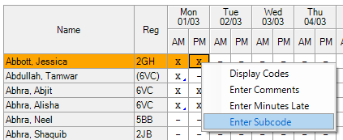

- A pop up box will appear, select the desired subcode from the dropdown and click ok. Once a subcode has been successfully entered you will see a small blue triangle in the bottom right of the cell.
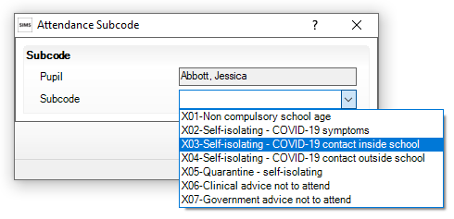

- To enter a sub code over a range of sessions, click on the first I or X code and hold down the shift key then click on the last code in the range to highlight them, now right click and select Enter Subcode.
Note: If the Enter Subcode option is grey out, click on the Preserve Icon that looks like a padlock to allow you to Overwrite a mark

Deleting an incorrect subcode
- To delete a subcode, enter a new mark in the cell. If you want to delete the subcode but keep the mark, right click on the mark, select Enter Subcode and press delete on the keyboard to remove the highlighted subcode.
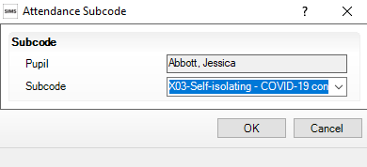
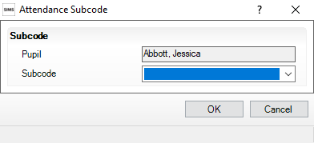

Note: Where session marks are replaced using the following routines, any subcodes previously entered for the affected sessions will be lost:
• Enter a code over a date range (via Focus | Attendance | Enter a Code over a Date Range)
• Enter a weekly pattern (via Focus | Attendance | Enter a Weekly Pattern)
• Recording exclusions (via Focus | Pupil/Student | Exclusions and Focus | Pupil/Student | Pupil/Student Details – Exclusions in the Links panel)
For Secondary schools, Subcodes are only applicable to session marks and not lesson marks. To avoid subcodes entered in a session being overwritten the Copy Lesson Marks To Session in Lesson Monitor Setup needs to be unticked.

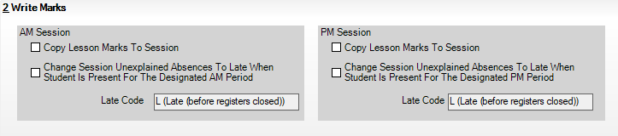

Covid 19 Daily Attendance Analysis Report
Once the information has been entered in SIMS the Covid 19 Daily Attendance Analysis Report can be run to assist with the completion of the DfE Educational Status form.
- Once the report has been downloaded, right click and select extract all, you can use the suggested path.
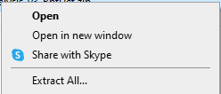
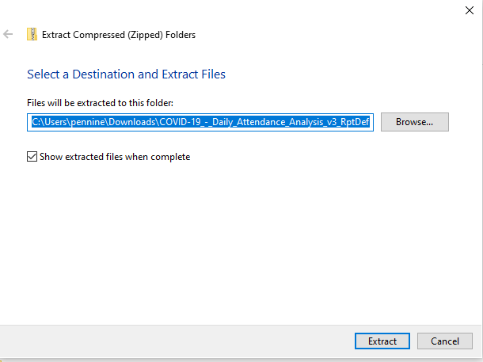
- In SIMS follow the path Report | Import Reports, locate the report folder you have extracted, open it and select the report. Click Import and the ok.
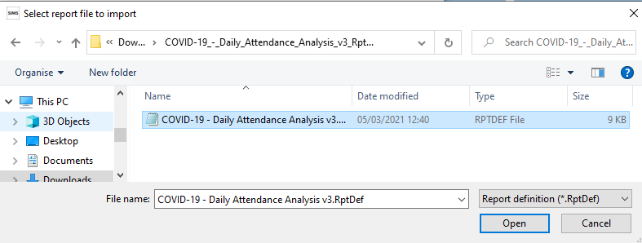
- Open Report | Run Report and click on Students, find the report that was imported, click on the Updated column to sort the reports to most recently updated. Double click on the report to run.

- In the pop up box make sure both dates are the same, click ok.
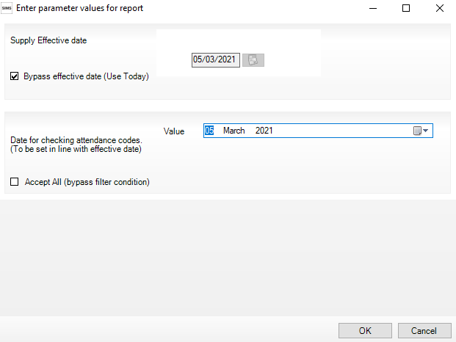
- The SIMS Analysis report will pop up, you can change the row to show the type or description of the subcode by selecting another option from the Row dropdown.
