Preparing for the School Census – Spring 2024

Permissions
You will need the School: Data Returns: Administer permission to be able to access and run the School census.
You'll also need specific permissions to resolve certain errors and queries, depending on the area you're resolving the error for. Some example permissions you might need are:
- School: General Admin: Administer - Access and edit the data in the Data Quality Dashboard for students
- Student Profile: Admin: Administer All Students - Add student funding or early years pupil premium eligibility.
- Student Profile Language Abilities: Administer All Students - Add language abilities.
- Student Profile: In Care: Administer All Students - Add in care notes for students.
- Student: Consents: Administer - Update YSSA
If you don't have the permission, you'll need to ask your admin team to give you permission using these instructions.

Changes to the census this academic year
The only change this year, for Autumn, Spring and Summer censuses is that the Gender field has been replaced by Sex. Guidance can be found here: Sex, Gender and Gender Identity in Arbor and statutory returns. Schools can choose to record Gender Identity but this is not returned in the census.
- For full guidance from the DfE on changes to the census, click here.
- For further information detailing what data your school must return in the Autumn, Spring or Summer census, click here.

Preparing your data
Before the Dry Run facility opens, you can start preparing for Census using these three key areas:
- Check your recorded School Details, Childcare and Weekly School Hours Open by going to School > School Details.
- Check for duplicate student profiles in the Suspected Duplicates section
- Add and update basic details in the Students > Identity and Students > Demographics sections. Just click a cell to add the data!

Preparing your school data
Check your recorded School Details by going to School > School Details.
- Ensure that your LA is filled in, Establishment Number, School telephone number and email address, Intake sex, School phase, School type, Governance type, Intake type and URN all have information present (especially important to check if you have recently become an Academy).
- Make sure you have recorded any childcare details - this needs to be filled in even if you don't provide childcare. You can see how to do this here: Recording Childcare for the Spring Census
- Add details for school time by filling in the Weekly Hours Open field: Recording School Time for Weekly Hours Open
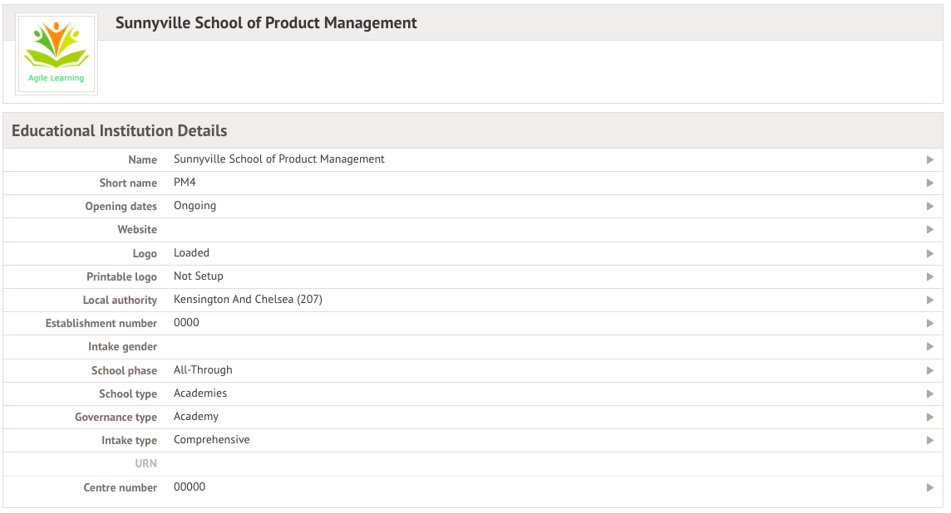

Merge or delete any duplicate students
You can see a list of potential duplicate students in School > Data > Data Quality Dashboard > Suspected Duplicates > Students.
You can then merge or delete these. Take a look at this article to see how to do this.
Top Tips:
- If you know that two students are duplicates but they aren't flagging as such, make sure their names are identical.
- You won't be able to delete or merge a profile that has attendance marks. To do so, you'll need to first delete the student's attendance marks following these instructions.
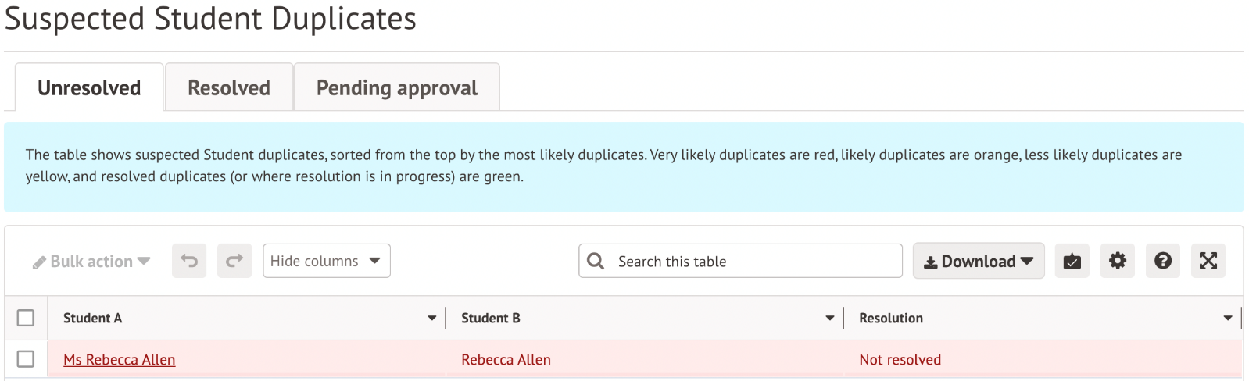

Check data for students
To check that all students have information entered for key Census fields, go to School > Data > Data Quality Dashboard > Students. This will open three sections where you can update and add information - Contact Details, Identity and Demographics. Click into each to check your student data.
Top Tip: You’ll need the School: General Admin: Administer permission to access this area. If you don’t have permission, ask your office team to give it to you using these instructions.
Religion, country of birth and nationality are not reported in the census, so these fields are not required.
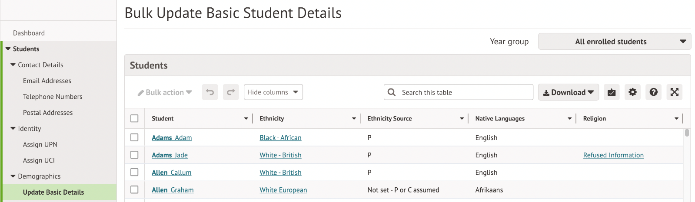

Assign UPN - Make sure all students have a UPN. If a student has no UPN against their profile they will show up in the list here. To generate a UPN for a student, use the bulk actions.
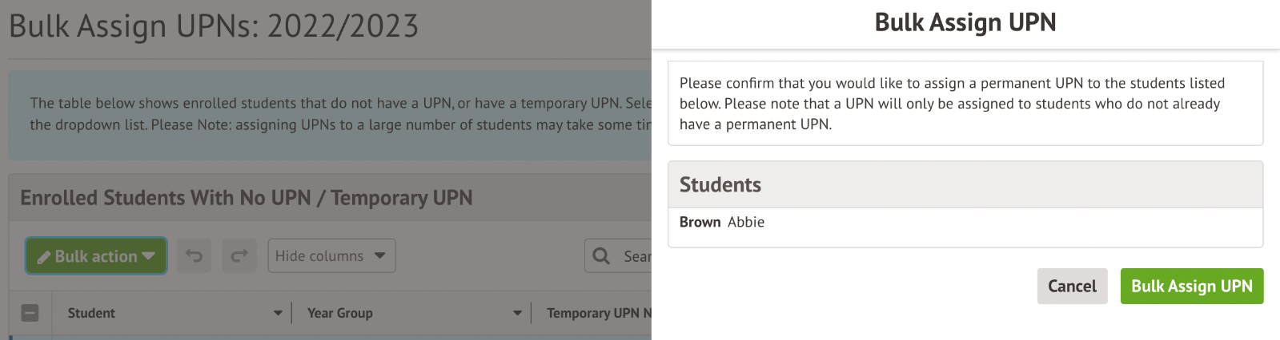

To assign a known UPN to a student, add this from the Identity section of their student profile:
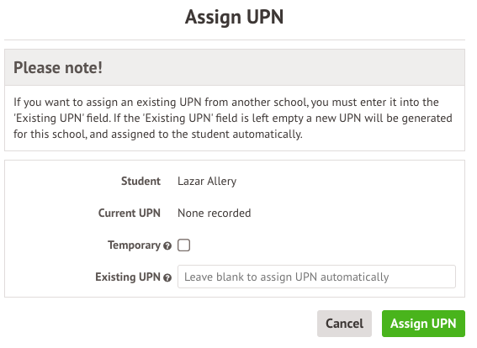

Update Basic Details - This allows you to quickly check that you have filled in some key information regarding students.
To add or change any of the information, just click on the cell you wish to edit and a slide over will appear where you can add or update the correct information. For example, to add an Ethnicity source, select the students then select Bulk Set Ethnicity to choose the source.

For Nursery years: Update Funded Hours - Clicking on this will take you to a table that contains hours and funding information required in the School Census for Early Years and Nursery students.
- You can see full guidance on what to fill in from the DfE here: Funded hours
- Guidance on what to fill in for students and how can be found here: Hours at setting, funded hours, extended hours and 30 hour codes

You can add some information in bulk, but you will need to add the 30 hours code by clicking on the students.
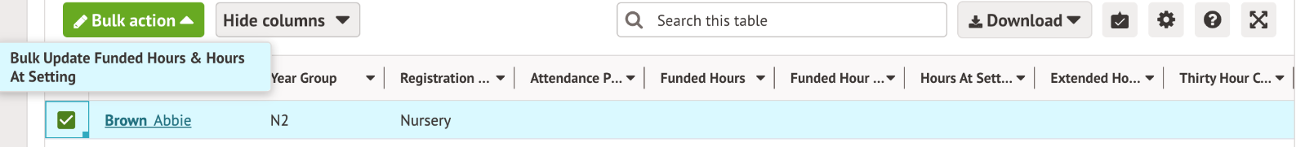

Update National Tutoring Programme Hours - If you have recorded a student as being in receipt of School Led Tutoring or National Tutoring Programme funding, you must add their number of tuition hours. You can see how to do this here: National and School Led Tutoring funding and teaching hours
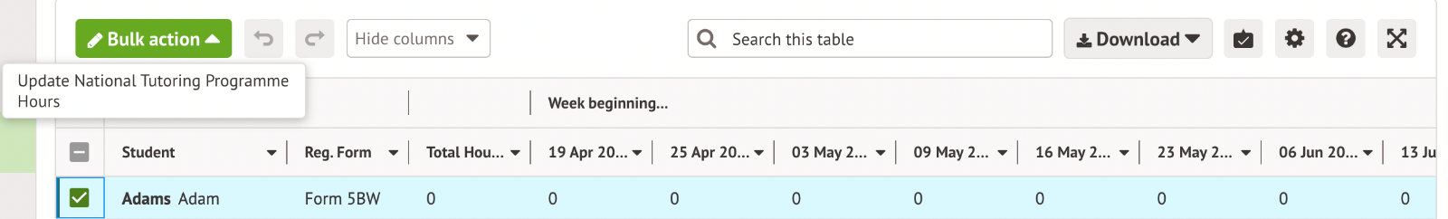

For students 11+: Update YSSA - If you have students whose information you are sharing with Connexions etc make sure that this is noted in the Youth Support Services Agreement section.
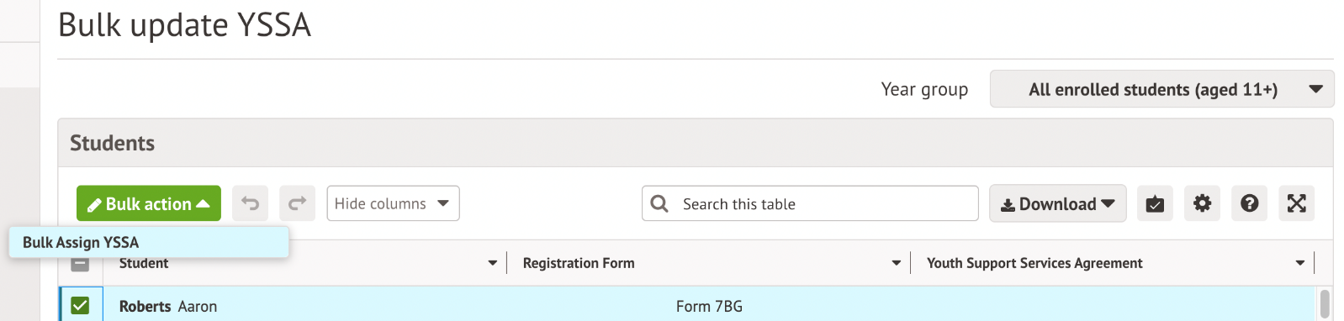

If you’re not requesting this information, you can mark your students as Unsought.
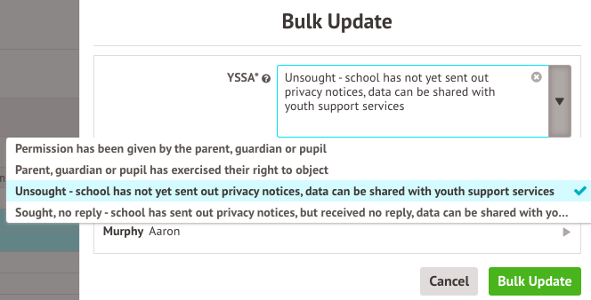

Other things to make sure you've recorded
Data Collection periods
Here are some of the main data points collected in the census, including a link to the easiest way to report on them to check your data.
- Attendance data from 1st August to 31st December 2023 - Viewing statistics for attendance
- Free School Meal Eligibility from 6th October 2023 and 18th January 2024 - FSM students and eligibility dates
- Suspensions and permanent exclusions from 10th April to December 2023 - Behaviour reporting
- National Tutoring Programme since the start of the academic year, up to and including census day - Check National Tutoring Programme funding numbers for the census
This includes both on and off-roll students. More information can be found here: Data items 2023 to 2024
Please note that Pupil Premium is not directly output: Is Pupil Premium output in census?

Alternative Provisions
- Add details about PRU or Alternative Provision indicators: PRU or Alternative Provision indicators
- Record which students have had Alternative Provision (AP) placements: Alternative Provision placement details

National Tutoring Programme
Have you added funding records and teaching hours? You can see how to add this to students here: National and School Led Tutoring funding and teaching hours

Exclusions
Mark Permanent Exclusions in review as Do not return in school census.

Young carers
Record which students are Young Carers from the Background section of their student profile: Logging and reporting on student Young Carers

