

|  |  |  |
| --- | --- | --- |
| How to Import Pupil PremiumIndicators into SIMS Guidance For Schools  **Changes to Previous Years**  ***Three downloads compared to two previously.***  **First download**   * To be made available in spring 2023. * It will make use of data provided by School Census Autumn 2022 but is provided too early to take account of the Alternative Provision Census 2023 or the SSDA903 collection. * It will be of interest to all State Schools in England EXCEPT AP Academies, AP Free Schools, and Pupil Referral Units. * A proxy is used for identifying looked after children, as the SSDA903 collection does not take place until March 2023. Where a pupil is identified as looked after the school will NOT receive the deprivation pupil premium for that pupil.   **Second download**   * To be made available in summer 2023. * It will make use both of data provided by School Census Autumn AND data provided by the Alternative Provision Census 2023 but is still provided to early to take account of the SSDA903 collection. * It will be of interest to all State Schools in England INCLUDING AP Academies, AP Free Schools, and Pupil Referral Units. * A proxy continues to be used for identifying looked after children, as the SSDA903 collection does not take place until March 2023.   **Third download**   * To be made available in autumn 2023 and is provided late enough in the year to take account of all relevant collections, i.e. School Census Autumn 2023, Alternative Provision Census 2023 and the SSDA903 collection. * It will be of interest to all State schools in England and indicates the final allocations for financial year 2023/24.   NOTE: SSDA903 is the return completed by the Local Authority for Looked after children. Downloading Pupil Premium file from Get Information About Pupils (GIAP) Click in the link to Navigate to [DfE Sign-in](https://services.signin.education.gov.uk/)  Select Get Information About Pupils (GIAP), when you first login you will see How To Use GIAP screen, click continue. You will the be required to read and confirm you have rean and understood the conditions, then click next. The How To Use GIAP screen will pop up again, click continue.  Graphical user interface, text  Description automatically generated Graphical user interface, text, application, email  Description automatically generated  Navigate to Data Downloads area to the top of the screen.  Graphical user interface, text  Description automatically generated  Once you have clicked on **Data Downloads** you will see your schools **Pre-prepared downloads**  Graphical user interface, text, application  Description automatically generated  Select the Pupil Premium file which is called ‘**pp2223_xxxxxxx_1’**, from the menu and click to download. The x’s will represent your schools DfE number.     |  | | --- | | **NOTE: The screenshots have not been updated and are for reference only**  **NOTE:** It is important that when you are saving the file, that it is saved to a secure location, rather than somewhere public such as the desktop, as the file contains UPNs and information that can indicate a pupil’s vulnerability e.g. in care with local authority. |   In SIMS Select **Tools / Pupil Premium / Import**  Select all the import Options:-  If you are unsure which options to select place a tick in ALL options as if there is no data of that type in the file the import will not fail.  Select required import options.  Click on the folder icon alongside the **Choose File** field and navigate to the location that you have saved your DfE csv file to.   Highlight the file and select **Open**  You will then be presented a message asking you to confirm the update. |  |
|  |

Click on the **Import** button to populate a temporary table, which will illustrate the data contained in the csv file, as shown in the example below.

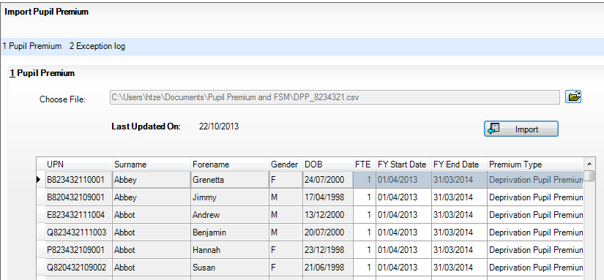

**NOTE:** It is not until you Click **Save**, at the bottom of the table, that the information will be written back to SIMS, and the individual student records updated accordingly.

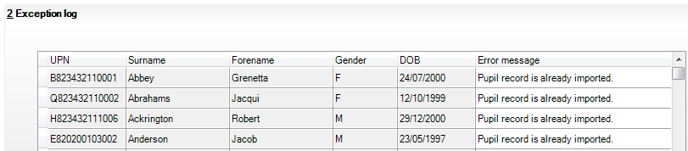

The Exception Log will display records that have already been imported and also records where the student does not exist on your SIMS database.

## The 2023/24 Indicator will now be marked on the pupil record

**Pupil Premium eligibility and Funding rates 2023-2024**

