How to Import Pupil Premium

Indicators into SIMS

Guidance for Schools

The DfE compile a csv (comma separated value) file for each school, listing pupils who have attracted the Pupil Premium. The DfE files were previously based on the January Census, and are made available to schools in July and October. Due to the Coronavirus Pandemic, this year and going forward the DfE files will be based on the October Census.

These files can then be imported into SIMS and will update the Pupil Premium Indicator for 2021/22 on the individual pupil record. If schools have manually entered the ticks onto the pupil record, the import will not overwrite any of the manual entries.
If schools have not previously used the Pupil Premium Indicator, there are distinct advantages to doing so, as you are able to produce reports on Pupil Premium Pupils, as well as display a Pupil Premium Indicator on Attendance Registers and Assessment Marksheets.

The DfE previously uploaded these files onto the Key to Success website which is accessed via the DfE Secure Access website Login. The DfE have developed a new digital service called Get Information About Pupils (GIAP) which can be accessed through the DfE Sign-in. If you can not see the GIAP service when using the DfE Sign-in please see the advice below from the DfE:

DfE Sign-in users who want access to GIAP
An approver at your organisation will be able to provide you with access to GIAP. An approver is someone at your organisation responsible for controlling who has access to DfE Sign-in and the services within the system. It is usually a senior role, such as an administrator, manager, or headteacher
Click in the link to Navigate to DfE Sign-in

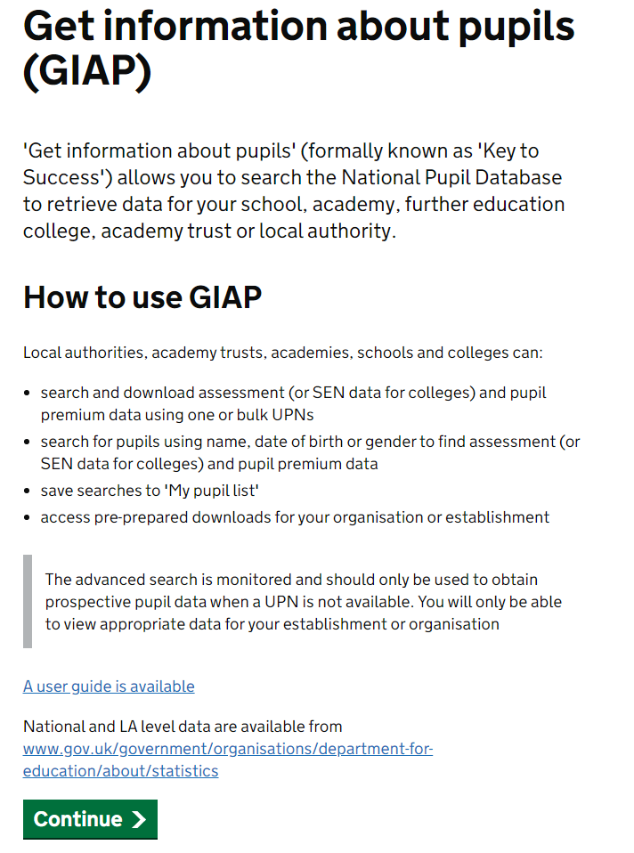
Select Get Information About Pupils (GIAP), when you first login you will see How To Use GIAP screen, click continue. You will the be required to read and confirm you have rean and understood the conditions, then click next. The How To Use GIAP screen will pop up again, click continue.

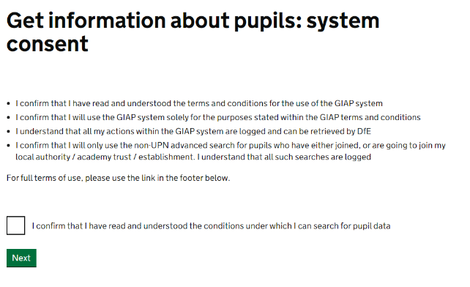

Navigate to Data Downloads area to the top of the screen.
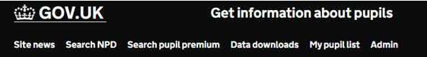

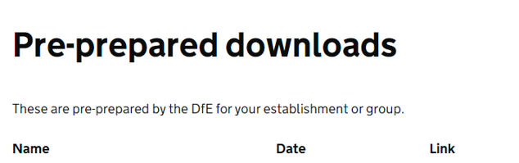
Once you have clicked on Data Downloads you will see your schools Pre-prepared downloads
NOTE: It is important that when you are saving the file, that it is saved to a secure location, rather than somewhere public such as the desktop, as the file contains UPNs and information that can indicate a pupil’s vulnerability e.g. in care with local authority.
Select the Pupil Premium file which is called ‘pp2122_xxxxxxx_1’, from the menu and click to download. The x’s will represent your schools DfE number.

Importing the Pupil Premium File

Importing this file into SIMS will not overwrite student records which have been previously manually updated with the Pupil Premium indicator.

In SIMS Select Tools / Pupil Premium / Import

Select all the import Options: -
If you are unsure which options to select place a tick in ALL options as if there is no data of that type in the file the import will not fail.

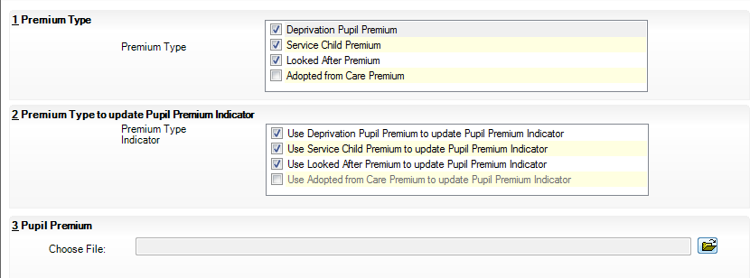
Select required import Options

Click on the folder icon alongside the Choose File field and navigate to the location that you have saved your DfE csv file to.
Highlight the file and select Open.

You will then be presented with the following message asking you to confirm the update.
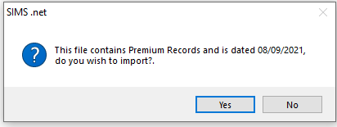
Click on the Import button to populate a temporary table, which will illustrate the data contained in the csv file, as shown in the example below.
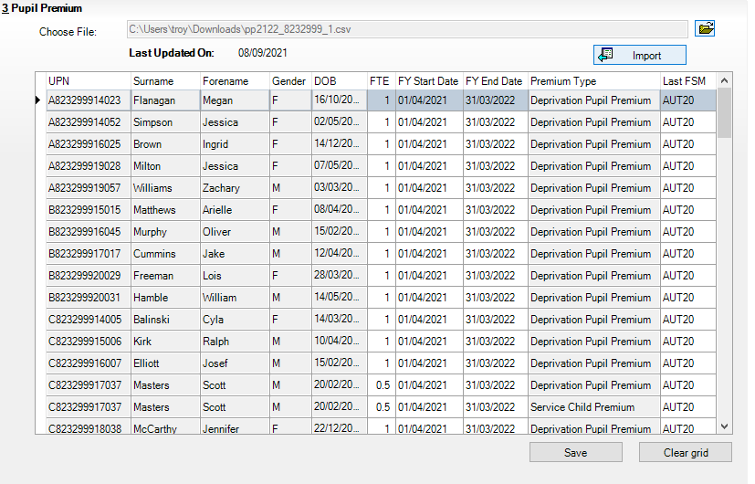
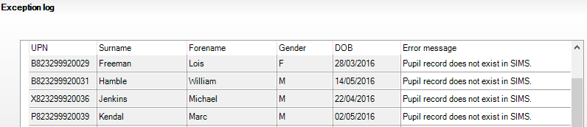
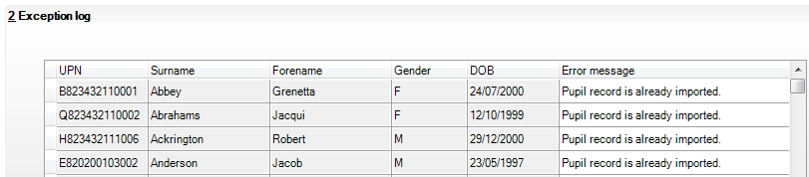
NOTE: It is not until you Click Save, at the bottom of the table, that the information will be written back to SIMS, and the individual student records updated accordingly.

The Exception Log will display records that have already been imported and also records where the student does not exist on your SIMS database. The 2021/22 Indicator will now be marked on the pupil record.

