How to Import Pupil Premium

Indicators into SIMS

Guidance For Schools

The DfE compile a csv (comma separated value) file for each school, listing pupils who have attracted the Pupil Premium. The DfE files are based on the January Census, and are made available to schools in July and October. These files can then be imported into SIMS, and will update the Pupil Premium Indicator for 2019/20 on the individual pupil record. If schools have manually entered the ticks onto the pupil record, the import will not overwrite any of the manual entries.
If schools have not previously used the Pupil Premium Indicator, there are distinct advantages to doing so, as you are able to produce reports on Pupil Premium Pupils, as well as display a Pupil Premium Indicator on Attendance Registers and Assessment Marksheets.
The DfE upload these files onto the Key to Success website which is accessed via the DfE Secure Access website Login.
Navigate to https://sa.education.gov.uk/idp/Authn/UserPassword

Select KTS - Key to Success and navigate to the Pupil Premium area to the left of the screen

Select the “Pupil Premium 2019/20”option from the menu and Select CSV Files and download
NOTE: It is important that when you are saving the file, that it is saved to a secure location, rather than somewhere public such as the desktop, as the file contains UPN and information that can indicate a pupils vulnerability e.g. in care with local authority.
Importing this file into SIMS will not overwrite student records which have been previously manually updated with the Pupil Premium indicator.

In SIMS Select Tools / Pupil Premium / Import

Select all the import Options:-

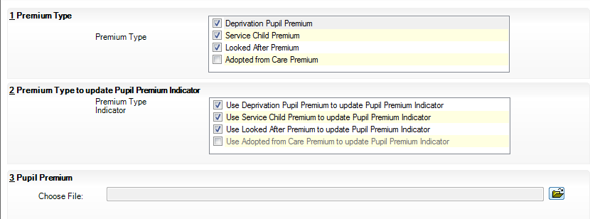
Select required import Options

Click on the folder icon alongside the Choose File field and navigate to the location that you have saved your DfE csv file to.
Highlight the file and select Open

You will then be presented with the following message asking you to confirm the update.
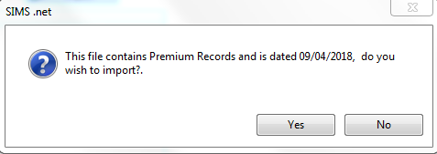
Click on the Import button to populate a temporary table, which will illustrate the data contained in the csv file, as shown in the example below.
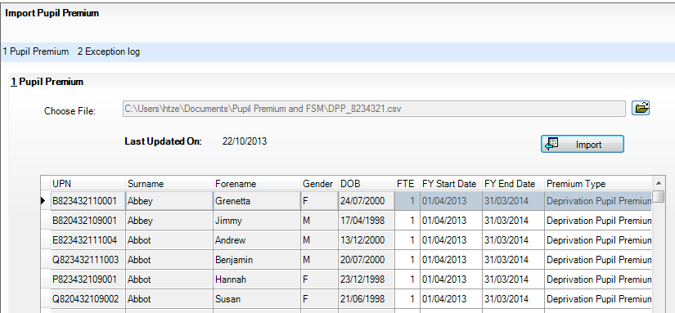

NOTE: It is not until you Click Save, at the bottom of the table, that the information will be written back to SIMS, and the individual student records updated accordingly.

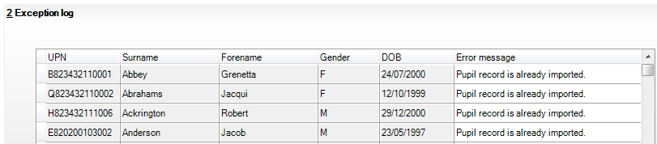

The Exception Log will display records that have already been imported and also records where the student does not exist on your SIMS database.

The 2019/20 Indicator will now be marked on the pupil record

