How to Identify and Correct Data Impacted by the CTF Import Incident
Guidance

Document Ref: | CTF 19 | Version: | 1.0
Document Author: | Elaine Smith | Valid from: | 1.7.2019

Contact: | Pennine Education Ltd | e-Mail: esmith@pennineeducation.co.uk

Document purpose

This document describes a three-step process required to identify and correct contact information which may have been incorrectly updated during the import of contacts via CTF.

Background

The scope of potentially affected CTF imports includes those run between SIMS 2019 Spring Release and the application of Patch 25040.

Patch 25040 was made available on the 4th/5th July 2019 and addresses a defect in the SIMS Spring 2019 Release 7186. Once the patch is applied, the import of CTFs can continue without further issue. The patch does not correct data affected by the original defect.
The patch has been included within the Summer Release which has been released to schools through Solus

Step 1
Install SIMS Database Diagnostic Tool

Step 2
Run Diagnostics Check100
Step 3
Complete remedial action (if appropriate)

Step 1 - Install SIMS Database Diagnostic Tool

Apply Patch 25058 to install the Database Diagnostic Tool. Please note this patch is applicable for both the Spring 2019 7.186 and Summer 2019 7.190 release.

Step 2 - Run the diagnostics

Patch 25058 adds a "Check 100" to Database Diagnostics which is run from within the SIMS. "Check 100" will identify potentially affected contact records.

As a user with System Manager permissions:
- Navigate to Tools | System Diagnostics | Database Diagnostics.
- Click Run.

Please note that this routine can take time to complete and should ideally be done at times of the day of low activity.

- Click on the check 100 CTF Contact issue June 2019 Diagnostic entry which will be displayed at the bottom of the list in the top panel.

  - If no records are returned, there are no issues for your school and no further remedial action is required (i.e. Step 3 is not required). This is not unusual as the specific nature of the incident means few schools are likely to be impacted.

  - If you do have records returned, these potentially affected contact details will be displayed in red within the Error Details section.

- If any records are displayed, with 100 CTF Contact issue June 2019 Diagnostic highlighted click Print. The output will be displayed in a new window.
- From the new window click Save and change the save file type All file (*.*).
- Name it as a CSV file, for example “Check100output.CSV”. This provides you a record should you want to access the detail to aid remedial actions using Excel.

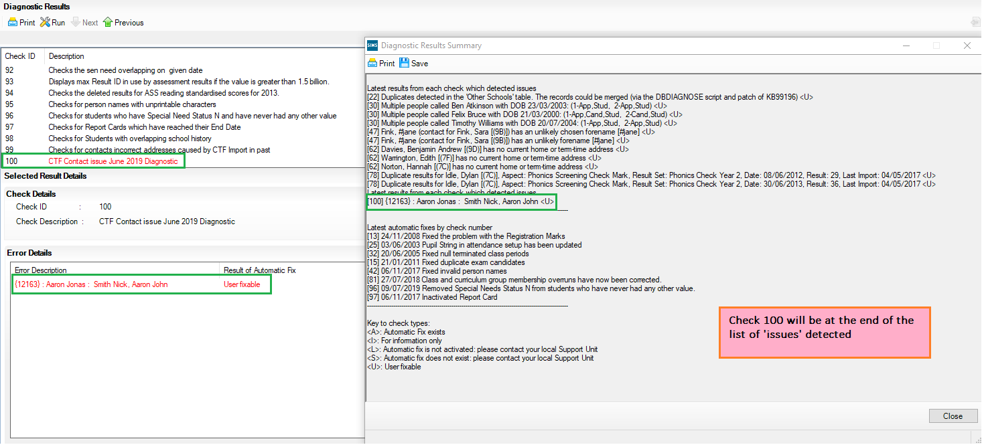

Step 3 – Complete remedial action (if appropriate)

If the diagnostic tool (Check 100) output does not identify any contact records, your data has not been impacted by this issue. Please also ensure that Patch 25040 referenced under the “Background” section has been applied.

If contact records are identified by the diagnostics tool (Check 100) manual checks will need to be made by your school and contact data potentially updated. The following information provides further guidance.

- To find the contact in SIMS, enter the number shown in the Contact ID column in the diagnostic output into the quick search field on the SIMS Homepage, using braces { }
(For example, {12163}).

Double click the contact name to open the record.

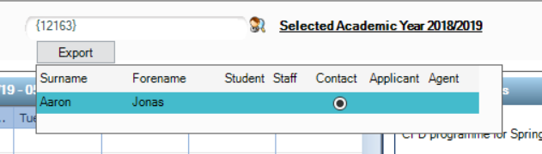

- In Panel 2 on the contact record you can view Telephone Numbers and email addresses. The option to delete or modify these details can be chosen if changes are required. If the correct details are unknown, deletion is the best option to ensure incorrect details are not being held while correct details are obtained.

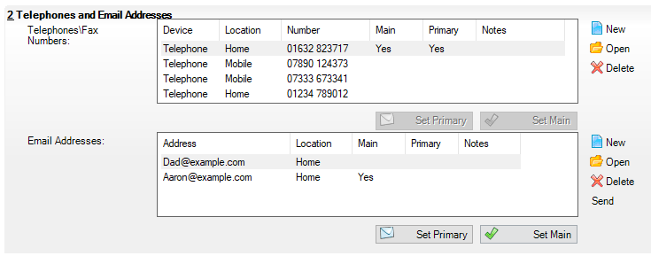

On Panel 4 you can see students associated with this contact. The option to remove or modify the association can be chosen if changes are required.

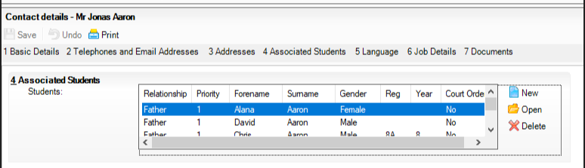
If you need any assistance with this procedure please do not hesitate to log a call with the helpdesk.

