13

Pennine Education

OL8 3QL

FMS EOY Overview

This course covers the end of year procedures and provides you with an opportunity to consider, prior to year end, the areas that will support the smooth closure of the accounts.

The overview will include procedures on how to process the following.

• orders and commitments  
• Invoices and credit notes  
• reconciliation - to the local authority and the bank  
• petty cash, income and journals  
• fund balances and carry forward figures  
• the new year Chart of Accounts  
• salary commitments and year end balances.

The cost of this would be £40+VAT and would be a half day remote session.

If you would like to book on this course, please book using the link below.

[Course Booking Form - PENNINE EDUCATION LTD](https://www.pennineeducation.co.uk/course-booking-form.html)

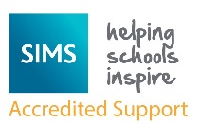

Pennine Education

Hollinwood Business Centre

Failsworth

Oldham

OL8 3QL

0161 684 2320