Instructions of how to increase a Dinner Money Charge

Document Ref: | DMCharge | Version: | 1.0
Document Author: | Elaine Smith | Valid from: | 18.4.2017

Contact: | Pennine Education Ltd | e-Mail: esmith@pennineeducation.co.uk

From the 1st April Oldham have increased the charge for Dinner Money to £2.10
For schools which use Dinner Money the following changes will need to processed in Sims Dinner Money to ensure these changes are calculated correctly.

- Go to Tools/ Dinner Money/Pupil Meal Definitions
- Click on search.
- Double click into all the meals with the old price of £2 and click on new next to the charges box
- Input todays date with the new charge of £2.10

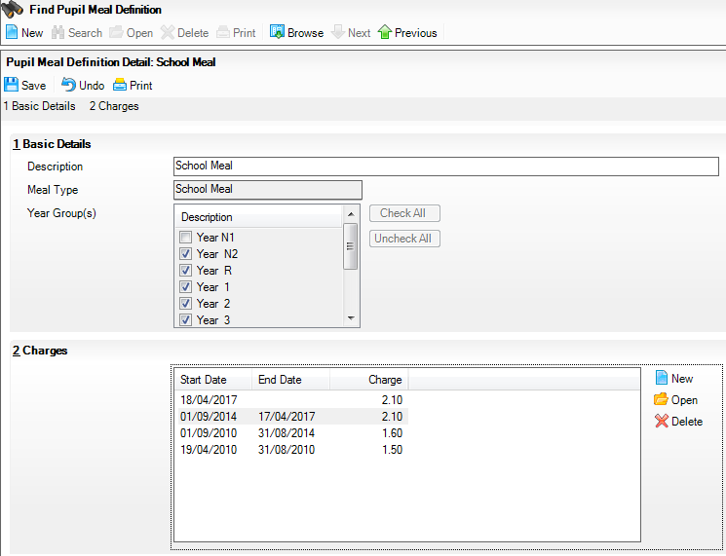

If the date shows as tomorrows date you will have to go to ensure everyone is logged out of Dinner Money and then go to
- Tools/Dinner Money/Backdate Meals Processed.
- Ensure the dates cover this terms dates e.g. start date should be 18.4.2017 to todays date.
- Then repeat the action 1 to 4 above and change the amount in the Meal definition.
- Once saved go to:
- Tools /DinnerMoney/Unlock meal processing and put a tick in the tick box and click OK
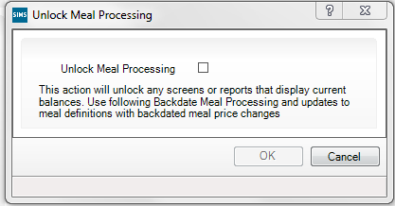

If you have any problems with this procedure please do not hesitate to contact the helpdesk and a member of the Team will be pleased to help.

