

How to add and use a Charge Account in FMS



|  |  |  |  |
| --- | --- | --- | --- |
| **Document Ref:** | *FMSCharge* | **Version:** | *1.0* |
| **Document Author:** | *ESmith* | **Valid from:** | *1.4.2017* |

|  |  |  |
| --- | --- | --- |
| **Contact:** | *Pennine Education Ltd* | e-Mail: esmith@pennineeducation.co.uk |

**Introduction**

FMS can now be used to create a charge account with one or more charge cards linked.

This enables users to record Accounts Payable transactions (invoices and credit notes) against a charge account, and manage the reconciliation and payment of these transactions.

This functionality has been made available in the Spring 2017 release of FMS version 6.174

*NOTE: A charge account ledger type must have been recorded for this*

*option to be available.*

**Adding/Editing a Charge Account Ledger Code**

Please remember that any ledger codes added should be in the earliest year open.

This enables you to set up a charge account with one or more associated

charge cards, with which payments can be made.

1. Select Tools | General Ledger Setup, click the Ledger Codes tab and

click the Add Item button.

2. Select Charge Liability from the drop-down list and then click the Next

button.

3. Select the group to which the new Ledger Code belongs by clicking the Field

Browser button and selecting from the dialog.

4. Click the Next button.

5. Enter a new code, e.g. CL, and a description for the Ledger Code, e.g. Acme

Charge Account.

6. Click the **Finish** button to display the **Ledger Code Definition** dialog as shown below



7. Edit the Description and select a different Ledger Group by clicking the

Field Browser button, if required.

8. Enter the Account Name.

9. The Sort Code and Account Number can be added, if appropriate.

10. Click the Add Item button to add Charge Card Details in the Charge

Code Maintenance dialog.



11. Enter the last four digits of the Charge Card Number.

12. Enter the name of the Charge Card Holder.

13. Select the **Month** and **Year** of the **Expiry Date**.

*NOTE: FMS will not prevent you from selecting a charge card for payment*

*that has passed its expiry date.*

14. The Charge Card Active check box is selected by default but can be

deselected, if required.

15. Click the OK button to return to the Ledger Code Definition dialog.

Additional charge cards belonging to the same account can be added, as

necessary.

Making Payments from a Charge Account

This process enables you to record the payment of an invoice/credit note

from a charge account.

*NOTE: A charge account ledger type must have been recorded for this*

*option to be available.*

1. In the Invoice/Credit Note Processing browser, open the relevant

invoice/credit note with a status of Un-Authorised or add a non-order

invoice.

2. In the **Pay From** field, select the appropriate charge account.

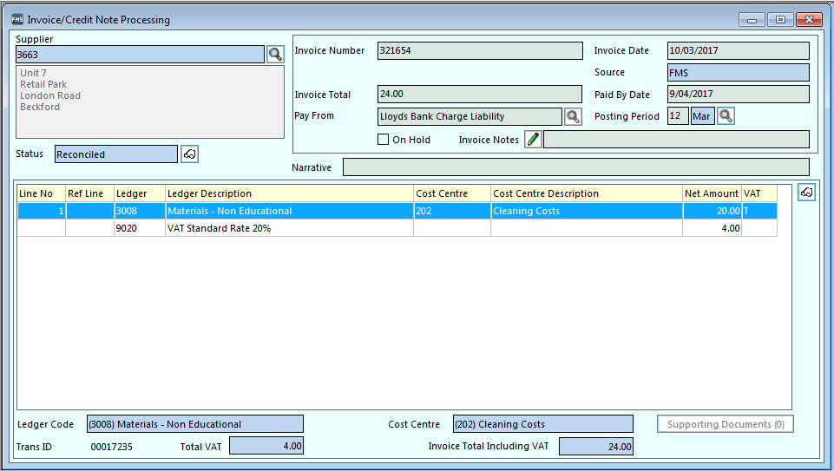

3. Process and authorise the invoice as normal.

4. Once the invoice has been fully authorised, either select it in the browser or

open the record and then click the Direct Payment Processing button.

5. If only one charge card is associated with the account in FMS, this will be

displayed automatically. If multiple cards are recorded, click the **Field**

**Browser** button and select the correct one.

6. Click the **Pay** button.

**New Charge Account Report**

*Reports | Accounts Payable | Payments | Charge Account Transactions Report*

This report produces a list of Charge Account payments and includes both paid and unpaid invoices and credit notes.

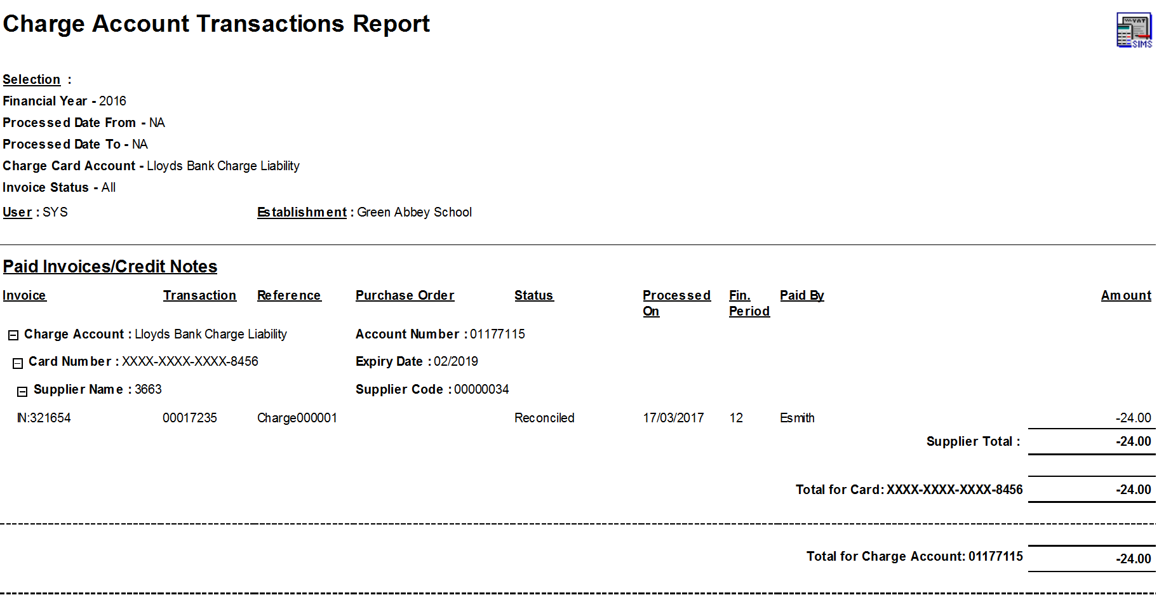

**Charge Card Statement reconciliation**

The Charge Account reconciliation area enables you to reconcile the

statements from any charge accounts used by the school.

1. Click the General Ledger button on the Application Bar.

2. Click the Charge Account Reconciliation button or select Focus/

General Ledger/Charge Account Reconciliation.

3. When you have finished working with a section in the General Ledger, click

the Close Window button on the Focus Bar or select the Close option from

whichever, secondary menu is displayed, e.g. Charge Account

Reconciliation/Close. You can also press Ctrl+F4.

**Viewing Charge Account Reconciliation Details**

When the **Charge Account Reconciliation** dialog is opened, a browser

displays a list of all entered charge account statements.

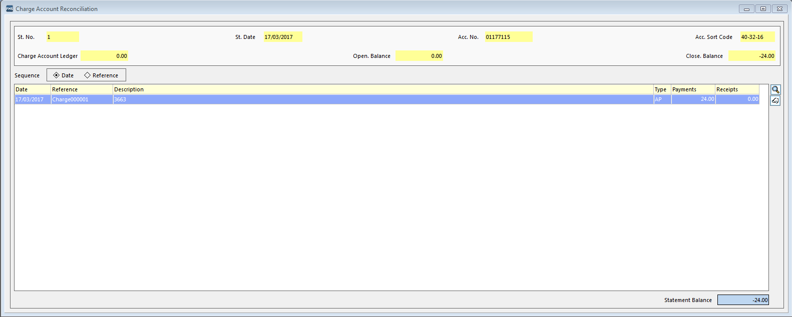

Statements can be ordered according to statement number or date, by

selecting the appropriate option from the Sequence section. In addition,

the statements can be sequenced in Ascending or Descending order by

selecting the required radio button.

1. To find a specific statement quickly without scrolling through the complete

list, enter either the statement number or the date in the Looking for

panel. The statement is highlighted or the nearest match located.

2. To find the statement date, click the Calendar button and select the

required date.

3. If a number of charge accounts have been defined, you may want to review

the statements for a specific account. Click the Field Browser button and

select the required account.

4. To select the statement for review, highlight the one you require and then

double-click it or click the Focus Browser button on the Focus Bar. It is

also possible to select Charge Account Reconciliation/Browser or press

Ctrl+F3.

*NOTE: If you detect a mismatch in the Charge Account Ledger Balance and*

*the Closing Balance, you should run the verification routine from the*

*Charge Account Reconciliation menu.*

Verifying Statements

Running this routine rectifies any mismatched balances that are detected,

recording the changes made in the audit trail.

*NOTE: Changes made are recorded in the audit trail for the financial year*

*in which the statement occurred.*

Where a mismatch between the Charge Account Ledger and the Closing

Balance has been detected, select Charge Account Reconciliation/Verify Balances or press the F7 key.

*NOTE: This routine can be run from the Charge Account Reconciliation*

*browser by a single user. No other person should be working in Charge*

*Account Reconciliation at the same time.*

You are asked to confirm your decision to verify the statements. Click the

Yes button to continue. Once the routine has completed verifying statement

balances, a message is displayed.

Adding a Statement

1. Either click the Add Record button on the Focus Bar or select Charge

Account Reconciliation/Add. You can also add a statement by pressing

Ctrl+F2.

2. If there is only one charge account defined, this is selected automatically.

However, if more than one has been defined, click the Field Browser

button and highlight the charge account to which the statement relates.

Click the Select button.

3. The account number is recorded automatically, but the statement number

can be changed. Delete the default number from the Statement Number

field and enter the new number, if required.

4. Today’s date is displayed by default. Click the Calendar button and select

another date, if required.

5. When you have completed the account details and set up the statement,

click the Save button. This gives you immediate access to the Charge

Account Reconciliation processing screen.

Understanding the Statement Contents Chooser

All the processed transactions for the selected charge account are available

for selection.

*NOTE: The red arrow indicates which tables are affected by the sequence*

*items selected. To change the focus, click into the other table.*

1. Select whether the Reconciled and Unreconciled lists should be ordered

according to Date, Reference, Payments or Receipts by selecting one of

the radio buttons in the Sequence section.

2. To locate a specific payment, enter the date, reference, payment or receipt

value in the Looking for section. The relevant payment is located and

highlighted or the nearest match located.

3. To find a date, click the Calendar button and select the required date.

Selecting Transactions for Reconciliation

1. If you want to transfer individual payments from the Unreconciled list to

the Reconciled list, highlight the payment and click the Choose button.

2. To transfer all the payments listed, click the Choose All button.

3. If you want to remove individual payments from the Reconciled list, click

the Remove button. To remove all the payments from the Reconciled list,

click the Remove All button.

4. If you wish to record the charge account payment, a Cashbook Journal

can be added by clicking the Add Journal button.

5. Enter a Narrative and Reference and select the Bank Ledger Code that

will to be used to pay the charge account.

6. Click the Add button and add the Amount and Narrative.

7. Click the Update and Close button.

8. Save and Post the journal.

Once the statement contents have been chosen, the opening balance and

the new closing balance are displayed. The total of payments added is also

displayed.

9. To record the information on the statement, click the Save button. Clicking

the Cancel button abandons any choices without saving them.

10. Once transactions for reconciliation have been selected and saved, complete the statement details by clicking the Save Record Changes button on the

Focus Bar or select Charge Account Reconciliation/Save. Pressing the

F9 key also saves the statement details.

11. If you decide not to save the statement details at this point, click the Undo

Record Changes button on the Focus Bar or select Charge Account

Reconciliation/Undo. Pressing the Esc key will also have the same

effect.

Viewing/Deleting Individual Statement Entries

Once you have selected the transactions to include on the statement, you

may decide to check the content of the different types of transaction

entered.

1. Highlight a statement entry on the Charge Account Reconciliation

statement page and click the View Item button. This enables you to review

the full payment details concerning the original transaction.

2. To produce a printed copy of the statement, click the Print Record button

on the Focus Bar or select Charge Account Reconciliation/Print.

Pressing Ctrl+P will also produce a printed copy of the statement.

3. Only empty statements can be deleted. If you try to delete a statement that

has been reconciled, a warning message is displayed and the statement will

not be deleted.

To delete a statement containing no reconciled transactions, click the

Delete Record button on the Focus Bar or select Charge Account

Reconciliation/Delete. Confirm the deletion of the statement by clicking

the Yes button.