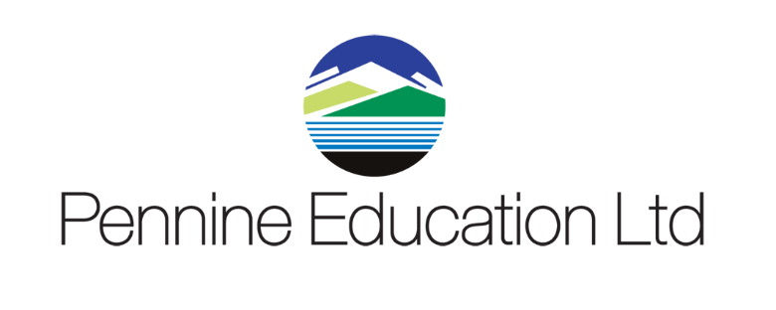

Helpdesk Support calls KPI monitoring report Sept 2022 to August 2023
Month | Total No Calls | Resolved in SLA | Resolved on 1st Contact
September | 740 | 100% | 91%
October | 424 | 100% | 91%
November | 467 | 100% | 87%
December | 167 | 100% | 84%
January | 456 | 100% | 91%
February | 253 | 100% | 87%
March | 349 | 100% | 85%
April | 237 | 100% | 90%
May | 399 | 100% | 90%
June | 472 | 100% | 85%
July | 400 | 100% | 90%
August | 90 | 100% | 90%

