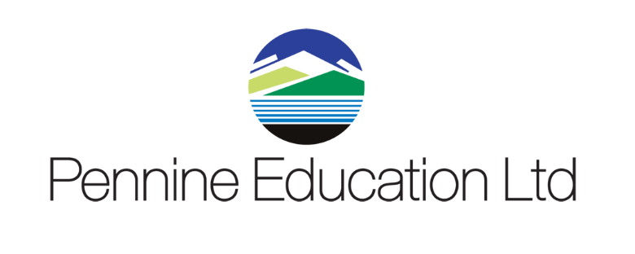

Helpdesk Support calls KPI monitoring report Sept 2020 to August 2021
Month | Total No Calls | Resolved in SLA | Resolved on 1st Contact
September | 591 | 100% | 97.8%
October | 371 | 100% | 98.5%
November | 359 | 100% | 97.66
December | 218 | 100% | 98%
January | 402 | 100% | 98.33%
February | 172 | 100% | 99.75%
March | 313 | 100% | 98.16%
April | 172 | 100% | 98.40%
May | 379 | 100% | 98.2%
June | 288 | 100% | 98%
July | 287 | 100% | 99%
August | 77 | 100% | 93.08%

