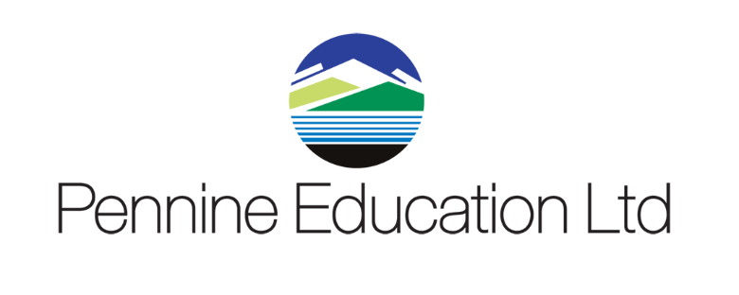

Helpdesk Support calls KPI monitoring report Sept 2019 to August 2020
Month | Total No Calls | Resolved in SLA | Resolved on 1st Contact
September | 445 | 100% | 99%
October | 343 | 100% | 99.6%
November | 284 | 100% | 99.4%
December | 115 | 100% | 98.8%
January | 356 | 100% | 99.3%
February | 148 | 100% | 97%
March | 252 | 100% | 99.66%
April | 115 | 100% | 100%
May | 136 | 100% | 100%
June | 234 | 100% | 98.25%
July | 250 | 100% | 96.33%
August | 68 | 100% | 96.16

