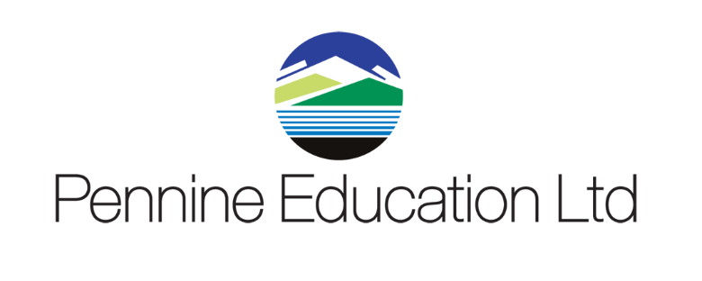

Helpdesk Support calls KPI monitoring report Sept 2018 to September 2019
Month | Total No Calls | Resolved in SLA | Resolved on 1st Contact
September | 558 | 100% | 99.5%
October | 333 | 100% | 97.5%
November | 253 | 100% | 98.25
December | 173 | 100% | 98.75%
January | 457 | 100% | 98.4%
February | 173 | 100% | 99%
March | 310 | 100% | 99.25%
April | 219 | 100% | 98.4%
May | 241 | 100% | 99%
June | 316 | 100% | 98%
July | 279 | 100% | 100%
August | 52 | 100% | 96%
September | 445 | 100% | 99%

