

FMS End of Year
March 2021

Document Ref: | FMSEOY20 | Version: | 1.0
Document Author: | Elaine Smith | Valid from: | 14.01.2021

Contact: | Pennine Education Ltd | e-Mail:esmith@pennineeducation.co.uk

INTRODUCTION

These instructions are to be used to assist the financial staff within schools to complete the End of Year procedures for the Financial Year End March 2021.
These instructions should be used in conjunction with any guidance or timetable provided by your Local Authority. Any instructions that are given by the Local Authority should always be given priority as these instructions are only a guide.
If any schools have any questions or are unsure of the procedures in this document please log a call with the Helpdesk by calling 0161 684 2320

This document contains instructions for the following:

- Tidy up the Old Ledger codes in the Chart of Accounts Review
- Create the new financial Year
- Prepare for preliminary closure
- Finalise the accounts to the Local Authority

Preparing for Year End

Prior to the year end there are a number of areas that will need considering in order to assist with the smooth closure of the accounts. These include:

- Creating the New Financial Year in FMS
- All Outstanding processes
- Verifying year end balances using reports

Checks can be undertaken in these areas prior to Period 12, to give time to chase up outstanding invoices and payments and so ensure that the least number of transactions are outstanding at year end.

The New Financial Year

A new financial year can be created at any time (but not necessarily opened). When the new financial year is created, it is based upon the old year’s structure. Opening the new financial year will allow you to run the Year End System Checks Report. This report gives a list of items that must be resolved before closing the year.
Only two financial years can be open at any given time. Changes to funds, ledger codes, cost centres and ledger code/cost centre links can be made in the new financial year.
Any funds, ledger codes or cost centres no longer required can only be deleted in the new financial year, after the old year has a Status of Finalised and prior to the creation of any future financial years.

NB. PLEASE ENSURE THAT THE CHART OF ACCOUNTS IS TIDIED AS FAR AS POSSIBLE BEFORE CREATING THE NEW FINANCIAL YEAR.

Updating the Chart of Accounts

You are able to add ledger codes and cost centres to the chart of Accounts in the New Year without the year being open.
You are reminded, however, that any new cost centres and ledgers codes added should be added in the earliest year open on your system
You can add new cost centres and ledger codes through the following route:
Tools\General Ledger Setup.

Activity: Add any new Cost Centres as required – Tab 2: cost centres
- Description: Media Studies, Code 521
- Description: Modern Foreign Language, Code 522.
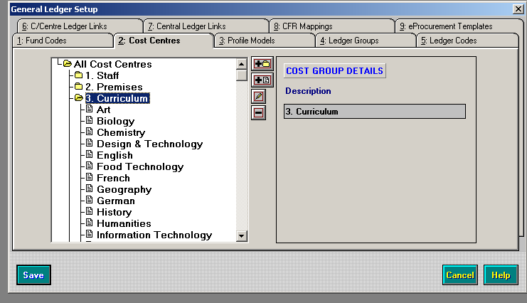
Please ensure you add a cost centre whilst the group is highlighted
Add any new Ledger Codes required – Tab 5: ledger codes in accordance with Local Authority ledger codes.
- Description: Film Materials, Code 4015, Fund 01.
Add any new cost centre/ledger links – Tab 6: C/Centre Ledger Links.
- Attach appropriate ledger codes to new cost centres.

You can also delete cost centres and ledger codes in the New Year by following the procedure below:

Cost Centre:
- Unlink any ledger codes
- Ensure the cost centre is not used in any User Defined Report
- Ensure the cost centre is not used in any Service Term Mapping
- Ensure that the Cost Centre has no budget allocation against it.

Ledger Code:
- Un-map the ledger code in the CFR mapping screen
- Unlink the ledger code from any cost centre
- Ensure the ledger code is not used in any User Defined Report
- Ensure the ledger code is not used in any Service Term Mapping
- Ensure the ledger code has no budget allocation against it.

If you are unable to delete a cost centre or ledger code check the following:
- Ensure that the cost centre or ledger code has not been used in the last 12 months
- Try again once the previous financial year has been finalised.

Creating the New Financial Year

Process for Creating the New Financial Year:

Before you create the Financial year you must ensure that a full system back up has been done.

Select Tools\Define Financial Years\Define Edit Years to display the Define Years screen:

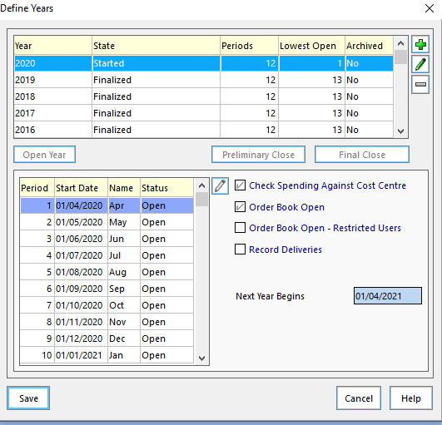

Add the New Financial Year by clicking on the + button at the right hand side of the screen.

The following screen will be displayed:

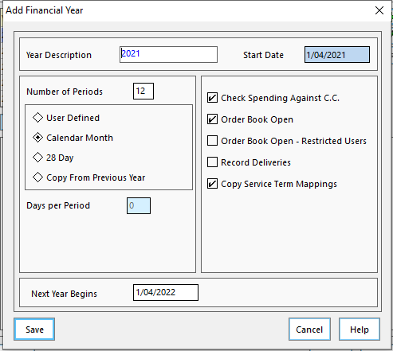

Input the following information:

- Year Description: 2021.
- Number of Periods: 12.
- Select the Calendar Month radio button.
- Next Year Begins: 01/04/2021.

You have the choice of:
- Check Spending Against C.C
- Order Book Open (you may wish to close the order book in old year now)
- Record Deliveries - (If your school wishes to use or not use deliveries in the financial year this should be deselected or selected as applicable)
- Copy Service Term Mappings.
- Click the Save button.
You should wait a few seconds while it copies the structure.

The Define Year screen will now show the New Year with the status of Not Started.

Creating Vat/ Salary Periods.

You must also ensure that in your new year you have defined periods for the VAT and for salaries, if required. This can be performed through the route Tools \ Define Financial Years \ Define Salary Periods and through the route Tools \ Define VAT Periods.

Updating Next Year Structure
The structure of your accounts will be as per the date you created the New Year. If for any reason you need to alter this in the old year, you will need to mirror this in the New Year also – this does not automatically happen.
To do this select: Tools \ Define Financial Years \ Update Next Year’s Structures. Select Tab 1 (Ledger Codes), Tab 2 (Cost Centres) and Tab 3 (Groups/Templates) in turn and then tag the codes you want to copy to the New Year. Then click the Copy Tagged button.
You will also need to select this option to ensure that any paying in books or products created since the New Year was created are also copied across.

You should also be aware that changes to the structure will affect any User Defined Reports and standard templates you have, so these will need amending to bring them into line with your new cost centres/ledger codes etc. a useful report to check this is the Chart of Accounts Listing Report. To display the report select Reports \ General Ledger Setup \ Chart of Accounts Listing.

Order Books
Some Local Authorities require a new order book to be created each financial year.
To close the existing order book:

- Tools\Books- The following screen appears
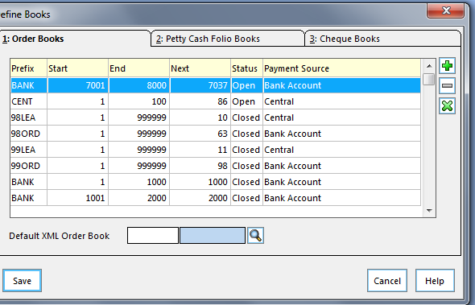

- Highlight the Order book to be closed and click on the X button.
- You will receive a message to Free unused numbers for use in new books.
- Click no.
- The status of the book will change to Closed.

To add a new Order Book:

- Tools\Books
- To add a new book click on the + sign and the following screen will appear
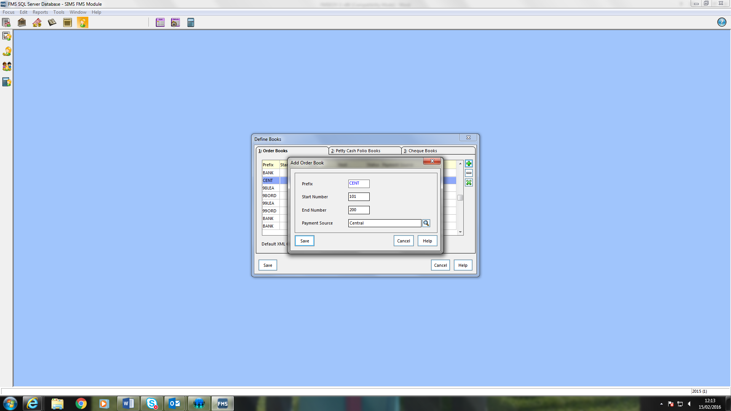

- Enter the prefix you require. You may need to look at the existing books to see the prefix you use. Some schools use their school DfE number and some schools will use the financial year.
- Insert the start and end numbers
- Click on the magnifying glass and choose Central if invoices are paid by the Local Authority or Bank if you have your own bank account.

Year End System Checks

Select Reports \ Year End \ System Checks.
When running the report for the first time please leave transferable transactions unticked.
This report gives a list of items that must be resolved before closing the year.
Whilst some of the transactions will actually prevent a year being closed there may be other items which will require additional actions before the year end can be processed. Additional reports will be needed to review each area of FMS.
Transactions that will prevent a year end close must be processed, that is, deleted, cancelled, posted or authorised before the year can be closed.
Transaction Type | Status on Report | Action Before Year End
Order | Not authorised | Delete or authorise
AP Invoice (local) | Not fully authorised | Cancel or authorise
 | On Hold | Change status or cancel commitment
AP Invoice (central) | Not fully authorised | Authorise and print authorisation slip or cancel
 | Authorisation slip not printed | Print authorisation slip or cancel
 | Invoice on hold | Change status, cancel invoice. (Transferable if authorisation slip is printed)
Credit Notes | Not authorised | Cancel or authorise
Non-Invoiced Income | Created | Delete or post
AR (Invoiced Income) | Created or authorised | Authorise and print, print or cancel
Petty Cash | Unposted | Delete or post
All Journals | Unposted | Delete or post

At the end of the report, further reasons may be given as to why it is not possible to run preliminary/final close, e.g. ledger codes have been added since the new financial year was defined.
Once the items have been investigated and cleared please run the report again with the transferable transactions ticked. Note the symbols as below:
- Transactions marked with a T may be transferred and require processing in the new financial year
- Transactions marked TS may be transferred as supporting items e.g. the order supporting an invoice.
Processing Outstanding Transactions

Before a financial year can be closed all transactions that are outstanding will need to be investigated. The following areas will need to be included in this investigation:

- Orders and Commitments
- Invoices (Accounts Payable)
- Petty Cash
- Non-Invoiced Income
- Salary Commitment – Personnel Links
- Cheque/Bacs Processing
- Accounts Receivable Invoices – Invoiced Income
- Reconciliation – Bank
- VAT Claims
- Reconciliation to LA Systems (Central/Partial)

Orders and Commitments:
Print off the following reports to assist with year end procedures
Outstanding Orders:
This is through the route Reports \ Accounts Payable \ Purchase Order Reports \ Purchase Order. Select the Outstanding Orders button then click the OK button to print.
You should check this listing and authorise and send off, fax or cancel any outstanding orders. Alternatively cancel the order and raise it in the new financial year.
Schools which record deliveries and have orders that remain undelivered these orders can remain outstanding and will be transferred once the first Preliminary close has been completed.
Prior to cancelling any orders, you may wish to print off a Cost Centre Commitment Report to find out what commitments are against each cost centre.

Cost Centre Commitment Report:
This is through the route Reports \ Accounts Payable \ Purchase Order Reports \ Cost Centre Commitments. Click Summary Report and then click the OK button to print. Choose the detailed line report.

Cancelling an Order:
If you need to cancel an outstanding order you will need to:
Select Focus \ Accounts Payable \ Purchase Order
Change the View field from All to Outstanding and click the Select button.
A list of unauthorised and outstanding orders will appear.

Clicking the Cancel Outstanding Orders button at the top right of the screen will cancel any outstanding orders you no longer need. It may be worth viewing each order individually before cancelling.
Cancel Outstanding Orders button
The same button will also clear any remaining commitment if the order is Partly Invoiced.
If you have any unauthorised orders that need cancelling you would delete them by clicking the Minus button at the top of the page.
Minus button

Analyse any outstanding commitments, chase up suppliers or cancel if no longer available
This report is also helpful when budgeting for the new financial year. Your school policy may be to cover the cost of the outstanding commitments from the old year by increasing the cost centre budget allocation in the New Year.

Invoices (Accounts Payable)

There will be suppliers’ invoices and credit notes at various stages of processing.
- Suppliers’ invoices or credit notes that have been entered to be paid locally but not yet authorised should be authorised or cancelled
The following table illustrates the status if invoices for local payment will change after each process within FMS.
Process | Local
Entered and Saved | Unauthorised
Authorised | Fully Authorised
Central Authorisation | N/A
Local Cheque | Paid
Central Reconciliation | N/A
Bank Reconciliation | Reconciled

Authorisation of Invoices:
You need to find out if you have any unauthorised invoices.
- Select Focus \ Accounts Payable \ Invoice/Credit Note.
- Change the Status field from All to Unauthorised.
A list of any unauthorised invoices will appear

You should authorise these invoices by clicking the Authorise Invoice button at the top right of the screen or cancel by clicking the Cancel Invoice button next to it. These cancelled invoices and orders may need to be raised in the new Financial Year
 | Authorise Invoice button
 | Cancel Invoice button
Remember that any orders attached to invoices you may have cancelled will then be released back into the system and may also need to be cancelled.
Cancel all credit notes and request cheques from the suppliers or raise again in the New Year.

Petty Cash
All petty cash transactions must be posted. In addition the cash in hand figure on the system should match the actual value of the petty cash held in the school petty cash tin.
A preliminary year end will fail if there are any unposted petty cash transactions.
Please be aware that you cannot post petty cash after 31st March.
We would recommend evidence of the above check is held by printing a report showing the cash in hand figure with a breakdown of the cash on the report. This evidence should be signed by the Head Teacher or authorised Finance Manager.

Journals:
All unposted journals must be posted or deleted. A preliminary year end will fail if there are any unposted journals. There are a number of different types of journals, which may be awaiting posting or might have to be deleted:
- Normal Journals
- Reversing Journals
- Cash book Journals
- VAT Reimbursement Journals.
To check for any unposted journals.
Select Focus \ General Ledger \ Manual Journal Processing.
If you have any unposted or incomplete journals they will be visible as shown on the following page. Note that there is a U for unposted in the Status column.
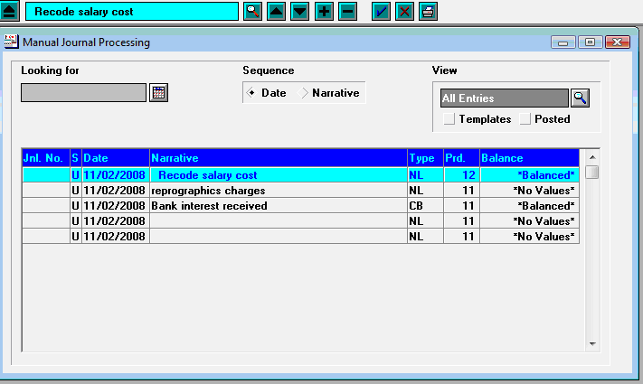
This is an unposted journal
You should decide what you wish to do with this journal.
If you wish to delete the journal, you would click the Minus button at the top of the screen.
If you wish to post the journal, you should click the Post Journal button at the top right of the screen.
Post Journal button
Journal templates you have created in the year will be carried forward to use in the New Year when it is created.

Non Invoiced Income:
Any Non-Invoiced income received should be paid into either your local bank account or the central bank via a paying in slip posted by 31st March
Do not leave any receipts unattached to a paying in slip.
NOTE: Any income posted after this date, even if you change the date will be posted into the new financial year
Raise Debtors provision in accordance with the Local Authority requirements e.g. £1000(Confirm this figure with the Finance Team) or over, excluding VAT
If you post income relating to New Year before the 1st April please contact the finance team as provision in advance needs to be made.

Salary Commitment - Personnel Links:

If you use personnel links, you will have to clear any outstanding salary commitments within FMS. You would do this once all salary payments have been completed.
To clear any outstanding salary commitments.

- Select Focus \ Personnel Links \ Salary Projection.
- Click the Clear Commitment button at the top right of the screen.
Clear commitment button
Check each month for any outstanding commitments by clicking into the Commitments for Period field. If you have any outstanding commitments you should click the Tag All and Clear Commitments buttons for each period.

Cheque Processing:
To pay any cheques due for payment select Focus \ Accounts Payable \ Cheque Processing.

Cancelling Unwanted Cheques:

Please do not cancel cheques after 31st March until after the year has been finalised.
All cheques should be printed before the 31st March and sent to the supplier

It may be necessary to cancel cheques that are no longer required, perhaps because of a dispute with a supplier, an alternative method of payment has been found or the cheque presentation period has expired.
Select Focus \ Accounts Payable \ Cheque Processing.
Select the relevant cheque run or use Find Cheque number. Once the cheque has been located click the Cancel Cheque icon and confirm you wish to cancel the cheque.
Remember to cancel the invoice and order if the commitment is no longer required.

Bacs
BACS runs and payments are not transferred from one year to the next. Therefore, it is essential that all BACS transactions are reconciled before running preliminary and final close.

If you decide to run a preliminary close within one calendar month of year end or a BACS run within the last month of the year a warning message will be displayed advising you to ensure that all BACS transactions and possible contra transactions have been reconciled to the bank statement.

This does not apply to failed BACS files as these never appear on bank statements. It is possible for a BACS file to appear on one bank statement and any contra records for BACS transactions which have failed to appear on a later statement.

Once a preliminary close has been run for the previous financial year staff will only be able to view BACS payments. No further processing for the year may take place.

Ensure that all BACS transactions have been reconciled, as outstanding BACS files will not be transferred to the New Year.

Accounts Receivable Invoices – Invoiced Income

You can issue accounts receivable invoices right up to the date of the 31st March for the financial year 2020/21. After this date, you should be producing the AR invoices in the new financial year.
All Accounts Receivable Invoices should be printed by the 31st March.

Currently only the paying in books are transferred at Year End by selecting the FMS Module, select Tools \ Define Financial Years \ Update Next Year’s Structures and clicking Tab 4: Invoiced Income. All other books are visible in all financial years, so they do not need to be transferred at Year End
- As there are strict rules concerning invoice, receipt, pay in, period and tax point dates, the System Check Report in FMS must be run before 1st April or whenever the new financial year starts. This will allow you to identify any invoices, credit notes, receipts and pay in slips which require printing and posting
NOTE: These must be printed and posted before attempting to close the financial year, as preliminary close will fail if any created items that have not yet been posted are found.
- When the old year is closed, either through preliminary or final closure, invoices are not transferred into the New Year. This does not mean, however, that they are not available when entering a receipt for payment received in the new financial year. A list of all outstanding invoices and receipts is available for matching to payments.
NOTE: If a credit note or write-off is required for an AR Invoice in the new financial year the AR Invoice will need to be transferred into the New Year. This is achieved by changing back to the appropriate year in FMS. Then enter the Accounts Receivable Module. Locate the invoice in question, highlight and click the Write-Off button. This will present you with a message asking if you want to copy the invoice into the next financial year. Clicking the Yes button will move the invoice into the next year. The invoice can then be dealt with in the normal way in the New Year.

Debtor Review
We recommend that you print, review and retain the Aged Debtor Report and write off within the financial year, any debts that you consider unrecoverable.
Re print the report if any adjustments are made which may alter the debtor review.

Products and Books
All accounts receivable invoice products are carried over into the new financial year. We recommend that you review them in the new financial year and mark the ones no longer required as not in use by selecting Accounts Receivable \ Tools \ Manage Products.
All books associated with accounts receivable are carried over into the new financial year. You can close any that are no longer required and open new ones by selecting Accounts Receivable \ Tools \ Manage Books.

Creditor Control Ledger code:
Make sure all the cheques are printed off and all bacs runs have been completed for the local invoices you have authorised, as ideally you do not want any authorised invoices, awaiting cheque/bacs runs, going forward at the first preliminary year end.
Those invoices and credit notes that have been entered and authorised for local payment, but have not yet been paid at year end’s value will be the value of the creditor control.
(It is encouraged that the creditor control has a nil balance before the first preliminary year end).
To check the balance on creditor control prior to the first preliminary year end, you should view the Balances and Reserves Report by selecting Reports \ General Ledger \ Balances and Reserves.

Reconciliation – Bank

All bank reconciliations should be completed to the actual statement dated 31st March or as soon after the date as possible and the actual bank statement balance should match the statement balance within the Bank Reconciliation screen in FMS as well as sending the Bank Claim to the Authority if required. Please check with your Local Authority the deadline date information

A bank statement that extends into April should be ruled off at the 31 March and any April transactions reconciled in the new financial year immediately following a preliminary close.
All the relevant returns at month end should be sent to the LA. If you are unsure which returns are required please contact the finance team.
FMS will automatically carry forward all unreconciled items in the bank account on the first preliminary year end.
Run off an unreconciled transaction listing and cancel any cheques that are over six months old. If the date has passed 31st March please wait until after the Year has been finalised.
To do this, run the Unreconciled Transaction Listing Report by selecting Reports \ General Ledger \ Bank \ Unreconciled Transaction Listing. Select the bank account but leave the From and To Dates blank.
Staff should also consider reconciling the bank ledger code balance as follows:
Balance of last Reconciled Bank statement -/+ movement from the Unreconciled transaction report= Bank ledger code balance.
We recommend that you speak with your LA finance team and refer to your Year End procedures for guidance on this.

VAT Claims
All VAT claims should be completed as at 31st March and the relevant reports sent to your Local Authority
NOTE: Do not process any other journals, accounts payable, accounts receivable or petty cash transactions once the last bank reconciliation, monthly LA reconciliation and VAT claim has been submitted.

Reconciliation to LA Systems (Central/Partial)
The Central Reports received from your Local Authority should be used to ensure all transactions have been included up to Period 12. Any future reconciliations relating to the current year can be done in Period 13, but reconciled into Periods 01 to 12. These will usually relate to the Period 13 Central Report issued by the LA.
It is the schools responsibility to ensure that they are in balance with the Local Authority

Recommended Reports

At year end it is beneficial to run off a range of reports to verify the position. Reports recommended and why:
- Cost Centre Summary Report: Select Reports \ General Ledger \ Transactions \ Cost Centre Summary Transactions \ Cost Centre Summary by Cost Centre – will show commitments to be carried into the new financial year
- Payroll Control Account: Select Reports | General Ledger | Trial Balance | Ledger Code Balances – select Period 13 and Payroll Ledger Code-
will show transactions due to be processed after 1 April 2021
- Chart of Account Review: Select Focus \ General Ledger \ Chart of Accounts Review select Ledger Codes, click Ledger Group and select VAT Review VAT Codes to ensure the actual figure agrees to the final VAT claim. Chart of accounts can check total balances or individual transactions on any ledger code or cost centre
- Unreconciled Bank Transactions: Select Reports \ General Ledger \ Bank \ Unreconciled Transactions Listing select the bank account and leave the From and To boxes empty. This report would have been printed as part of your reports for the March bank statement reconciliation
- Aged Creditor Report: Select Reports \ Accounts Payable \ Supplier Analysis \ Aged Creditor will provide a list of creditors (the school owes money to) – fully funded only
- Aged Debtor Report: Select Focus \ Accounts Receivable \ Reports \ Aged Debtor – leave debtor blank to obtain a list of all monies owed to the school
- Year End Transferred Transactions: Select Reports \ Year End \ Transferred Transactions select both transferable transactions and support items.
The following Reports are generally also required by the Local Authority:
- Reports \ General Ledger \ Vat Reports\ Vat Long Summery
- Reports \ General Ledger \ Bank \ Unreconciled Transactions
- Reports \ General Ledger\ Petty Cash\Transaction Listing
- Focus \ General Ledger \ Chart of Accounts Review \ Creditor Control
- Focus \ General Ledger \ Chart of Accounts Review \ Debtor Control
- Reports \ General Ledger \ Vat Reports \ VAT Submittal

Debtors and Creditors

Year End Balances:

Creditors
It is essential to identify your Local Authority’s procedures for creditors at year end. For items delivered by the 31/03/2021 but not yet invoiced, if the LA debits the ledger code in the old year and credits the ledger code in the New Year with the value of the outstanding commitment, then FMS should reflect this.
For the centrally funded and partially funded schools, the LA may require the completion of a creditors list. This list will most likely contain the ledger code and amount. It may also require the order number and the name of the supplier. The debit will occur in 2020 (Period 12 or 13) and the credit will appear in 2021 (Period 1). It is important that you understand this procedure and mirror on FMS the LA central processed entries.

Creditors List
To prepare a creditors’ list at year end, it will be necessary to identify all the outstanding commitments. This can be done in several ways:
- Select Reports \ Accounts Payable \ Purchase Order Reports \ Purchase Orders and click Outstanding Orders
- Select Reports \ Accounts Payable \ Purchase Orders Reports \ Cost Centre Commitments \ All Cost Centres – Detailed.

Using the list of outstanding orders, check against the delivery notes to identify those orders that have been delivered by 31/03/21, but not yet invoiced. When the cost centre and/or the orders have been identified, a report by ledger code can be used to show the ledger code amounts required by the LA. To display this report select Reports \ General Ledger \ Analysis \ Cumulative Expense Analysis.
Refer to your Local Authority for the creditor figure e.g. anything over £1000
If there are any orders over the creditor’s figure which after analysis have been cancelled the question should be asked “do these need a provision?” If so please complete a Creditors list. Also consider non-order invoices.

Debtors
You would fill out your debtors list exactly the same way as the creditors list. The debtors will be income that is owed to the school, i.e. Lettings, where the letting occurred before the 31/03/21, but the cash has not yet been received.
Please note that should you supply your LA with the above lists, amendments will take place in Period 13 (for which you will receive Central Reports). You must mirror these transactions on your system through reversing journals or Central Payments and Central Receipts. Then in Period 1 the LA will reverse the prior year transactions which you must also mirror on your system via the same route. In the meantime in Period 1 you will have processed the invoices (accounts payable) on the creditors list and banked the income on the debtors list, so negating the charge to the school in the New Year as the LA would have charged it back to the old year in their journals.

Prepare a Debtors List Report- Are you expecting any income of £1000 (Confirm the figure with your Local Authority) or more that relates to the previous year. Please complete a Debtors Form obtained from the finance team.

At the Year End
When the year end actually arrives, there are a number of procedures to be carried out. The first is to switch off orders in the old year. The new financial year should then be opened and the ordering process activated.

Ordering – Old Year
Switch the ordering off in the old year by selecting Tools \ Define Financial Years \ Define \ Edit Years. Double-click the old year and switch ordering off by deselecting the Order Book Open check box. This can be done at any time leading up to year end.

Ordering – New Year
Switch the ordering on in the new year by selecting Tools \ Define Financial Years \ Define \ Edit Years. Double-click the New Year and activate ordering by selecting the Order Book Open check box. This will not be able to be done until 1 April 2021.

Checking Balances
FMS will calculate the carry forward figure at the year end and carry it forward into the New Year.
Please check this carry forward figure is correct to the Local Authority figure.

PLEASE DO NOT RUN A PRELIM CLOSE UNTIL YOU ARE SURE YOU ARE IN BALANCE WITH YOUR LOCAL AUTHORITY
You would run a preliminary year end after the completion of all of the Period 12 Central Reports. FMS will determine the school under spend at that moment in time, and take the balance over to the New Year. However this is a temporary balance, as a preliminary year end would be run after the reconciliation of each Central Report. Each consecutive preliminary will adjust this figure accordingly.

Open the financial Year.

Follow route Tools/Define Financial Year/Define Edit Financial Year.
Highlight the New Year and click on open year.

Journal Adjustments / Virements

Identify any miscoding by comparing the ledger code balance on your FMS system to the central system at your Local Authority and if any items of expenditure or income are appearing on the incorrect code journals will need to be done to amend the balances. This should also be done once the Period 13 Central Report is received.

Preliminary and Final Closure of Accounts

Preliminary Closure

PLEASE DO NOT UNDERTAKE THE PRELIMINARY CLOSE UNTIL:

- YOU HAVE A FULL SYSTEM BACKUP
- YOU HAVE BALANCED WITH THE CENTRAL REPORT AND COMPLETED ALL VIREMENTS AND JOURNALS AS REQUIRED.

When you have completed the monthly reconciliation, bank reconciliation, VAT claim and petty cash for Period 12 and balanced with the LA, you are ready to run the first preliminary year end. If you do not close periods every month, this first preliminary year end will automatically close all the periods and automatically create a Period 13. You can run the preliminary closure as often as you like.
After this first preliminary no further financial transactions can take place in the old year except for additional Central Payments and Receipts to ensure the Central Report agrees to the LA and closing balance journals (to make adjustments).
NOTE: Bank reconciliation cannot be undertaken in the old year after the first preliminary close, as all unreconciled transactions and bank balances are automatically carried forward at this time. Therefore, it is very important that the bank balance reconciles to the actual bank statement at this point.
You cannot attempt to run a preliminary year end until at least the 1st April 2021.
NOTE: Once you are in balance with your Local Authority you can perform the first Preliminary Close as follows:
- Select Tools \ Define Financial Years \ Define/Edit Years.
- Highlight the Year 2020 and click the Preliminary Close button.
- Click the Yes button in response to the following message only to confirm that the Prelim CFR report has been run and balances to Central Report Period 12.
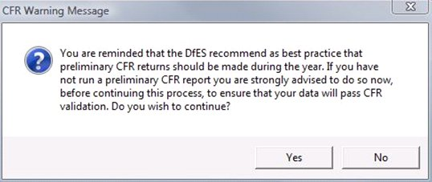
The following table will appear:
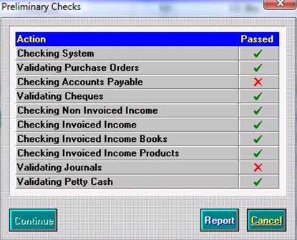
- If you have a red cross in any of the boxes you can click the Report button and it will print a report to tell you why this part of the preliminary has failed or click the Cancel button to exit. You will not have the option to continue if you have any failed areas.
- You would then make adjustments, by revisiting the areas that have failed, and start the Preliminary Year End procedures again.
Should you wish to run a preliminary year end again.
- Select Tools \ Define Financial Years \ Define/Edit Years.
- Highlight the Year 2020 and click the Preliminary Close button.
- Click the Yes button in response to the following message:
- Once you have all green ticks (as shown in the following graphic) you can click the Continue button.
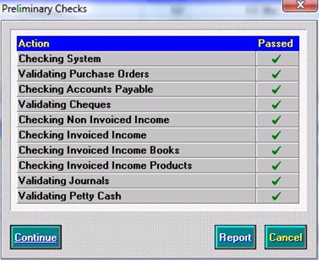
You will then reach the Select Transfer Mode screen as shown in the following graphic.
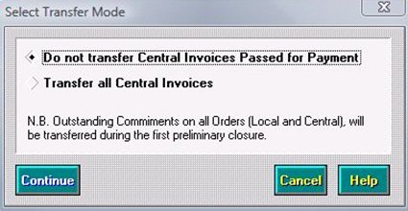
- If you are a centrally funded school or a partially funded school it is imperative that you select the Do not Transfer Central Transactions radio button at this stage. This means that any central invoices or central receipts will stay in the old year awaiting the next Financial Statement from the LA. It is important that you choose correctly.
- Click the Continue button and the Preliminary Close screen will be displayed:
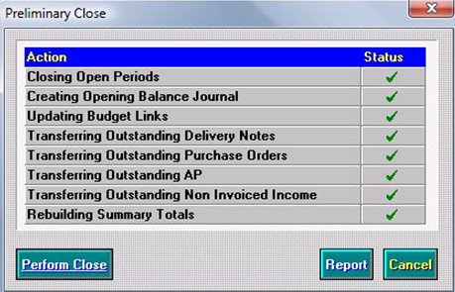
- Again you should obtain green ticks against each process. If a red cross appears, it means that the business rules for the process have not been achieved. You will need to revisit these areas and make the appropriate adjustments. You will not have the option to perform close if you have any red crosses. You would click the Cancel button to exit or click the Report button to find out the reasons for failure.
- However, once you have all green ticks you should click the Perform Close button. Please note Rebuilding Summary Totals can take several minutes to complete.
- Click the Yes button in response to the following prompt:
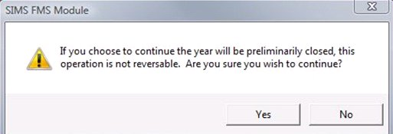
The year will then be preliminary closed and it will say Closed – Not Finalised.

The New Year

- Go into the new financial year:
You should check the results of the first Year End, e.g. Orders/Invoices carried forward into the New Year.
- Look at the bank, petty cash and VAT balances in the new year by selecting Reports \ General Ledger \ Balances/Reserves.
- Look at the FD balances transferred in Focus/General Ledger/Chart of Accounts review.
This is the under or over spend brought forward at that moment in time. You should make a note of this figure. This figure plus the transactions that occur on additional Financial Statements will be the final under spend or over spend from the previous financial year.

After the Preliminary Year End
After the preliminary closure has been run, FMS moves into Period 13. It may still be necessary to make adjustments to the accounts on the old year. Functions permitted in the previous financial year after preliminary close are listed in Appendix A.
There may also be some final Central Report reconciliation from the LA. You should continue to reconcile these Central Reports in the old year in the same way, using manual reconciliation or direct central payments/receipts. You should run a preliminary Year End after the completion of each Central Report. Each preliminary closure will produce journals to update the balances in the New Year and adjust the FD Code accordingly.

Automatic Reconciliation in the Old Year
If during the old year, automatic reconciliation has been used, the Suspense file must be cleared before the final year closure. Preliminary closure cannot be performed with items in suspense.

Completion of Central Reports
Once the Central Report reconciliation from your Local Authority is complete and you have gone through several preliminary closures, you should check the balances in the New Year, (FD Code).
This balance in the New Year, is the system’s version of the school’s under or over spend. There will be balances against each FD for both capital and revenue balances. You should check that these balances are in line with the Local Authority central balances before completing a Final Year End.
Once this balance has been agreed by the Local Authority you can run a Final Year End.
Do not attempt to run a Final Year End until this balance has been verified by your Finance Team.
Your Local Authority may want a preliminary Consistent Financial Report before the Final Year End procedure is carried out. Check this with your Local Authority before you carry out the Final Year End on FMS.

Cross Year Symbols
Any orders or invoices transferred to the New Year will appear with cross year symbols. This helps when transactions are cancelled in the New Year, e.g. an unpresented cheque. The symbols used are as follows:

Old Year
- T - Indicates that the listed item has been transferred to the new year and requires additional processing
- TS - Indicates that a copy of the item has been transferred to the new year as a supporting item
- TR - Indicates that a transaction has been copied in support and then been cancelled.

New Year
- F - Indicates that the listed item has been transferred from the old year and requires further processing
- FS - Indicates the item has been transferred from the old year as a supporting item
- FR - Indicates a transaction has been copied from the old year in support and the item it was supporting has been cancelled. Further processing may be required.

Final Year End Closure

PLEASE DO NOT UNDERTAKE THE FINAL CLOSE UNTIL
- YOU HAVE A FULL SYSTEM BACKUP
- YOU ARE IN BALANCE WITH YOUR LOCAL AUTHORITY

Once the Local Authority has clarified your under or over spend and given you the go ahead to finalise the years accounts, you can run the Final Year End. This may not be until late June or early July, once you have submitted your proposed Consistent Financial Report.

You wish to finalise the year’s accounts.
NB: Once the Final Year End is complete, no transactions at all can be put through the old year. This cannot be reversed and you can perform a final closure only once. Only reports can be printed.
Select Tools \ Define Financial Years \ Define/Edit Years.
- Highlight the Year 2020 which says Closed – Not Finalised and click the Final Close button as shown in the following graphic.
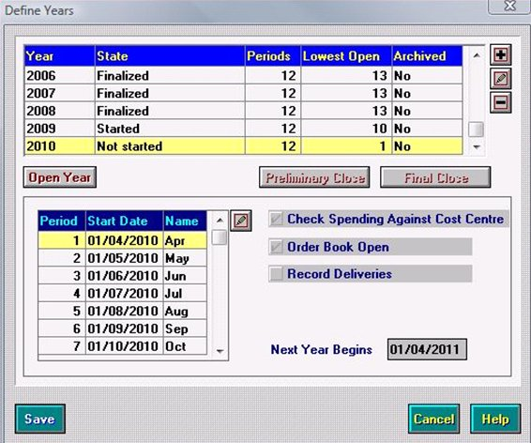
- Click the Yes button in response to the following prompt if it is displayed.

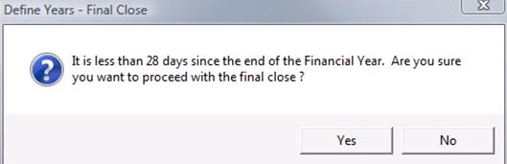
- Click the Yes button in response to the following dialog if your LA has given you the go ahead
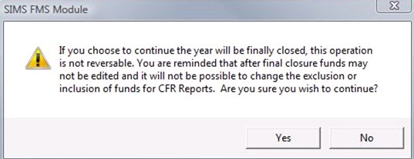

The Final Checks screen will appear with another tick list showing green ticks and red crosses.
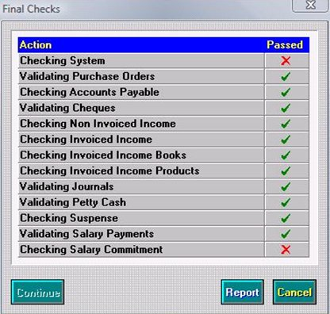
- If there are any red crosses click the Report button. This report will highlight the reasons why the system would not finalise.
Once you have made the appropriate checks, revisited the area and made the appropriate adjustments, you can run through this final Year End procedure again.
When you have achieved a full table of green ticks you should click the Continue button as shown in the following graphic.
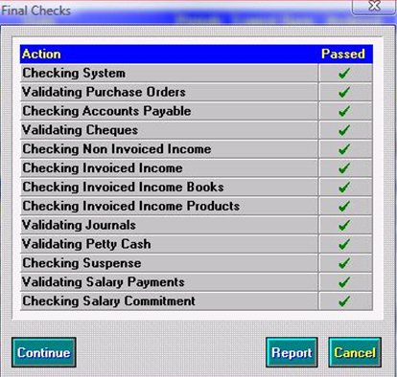
A second tick table will then appear.
- When all green ticks have been achieved you may click the Perform Close button. This is only if you have completed a back up and received agreement from your Finance Officer.
- Click the Yes button in response to the following prompt.
The year will then show with the status of finalised as shown in the following graphic.
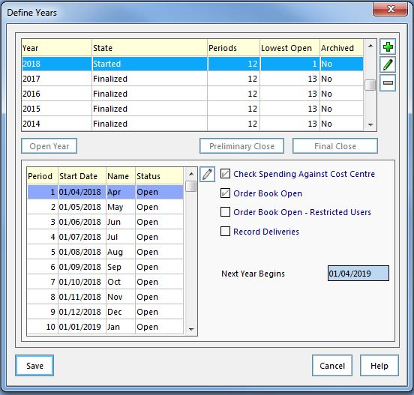
- Click the Save button to complete. For schools producing their own CFR the final return may now be produced.

Reducing the Fund Allocation Balance to NIL – In the new Financial Year

Some Local Authorities require that once the Financial Year has been finalised the Fund Allocation balance is reduced to Nil. The brought forward balance is then allocated to a brought forward ledger code. Please check with your finance officer if this is the case.

To achieve this:
Go into the New Financial Year once the previous year has been finalised.
Route: Focus \ Budget Management \ Fund Allocation.
In accordance with Your Local Authority requirements the Fund Allocation Balance may need to be NIL. This should be undertaken once the final carried forward figure is established. Please check the previous year’s balance has been reduced to NIL.
To achieve this once the Fund Allocation Detail screen shows double click on Fund 01.
Go into the history by clicking on the tab.
Establish how many increases there are by taking the tick out of the decrease box. Make a note of the number of increases and the amount of these increases.
Establish the number of decreases there are by taking the tick out of the increase box. Make a note of the number of decreases and the amount of these decreases.
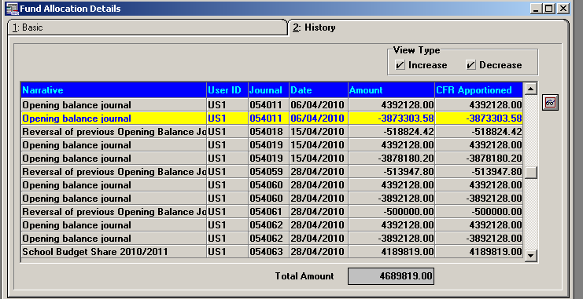
Click here to deselect the increases or decreases.
These need to be equal so add a decrease or increase as required by going back to the Fund Allocation Detail Screen and choosing the relevant action.

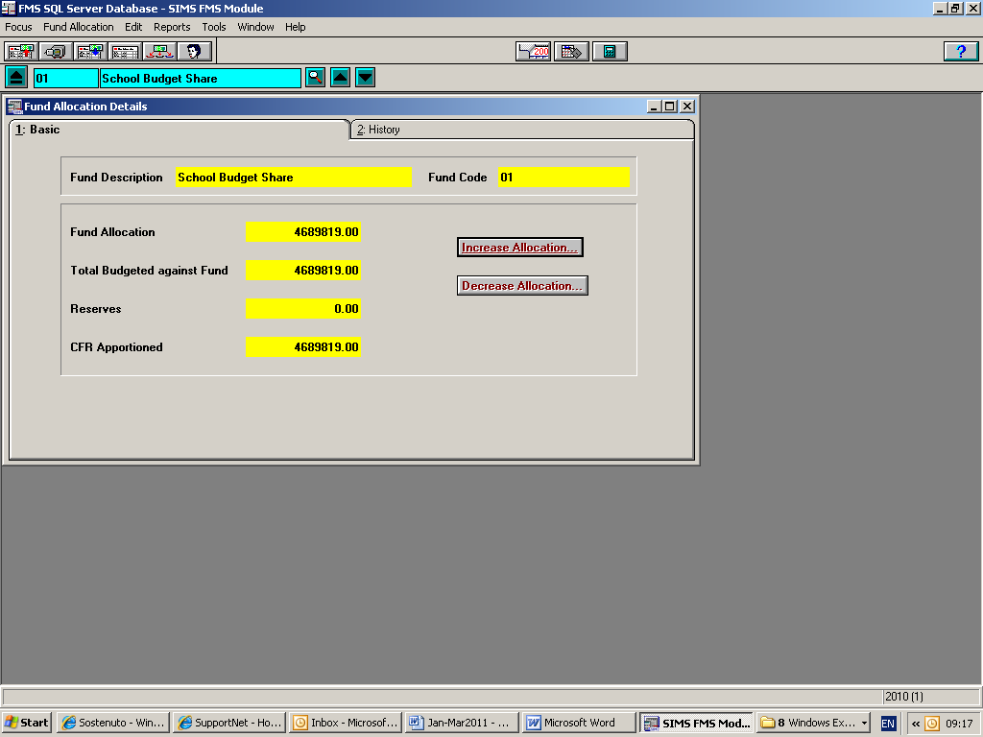
Click here to add an increase or decrease

Budget Management in the New Year
NOTE: You must be in the new financial year.
The budget may appear on the Central report for period 1.

Manual Entry of Budget:

Cost Centre Allocations

- Select Focus \ Budget Management \ Cost Centre Allocation to be presented with the Cost Centre Allocation Details screen.
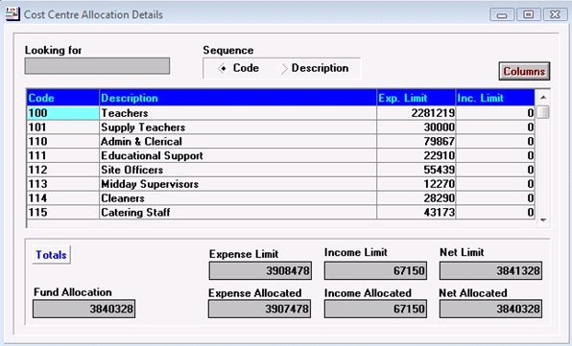

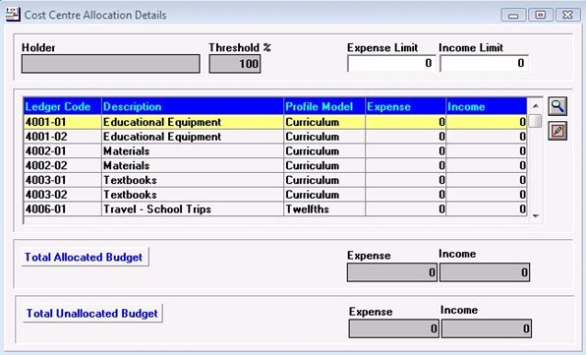
- Double clicking the Maths Cost Centre, for example, shows a list of ledger codes attached to this cost centre.
The budget to be allocated to this cost centre should then be split across the relevant ledger codes. Double click a ledger code to display the Budget Details screen.
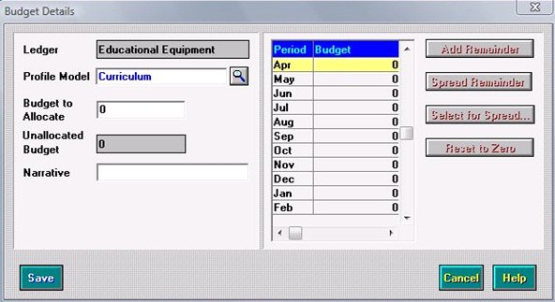
- Enter an amount in the Budget to Allocate. If a Profile Model is provided then this will be split across the periods appropriately, a manual spread will be required.
- Clicking the Save button may present you with the following indicating that the budget limit will be increased or decreased automatically. Click the Yes button.
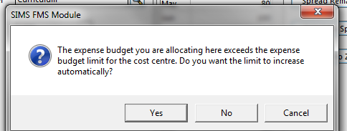

- When all of the budget has been split across the ledger codes, click the Blue Tick button to save and enter an appropriate narrative for the audit log, then click the Save button. To return to the list of cost centres click the Focus Mode button. Continue to allocate the budget across the cost centres.
- Once the initial budget has been entered then this may be fixed by clicking the Fix Budget button once this has been agreed by the Governing Body. This takes a snap shot of the budget and will be referred to as the Original Budget in certain reports. This process is not reversible. However, cost centre allocations can still be made once this has been done and will appear under the Current Budget in some reports.

Appendix A

- Functions Permitted in Previous Financial Year After Preliminary Close

Functions Permitted in Previous Financial Year After Preliminary Close
 | Can Access | Cannot Access
General Ledger
General | Reviews and reports
Journals | Reversing journals | Any other journals
 | Closing journals
Central | Direct central payments/receipts | Fund to bank transfers
 | Centrally paid invoices which have not been transferred
 | Central income which has not been transferred
 | Define/test import files
 | Link/unlink central payment mappings
Budgets | All reports and reviews | Cash profiles
 | Increase/decrease fund allocation | Budget allocations
 |  | Profile models
Bank | View/print only
Petty Cash | View/print folios | Enter, adjust or cancel transactions
 | Access reports
Accounts Payable
Order Processing | Reviews and reports | Process orders
 |  | Authorise orders
 |  | Print orders
 |  | Print dummy orders
Invoice Processing | Reviews and reports | Process invoice/credit notes
 |  | Authorise invoices
 |  | Hold or cancel invoices
 |  | Print authorisation slips
 |  | Print cheques
 |  | Cancel cheques
Non-Invoice Income
Receipt Processing | Print authorisation slips | Enter receipts
 | Reviews and reports | Match receipts
 |  | Cancel non-invoiced income
 |  | Transfer receipts
General Ledger Setup
Define Financial Years | Preliminary and final closure | Edit closed year details
 | Update structure for new financial year | Period end (all periods are closed by the Preliminary Close Function)
Funds | Add funds and rename existing funds and LA Codes | Unlink funds from Ledger Codes
 | Link additional funds to Ledger Codes
Ledger Groups | Add new ledger groups | Delete un-used ledger groups
Cost Centres | Define new cost centres
Ledger Codes | Add new Ledger Codes
 | Edit short code and description of ledger codes
 | Alter ledger group, normal profile, normal VAT on a ledger code
Cost Centre/Ledger Links | Create new links between cost centres and ledger codes | Delete ledger code/cost centre links where actuals posted or budgets allocated
General | Print all listings | Define profile models
 | Define permissions

Appendix B

Checklist for Year End

Action Required | Route | Page | Complete
Full System Backup | Using normal backup process | N/A
Tidy Chart of Accounts | Tools/General Ledger Setup | 5
Full System Backup | Using normal backup process | N/A
Create New Financial Year | Tools/Define Financial Year/Define Edit Years | 7
Create Vat Periods if cheque book school. | Tools/Define Vat Periods | 9
Create Salary Periods | Tools/Define Financial Year/Define Salary Periods – if applicable | 9
Run Year End System Check Report | Reports/Year End/System Checks | 12
Clear Outstanding transactions. | Focus/Accounts Payable/Orders  Focus/Accounts Payable/Invoices  Focus/General Ledger/Petty Cash  Focus/General Ledger Manual Journal Processing  Focus/ Non Invoiced Income/Receipts  Focus/ Non Invoiced Income/Pay In  Accountants Receivable – Invoices  Accountants Receivable – Receipts  Focus/Personnel Links/Salary Projection/Clear Commitments | 13
Run Final Cheque/Bacs Run | Focus/Accountants Payable/Cheque/Bacs processing | 17
Run Final Bank/ Central Period 12 Reconciliation | Focus/General Ledger/ Bank reconciliation | 20
Run final Vat Submittal if applicable | Reports/General Ledger/Vat | 20
Complete Debtors/Creditors list | Send details of Creditors /Debtors to the LA | 22
IN NEW YEAR AFTER 1.4.2021
Disable ordering in Old Year | Tools/Define Financial Year/Define Edit Years | 24
Enable ordering in the New Year | Tools/Define Financial Year/Define Edit Years | 24
Open Year | Tools/Define Financial Year/Define Edit Years | 24
Full System Backup | Using normal backup process | N/A
Run Year End System Check Report for year to be closed | Reports/Year End/System Checks | 12
Complete Prelim Close once in balance | Tools/Define Financial Year/Define Edit Years | 26
Check Balances in New Year | Focus/ General Ledger/Balance & Reserve | 30
Summery Trial Balance of Old Year to match ledger codes to LA Report | Reports/General Ledger/Trial Balance/Summery Trial Balance/Ledger Code | 21
Summery Trial Balance of Old Year to match LA Report | Reports/General Ledger/Trial Balance/Summery Trial Balance/Ledger Code | 21
Confirmation from LA to Close Year | N/A | 26
Full System Backup | Using normal backup process | N/A
Complete Prelim CFR Report | Reports/CFR/CFR report  If required by Local Authority | 26
Close Final Year | Tools/Define Financial Year/Define Edit Years | 32
Complete Final CFR Report | Reports/CFR/CFR report  If required by Local Authority | 35
Ensure all reports are run for Year-end are signed and filed | Various | N/A
Enter New Financial Year Budget- Fix | Focus/Budget Management/Cost Centre Allocation | 37

