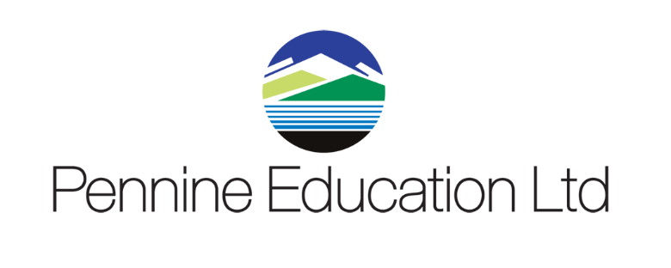

Course Title: FMS Daily Tasks

Duration:
1 Day

Times:
9.30am – 4.00pm

Course Aims:
This course will cover the day to day aspects of FMS, including orders, invoices, payments, recording income and dealing with petty cash. Local bank/central processes will be covered as appropriate.

Course Objectives:
By the end of the course you will be able to:
- Understand the accounts payable process (orders, invoices, credit notes, deliveries)
- Understand the payments processes (bank and/or central)
- Understand recording income
- Understand petty cash process
- Understand central processes.

Target Audience:

New Users to FMS module

Requirements:
A prior knowledge of FMS and an understanding of the school’s current office/financial systems is advised, but is not essential.

