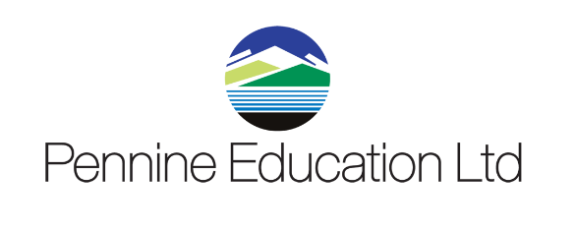13

Pennine Education

OL8 3QL

Secondary Schools User Group – Autumn 2021

**Location: Remote (via Microsoft Teams)**

**Date: 23rd September 2021, 13:30 – 15:30**

Session contents:

* Statutory Returns
* Pupil Premium
* School Workforce Census
* Housekeeping Routines
* SIMS Software Update
* Power BI
* Training / Consultancy
* Performance Summary

This is a free and would be a 2 hour remote afternoon session.

If you would like more information on this or if you would like to opt into this service, please register via the email invitation or click the link below:

[Secondary Schools User Group – Autumn 2021](https://teams.microsoft.com/l/meetup-join/19%3ameeting_YzM5MzI0ZDMtN2FiNC00NzA3LTgwZTEtMDYwMmYyZTVhMDRk%40thread.v2/0?context=%7b%22Tid%22%3a%22a08b33f4-cb98-4687-81dd-b1ff40605135%22%2c%22Oid%22%3a%22ea37398b-0694-46a6-90df-8e34a437d61f%22%7d)

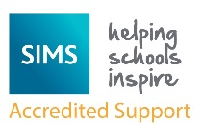

Pennine Education

Hollinwood Business Centre

Hollinwood

Oldham

OL8 3QL

0161 684 2320