**Fileset Import Instructions**

There is a new Fileset available which provides updated validation provided by the DfE. All schools are advised to import this as per the instructions below.

1. Please save the attached files to a location on your workstation.
2. When this is saved, right click and extract all to unzip the file to the location
3. To import the file, enter SIMS.net with the appropriate access level (System Manager) and import via **Tools | Setups | Import Fileset**.

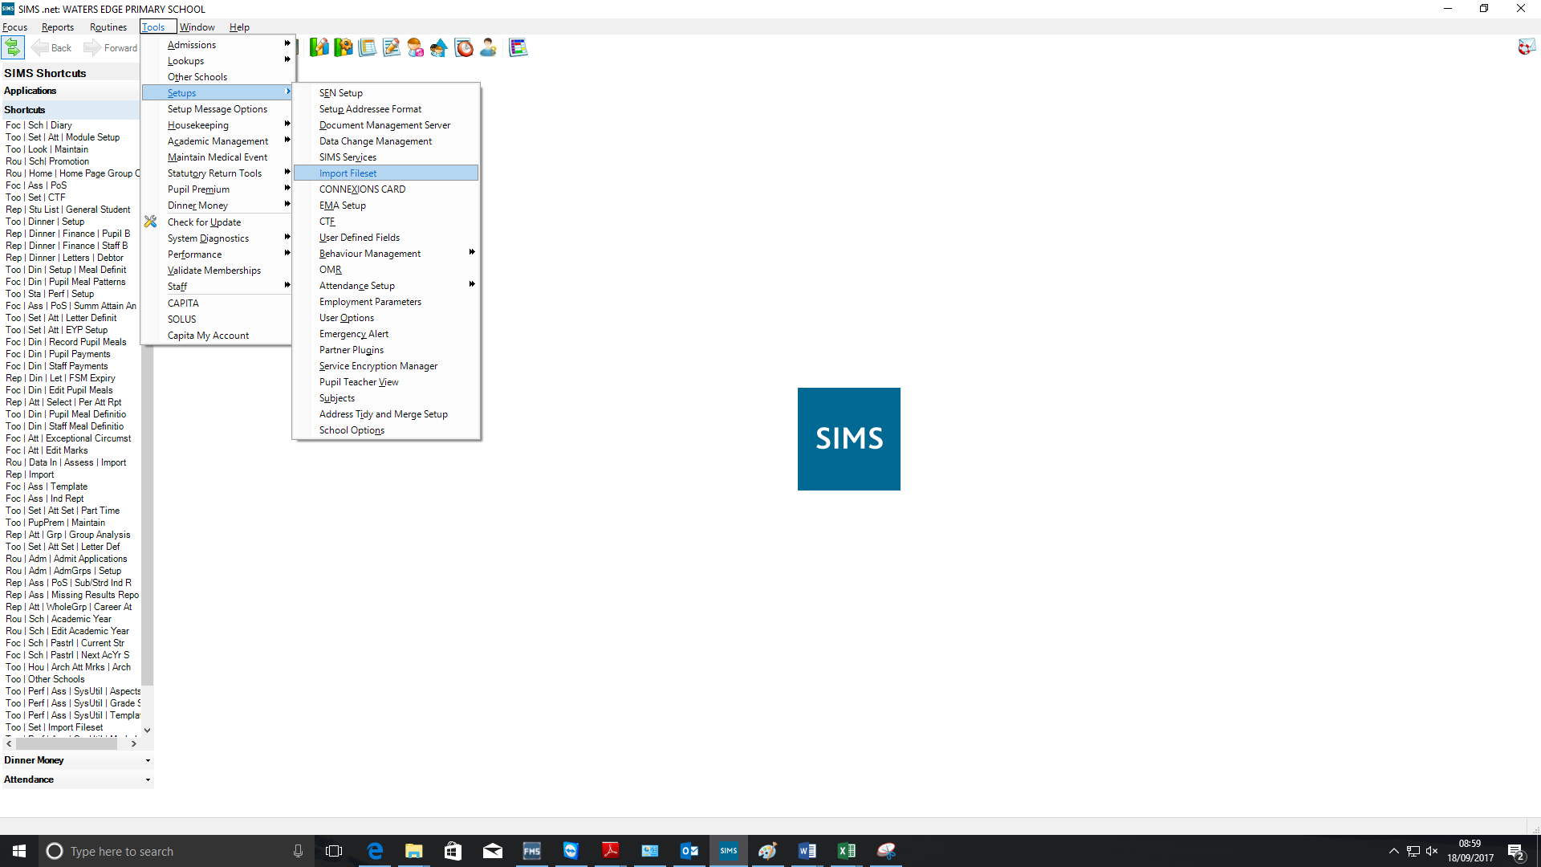

1. In the file location box which appears use the browse button to the right to navigate to the location where you had previously saved the fileset, click **Open**. Please note that although you have saved two files, you will only see one file to select. This is correct behaviour
2. The details of fileset will show, click the **Import Fileset** button to complete the process.
3. The Import complete message will appear to indicate successful completion.
4. Close the screen.
5. You will need to log out and back into SIMS for this to take effect.

You are also advised to run a new census return if you have already completed a dry run.