13

Pennine Education

OL8 3QL

Dinner Money Overview

Pennie Education are happy to be offering a remote overview for Dinner Money.

This remote session is a thorough introduction to recording dinner information within SIMS.

• Populating SIMS Dinner Money with appropriate data  
• Record and report on student meals  
• Creating opening balances registers  
• Payments and banking  
• Maintaining dinner money  
• Reports, letters and statements.

The cost of this would be £40+VAT and would be a half day remote session.

If you would like to book on this course, please book using the link below.

[Course Booking Form - PENNINE EDUCATION LTD](https://www.pennineeducation.co.uk/course-booking-form.html)

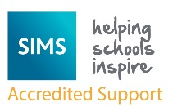

Pennine Education

Hollinwood Business Centre

Failsworth

Oldham

OL8 3QL

0161 684 2320