Admissions Handbook
Managing Pre Admissions

Document Ref: | Admissions | Version: | 1.0
Document Author: | Rebecca Smith | Valid from: | 23/02/2023

Contact: | Pennine Education Ltd | e-Mail: rsmith@pennineeducation.co.uk

Intake/Admission Groups
Intake and admission groups are used to maintain lists of the applicants who have registered an interest in being taught at your school. It is now possible to create an intake group containing one or more admission groups. For example, an intake group consisting of separate admission groups for those joining in Autumn, Spring and Summer terms might be set up for your Nursery.
If you have previously created admission groups with an incorrect Date of Admission, amending the date also amends the Date of Admission for every applicant who is a member of the group, preventing the need to edit them individually.

NOTE: If you need to add a New Year group but have already created intake/admission groups, you will need to create new intake/admission groups after the additional year group has been added and then move any existing members to the new intake/admission group(s).

This is also a good time to delete or make inactive any unwanted admission groups.

Creating a New Intake Group

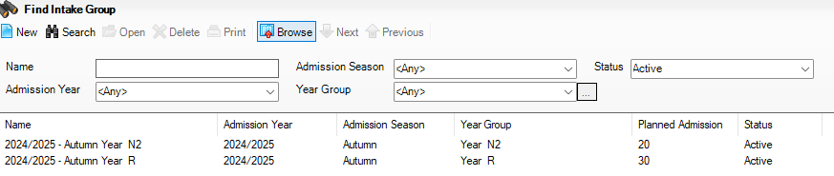
- Select Routines | Admission | Admission Groups | Setup to display the Find Intake Group browser.

- Carry out a search to ensure that the intake group does not already exist.
- Click the New button to display the Intake Group Details page. Mandatory fields are highlighted in red. The page will look slightly different depending on whether you have set up SIMS to allow multiple admission groups to be added.
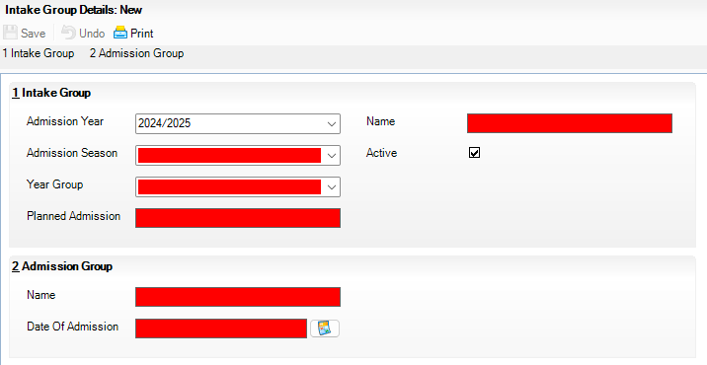
- In the Intake Group panel, select the Admission Year to which the intake group relates (e.g. 2023/2024) from the drop-down list (this defaults to the current academic year).
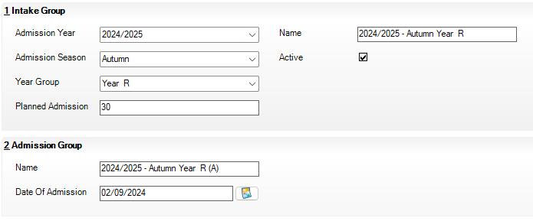
- Select the required Admission Season (Autumn, Spring or Summer) or, if the intake group does not apply to a specific season, select Integrated from the drop-down list.

- Select the required Year Group from the drop-down list.
- Enter the number of applicants that you expect to admit to this intake group in the Planned Admission field.
- If you press the Tab key to move to the Name field or click in this field, a default name is supplied for the intake group, based on the Admission Year, Admission Season and Year Group, e.g. 2023/2024– Autumn Year N1. The default name can be amended, if required.
- The Active check box is selected by default and indicates that the intake group is available for use. Deselect this check box only if you wish to create intake groups that will be used at some point in the future (they will not be displayed in the Find Intake Group browser by default).

Adding an Admission Group (Multiple Groups Not Enabled)
- Clicking in the Name field provides a default name for the group, which can be overtyped as required.
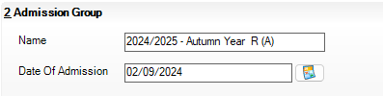
- Enter the Date Of Admission for the group, this should be the first day that the pupils are expected to attend eg, 4/9/2023.
- Click the Save button to create the intake and admission group.
Once admission groups have been created, you can add any applicants to SIMS and assign them to the required admission group.

Adding One or More Admission Groups
This section is applicable if SIMS is set up to allow the use of multiple admission groups and describes how to add one or more admission groups to an intake group. If you are not sure, please refer to the graphics in the previous section. If the second panel is labelled Admission Groups, SIMS is set up to allow multiple admission groups. If the second panel is labelled Admission Group, SIMS is not set up to allow multiple admission groups.
- From the Admission Groups panel, click the New button to display the Add Admission Group dialog.
- Enter a Name for the admission group together with the Date Of Admission. Alternatively, click the Calendar button and select the required date.
IMPORTANT NOTE: Please ensure that the Date Of Admission falls within the applicable academic year.
Click the OK button to add the admission group and return to the Intake Group Details page.
- If any further admission groups are required, click the New button in the Admission Groups panel and repeat steps 2 and 3.
- Click the Save button to create the intake and admission groups.
Once admission groups have been created, you can add any applicants to SIMS and assign them to the required admission group.

Importing a New Intake File from the LA/SAM
It is possible to import either a CTF or an ATF file from the local authority. For those using SAM we would recommend importing the ATF file, rather than the CTF. If you require assistance please log a call with the Pennine Education Helpdesk.

NOTE: Files are only produced in SAM for the Reception intake not Nursery

Importing Common Transfer Files (CTFs)

This section provides a summary of the steps required to import a CTF.
Import any CTFs that have not yet been imported. Pupil with CTFs can be imported into an admission group or directly on-roll.
If any of the pupil in the CTF already exist in the system, any blank fields in their record are updated with data from the CTF. Any existing data is not overwritten, as it is deemed to be the most up-to-date information. Any such information is highlighted in the Exception Log that is displayed at the end of the import process.
Appropriate intake/admission groups must be created before you can import CTF files

Importing an Admissions Transfer File (ATF)
After places have been finalised, schools receive an Admissions Transfer File (ATF) from their LA. This file contains the names of applicants who have been offered a place at your school for the following September, together with additional basic applicant information. Once the ATF has been imported into SIMS and applicants have been accepted, the curriculum planning process can be started.
NOTES: Before proceeding, please ensure that you have received an ATF from the LA and that it is stored in an accessible and secure location.
An intake group and admission group combination must also have been defined, into which applicants can be imported.
- Select Routines | Admission | Import ATF File to display the Import ATF File wizard.
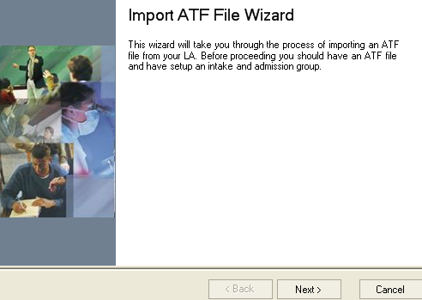
- Click the Next button to continue.
- Click the Browse button to display the Open dialog.
- Navigate to the location of the stored ATF, highlight it then click the Open button.
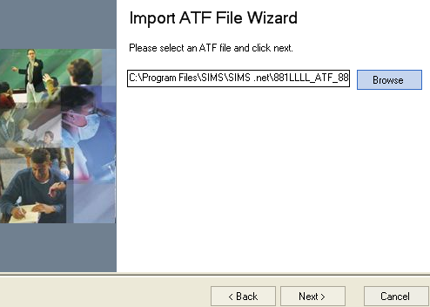
- Click the Next button to validate applicant addresses in the ATF.
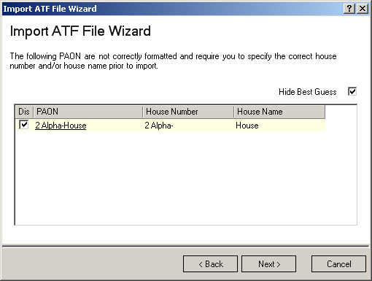
The House Number and House Name of an address are held in a single field of the XML file structure. This field is called a PAON (Primary Addressable Object Name).
This page is displayed only if the ATF contains addresses with incorrectly formatted PAON fields and enables you to correct the address details to prevent SIMS from rejecting the address.
The Hide Best Guess check box is selected by default.
Addresses that can be reconciled without user intervention are not displayed. The only addresses displayed in the lower section of the page are those that cannot be resolved automatically. These addresses can be corrected by clicking either the House Number or House Name field then entering the correct information manually. Alternatively, address details can be discarded and therefore not imported by selecting the Discard check box adjacent to the relevant entry.
If a large number of addresses require correction during import, you should request a correctly structured ATF from the LA.
- After correcting or discarding incorrect addresses, click the Next button to continue. Select the required Intake Group from the drop-down list.
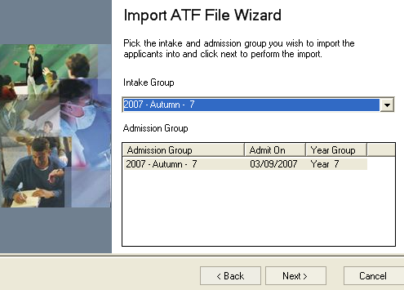
SIMS checks that the details contained in the ATF file header correspond with the details of the intake group into which the file is being imported. All admission groups associated with this intake group are displayed in the panel at the bottom of the wizard.
- Highlight the required Admission Group then click the Next button to import the ATF. A progress bar is displayed.
Schools that have started to enter manually the details of next year’s applicants may encounter some duplicate applicants when importing the ATF. To reduce the risk of duplicate applicants, SIMS checks the information in the ATF against existing applicant details. Any details that match based on surname and forename are displayed.
NOTE: These details require investigation to determine whether they are new applicants or duplicates of existing, manually entered applications.
Application Reference Numbers (ARNs) play a key role in the matching of applications. Applicants who have been entered manually in SIMS are not issued with an ARN. ARNs are created as part of the LA process and applicants contained in the ATF have been given their own unique number, which is imported into SIMS with the rest of their details. These applicants are not displayed on this page.
If an applicant in the ATF is a match for an existing applicant, select the Update Application check box. This updates the existing application and adds the applicant’s ARN to their current record.
If an applicant in the ATF is a match for an existing applicant in SIMS, where their application was originally from another admissions year or they are currently an existing pupil in the Nursery year, select the New Application check box. For example, an applicant applied to join the school for the Nursery year in September 2012 but their application was unsuccessful, so they have now applied to join the Reception year in September 2013. These applicants are created as new applications.
If an applicant in the ATF is a completely new applicant and is not the same as the individual found by SIMS, select the New person check box to record a new person and a new application.
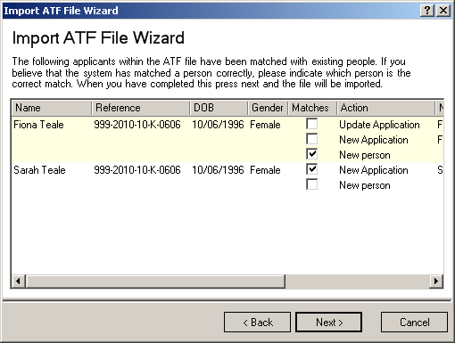
View all the fields in the panel using the scroll bar to move backwards and forwards across the page.
- Click the Next button to continue.
SIMS also checks for Contact matches, e.g. any applicant in the incoming ATF who shares a contact who is already present in the system.
If any of the contacts listed on the following page of the wizard prove to be a match for an existing contact, select the Matches check box adjacent to the correct Name.
If any of the contacts listed on the following page of the wizard prove to be a new contact, select the Matches check box adjacent to the New person record in the Name column.
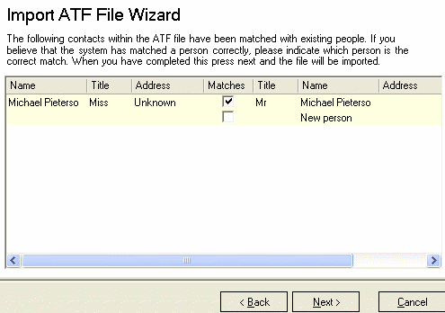
- Once you have dealt with each contact, click the Next button to continue.
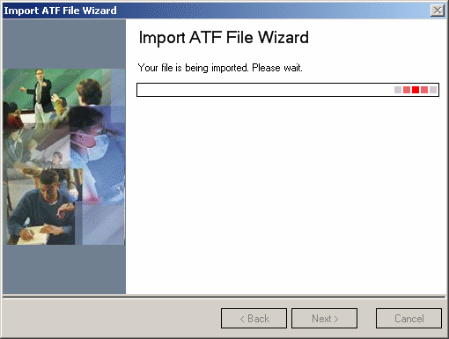
When the import is complete, the Number of applications in file, the Number of applications processed and the Number of new applications are displayed.
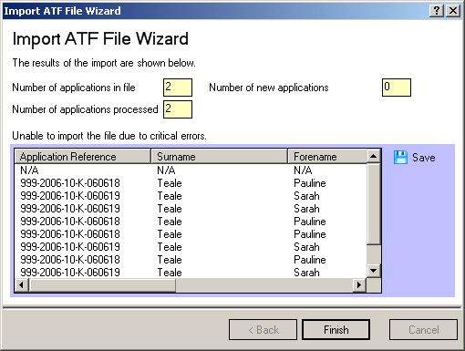
Applicants are imported with a status of Offered and their details can be viewed and updated by clicking the Application icon on the toolbar or selecting Focus | Admission | Application. Warnings or errors in the ATF import are listed, as shown in the previous graphic.
It is possible to Save or Print these details by clicking the appropriate button on the right-hand side of the page.

IMPORTANT NOTE: If a pupil has been with you in nursery and is coming back in reception. Once the ATF has been imported on the Accept Applicants page, withdraw this applicant. This will then ensure the School History of the child on roll continues as the End of Year procedure runs and the pupil is moved up a year. Please see page 12 for details on withdrawing a pupil.

Transferring Admission Group Members
All applications received by a school must be associated with an intake and admission group. The intake and admission groups define the intended date of admission and the year group for each individual application.
Occasionally, it may be necessary to associate applications with an alternative intake and/or admission group. This may be because of oversubscription to an intake and/or admission group, or because the application was originally placed in the wrong intake or admission group.
- Select Routines | Admission | Admission Groups | Transfer Applications to display the Transfer Admission Group Members page.
- On the left-hand side of the Members panel, select the Intake Group and Admission Group from which you want to transfer members from the drop-down lists. Only admission groups that have been associated with the selected intake group are available for selection.
All the applications that are currently associated with this intake/admission group combination are displayed in the panel on the left-hand side of the grid.
- On the right-hand side of the Members panel, select the Intake Group and Admission Group to which you want to transfer members from the drop-down lists. Only admission groups that have been associated with the selected intake group are available for selection.
All the applications that are currently associated with this intake/admission group combination are displayed in the panel on the right-hand side of the grid. If you have inadvertently selected the same intake/admission group combination on both sides of the screen, a warning message is displayed in the Status Bar advising that it is not possible to transfer members.
NOTE: If you would like to keep a record of the original allocations, click the Print button before continuing.
- Highlight the applications you wish to transfer then click the Forward and Backward buttons to move the applications. Applications can be selected individually or in multiples by using the Ctrl & Click or Shift & Click.
- Click the Save button to save the transferred applications.

Accepting and Declining Applications
When an acceptance notice is received from an applicant to whom you have offered a place, the application status should be updated. Only applications with a status of Accepted or Admitted are available when planning registers and detailed timetables.
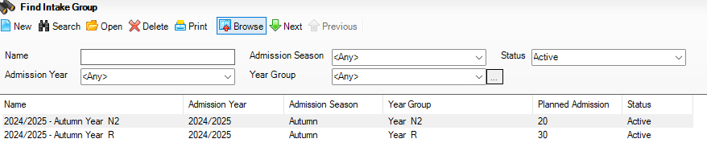
- Select Routines | Admission | Accept Applications to display the Find Intake Group browser.

- Search for the required intake group, highlight it then click the Open button to display the Accept/Decline Applications page.

The Summary panel displays the current statistical information relating to the selected intake group.
Planned Admission – indicates the original number of applications intended for this group (the PAN).
Total Applicants – indicates the number of applications that have already been received and provisionally assigned to this intake group.
Applied – indicates the number of applicants who have already applied for a place in this intake group.
Offered – indicates the total number of places within this intake group that have already been offered to applicants.
Accepted – indicates the number of applicants who have accepted their offered place.
Withdrawn – indicates the number of applications that have been withdrawn from this intake group.
Rejected – indicates the number of applicants who have been rejected from this intake group.
Admitted – indicates the number of applicants who have already been admitted from this intake group.
Clicking the chevron button minimises the Summary panel, enabling more space on the screen for the Applications grid.
The Applications panel enables you to change the Current Application Status of the applications displayed in the grid. Select the required status from the drop-down list to change the selection of applications displayed.

The grid displays the applications, together with the applicant Name, Gender, DOB and their current Application Status. It is possible to change the order in which the applicants are displayed in the grid by clicking any of the four column headings.
There are five additional columns, Offered, Accepted, Withdrawal, Withdrawal Reason and Destination School. The last two columns are available only if the Record Withdrawal Information check box is selected on the Setup Details page (via Tools | Admissions | Defaults).
Work through the list of applications, marking each applicant appropriately by clicking the relevant cell.
Any changes made to an applicant’s Current Application Status are updated only when you click the Save button. The figures in the Summary panel are updated each time the information is saved. SIMS validates that the total number of applicants who have been accepted or admitted from this intake group does not exceed the planned admission number (PAN) for the intake group.
- Click the Save button to save the changes.

Withdrawing Applications
It is possible to mark an applicant as Withdrawn if they eventually decide not to attend your school, perhaps because the family have moved out of the area. To ensure that your records are maintained correctly, it is advisable to remove these applicants as soon as the outcome of their application is known.
In addition to the following process, it is also possible to withdraw applicants individually via the application record (Focus | Admission | Application).
- Select Routines | Admission | Accept Applications to display the Find Intake Group browser.

- Search for the required intake group, highlight it then click the Open button to display the Accept/Decline Applications page.
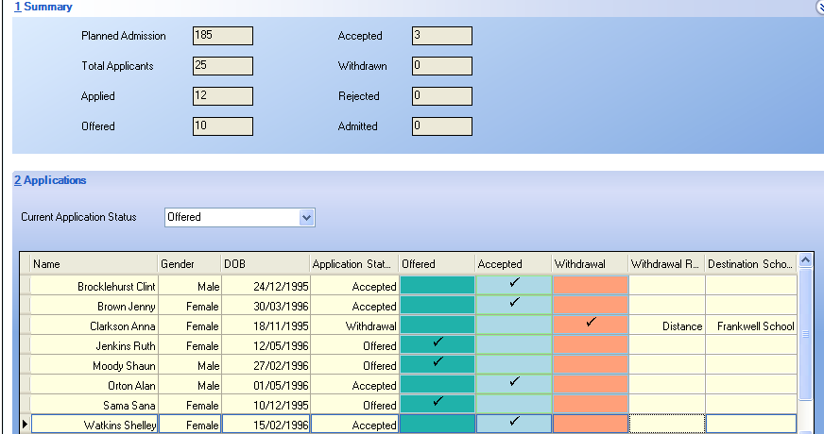
All the applicants who have been allocated to this intake group are displayed in the Applications panel.
- Work through the list of applications, offering places and rejecting applicants where appropriate. The figures in the Summary panel are updated each time the information is saved.
- For each applicant who is marked as withdrawn, a Withdrawal Reason should be selected from the drop-down list to indicate why the applicant will not be attending your school.
- Click the Destination School cell then click the Browse button to display the Schools Browse dialog.
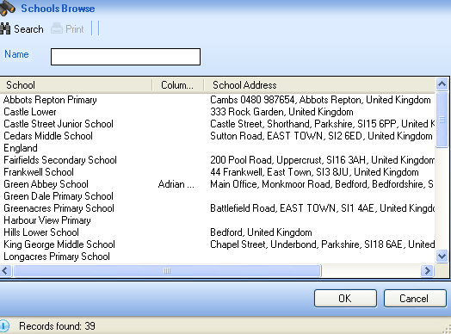
- Enter the required school Name then click the Search button to display a list of schools that match the search criteria entered.
- Highlight the required school then click the OK button to return to the Accept/Decline Applications page.
- Click the Save button to save the changes.

Admitting Applications
It is possible to admit applicants only when a place has been offered and the place has been accepted. Applicants should be admitted only when you are certain that they will be attending your school.
- Select Routines | Admission | Admit Applications to display the Find Intake Group browser.

- Enter all or part of the intake group Name or select the appropriate options from the drop-down lists then click the Search button to display all intake groups that match the search criteria entered. Alternatively, click the Search button without entering or selecting search criteria to display all intake groups.
- Highlight the required intake group then click the Open button to display the Admit Applicant Detail page.
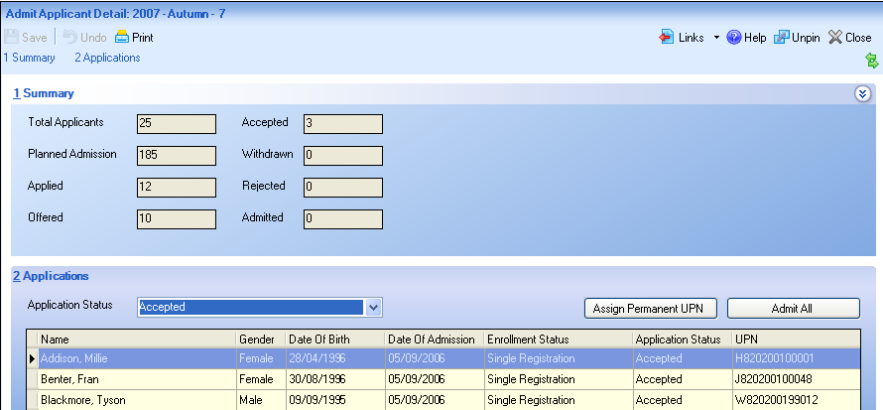
The Summary panel displays the current statistical information relating to the selected intake group.
Total Applicants – indicates the number of applications that have already been received and provisionally assigned to this intake group.
Planned Admission – indicates the original number of applications intended for this group (the PAN).
Applied – indicates the number of applicants who have already applied for a place in this intake group.
Offered – indicates the total number of places within this intake group that have already been offered to applicants.
Accepted – indicates the number of applicants who have accepted their offered place.
Withdrawn – indicates the number of applications that have been withdrawn from this intake group.
Rejected – indicates the number of applicants who have been rejected from this intake group.
Admitted – indicates the number of applicants who have already been admitted from this intake group.
Clicking the chevron button minimises the Summary panel, enabling more space on the screen for the Applications grid.
The Applications panel enables you to change the Application Status of the applications displayed in the grid. Select the required status from the drop-down list to change the selection of applications displayed.
The grid displays the applications, together with the applicant Name, Gender, Date Of Birth, Date of Admission, Enrolment Status, their current Application Status and their UPN.
The Assign UPN column can be edited. If an applicant does not have an existing UPN, click this cell, select the appropriate action from the drop-down list then click the Save button. Alternatively, click the Assign Permanent UPN button to assign UPNs to all the applicants in the grid. Permanent UPNs are issued to applicants only when it is believed that they have never been allocated a UPN, or to replace a temporary UPN.
There are several additional columns, including Admitted, Withdrawal, Withdrawal Reason and Destination School. The last two columns are available only if the Record Withdrawal Information check box is selected on the Setup Details page (via Tools | Admissions | Defaults).
Work through the list of applications, marking each applicant appropriately by clicking the relevant cell. Clicking the Admit All button selects the Admitted cell for each applicant in the Applications grid.
Any changes to an applicant’s current Application Status are updated when the record is saved. The figures in the Summary panel are updated each time the information is saved.
- Click the Save button to save the details and update the information in the Summary panel.

Re-admitting Pupil/Students
It is sometimes necessary to re-admit pupil/students because they have left, they have joined the school mid-term or they have disappeared from view because their Date of Admission was a date in the future.
- Select Focus | Pupil (or Student) | Pupil (or Student) Details to display the Find Student browser.
- Click the New button to display the Add Pupil (or Student) page. Enter any known details of the required pupil/student in the Basic Details panel to facilitate the search.
- Click the Continue button to display the Matched People panel, which displays all the people who match the search criteria entered.
- Highlight the required pupil/student then click the Open button to display the following warning message.
The selected pupil/student is a Leaver, do you want to re-admit the pupil/student?
- Click the Yes button if you are certain that this is the pupil/student who should be re-admitted to display the pupil/student’s details on the Pupil (or Student) Details page.
- Click the Save button to highlight the mandatory fields that must be completed before you can save the details. These include the Registration Group, Year Group, Year Taught In, Enrolment Status and Admission Date fields.
- Click the Save button when all the required information has been entered.

