Key Stage 1 & 2 Acceptable
Entries 2019

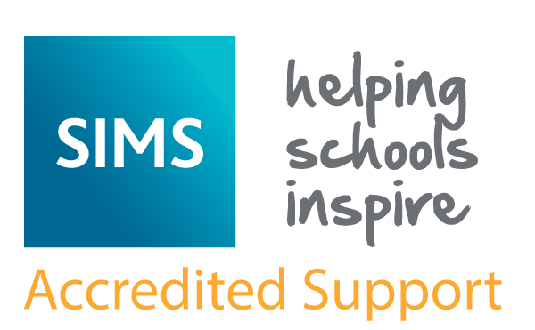

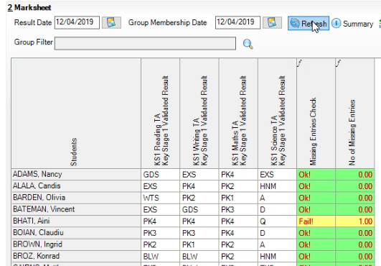
KS1 - ACCEPTABLE ENTRIES

Column Headers show what each column contains and what data should be entered.

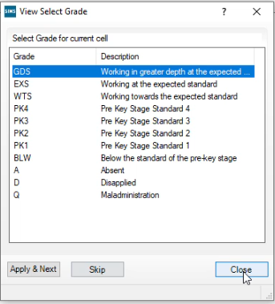
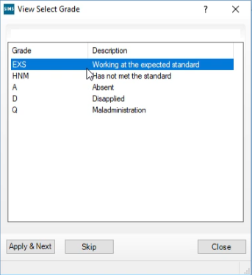
Reading, Writing & Maths Science

Permissible P Scale Entry Grades

Speaking | P4, NOTSEN | Number | P4, NOTSEN
Listening | P4, NOTSEN | Using& Applying | P4, NOTSEN
Reading | P4, NOTSEN | S, S & M | P4, NOTSEN
Writing | P4, NOTSEN | Maths | P3ii, P3i, P2ii, P2i, P1ii, P1i, NOTSEN
English | P3ii, P3i, P2ii, P2i, P1ii, P1i, NOTSEN | Science | P4, P3ii, P3i, P2ii, P2i, P1ii, P1i, NOTSEN

KS2 - ACCEPTABLE ENTRIES

Reading & Maths Writing
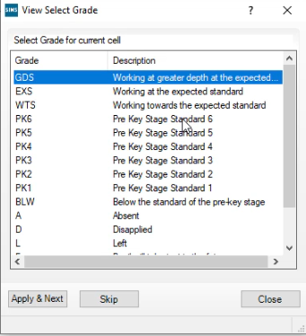
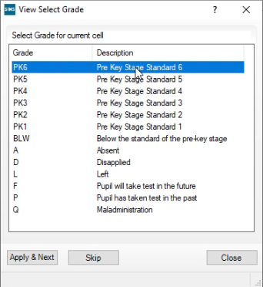

Science

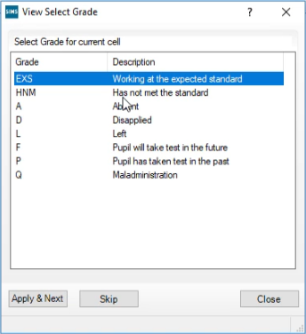

Reminder - P SCALE ACCEPTABLE ENTRIES

P4, NOTSEN (For children with English as an additional language) | For assessing, Reading, Writing, Speaking, Listening, Number, Use Maths and Shape, Maths
P3ii, P3i, P2ii, P2i, P1ii, P1i, NOTSEN | For assessing English and Maths
P4, P3ii, P3i, P2ii, P2i, P1ii, P1i, NOTSEN | For assessing Science
P1i – P3ii are applicable to children in Special Schools only; children in mainstream schools would be assessed against P4

KS2 C. Test Outcomes 2019
The Key Stage 2 Test Outcomes are detailed in the following table.
