FMS Academy End of Year
August 2021

Document Ref: | PE – FMSEOY-Acad | Version: | 1.0
Document Author: | Elaine Smith | Valid from: | 30.6.21

Contact: | Pennine Education Ltd | e-Mail:esmith@pennineeducation.co.uk

INDEX

- Introduction………………………………………………………. 3

- Updating the Chart of Accounts……………………………….. 4

- Creating the New Financial Year……………………………… 7

- Year End System Checks……………………………………….12

- Processing Outstanding Transactions…………………… ….14

- Recommended Reports………………………………………….21

- Budget Management in the New Year………………………….22

- Academies Budget Forecast Report…………………………… 25

- Actions Required on 1st September 2021………………………26

- Preliminary Closure………………………………………………27

- The New Year……………………………………………………..32

- Final Close………………………………………………………..33

- Appendix A: Functions permitted after Preliminary Close….37

- Appendix B: Checklist for Year End Closure…………………39

- INTRODUCTION

These notes are to assist the financial Staff in Academies with the smooth closure of accounts.
It is essential before undertaking any year end processes in FMS as an Academy you have read and understood all the necessary guidance from the Department for Education (DfE) and you’re Accountants/Auditors.

Each Academy may have different accounting policies so no specific advice will be given on accounting practices. Any accounting assumptions in these notes are purely for the notes only. If you are in any doubt of your own academy policies please seek advice.

Preparing for Year End

Prior to the year end there are a number of areas that will need considering in order to assist with the smooth closure of the accounts. These include:

- Modifying the chart of accounts
- Creating the New Financial Year in FMS
- Transaction processing
- Bank Reconciliation
- Year End Reports
- Retained Earnings
- Preliminary Close Down
- Year End Adjustments
- Final Closure of the accounts.

Checks can be undertaken in these areas prior to Period 12, to give time to chase up outstanding invoices and payments and so ensure that the least number of transactions are outstanding at year end.

- Updating the Chart of Accounts

You are reminded that any new cost centres and ledgers codes required for the Academy FMS structure should be added in the earliest year open on your system
You can add new cost centres and ledger codes through the following route:
Tools\General Ledger Setup

Add any new Cost Centres as required – Tab 2: cost centres
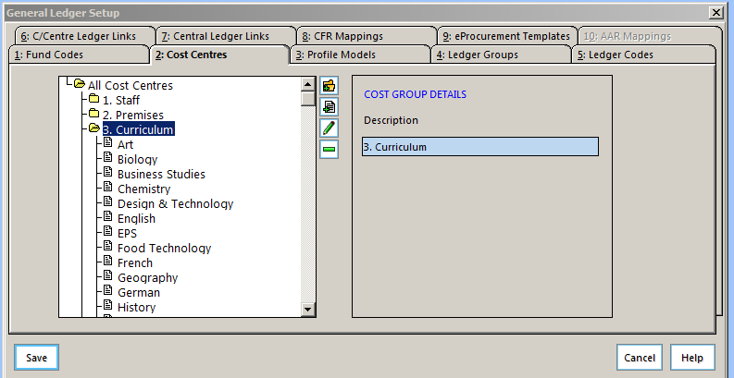
Please ensure you add a cost centre whilst the group is highlighted
Add any new Ledger Codes required – Tab 5: ledger codes
Add any new cost centre/ledger links – Tab 6: C/Centre Ledger Links.

You can also delete cost centres and ledger codes by following the procedure below:
Cost Centre:
- Unlink any ledger codes
- Ensure the cost centre is not used in any User Defined Report
- Ensure the cost centre is not used in any Service Term Mapping
- Ensure that the Cost Centre has no budget allocation against it
Ledger Code:
- Un-map the ledger code in the CFR mapping screen - if applicable
- Unlink the ledger code from any cost centre
- Ensure the ledger code is not used in any User Defined Report
- Ensure the ledger code is not used in any Service Term Mapping
- Ensure the ledger code has no budget allocation against it

If you are unable to delete a cost centre or ledger code check the following:
- Ensure that the cost centre or ledger code has not been used in the last 12 months
- Ensure that no budget is allocated to the cost centre/ledger code
- Ensure that the cost centre/ledger link is removed so nothing can be posted in error in the next year
- If unable to delete the link it can be hidden by changing the view to “In use” and then flagging the link and clicking on Hide tagged link
- Try again once the current financial year has been finalised

Income codes
It is advisable to check the funding allocations for your academy. Sometimes new income codes are required to reflect these funding streams. Funding streams can be found in the guidance notes produced by the ESFA:
https://www.gov.uk/guidance/academies-funding-allocations
If a new income code is required you should follow:
Tools/General Ledger setup/click on Tab 5 Ledger codes
- Click the + icon to add the new code via the ledger code definition wizard.
- Select Income from the Ledger Type- Next
- Select the appropriate Ledger Group- Next
- Select the appropriate Fund- Next
- Type in the code you are adding
- Type in the description of the code – Next- The ledger code definition screen will then come to screen
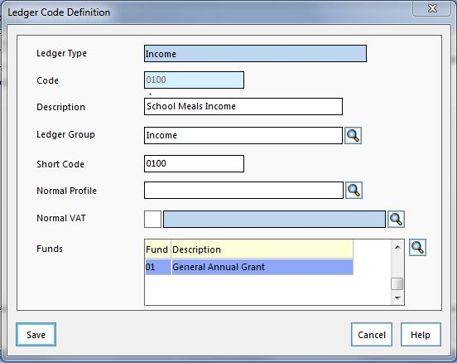
- Select the normal profile and the appropriate Vat code
- Click the save button
The ledger code will then need to be linked to a cost centre in Tab 6 Cost Centre /Ledger Code Links
- Click the + icon
- The next screen will display all the cost centres in the top left of the screen and all the ledger codes in the bottom left of the screen
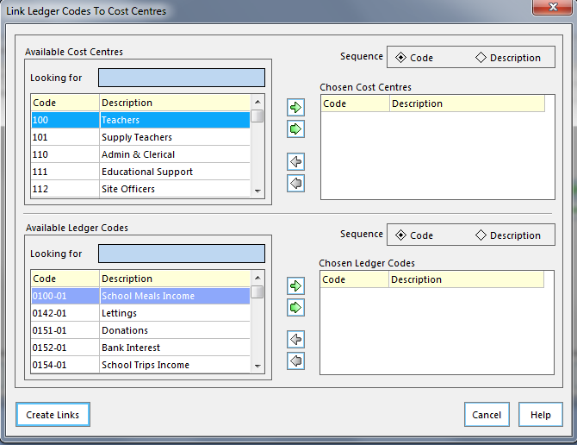

- Choose the required cost centre by double clicking on it. The cost centre will then appear in the Chosen Cost Centre panel
- Choose the required ledger code by double clicking on it. The ledger code should then appear in the Chosen Ledger Code panel
- Click the create links button- a message will appear stating how many links have been created and how many already exist
- Click Save

The New Financial Year

A new financial year can be created at any time (but not necessarily opened).
When the new financial year is created, it is based upon the old year’s structure. Opening the new financial year will allow you to run the Year End System Checks Report. This report gives a list of items that must be resolved before closing the year.
Only two financial years can be open at any given time.
Changes to funds, ledger codes, cost centres and ledger code/cost centre links can be made in the new financial year, however, it is recommended that these are added to the earliest year open.
Any funds, ledger codes or cost centres no longer required can only be deleted in the new financial year, after the old year has a Status of Finalised and prior to the creation of any future financial years.

Creating the New Financial Year

Process for Creating the New Financial Year:

Before you create the financial year you must ensure that a full system back up has been done and a note of the file name is kept.

Back up For FMS
Select Tools / FMS Transaction Backup /Click yes and once finished make a note of the file name.

Back up For Sims
In Sims go to Focus / System Manager / System Manager 6

Close the Welcome Screen

Navigate to Tools/Create backup

In the backup description box type in a suitable narrative e.g. Creation Year

Select Tools\Define Financial Years\Define Edit Years to display the Define Years screen:

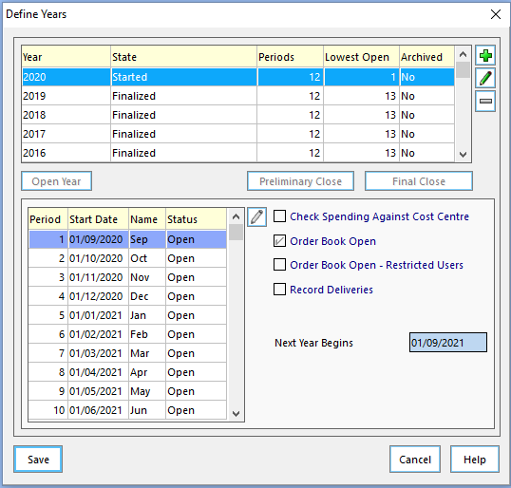

Add the New Financial Year by clicking on the + button at the right hand side of the screen.

The screen on the following page will be displayed:
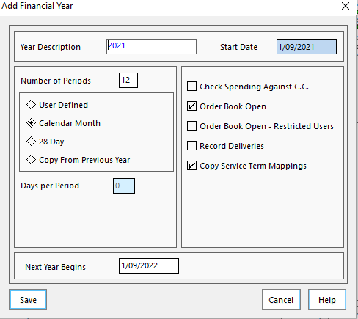

Input the following information:

- Year Description: 2021 or 2021/22 – Ensure the start date is 1/9/2021
- Number of Periods: 12
- Select the Calendar Month radio button
- Next Year Begins: 01/09/2022
You have the choice of:
- Check Spending Against C.C – deselect until the budget has been input
- Order Book Open – Deselect until 1st September
- Record Deliveries – cannot change back until the next financial year is added
- Copy Service Term Mappings.- Only one chance to select this so ensure tick is in the box
- Copy Fixed Assets Cost Centre if you use the Asset Management software.
- Click the Save button
You should wait a few seconds while it copies the structure.

The Define Year screen will now show the New Year with the status of Not Started.

Defining the Vat Year

You must also ensure that in your new year you have defined periods for the VAT.
- Tools \ Define VAT Periods.
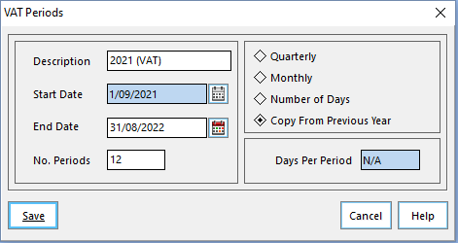

Defining the Salary Periods – only required for Academies that integrate the Sims Contracts into FMS
For Academies that take the contracts from Sims.net into FMS to commit the salaries you should also remember to Define the Salary periods through
- Tools/Define Financial Years/Define Salary periods. Click on the plus and select 2021 year from the magnifying button.
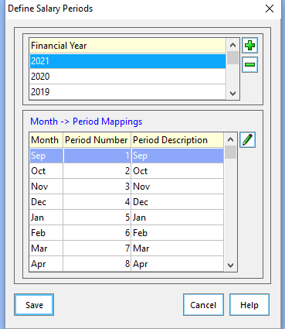

NOTE: The structure of your accounts will be as per the date you created the New Year. If, for any reason, you need to alter this in the old year, you will need to mirror this in the New Year also – this does not automatically happen.
To do this select: Tools \ Define Financial Years \ Update Next Year’s Structures. Select Tab 1 (Ledger Codes), Tab 2 (Cost Centres) and Tab 3 (Groups/Templates) in turn and then tag the codes you want to copy to the New Year. Then click the Copy Tagged button.
You will also need to select this option to ensure that any paying in books or products created since the New Year was created are also copied across.

You should also be aware that changes to the structure will affect any User Defined Reports and standard templates you have, so these will need amending to bring them into line with your new cost centres/ledger codes etc. A useful report to check this is the Chart of Accounts Listing Report. To display the report select Reports \ General Ledger Setup \ Chart of Accounts Listing.

- Year End System Checks

Select Reports \ Year End \ System Checks.
When running the report for the first time please leave transferable transactions unticked.
This report gives a list of items that must be resolved before closing the year.
Whilst some of the transactions will actually prevent a year being closed there may be other items which will require additional actions before the year end can be processed. Additional reports will be needed to review each area of FMS.
Transactions that will prevent a year end close must be processed, that is, deleted, cancelled, posted or authorised before the year can be closed.

Transaction Type | Status on Report | Action Before Year End
Order | Not authorised | Delete or authorise
AP Invoice (local) | Not fully authorised | Cancel or authorise
 | On Hold | Change status or cancel commitment
AP Invoice (central) | Not fully authorised | Authorise and print authorisation slip or cancel
 | Authorisation slip not printed | Print authorisation slip or cancel
 | Invoice on hold | Change status, cancel invoice. (Transferable if authorisation slip is printed)
Credit Notes | Not authorised | Cancel or authorise
Non-Invoiced Income | Created | Delete or post
AR (Invoiced Income) | Created or authorised | Authorise and print, print or cancel
Petty Cash | Unposted | Delete or post
All Journals | Unposted | Delete or post

At the end of the report, further reasons may be given as to why it is not possible to run preliminary/final close, e.g. ledger codes have been added since the new financial year was defined.

Once the items have been investigated and cleared please run the report again with the transferable transactions ticked. Note the symbols as below:
- Transactions marked with a T may be transferred and require processing in the new financial year
- Transactions marked TS may be transferred as supporting items e.g. the order supporting an invoice.

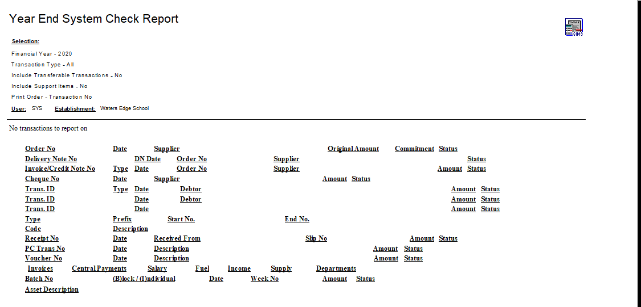

- Processing Outstanding Transactions

Before a financial year can be closed all transactions that are outstanding will need to be investigated. The following areas will need to be included in this investigation:

- Orders and Commitments
- Invoices (Accounts Payable)
- Petty Cash
- Non-Invoiced Income
- Salary Commitment – Personnel Links
- Cheque Processing
- Accounts Receivable Invoices – Invoiced Income
- Reconciliation – Bank
- VAT Claims

Orders and Commitments:

Before the financial year can be closed all orders have to be in the correct state:

Status of Order | Outcome | Action Required
Authorised, Printed or Partially invoiced | Will transfer on prelim close | None
Fully Invoiced | May be transferred in support of invoice, payment or reconciliation | None
Not Yet Authorised | Prelim close will fail | Delete or Authorise
On Hold | Prelim close will fail | Remove On hold, Delete or Authorise

As part of the monthly procedures Academies should be adopting a creditor control procedure and as a result the year end list of orders outstanding should be less onerous to investigate.
To assist with ascertaining the creditors figure print off the following reports at year end
- Reports \ Accounts Payable \ Purchase Order Reports \ Purchase Order. Select the Outstanding Orders button then click the OK button to print.
You should investigate orders that are showing on this list to ensure that the items are still outstanding and that the items will be delivered. It may be worth annotating this report as evidence and asking the Headteacher, or suitably authorised person, to sign the report.
This report should be kept as part of the Year End File.
Outstanding orders should be dealt with as per the table above.
This report is also helpful when budgeting for the new financial year. Your policy may be to cover the cost of the outstanding commitments from the old year by increasing the cost centre budget allocation in the New Year.
Schools who have orders that remain undelivered can remain outstanding and will be transferred once the first Preliminary close has been completed.
Prior to cancelling any orders, you may wish to print off a Cost Centre Commitment Report to find out what commitments are against each cost centre.
- Cost Centre Commitment Report:
- This is through the route Reports \ Accounts Payable \ Purchase Order Reports \ Cost Centre Commitments. Click Summary Report and then click the OK button to print. Choose the detailed line report.
It may be worth annotating this report as evidence and asking the Headteacher, or suitably authorised, person to sign the report.
This report should be kept as part of the Year End File.

Cancelling an Order:
If you need to cancel an outstanding order you will need to:
Select Focus \ Accounts Payable \ Purchase Order
Change the View field from All to Outstanding and click the Select button.
A list of unauthorised and outstanding orders will appear.

Clicking the Cancel Outstanding Orders button at the top right of the screen you can cancel any outstanding orders you no longer need. It may be worth viewing each order individually before cancelling.
Cancel Outstanding Orders button
The same button will also clear any remaining commitment if the order is Partly Invoiced.
If you have any unauthorised orders that need cancelling you would delete them by clicking the Minus button at the top of the page.
Minus button

Invoices (Accounts Payable)
There will be suppliers’ invoices and credit notes at various stages of processing.
- Suppliers’ invoices or credit notes that have been entered to be paid but not yet authorised should be authorised or cancelled
The following table illustrates the status of the invoice and the outcome and action required at year end
Status of Invoice | Outcome | Action Required
Fully Authorised | Will transfer on prelim close | None
Paid | May be transferred in support of invoice, payment or reconciliation | None
Unauthorised | Prelim close will fail | Cancel or Authorise
On Hold | Prelim close will fail | Remove On hold, Cancel or Authorise

Authorisation of Invoices:
You need to find out if you have any unauthorised invoices.
- Select Focus \ Accounts Payable \ Invoice/Credit Note
- Change the Status field from All to Unauthorised
A list of any unauthorised invoices will appear

You should authorise these invoices by clicking the Authorise Invoice button at the top right of the screen or cancel by clicking the Cancel Invoice button next to it. These cancelled invoices and orders may need to be raised in the new Financial Year
Authorise Invoice button
Cancel Invoice button
Remember that any orders attached to invoices you may have cancelled will then be released back into the system and may also need to be cancelled.
Credit notes will be transferred on prelim close.

Petty Cash
All petty cash transactions must be posted. In addition the cash in hand figure on the system should match the actual value of the petty cash held in the school petty cash tin.
A report showing the cash in hand figure should be retained, with a breakdown of the cash held as evidence of the year end balance and signed by the Headteacher or a suitably authorised person within the Academy.
This report should be kept as part of the Year End File.
A preliminary year end will fail if there are any unposted petty cash transactions.
Please be aware that you cannot post petty cash after 31st August. - The system will allow you to create the petty cash transaction but it will take the system date.

Journals:
All journals must be posted or deleted. A preliminary year end will fail if there are any unposted journals. There are a number of different types of journals, which may be awaiting posting or might have to be deleted:
- Normal Journals
- Reversing Journals
- Cash book Journals
- VAT Reimbursement Journals
To check for any unposted journals:
- Select Focus \ General Ledger \ Manual Journal Processing
If you have any unposted or incomplete journals they will be visible as shown in the following image. Note that there is a U for unposted in the Status column.
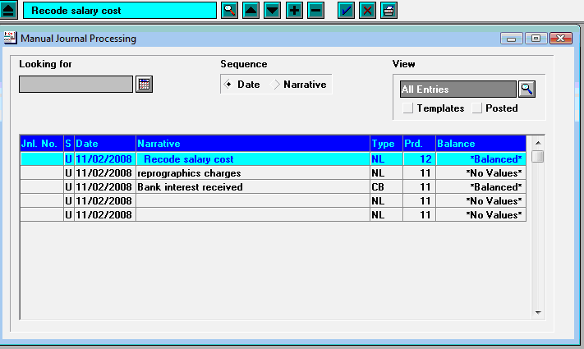
This is an unposted journal
You should decide what you wish to do with this journal.
If you wish to delete the journal, you would click the Minus button at the top of the screen.
If you wish to post the journal, you should click the Post Journal button at the top right of the screen.
Post Journal button
Journal templates you have created in the current year will be automatically copied forward to use in the New Year when it is created.

Non Invoiced Income:
Any Non-Invoiced income received should be paid into the bank account via a paying in slip posted by 31st August
Do not leave any receipts unattached to a paying in slip.
All paying in slips must have a status of posted.
NOTE: Any income posted after this date, even if you change the date, will be posted into the new financial year

Salary Commitment - Personnel Links:
If you use personnel links, you will have to clear any outstanding salary commitments within FMS. You would do this once all salary payments have been completed.
To clear any outstanding salary commitments.

- Select Focus \ Personnel Links \ Salary Projection.
- Click the Clear Commitment button at the top right of the screen.
Clear commitment button
Check each month for any outstanding commitments by clicking into the Commitments for Period field. If you have any outstanding commitments you should click the Tag All and Clear Commitments buttons for each period.

Cheque Processing:
It is recommended to pay any cheques due for payment by selecting Focus \ Accounts Payable \ Cheque Processing and completing a cheque run before 31st August

Cancelling Unwanted Cheques:

Please do not cancel cheques after 31st August until after the year has been finalised.

It may be necessary to cancel cheques that are no longer required, perhaps because of a dispute with a supplier, an alternative method of payment has been found or the cheque presentation period has expired. Select Focus \ Accounts Payable \ Cheque Processing. Select the relevant cheque run or use Find Cheque number. Once the cheque has been located click the Cancel Cheque icon and confirm you wish to cancel the cheque. Remember to cancel the invoice and order if the commitment is no longer required.

BACS Payments
BACS runs and payments are not transferred from one year to the next. Therefore, it is essential that all BACS transactions are reconciled before running preliminary and final close.
If you decide to run a preliminary close within one calendar month of year end or a BACS run within the last month of the year, a warning message will be displayed advising to ensure that all BACS transactions and possible contra transactions have been reconciled to the bank statement. This does not apply to failed BACS files, as these never appear on bank statements. However, it is quite possible for a BACS file to appear on one bank statement and any contra records for BACS transactions which have failed to appear on a later statement.
Once a preliminary close has been run for the previous financial year, staff will only be able to view BACS payments. No further processing for the year may take place.
Ensure that all BACS transactions have been reconciled, as outstanding BACS files will not be transferred to the New Year.

Accounts Receivable Invoices – Invoiced Income
You can issue accounts receivable invoices right up to the date of the 31st August for the financial year. After this date, you should be producing the AR invoices in the new financial year.
All AR invoices must be authorised and printed before 31st August.

Currently only the paying in books are transferred at Year End by selecting the FMS Module, select Tools \ Define Financial Years \ Update Next Year’s Structures and clicking Tab 4: Invoiced Income. All other books are visible in all financial years, so they do not need to be transferred at Year End
- As there are strict rules concerning invoice, receipt, pay in, period and tax point dates, the System Check Report in FMS must be run before 1st September or whenever the new financial year starts. This will allow you to identify any invoices, credit notes, receipts and pay in slips which require printing and posting
NOTE: These must be printed and posted before attempting to close the financial year, as preliminary close will fail if any created items that have not yet been posted are found.
- When the old year is closed, either through preliminary or final closure, accounts receivable invoices are not transferred into the New Year. This does not mean, however, that they are not available when entering a receipt for payment received in the new financial year. A list of all outstanding invoices and receipts is available for matching to payments.
NOTE: If a credit note or write-off is required for an AR Invoice in the new financial year the AR Invoice will need to be transferred into the New Year. This is achieved by changing back to the appropriate year in FMS. Then enter the Accounts Receivable Module. Locate the invoice in question, highlight and click the Write-Off button. This will present you with a message asking if you want to copy the invoice into the next financial year. Clicking the Yes button will move the invoice into the next year. The invoice can then be dealt with in the normal way in the New Year.

Debtor Review
We recommend that you review the Aged Debtor Report as part of the month end procedures making the year end task less onerous, any debts that you consider unrecoverable should be written off within the financial year after being reported to and approved by the governors.
We would recommend that the Aged Debtor Report is annotated and signed by the Headteacher or a suitably authorised person in the Academy.
This report should be kept as part of the Year End File.

Reconciliation - Bank
All bank reconciliations should be completed to the actual statement dated 31st August or as soon after the date as possible and the actual bank statement balance should match the statement balance within the Bank Reconciliation screen in FMS.
We would recommend the Headteacher signs the actual bank statement from the Bank and the reconciled statement from FMS as evidence that the balances match

A bank statement that extends into the new financial year should be ruled off at the 31 August and any September transactions reconciled in the new financial year immediately following a preliminary close.
FMS will automatically carry forward all unreconciled items in the bank account on the first preliminary year end.
This is a good time to check for any out of date cheques.
Run off an unreconciled transaction listing and cancel any cheques that are over six months old. If the date has passed 31st August please wait until after the Year has been finalised.
To do this, run the Unreconciled Transaction Listing Report by selecting
- Reports \ General Ledger \ Bank \ Unreconciled Transaction Listing. Select the bank account but leave the From and To Dates blank.

VAT Claims

It will be necessary to ensure that the final Vat report has been produced for the financial year.

The earliest date that this final Vat report can be run is the 1st September.

The appropriate Vat report will need to be run whether the Academy is Vat registered or not.

- Recommended Reports

The following is a list of the many reports that are available in FMS. These reports can be run to assist with the year-end process.
It is essential to be aware of the requirements of the ESFA and with this in mind we would recommend you discuss the reports required with your Accountant/Auditor.
This list is not exhaustive and if your accountant requires other reports from FMS these should be run.
All reports should be kept as part of the Year End file.
If any adjustments are made which effect these reports they should be run again, signed by an authorised signatory and retained as part of the Year End File.

- Cost Centre Summary Report: Select Reports \ General Ledger \ Transactions \ Cost Centre Summary Transactions \ Cost Centre Summary by Cost Centre – will show commitments to be carried into the new financial year
- Payroll Control Account: Select Reports | General Ledger | Trial Balance | Ledger Code Balances – select Period 13 and Payroll Ledger Code-
will show transactions due to be processed after 1 September 2021
- Chart of Account Review: Select Focus \ General Ledger \ Chart of Accounts Review select Ledger Codes, click Ledger Group and select VAT Review VAT Codes to ensure the actual figure agrees to the final VAT claim. Chart of accounts can check total balances or individual transactions on any ledger code or cost centre
- Unreconciled Bank Transactions: Select Reports \ General Ledger \ Bank \ Unreconciled Transactions Listing select the bank account and leave the From and To boxes empty. This report would have been printed as part of your reports for the March bank statement reconciliation
- Aged Creditor Report: Select Reports \ Accounts Payable \ Supplier Analysis \ Aged Creditor will provide a list of creditors (the school owes money to) – fully funded only
- Aged Debtor Report: Select Focus \ Accounts Receivable then Reports \ Aged Debtor – leave debtor blank to obtain a list of all monies owed to the school
- Year End Transferred Transactions: Select Reports \ Year End \ Transferred Transactions select both transferable transactions and support items.

Budget Management in the New Year

Once the budget for the New Year has been agreed this can be entered into FMS.
The budget can be entered manually into FMS whilst the New Financial Year has a status of “not started”.
For schools that use the HCSS software to import the budget please see the appropriate documentation with these packages.
Associated with the New Year is the requirement by the ESFA to produce an Academies Budget Forecast 2021/22 by 31st July 2021. Academies can do this manually, ask their Accountants to complete this or import the user defined report provided by Capita.

Manual Entry of Budget:

Cost Centre Allocations

- Select Focus \ Budget Management \ Cost Centre Allocation to be presented with the Cost Centre Allocation Details screen.
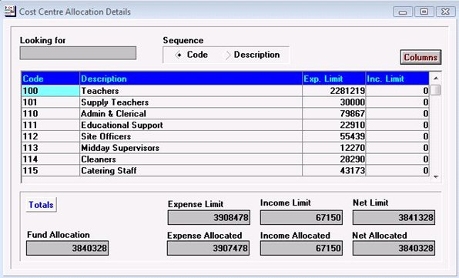
- Double clicking each of the Cost Centre in turn which shows a list of ledger codes attached to this cost centre.
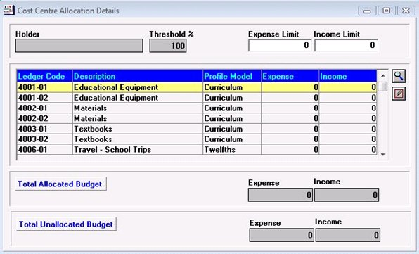
The budget to be allocated to this cost centre should then be split across the relevant ledger codes. Double click a ledger code to display the Budget Details screen.
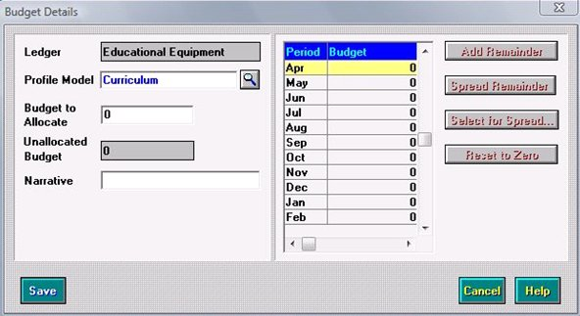
- Enter an amount in the Budget to Allocate. If a Profile Model is provided then this will be split across the periods appropriately.
- Enter the narrative as Initial Budget 2021/22.
- Clicking the Save button may present you with the following screen indicating that the budget limit will be increased or decreased automatically. Click the Yes button.

- When all of the budget has been split across the ledger codes, click the Blue Tick button to save, then click the Save button. To return to the list of cost centres click the Focus Mode button. Continue to allocate the budget across the cost centres.
- Run the Annual budget listing report to check all the entries are accurate through:
Reports/Budget Maintenance/Annual budget profile.
This report can be signed by an authorised signatory and kept with the original budget approved and signed by the Governing Body.
- Once the initial budget has been agreed by the governors and entered into FMS it may be fixed. Before fixing the budget a Full system back up should be taken. This takes a snap shot of the budget and will be referred to as the Original Budget in certain reports. This process is not reversible. However, cost centre allocations can still be made once this has been done and will appear under the Current Budget in some reports.

Academies Budget Forecast Report – Applicable to schools who use this report

Chapter Introduction
We understand that the submission of this return is now open and is due by 27th July 2021
Please see the information available from the ESFA by clicking on the link below:

https://www.gov.uk/guidance/academies-budget-forecast-return

“Academies budget forecast return outturn (BFRO)
This form collects financial outturn information as at the end of March each year. ESFA uses the information provided to ensure that the academy sector can accurately report its financial data to HM Treasury.

Further Information:
The ESFA have created a new set of ledger codes for Academies to use for reporting purposes.

As schools within different Local Authorities use different ledger codes, a mapping facility has been made available in FMS by Capita in the latest upgrade to allow schools to map their ledger codes now referred to as Internal codes to the codes used by the ESFA now referred to as External codes.

This is similar to the CFR mappings.

Once the upgrade has been carried out all Academies using FMS will need to go through a process of mapping their internal ledger codes to the new external ESFA codes

To assist Academies using FMS with this process Pennine Education has uploaded some instructions to the website www.pennineeducstion.co.uk under the documentation tab with the password Summer2021

Actions required on 1st September 2021
When the year end actually arrives, there are a number of procedures to be carried out. The first is to switch off orders in the old year. The new financial year should then be opened and the ordering process activated.

Ordering – Old Year
Switch the ordering off in the old year by selecting Tools \ Define Financial Years \ Define \ Edit Years. Double-click the old year and switch ordering off by deselecting the Order Book Open check box. This can be done at any time leading up to year end.

Ordering – New Year
Switch the ordering on in the new year by selecting Tools \ Define Financial Years \ Define \ Edit Years. Double-click the New Year and activate ordering by selecting the Order Book Open check box.

- Preliminary Closure

PLEASE DO NOT UNDERTAKE THE PRELIMINARY CLOSE UNTIL:

- RETAINED EARNINGS IS SWITCHED ON IN SCHOOL DETAILS
- YOU HAVE A FULL SYSTEM BACKUP (See page 7 for instructions how to do a backup)
- YOU HAVE RECEIVED CONFIRMATION FROM YOUR ACCOUNTANT AFTER YOU HAVE PROVIDED A SUMMERY TRIAL BALANCE REPORT.
- BACS -ALL PREVIOUS YEARS BACS TRANSACTIONS HAVE BEEN RECONCILED

To complete the preliminary close it is necessary that the Year End system check report is run and shows no issues remain.
To run this report:
Reports\Year End\System check report
It is recommended to check that the Retained Earnings ledger code is activated for the collection of your year end balances. This can be checked in:
- Tools\Establishment details\Tab 3 system parameters. A tick should show in the Retained Earnings panel at the bottom right of the screen.
If you do not close periods every month, this first preliminary year end will automatically close all the periods and automatically create a Period 13. You can run the preliminary closure as often as you like.
After this first preliminary no further financial transactions can take place in the old year except for additional end of year journals provided by your Accountant, to make adjustments.
NB. Any Vat adjustments must be done in period 12 as period 13 does not allow Vat adjustments.
NOTE: Bank reconciliation cannot be undertaken in the old year after the first preliminary close, as all unreconciled transactions and bank balances are automatically carried forward at this time. Therefore, it is very important that the bank balance reconciles to the actual bank statement at this point.
You cannot attempt to run a preliminary year end until at least the 1st September 2021
NOTE: Once you have completed the bank reconciliation, submitted the final Vat report and confirmed the trial balance report is correct with your Accountant you can perform the first Preliminary Close as follows:
- Select Tools \ Define Financial Years \ Define/Edit Years.
- Highlight the Year 2020 or 2020/21 and click the Preliminary Close button.

The following table will appear:
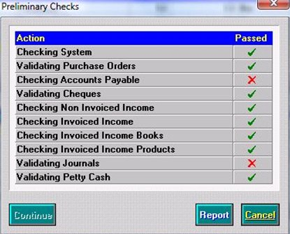
- If you have a red cross in any of the boxes you can click the Report button and it will print a report to tell you why this part of the preliminary has failed or click the Cancel button to exit. You will not have the option to continue if you have any failed areas.
- You would then make adjustments, by revisiting the areas that have failed, and start the preliminary Year End procedures again.
Should you wish to run a preliminary year end again.
- Select Tools \ Define Financial Years \ Define/Edit Years.
- Highlight the Year 2020 or 2020/21 and click the Preliminary Close button.
- Once you have all green ticks (as shown in the following graphic) you can click the Continue button.
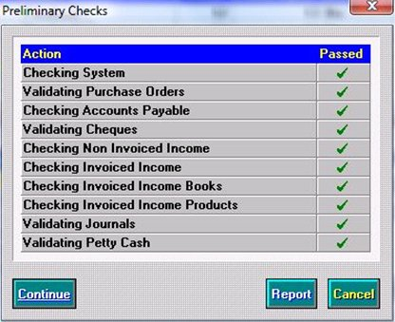
You will then reach the Select Transfer Mode screen as shown in the following graphic.
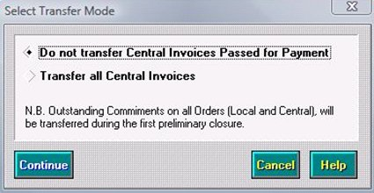
- Select the Do Not Transfer all Central Invoices radio button, and then click continue to display the Preliminary Close Screen, as shown in the image below:
- Click the Continue button and the Preliminary Close screen will be displayed:
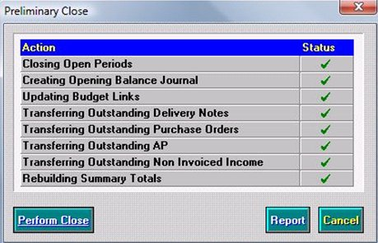
- Again you should obtain green ticks against each process. If a red cross appears, it means that the business rules for the process have not been achieved. You will need to revisit these areas and make the appropriate adjustments. You will not have the option to perform close if you have any red crosses. You would click the Cancel button to exit or click the Report button to find out the reasons for failure.
- However, once you have all green ticks you should click the Perform Close button. Please note Rebuilding Summary Totals can take several minutes to complete.
- Click the Yes button in response to the following prompt:
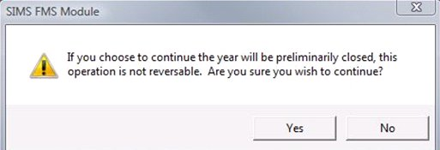
The year will then be preliminary closed and it will say Closed – Not Finalised.

After the Preliminary Year End
After the preliminary closure has been run, FMS moves into Period 13. It may still be necessary to make adjustments to the accounts in the old year. Functions permitted in the previous financial year after preliminary close are listed in Appendix A.
Your Accountant may then forward a request for you to input some End of Year journals into the Financial Year 2020 which should be created through:
- Focus/General Ledger/Manual Journal Processing.
- Click on the + button to add the journal
- The following screen will appear
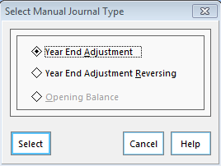
- Select the Year End Adjustment and continue to add the journal as specified by Accountant.
- Once all Year End journals have been processed forward a Summery Trial Balance to the Accountant to approve and confirm.
- Complete a second preliminary close after performing a full system back up.

Please note that any VAT adjustments must be completed in Perod 12 as the Vat codes are not available in Period 13. Please advise your Accountant that they must complete 2 journals in this respect. If the Preliminary close has alearedy taken place the Vat adjustments will have to be completed in Period 1 of the following year.

The New Year

You should check the results of the first Year End, e.g. Orders/Invoices carried forward into the New Year.
- Go into the new financial year:
- Look at the bank, petty cash and VAT balances in the new year by selecting Reports \ General Ledger \ Balances\Reserves.
- Look at the Retained Earnings Ledger Code balances transferred in Focus\General Ledger\Chart of Accounts review.
This is the under or over spend brought forward at that moment in time. You should make a note of this figure. This figure plus the transactions that occur on any End of Year Journals processed form the Financial Statements. This carried forward figure should be included in your budget spend for the next financial year or after referring to your accountant should be placed in a Balance Sheet Code.

Cross Year Symbols
Any orders or invoices transferred to the New Year will appear with cross year symbols. This helps when transactions are cancelled in the New Year, e.g. an unpresented cheque. The symbols used are as follows:

Old Year
- T - Indicates that the listed item has been transferred to the new year and requires additional processing
- TS - Indicates that a copy of the item has been transferred to the new year as a supporting item
- TR - Indicates that a transaction has been copied in support and then been cancelled.

New Year
- F - Indicates that the listed item has been transferred from the old year and requires further processing
- FS - Indicates the item has been transferred from the old year as a supporting item
- FR - Indicates a transaction has been copied from the old year in support and the item it was supporting has been cancelled. Further processing may be required.

Final Year End Closure

PLEASE DO NOT UNDERTAKE THE FINAL CLOSE UNTIL
- YOU HAVE A FULL SYSTEM BACKUP (See page 7 for instructions how to do a backup)
- YOU HAVE RECEIVED CONFIRMATION FROM YOUR ACCOUNTANT.

Once the Accountant has clarified your under or over spend and given you the go ahead to finalise the years accounts, you can run the Final Year End.
NB: Once the Final Year End is complete, no transactions at all can be put through the old year. This cannot be reversed and you can perform a final closure only once. Only reports can be printed.
Select Tools \ Define Financial Years \ Define/Edit Years.
- Highlight the Year 2020 or 2020/21 which will say Closed – Not Finalised and click the Final Close button as shown in the following graphic.
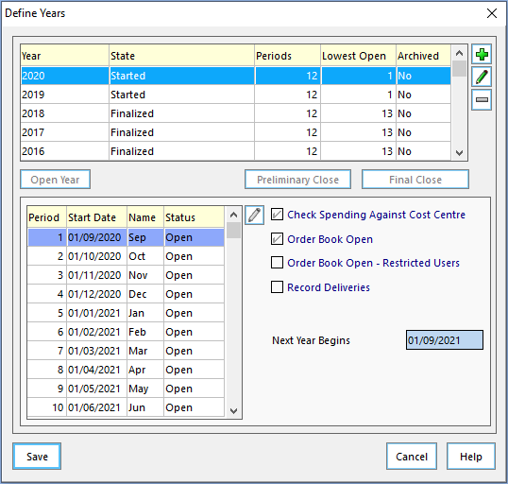
- Click the Yes button in response to the following prompt if it is displayed.
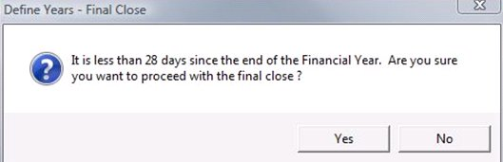
- Click the Yes button in response to the following dialog.
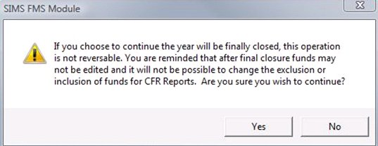

The Final Checks screen will appear with another tick list showing green ticks and red crosses.
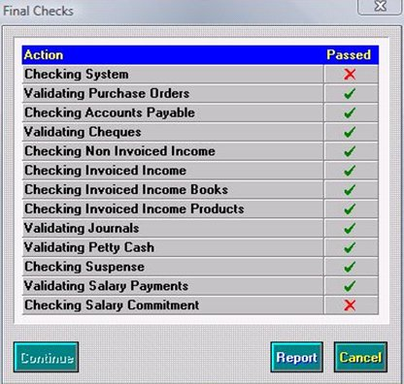
- If there are any red crosses click the Report button. This report will highlight the reasons why the system would not finalise.
Once you have made the appropriate checks, revisited the area and made the appropriate adjustments, you can run through this final Year End procedure again.
When you have achieved a full table of green ticks you should click the Continue button as shown in the following graphic.
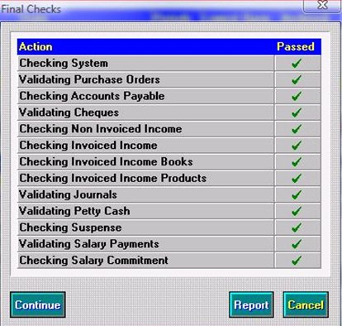
A second tick table will then appear.
- When all green ticks have been achieved you may click the Perform Close button.
- Click the Yes button in response to the following prompt.
The year will then be finalised similar to the following graphic with only the a New Year showing as Started.
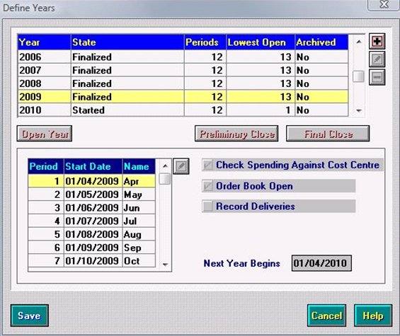
- Click the Save button to complete.

Appendix A

- Functions Permitted in Previous Financial Year After Preliminary Close

Functions Permitted in Previous Financial Year After Preliminary Close
 | Can Access | Cannot Access
General Ledger
General | Reviews and reports
Journals | Reversing journals | Any other journals
 | Closing journals
Central | Direct central payments/receipts | Fund to bank transfers
 | Centrally paid invoices which have not been transferred
 | Central income which has not been transferred
 | Define/test import files
 | Link/unlink central payment mappings
Budgets | All reports and reviews | Cash profiles
 | Increase/decrease fund allocation | Budget allocations
 |  | Profile models
Bank | View/print only
Petty Cash | View/print folios | Enter, adjust or cancel transactions
 | Access reports
Accounts Payable
Order Processing | Reviews and reports | Process orders
 |  | Authorise orders
 |  | Print orders
 |  | Print dummy orders
Invoice Processing | Reviews and reports | Process invoice/credit notes
 |  | Authorise invoices
 |  | Hold or cancel invoices
 |  | Print authorisation slips
 |  | Print cheques
 |  | Cancel cheques
Non-Invoice Income
Receipt Processing | Print authorisation slips | Enter receipts
 | Reviews and reports | Match receipts
 |  | Cancel non-invoiced income
 |  | Transfer receipts
General Ledger Setup
Define Financial Years | Preliminary and final closure | Edit closed year details
 | Update structure for new financial year | Period end (all periods are closed by the Preliminary Close Function)
Funds | Add funds and rename existing funds and LA Codes | Unlink funds from Ledger Codes
 | Link additional funds to Ledger Codes
Ledger Groups | Add new ledger groups | Delete un-used ledger groups
Cost Centres | Define new cost centres
Ledger Codes | Add new Ledger Codes
 | Edit short code and description of ledger codes
 | Alter ledger group, normal profile, normal VAT on a ledger code
Cost Centre/Ledger Links | Create new links between cost centres and ledger codes | Delete ledger code/cost centre links where actuals posted or budgets allocated
General | Print all listings | Define profile models
 | Define permissions

- Appendix B

Checklist for Year End

Action Required | Route | Page | Complete
Full System Backup | Using normal backup process | N/A
Tidy Chart of Accounts | Tools/General Ledger Setup | 4
Full System Backup | Using normal backup process | N/A
Create New Financial Year | Tools/Define Financial Year/Define Edit Years | 7
Create Vat Periods | Tools/Define Vat Periods | 10
Create Salary Periods | Tools/Define Financial Year/Define Salary Periods – if applicable | 10
Run Year End System Check Report | Reports/Year End/System Checks | 12
Clear Outstanding transactions. | Focus/Accounts Payable/Orders  Focus/Accounts Payable/Invoices  Focus/General Ledger/Petty Cash  Focus/General Ledger Manual Journal Processing  Focus/ Non Invoiced Income/Receipts  Focus/ Non Invoiced Income/Pay In  Accountants Receivable – Invoices  Accountants Receivable – Receipts  Focus/Personnel Links/Salary Projection/Clear Commitments | 14
Run Final Cheque/Bacs Run | Focus/Accountants Payable/Cheque/Bacs processing | 18
Run Final Bank Reconciliation | Focus/General Ledger/ Bank reconciliation | 20
Run final Vat Submittal | Reports/General Ledger/Vat | 20
Check Retained Earning Exists | Tools/Establishment Details/System Parameters | 27
Enter New Financial Year Budget- Fix | Focus/Budget Management/Cost Centre Allocation | 22
IN NEW YEAR AFTER 1.9.2021
Disable ordering in Old Year | Tools/Define Financial Year/Define Edit Years | 26
Enable ordering in the New Year | Tools/Define Financial Year/Define Edit Years | 26
Open Year | Tools/Define Financial Year/Define Edit Years | 26
Full System Backup | Using normal backup process | N/A
Run Year End System Check Report | Reports/Year End/System Checks | 12
Complete Prelim Close | Tools/Define Financial Year/Define Edit Years | 27
Check Balances in New Year | Focus/ General Ledger/Balance & Reserve | 32
Summery Trial Balance of Old Year to Accountants | Reports/General Ledger/Trial Balance/Summery Trial Balance/Ledger Code | 21
Complete Year End Journals In old Year | Focus/General Ledger /Manual Journal Processing | 29
Summery Trial Balance of Old Year to Accountants | Reports/General Ledger/Trial Balance/Summery Trial Balance/Ledger Code | 21
Confirmation from Accountant to Close Year | N/A | 33
Full System Backup | Using normal backup process | N/A
Close Final Year | Tools/Define Financial Year/Define Edit Years | 33
Ensure all reports are run for Year-end are signed and filed | Various | N/A

