SIMS Housekeeping Routines
Guidance Notes for Schools

SIMS Housekeeping Routines
Contents
Introduction 2
Running the Name Format Tidy 3
Updating the Mailing Point 4
Resetting Parental Ballot Flags 5
Updating Salutation/Addressee Information in Bulk 6
Updating Contact Salutation/Addressee Information in Bulk 9
Updating Parental Salutation/Addressee Information in Bulk 6
Bulk Deletion of Pupil Data 12
Running the Duplicate Contact Report 16
Deleting Unlinked Contacts 18
Deleting Unlinked Persons 20
Deleting Imported/Exported CTFs 21
Removing Access to SIMS and FMS for Staff Leavers 23
SIMS 23
FMS 24
Removing Obsolete User Defined Fields 25
Removing User Defined Groups 26
Tidy Up Reports within SIMS 27
Deactivating Intake Groups 28
Merging Agents and Agencies 29
Merging Agencies 29
Merging Agents 32
Tidying and Merging Address Details 35
Running the Unmatchable Address Report 35
Setting up Address Tidy and Merge 36
Tidy Address Data 37
Merging Address Data 38
Run Validate Memberships 41
Running the Database Diagnostic Tool 42

Introduction
The following routines are designed to enable users to tidy their existing data and make decisions about how their data is displayed globally throughout SIMS.
All of the routines described in the document can be run in isolation, as and when required.
Running the Name Format Tidy
Introduction:
This housekeeping routine enables School Administrators and Administration Assistants to ‘tidy’ the names of individuals entered in SIMS so that they are all displayed in a uniform way.
Changes can be applied to a combination of students/applicants, staff, agents, and contacts or to everyone, as required. The actual case changes can be made to either upper case or title case depending on the selection made.
- Select Tools | Housekeeping | General to display the Housekeeping page.
- In the Name Format panel, select the relevant check box next to the type of individual to whom the changes will Apply To.
- Select either the UPPERCASE or Title Case radio buttons next to the appropriate part of the name that you wish to change.
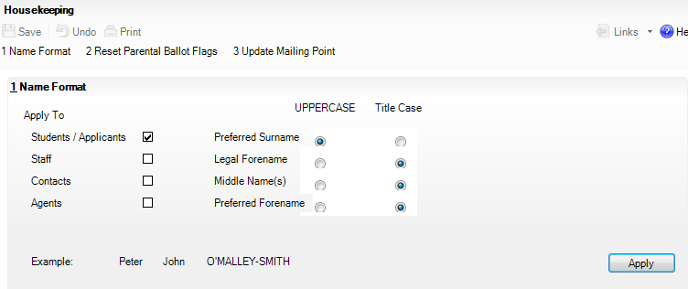
Any changes that you make are reflected at the bottom of the Name Format panel under Example enabling you to preview how the new selection looks before applying it.
- Click the Apply button to update the selected name formats.
- Click the Save button to keep the changes.

Updating the Mailing Point
Introduction:
The normal day-to-day correspondence intended for parent’s perusal, is usually sent home with one of the students in the family. To identify the chosen pupil from each family who is considered to be the mailing point, the Mailing Point check box should be selected on their Pupil (or Student) Details page.
This flag really identifies one pupil at a particular home address, regardless of their family relationship. For example, two pupils may be foster children and live at the same address but not actually be related, only one of these children would need to be designated as the mailing point. Two pupils may be brother and sister and live at different addresses so they would both be considered as a possible mailing point for each separate address. There is no reason why more than one pupil living at a particular address could not be flagged as the mailing point. This may ensure the safe delivery of letters by one or other of the pupils, if not both.
- Select Tools | Housekeeping | General to display the Housekeeping page.
- Click the Update Mailing Point hyperlink to display the Update Mailing Point panel.
- Specify the Effective Date by clicking the Calendar button and selecting the date.
The Effective Date field enables you to update the mailing point for dates in the past, present or future. Choosing an effective date in the future enables the school administrator to set which pupils/applicants will be used as their family’s mailing point for the forthcoming academic year.
The Mailing Point drop-down list defaults to Oldest Child but can be changed to Youngest Child, if required.
- Click the Apply button to update the pupil’s mailing point

Resetting Parental Ballot Flags
Introduction:
When there is a vacant position for a parent governor in the school, it is necessary to contact all the people who are eligible to stand for election to the position and who are eligible to vote for the final candidates.
All parents who have a child registered as ‘on-roll’ at the school are eligible for the election. The term ‘Parents’ includes natural parents and anyone else with parental responsibility.
The Parental Ballot check box, which is selected by the user on the Contacts Basic Details page (via Focus | Person | Contacts), indicates a contact's right to vote. If a contact is not eligible, the check box should be deselected.
- Select Tools | Housekeeping | General to display the Housekeeping page.
- Click the Reset Parental Ballot Flags hyperlink to display the Reset Parental Ballot Flags panel.
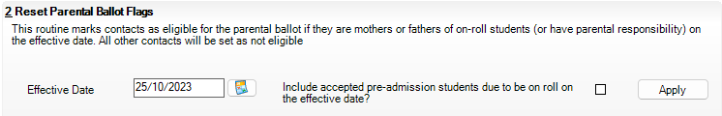
- Specify the Effective Date by clicking the Calendar button and selecting the date.
Calendar button
The Include accepted pre-admission students due to be on roll on the effective date? check box defaults to No, i.e. deselected. Select the check box if you would like to reset applicant’s contacts in addition to other pupil’s contacts with parental responsibility.
- Click the Apply button to reset parental ballot flags.

Updating Salutation/Addressee Information in Bulk
Introduction:
To ensure that parental and contact salutation/addressee information is recorded for all pupils and contacts, two housekeeping routines facilitate the entry of this information:
- The Generate Parental Salutation and Parental Addressee Information routine enables the Parental Salutation and Parental Addressee fields on pupil records to be generated and updated in bulk.
- The Generate Contact Salutation and Contact Addressee Information routine enables the Salutation and Addressee fields on contact records to be generated and updated in bulk.

1. Updating Parental Salutation/Addressee Information in Bulk
- Select Routines | Pupil (or Student) | Update Salutation/Addressee | Parental to display the Find Student(s) browser.
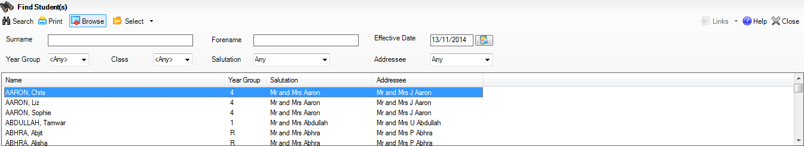
- Enter either all or part of the pupils Surname and/or Forename.
- Select applicable values from the drop-down lists to further restrict the list of pupils returned.
- Click the Search button to display all pupils who match the search criteria specified.
- Click the Print button to print the details currently displayed in the Find Student(s) browser.
- Highlight the required pupil (multiple pupils can be selected by holding down either the Shift or Ctrl keys and clicking the required names) then click the Select button to display their names in the Generate Parental Salutation and Parental Addressee Information panel. Alternatively, to display all pupils currently displayed in the browser, choose All from the Select drop-down menu.
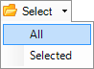
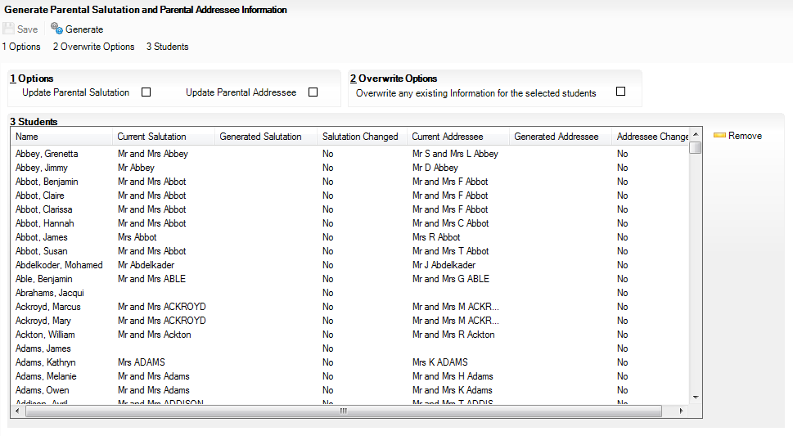
The Students panel displays the currently selected pupils, along with their Current Salutation and Current Addressee information, if recorded.
- If you have inadvertently selected a pupil who you do not wish to update, highlight their name and click the Remove button.
- To Update Parental Salutation and/or Update Parental Addressee information for the selected pupils, select the respective check boxes.
- If required, select the check box to Overwrite any existing Information for the selected students.
IMPORTANT NOTE: If this check box is selected, any pupil records with existing parental salutation and/or addressee information will be overwritten with the default values, as determined by SIMS. If parental salutation and/or addressee information is not currently recorded for a number of student records, and you wish to update only the records where this information is missing, deselect the check box.
- Click the Generate button. A preview of the changes to be made is displayed in the Students panel.
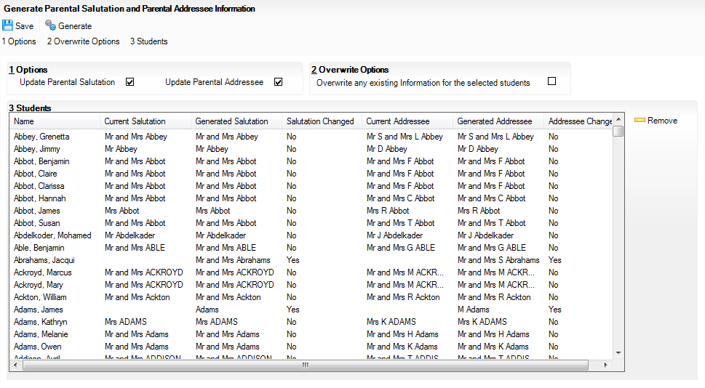
The Generated Salutation and Generated Addressee columns display the proposed changes. The Salutation Changed and Addressee Changed columns indicate where a change to the existing data will be made.
- Once you have reviewed and are happy with the proposed changes, click the Save button to update the pupil records.

2.Updating Contact Salutation/Addressee Information in Bulk
- Select Routines | Pupil (or Student) | Update Salutation/Addressee | Contact to display the Find Contact(s) browser.
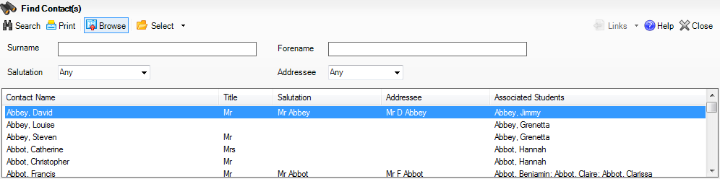
- Enter either all or part of the pupil's Surname and/or Forename.
- Select applicable values from the drop-down lists to further restrict the list of contacts returned.
- Click the Search button to display all contacts who match the search criteria specified.
IMPORTANT NOTE: Contacts associated with applicants will be displayed in the browser list but the applicants themselves will not be displayed in the Associated Students column because they are not yet on-roll pupils. However, this will not prevent you from generating Salutation and/or Addressee information for the associated contact.
- Click the Print button to print the details currently displayed in the Find Contact(s) browser.
- Highlight the required contact (multiple contacts can be selected by holding down either the Shift or Ctrl keys and clicking the required names) then click the Select button to display their names in the Generate Contact Salutation and Contact Addressee Information panel. Alternatively, to display all contacts currently displayed in the browser, choose All from the Select drop-down menu.
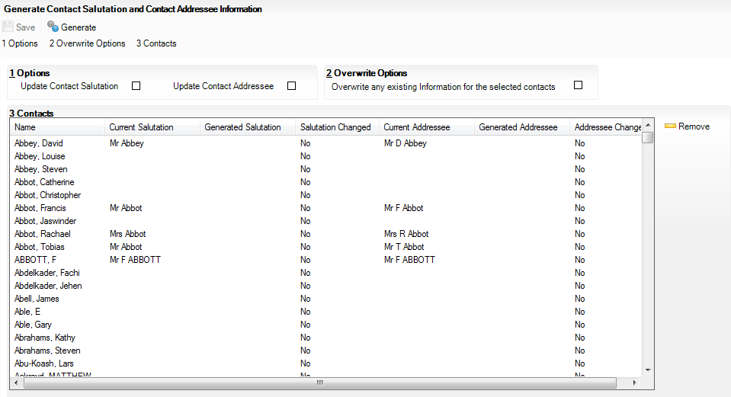
The Contacts panel displays the currently selected contacts, along with their Current Salutation and Current Addressee information, if recorded.
- If you have inadvertently selected a contact who you do not wish to update, highlight their name and click the Remove button.
- To Update Contact Salutation and/or Update Contact Addressee information for the selected contacts, select the respective check boxes.
- If required, select the check box to Overwrite any existing Information for the selected contacts.
IMPORTANT NOTE: If this check box is selected, any contact records with existing contact salutation and/or addressee information will be overwritten with the default values, as determined by SIMS. If contact salutation and/or addressee information is not currently recorded for a number of contact records, and you wish to update only the records where this information is missing, deselect the check box.
- Click the Generate button. A preview of the changes to be made is displayed the Contacts panel.
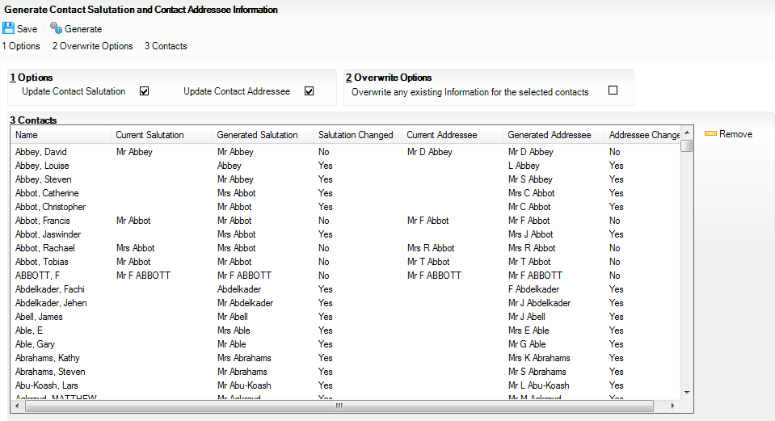
The Generated Salutation and Generated Addressee columns display the proposed changes. The Salutation Changed and Addressee Changed columns indicate where a change to the existing data will be made.
Once you have reviewed and are happy with the proposed changes, click the Save button to update the contact records

Bulk Deletion of Pupil Data
Introduction:
Note: Before completing ensure a full system backup is completed
Under GDPR guidance a school may wish to delete some of the data connected to pupils who have left some time ago but keep a record of the fact that they were at one time a pupil of the school.
Step by Step – Protecting Pupils from Bulk Deletion Process
A school may feel that it wishes to exclude certain pupils from the bulk deletion process.
Note: Pupils who have ever been SEN are excluded from bulk deletion by default and so this is only for other specific pupils where the school wishes to retain their full record.
- Select Focus | Pupil | Pupil Details.
- Change the Status to Leavers and search for and open the record for the required pupil. In the Basic Details panel tick the Protect from Bulk Data Deletion checkbox.
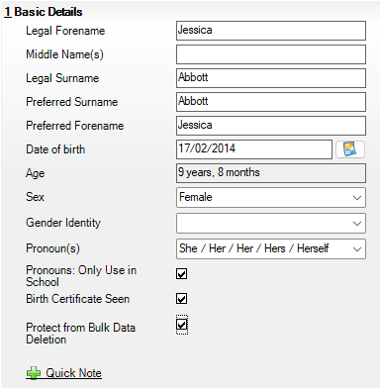
- Click Save and click on Yes when prompted with the message below:
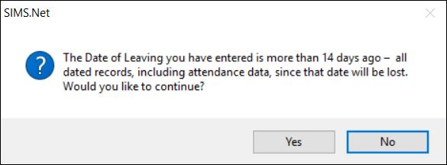

Step by Step – Bulk Deletion of Pupil Data and Bulk deletion of Pupils
Schools can choose to delete all data for Pupils or remove certain types of data in line with the school data retention policy. Only those who have left on or before 2019/20 can have data deleted as various aspects of SIMS require the more recent data, for example Discover behaviour graphs would require the conduct data.

- Select Routines | Pupil | Bulk Delete Pupil Data.
- Select the academic year you wish to delete data from the Delete data for pupils who left within or before the academic year drop-down.
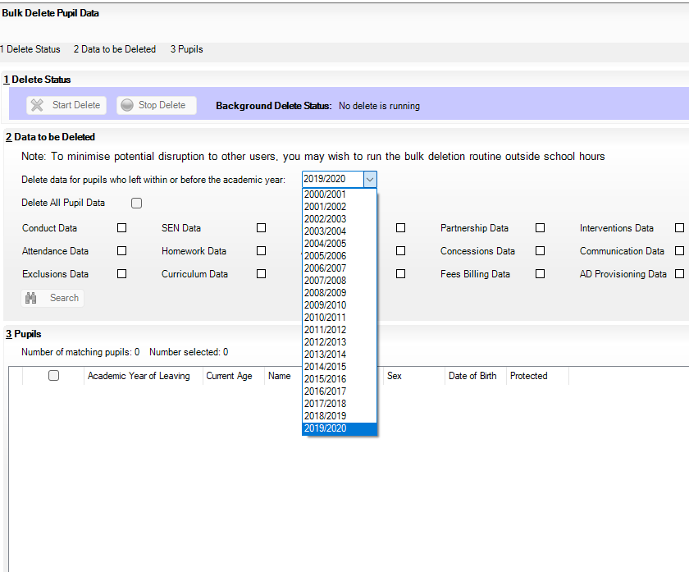
- Tick the required checkbox relating to the data area you wish to remove. If you wish to remove All Pupil Data for the pupils in the selected year tick Delete All Pupil Data
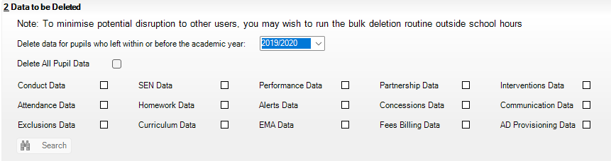

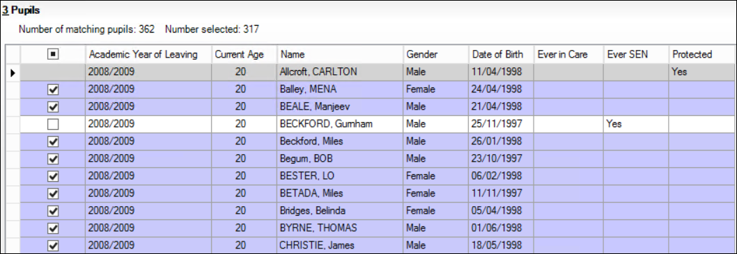
- Click Search.

- Click in the column heading for Academic Year of Leaving to sort pupils and select the pupils for data deletion.
- Note that the protected pupils are greyed out and cannot be selected.
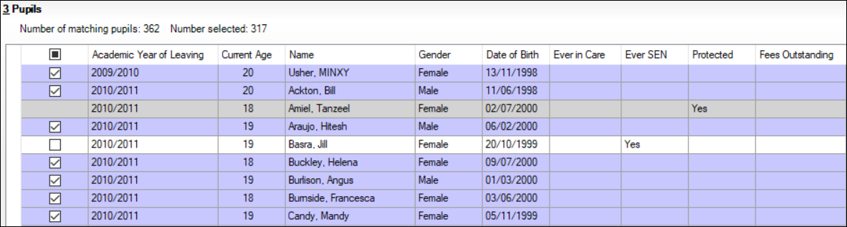
- Note that Jill Basra is not selected. This is because she is Ever SEN. She could however be selected by ticking the box in Selection column headed with the following symbol.
NOTE: From Spring 2019 upgrade Ever SEN does not include pupils who have only ever been N coded nor pupils who have only ever been gifted.
- Click Start Delete. The process may take some time and can run in the background whilst other SIMS tasks are performed.
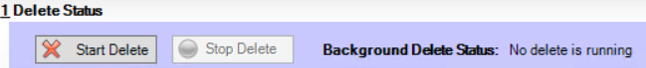
- The following confirmation request message appears. Click Continue when you are ready to proceed.
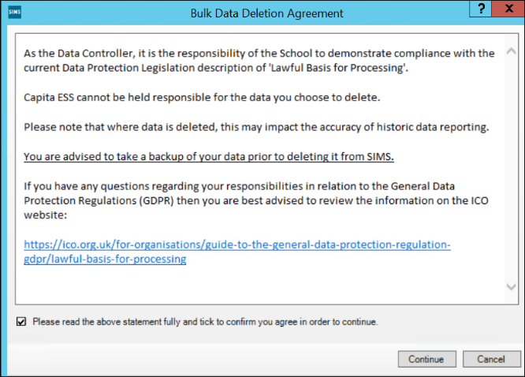
- Stop Delete can be selected at any time and a message will inform you how much data has been deleted.
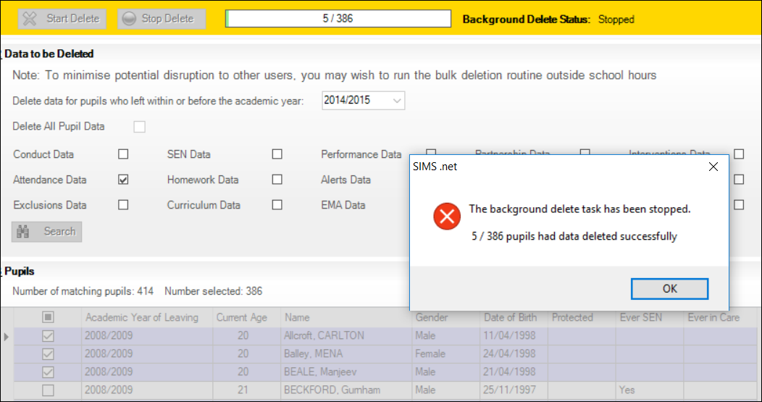
- Click OK.
NOTE: Whilst the delete process is running you can use other areas of SIMS as normal.
If more than one area is selected for deleting all areas are deleted for the first pupil before moving on to the next pupil.
If Delete All Pupil Data is selected the pupil record will be deleted completely as if the step by step Deleting a Pupil had been followed unless the pupil is also an employee, contact, enquirer, bill payer or agent. Unlikely but possible.

NOTE: If Delete All Pupil Data is selected the pupil record will be deleted completely and this leaves the pupils contacts unlinked. Therefore, after Delete All Pupil Data is run Delete Unlinked Contacts should be run and contacts removed.

Running the Duplicate Contact Report
Introduction:
This report produces a list of all contacts and their associated students.
- Select Reports | Run Report | Focus | Contact locate and run the Duplicate Contact check report. 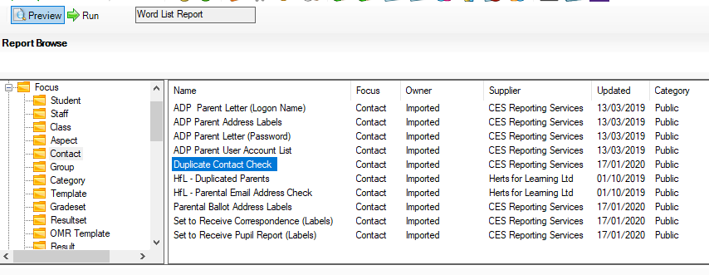
- The report will output to word, work through the report to pick out any contacts that have been duplicated.
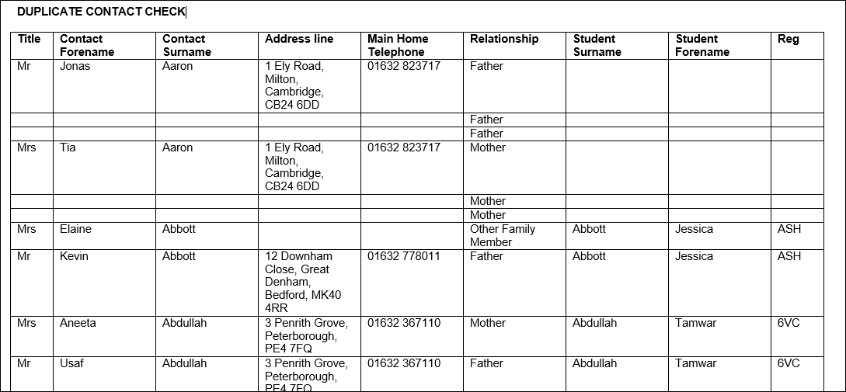
NOTE: Leavers will not show in the Student details columns
- If you want to amend how the report is run, select Reports | Design Report | Open | Focus | Contact locate and open the Duplicate Contact check report.
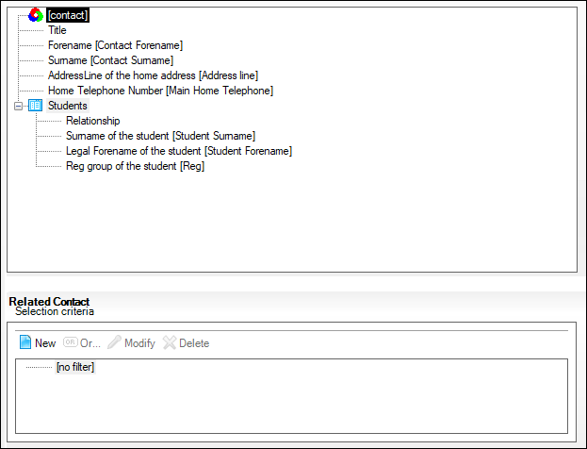
- Select Data fields, double click on Students, and from the Related Contact Selection Criteria select New.
- Click on Student to expand the selection, here you can select what you want to use to filter the report. Expand Registration and select Year Group and tick the Prompt at runtime box, this will allow you to filter by year group when you run the report. 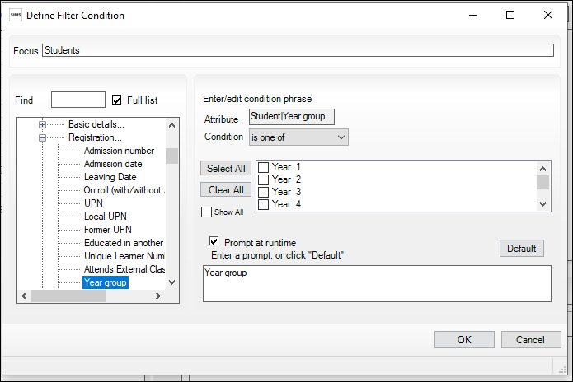
- Select Ok then Save As to save an amended version of the report.

Delete Unlinked Contacts
Introduction:
This routine enables you to delete contacts (e.g. siblings, agents, etc.) who are no longer linked to a Pupil or applicant in SIMS. Unlinked contacts might exist because:
- the Pupil has been deleted from SIMS.
- the link has been broken. This usually occurs when a contact is removed from family links.
- the contact is no longer required, e.g. they have moved away from the area. Contacts who are linked to Pupils who have left the school cannot be deleted, even if they have no links to current Pupils.
- Select Tools | Housekeeping | Delete Unlinked Contacts to display the Find Unlinked Contacts browser.
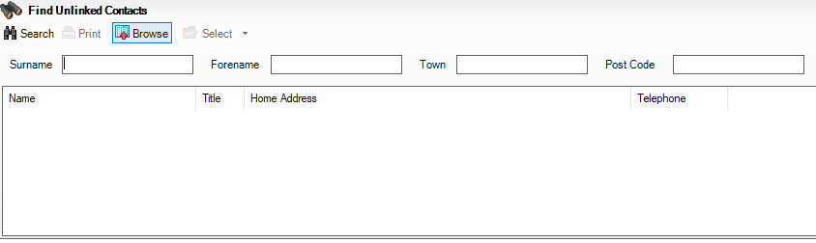
NOTE: Deleting unlinked contacts does not need to be run after tidying every contact but can be run periodically. It removes contacts sitting within SIMS that are no longer attached to any records.
- Click Search to display a list of contact records, some of which may have been duplicated. Filters can be used to locate specific records if required.
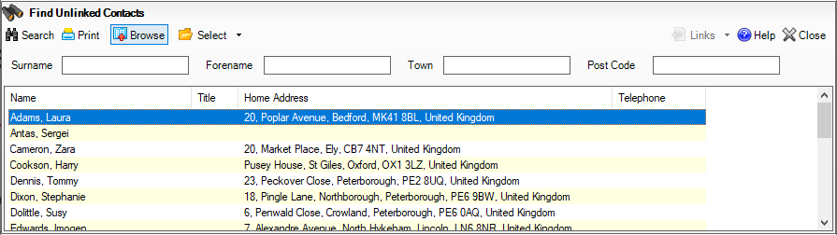

- If there is more than one unlinked contact record either Select All or highlight the ones to be removed and then choose Selected from the Select drop-down list.
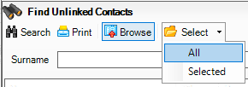
- The names of those selected are listed in the Contacts to be deleted section.
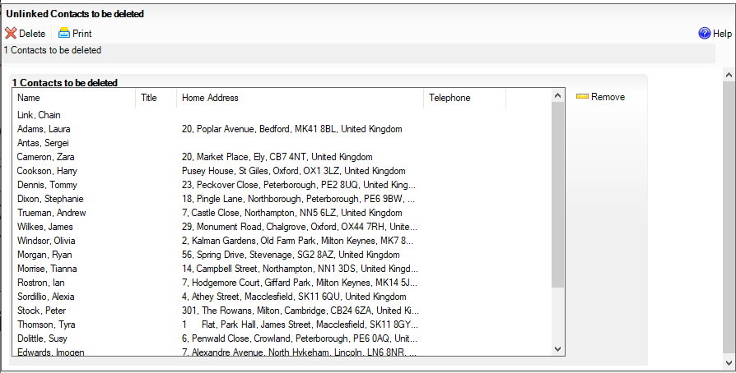
- Any records included by mistake can be highlighted and removed by clicking Remove.
- Click Delete and confirm that the selected records are to be deleted.
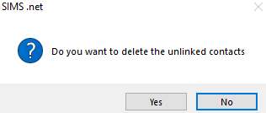
NOTE: Deleting contacts can take some time and it is recommended that this is done in batches of approximately ten at a time.
This routine should be run once a term.

Deleting Unlinked Persons from SIMS

Introduction:
Unlinked persons must be deleted from SIMS. These may be applicants, agents, pupils, employees, contacts, or other individuals whose historical personal data should no longer be retained in line with your schools GDPR guidelines. Unlinked persons could still be present because at the time of deletion, a secondary role for the individual may have existed within SIMS.
- Select Tools | Housekeeping | Delete Unlinked Persons to display the Delete Unlinked Persons page. All unlinked persons recorded in SIMS are displayed.
IMPORTANT NOTE: To assist schools in being GDPR compliant, you are strongly advised to delete all unlinked persons identified by this routine.
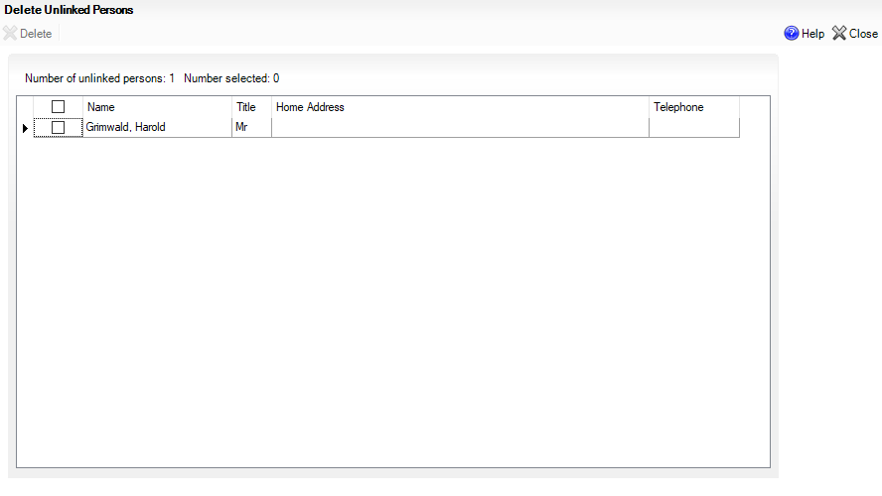
- Select the check box at the top of the left-hand column to highlight all the unlinked persons records.
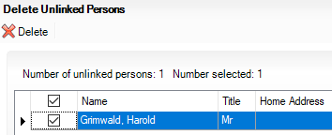
- Click Delete.
- Confirm the deletion by clicking Yes. This process may take several minutes to complete.
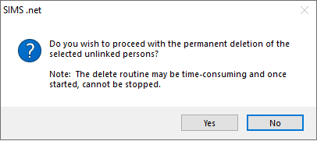

NOTE: This routine should be run once a term.
Deleting Imported/Exported CTFs
Introduction:
Common Transfer Files (CTFs) are XML files that are used to electronically import and export data when pupil/students transfer from one school to another. This usually happens at the start of a new academic year but can also occur at any other time throughout the year.
Each transfer file contains details of the transferring pupil/students (such as contacts, attendance history, assessment data, etc.), as well as details of the transferring and receiving schools. CTF files are also used to export Key Stage Results to LAs and the NAA.
Once generated, the CTF file is sent to the receiving school by using the DfE secure web site (s2s) or the local secure file transfer mechanisms. The receiving school or LA can then import the data into their SIMS/One system. The CTF import routine enables pupil/students to be placed either directly on-roll or into a pre-admission group.
NOTE: Due to the sensitive nature of some of the data stored in SIMS, careful consideration should be given when specifying the location of any folder into which you save sensitive data, e.g. census returns, imported and exported CTFs, etc. You should be mindful of your school's responsibilities with respect to information security. Consider which users have access to the chosen folder, especially if the folder is shared on a Server. The DfE recommends ISO27001 as the standard for information security, a copy of which can be found at http://www.itgovernance.co.uk/bs7799.aspx. If you are in any doubt, you should consult with your IT Security Officer before proceeding. Please ensure that you use either CTF or ATF files to import pupil/students into SIMS. Using both methods can produce duplicate entries.
We recommend that the CTFs both imported and exported are kept within a secure location on the network until they are imported or exported at which point they should be deleted from the system.
If a CTF is required to be imported again this can be re downloaded from the Secure Website.
If a CTF is required to be sent again it can be recreated within SIMS.
We would recommend the following checks:

- Check the path of the CTF import and export within SIMS is a secure location. This can be achieved by following the route: Tools | Setup | CTF. Both the paths should be checked to ensure they are secure.
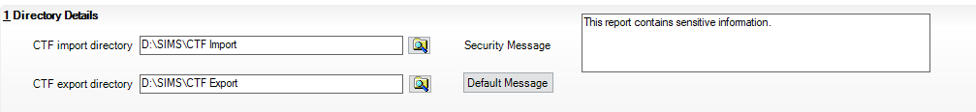
- Any CTFs that have been downloaded and appear in the download library are deleted once imported.
- Once a CTF has been imported delete it
- Once a CTF has been exported and uploaded to the Secure website it should be deleted.
- We would also recommend that contacts are not exported or imported via a CTF. To make this the default setting in SIMS please go to Tools | Setup | CTF and remove the ticks in Student Contacts in both the Import panel and Export panel as can be seen from the screen below:

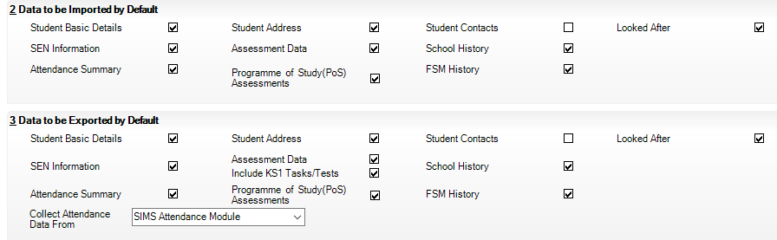
NOTE: This process should be followed on import and export of CTFs.

Removing Access to SIMS and FMS for Staff Leavers
Introduction
When a member of staff leaves the school the access to SIMS and FMS, if applicable, should be removed.
The school should check all active users are indeed current members of staff on a regular basis
SIMS
Follow route: Focus | System Manager | Manage Users.
- The following screen will appear and you should ensure that Yes is selected in the Active box

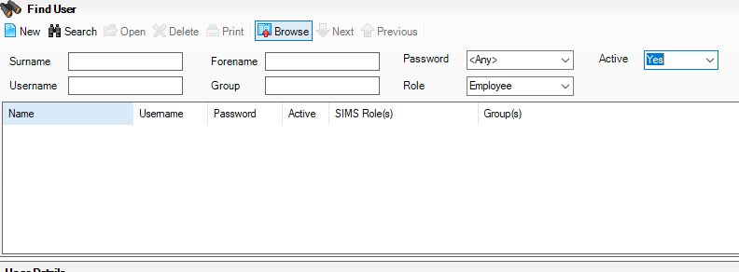

- Click on Search to show all active users who currently have access to SIMS.

- Double click on any member of staff’s record that has left.

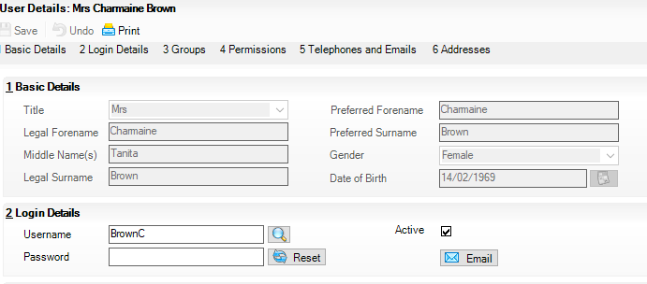

- Deselect the Active box and Save which will remove the ability of the member of staff to log in.

FMS
To remove access to FMS for staff leavers follow route: Tools | Manage Users
The following screen will appear
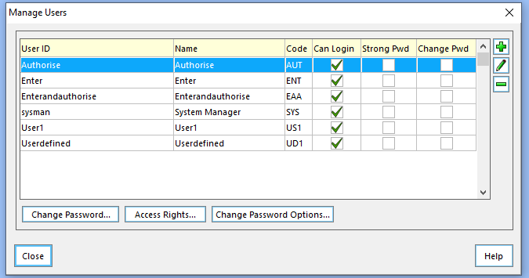
- Highlight the user that you are removing access for and click on the Access Rights button.
- Select No Access for the user as can be seen below
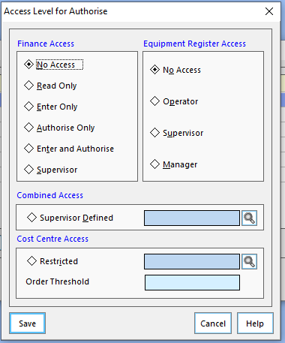
- Click on Save
- Ensure that the user has no tick in the Can Login Column.
NOTE: This procedure should be done when the member of staff leaves. A check should be done every term.

Remove Obsolete User Defined Fields
Introduction
In cases where a school needs to maintain extra information in addition to that which SIMS currently records, the school administrator can define school specific User Defined Fields.
The school administrator has the choice of which data entity or entities to add the field to. For example, additional fields can be added to record supplementary information about pupil/students, applicants, staff, contacts, etc.
You also have the option to specify the page and panel from where the user defined field will be available. Once defined, the user defined fields will also be available in the Reporting dictionary when designing reports.
- Select Tools | Setups | User Defined Fields to display the Find UDF Field browser. Click on search to show all User defined fields.
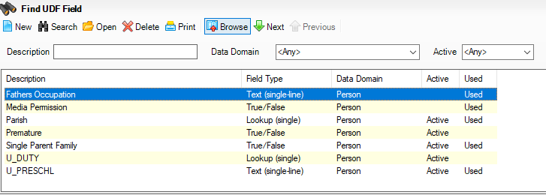
- Double click the user defined field that you wish to make inactive and deselect the Active box as below:

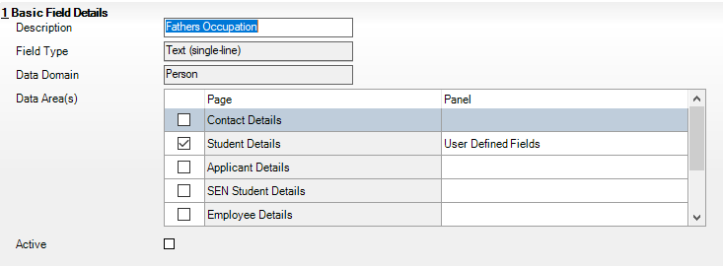

- Select Save

Removing User Defined Groups
Introduction:
User Defined Groups can be created by schools to enable them to record specific data that relates to a number of individuals. For example, the school's Under 16s football team would be classed as a user defined group.
The individuals who are members of a particular group can be amended throughout the life span of the group to reflect their involvement.
The creator of a User Defined Group is automatically allocated as the supervisor of the group.
Any User Defined Groups that are no longer required can be made inactive or obsolete
- Select Focus | Groups | User Defined Groups to display the Maintain User Defined Groups browser.
- Enter the Short Name for the Group or enter the Group Description before clicking the Search button.
Alternatively select the Active State from the drop-down list to display all existing User Defined Groups that match the search criteria entered.
NOTE: A combination of all the fields can be used to refine the search, depending on the information available to you. Alternatively, the fields can be left blank to list all the User Defined Groups in the system.
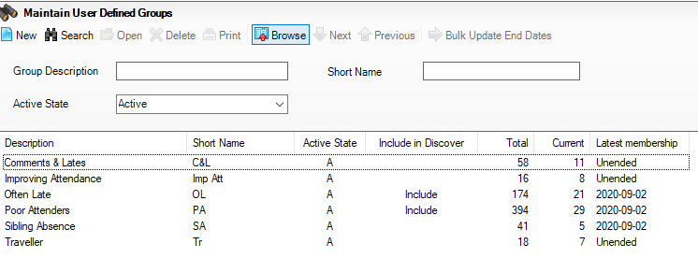
- Highlight the required User Defined Group from the list displayed and double-click to view the UDG Group Details page.
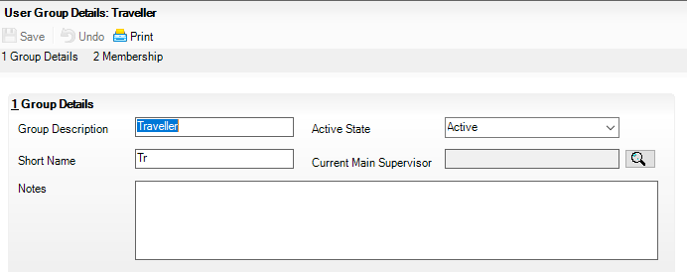
- Make the Group inactive or obsolete as required by clicking on the down arrow in the Active State box.

Tidy Up Reports within SIMS
Introduction:
It is possible to delete reports that you have created. With the required permissions, you can delete the reports of others. The master copy of each item is stored in your My Reports folder. You must delete the item from this folder if you wish to permanently delete it. Deleting a report from any other folder prevents that item from being accessed from that location.
Select Reports | Design Report to display the Report Designer.
- Click Open an existing report to display the Open report (report browser) dialog.
- Navigate to the required report.
- Highlight the report name then press the Delete key. A confirmation dialog is displayed. Click the OK button to complete the process. Alternatively, right-click the report name and select the Delete button.

Deactivating Intake Groups
Introduction:
Once students have been admitted, intake groups for the past year can be made inactive.
- Select Routines | Admission | Admission Groups | Setup.
- Open the Intake Group you wish to make Inactive.
- Remove the tick from the Active checkbox then click Save.
The following message may be displayed.
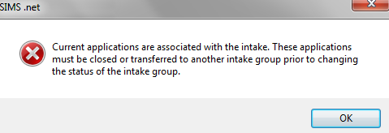
This indicates that there are applicants in the group whose status is still live; this is any status other than Admitted or a status with a Withdrawal category.
These applicants must either have their status changed to a Withdrawal status or the application must be moved to a future Intake Group. This can be done using the Transfer Applications routine.
NOTE: If you delete an intake group this will delete all application records associated with the intake group.

Merging Agents and Agencies
Introduction:
Over time, it is possible for duplicate agents and agencies to be entered into SIMS. This may have occurred during the migration from dBase to SQL, or simply where data has been inadvertently replicated.
It is possible to merge the information stored against duplicate agencies (including linked agents and pupils) or agents (including linked agencies, pupils and documents). Once merged, the agency or agent is then removed from SIMS.
NOTE: This process permanently merges duplicate agents/agencies. You may wish to carry out a backup before proceeding.

Merging Agencies
Agencies being merged must be of the same agency type, such as Medical or Social Services.
- Select Tools | Housekeeping | Merge Agencies to display the Merge Agencies page.
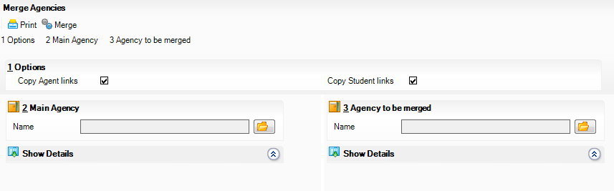
- In the Options panel, the Copy Agent Links and Copy Student Links check boxes are selected by default. Deselect these check boxes if required.
- Copy Agent Links – merges any agents associated with the agency (displayed in the Linked Agents panel).
- Copy Student Links – merges any pupils who are linked to the agency (displayed in the Linked Students panel).
IMPORTANT NOTE: If you elect not to copy agents to the main agency, you should ensure (either before or after merging) that they are assigned to another agency.
- In the Main Agency panel, select the agency that is to be retained by clicking the Open button to open the Select Agency browser.
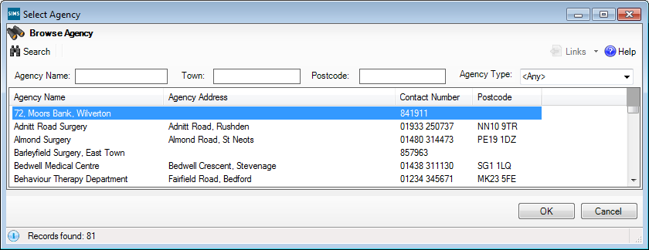
- Search for the required agency, highlight the name then click the OK button to select them. The details of the agency (including the Agency Type, Address and Telephone) are displayed together with any Linked Agents and Linked Students. These details can be hidden at any point by clicking the Hide Details hyperlink, which changes to display Show Details. This is a toggle feature and can be used to alternative been hide and show.
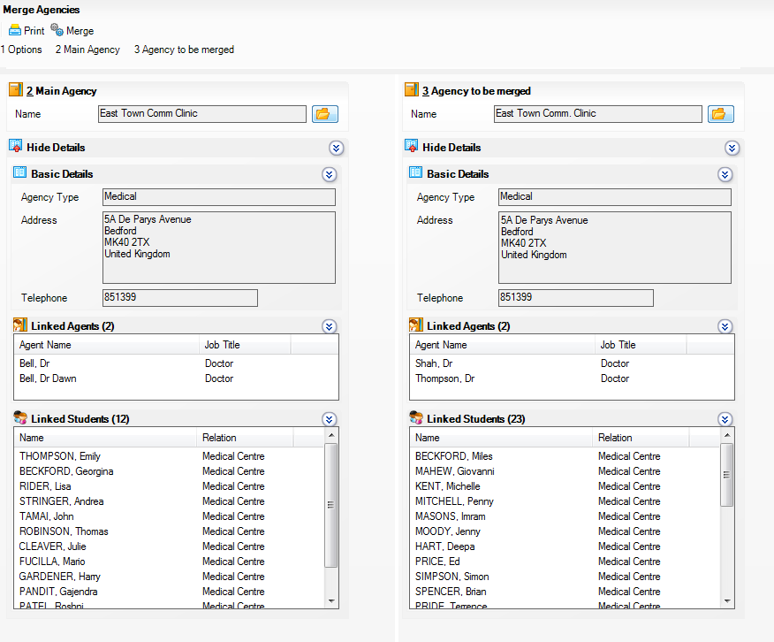
Alternatively, individual details can be hidden by clicking the chevron button on the individual section title, such as Basic Details. Click again to show the details.
- Select the agency whose details you wish to merge with the main agency by clicking the Open button in the Agency to be Merged panel. The details of the agency are displayed in the same way as the main agency.
- If required, print a copy of the details by clicking the Print button on the toolbar.
- Once you are certain that the required agencies have been selected, click the Merge button on the toolbar to merge the information.
- A message is displayed prompting for confirmation that you wish to continue. This process is irreversible. Only click the Yes button if you are sure that these agencies are to be merged.
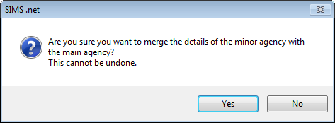
Any agents or pupils linked to the agency to be merged (minor agency) are linked the main agency (unless you elected not to do so). The Linked Agents and Linked Students panels for the main agency are updated to show any merged agents and/or pupils.
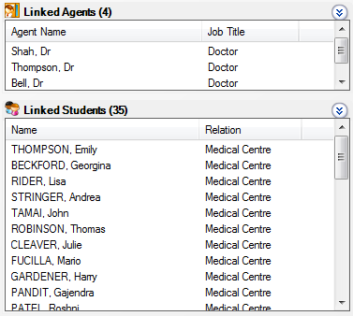

Merging Agents
When merging agents, any other role that an agent has is retained – only the agents are merged. If for example, an agent is also a contact, the agents are merged, but the contact record will still be retained. Check the Other Roles panel when merging.
- Select Tools | Housekeeping | Merge Agents to display the Merge Agents page.
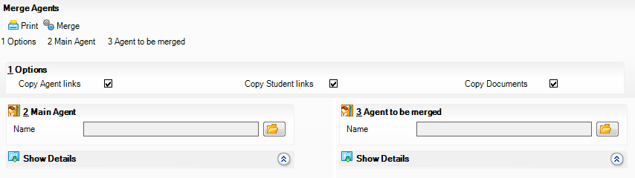
- In the Options panel, the Copy Agency Links, Copy Student Links and Copy Documents check boxes are selected by default. Deselect these check boxes if required.
- Copy Agency Links – merges any agencies with which the agent is associated (displayed in the Linked Agencies panel).
- Copy Student Links – merges any pupils who are linked to the agent (displayed in the Linked Students panel).
- Copy Documents – merges any attached documents to the main agent.
- In the Main Agent panel, select the agent that is to be retained by clicking the Open button to open the Select Agent browser.
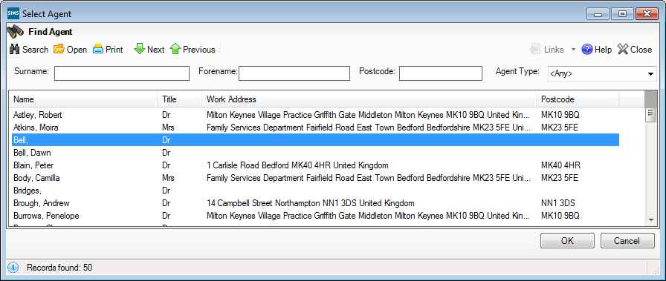
- Search for the required agent, highlight the name then click the OK button to select them. The details of the agent (including the Address and Telephone) are displayed together with any Linked Agencies and Linked Students. Any other roles held by the agent are displayed in the Other Roles panel. They could for example, also be a contact, pupil or member of staff. These details can be hidden at any point by clicking the Hide Details hyperlink which changes to display Show Details. This is a toggle feature and can be used to alternative been hide and show.
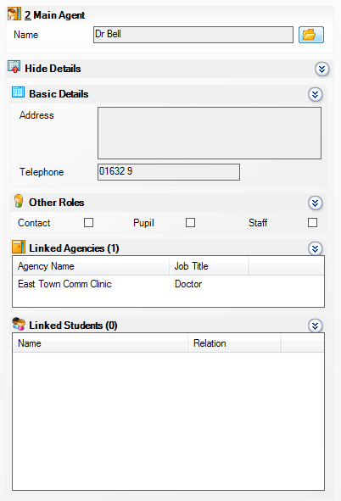
Alternatively, individual details can be hidden by clicking the chevron button on the individual section title, such as Basic Details. Click again to show the details.
- Select the agent whose details you wish to merge with the main agent by clicking the Open button in the Agent to be Merged panel. The details of the agent are displayed in the same way as the main agent.
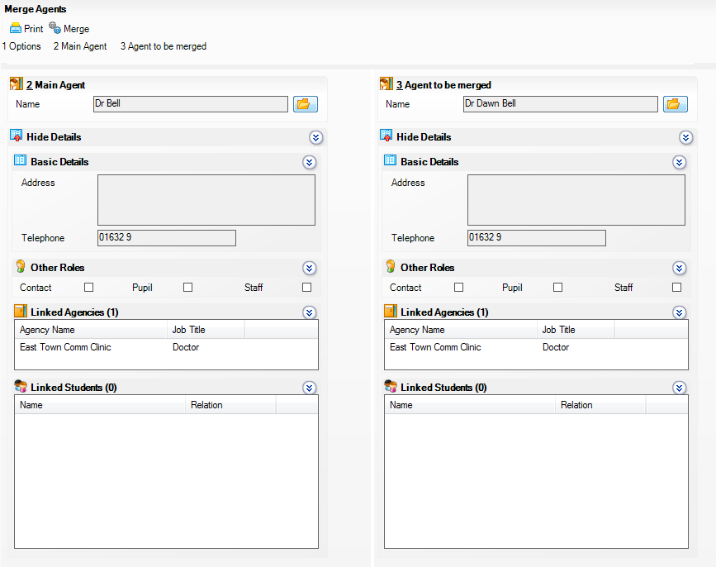
- Check the Other Roles panel to see any other roles that the agent may have. Any other role records are retained following the merge.
- If required, print a copy of the details by clicking the Print button on the toolbar.
- Once you are certain that the required agents have been selected, click the Merge button on the toolbar to merge the information.
- A message is displayed prompting for confirmation that you wish to continue. This process is irreversible. Only click the Yes button if you are sure that these agents are to be merged.
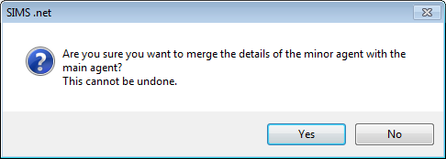
Any linked agencies, students or and/or documents are merged with the new agent. The Linked Agencies and Linked Students panels for the main agency are updated to show any merged agents and/or pupils.

Tidying and Merging Address Details

Overview of Tidying Addresses
The Address Tidy routine is used to review addresses stored in SIMS, identify those that contain erroneous or incorrectly formatted information, and wherever possible, make applicable changes to ensure addresses are accurate and uniformly formatted. A report identifying the proposed changes is produced, which can be checked before proceeding.
Address tidying can involve moving data between fields, (e.g. a post code that has been incorrectly entered in the Town field is moved to the Post Code field), moving telephone numbers and email addresses to their proper locations, or correcting the formatting in various ways (e.g. changing the capitalisation of county information).
Tidying addresses increases the likelihood of success when searching for an address and reduces the risk of the same address being added twice. The tidy process also increases the chances of identifying duplicate addresses (e.g. moving a post code incorrectly stored in the Town field, to the Post Code field, may then match another address based on that post code). Such addresses can subsequently be merged by the Address Merge routine.
When tidying addresses, all addresses that have not yet been validated are considered for tidying, including school and agency addresses. A count is applied to each address to ensure that it is included in the Address Tidy routine a maximum of two times only. This ensures that any manual changes to addresses are not overwritten by the Address Tidy routine in the future. It also reduces the number of addresses that need to be tidied and therefore increases the performance.
The Address Tidy routine should be run twice, because some of the rules used in the routine depend on a comparison with other addresses. Therefore, any addresses tidied during the first run may enable further improvements on the second run of the routine to be made.
It is therefore recommended that the Address Tidy routine is run either twice in succession, or ideally, within the same day. You should make any necessary further manual corrections to addresses only after the second run of the routine. This ensures that any addresses edited manually, are not affected by subsequent tidy routines.
Any new addresses added to the database since the tidy routine has been run are available for tidying twice.

Overview of Merging Duplicate Addresses
Duplicate addresses may exist in SIMS, because they have been double entered, or imported from an incorrectly formatted CTF/ATF file. These duplicate addresses can be merged into a single address, and each resident at that address is then assigned to the single address.

Running the Unmatchable Address Report
The Unmatchable Address report identifies any addresses that:
- Are too incomplete to represent a unique residence
- Have data in incorrect fields (e.g. post code data in the Town field)
- Contain superfluous data such as phone numbers or other contact details.
It is advisable to run this report before running the Tidy and Merge Addresses routine for the following reasons:
- It identifies addresses that obviously contain non-address information (e.g. telephone numbers, people’s names, etc.), which can then be manually corrected.
NOTE: This is particularly important because any phone numbers or email addresses found in address fields are removed during the tidy process and assigned to all the residents living at that address. You may therefore wish to manually move this information before proceeding with the tidy routine.
- It identifies addresses that are not complete enough to identify a unique residence. Such addresses should be manually edited before proceeding with the merge routine.
Select Tools | Housekeeping | Bulk Address Tools | Unmatchable Address Report to display the report in your web browser (the report may take a short while to display).
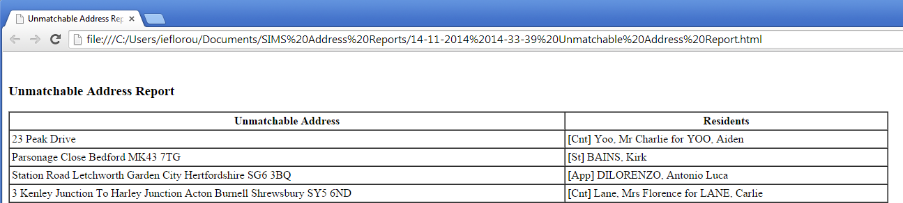
The report lists any unmatched addresses together with the name of the people who are residents at the address. It is recommended that these addresses are manually edited before proceeding further.
The report is saved to the following folder in both .html and .txt format:
C:\Documents and Settings\<Username>\My Documents\SIMS Address Reports

Setting up Address Tidy and Merge
Address tidying is controlled by around 160 rules. Some of these rules may not be applicable to your establishment and it is therefore possible to switch off these rules. For example, if you do not want the town name to be converted to upper case, then rule z1 needs to be turned off. The default option is to apply all rules.

In addition, you can also decide on which rules to report. By default, the Tidy Report (via Tools | Housekeeping | Bulk Address Tools | Tidy and Merge Addresses) lists all addresses that get tidied by one or more rules. You can switch off any rules that you do not wish to be included in the report by deselecting the Report option.
- Select Tools | Setups | Address Tidy to display the Address Tidy and Merge Setup page.
- Ensure that the relevant Report check box is deselected for any rules you do not want to be included in the Tidy Report.
NOTE: Addresses may still be included in the report for deselected rules, if the rule has been applied to an address which has been changed by at least one other rule that is being report on.
- Ensure that the Active check box is deselected for any rules that you do not wish to apply during the Address Tidy routine.
The Applied column lists the number of times each of the rules has been applied during the most recent Address Tidy routine.
- Click the Save button.

Tidying Address Data
It is recommended that you run the Unmatchable Address report (please see Running the Unmatchable Address Report on page 35) before proceeding. Due to the memory intensive nature of this routine, it is recommended that all other users log out of SIMS when this routine is run.
IMPORTANT NOTE: Please carry out a full backup of the SIMS database before running either of tidy or merge routines.
- Select Tools | Housekeeping | Bulk Address Tools | Tidy and Merge Addresses to display the Address Tidy and Merge wizard.
- You must run the Tidy report before the tidy process can be run. Click the Tidy Report button to produce the Address Tidy report (this may take several minutes to complete).
The report lists any incorrectly formatted addresses, together with the suggested reformat that will occur once the tidy and merge process has been run. It also shows the residents recorded as living at the address because their records are affected when the address is tidied.
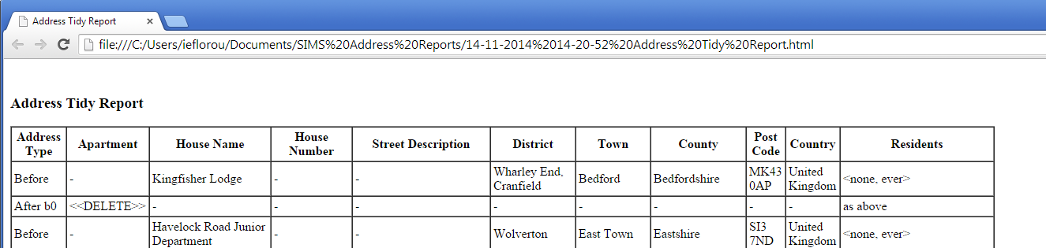
WARNING: Please check the report very carefully before clicking the Tidy button. The tidy process will permanently change the address data stored in SIMS. Any addresses that are incorrectly tidied will have to be manually amended.
Once the Address Tidy report has been produced, review the content and make any required manual changes. Click the Tidy button to initiate the tidy process (this may take several minutes to complete).
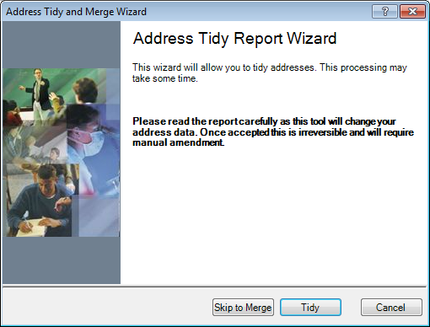
The reports are saved to the following folder in both .html and .txt format.
C:\Documents and Settings\<Username>\My Documents\SIMS Address Reports
The text document also includes tables of abbreviations that are used to identify for example, that ‘Drive’ might be abbreviated to ‘Dr’ or ‘Drv’.
Once the tidy process has been completed, it is recommended that you run the process a second time and then run and check the Unmatchable Addresses report again. Any addresses that still feature in the list probably require some manual amendment. They may not be complete enough to identify a unique residence or may contain non-address information that needs to be moved.

Merging Address Data
It is recommended that you run the Unmatchable Address report before proceeding. It is also strongly recommended that you run the Address Tidy routine (as described in the previous section) before merging address data because the tidy process increases the chances of duplicate addresses being identified.
Due to the memory intensive nature of this routine, it is recommended that all other users log out of SIMS when this routine is run.
IMPORTANT NOTE: Please carry out a full backup of the SIMS database before running the tidy or merge routines.
- From the Address Tidy and Merge wizard, click the Skip to Merge button and then the Merge Report button to produce the Address Merge report (this may take several minutes to compile).
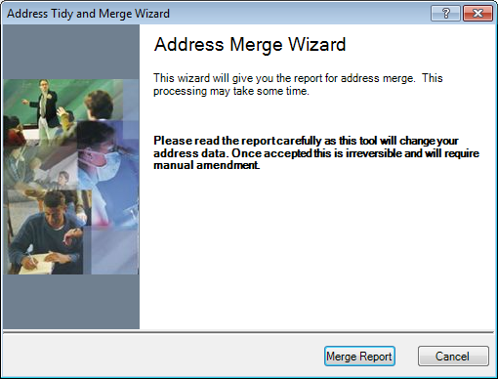
The report lists all duplicate addresses that will be merged into a single address, together with the residents who are recorded as living at the addresses about to be merged.
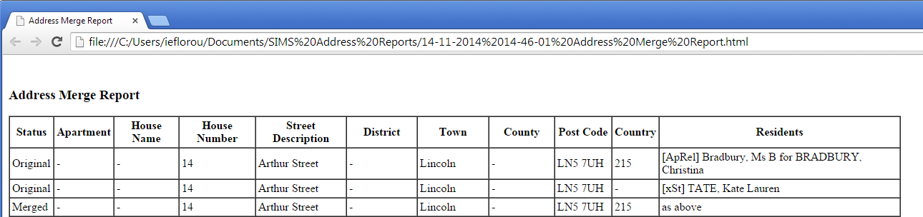
WARNING: Please check the report very carefully before clicking the Merge button. The merge process will permanently change the address data stored in SIMS. Any addresses that are incorrectly merged will have to be manually recreated.
- Once the Address Merge report has been produced, reviewed and printed, click the Merge button to start the merge process. This may take several minutes to complete.
The report is saved to the following folder in .html format:
C:\Documents and Settings\<Username>\My Documents\SIMS Address Reports
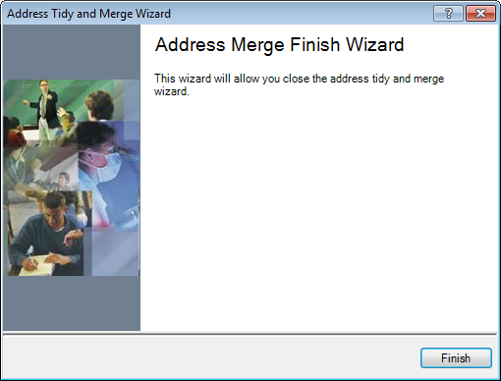
- Click the Finish button to close the wizard.
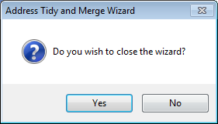
- Click the Yes button to complete the process.

Run Validate Memberships
Introduction
The Validate Memberships routine checks any changes that have been made to group memberships or other data that affects the group membership rules within SIMS. When the routine has finished checking the database, all the anomalies will be corrected automatically.
- Select Tools | Validate Memberships to run the validation process.
This process is most often run as part of the year end procedures.
NOTE: This routine should be run every half term.

Running the Database Diagnostic Tool
Introduction
Database Diagnostics will check every record in SIMS against its specific validation checks. Instead of producing a SQL report, you can view the fixes or warnings of Database Diagnostics in SIMS itself. Once it has completed, it will list all of its checks and provide any warnings. These warnings are either fixed automatically or will need to be resolved manually in SIMS by the user.
NOTE: that this routine can take time to complete and should ideally be done at times of the day of low activity.

- As a user with System Manager permissions: Navigate to Tools | System Diagnostics | Database Diagnostics. Click Run.

The following screen will appear once the tool has completed.
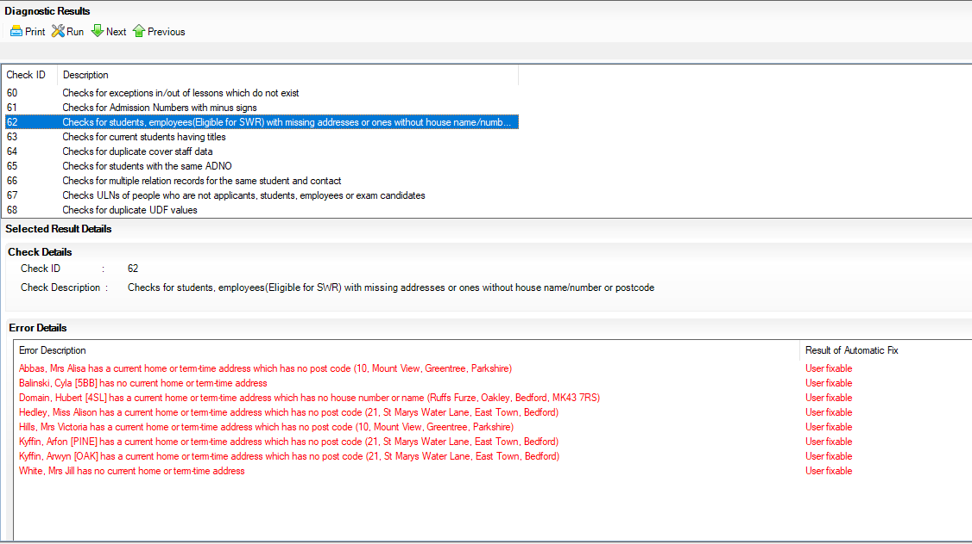

- The checks that have been completed will appear in the Top half of the screen.
- Scroll down the list of the checks.
- Any checks that are blue indicate that an automatic fix has been completed. Highlight these checks to see what the error was, and the fix will show under the Result of Automatic Fix.
- Any checks that fail will appear in red as can be seen from the screen above. The bottom of the screen will show you the person to which the fail refers to and advises that the error is User fixable under the Result of Automatic Fix.
- This means that the user can go to the person’s record and correct the data.

NOTE: This procedure should be carried out once a term.

