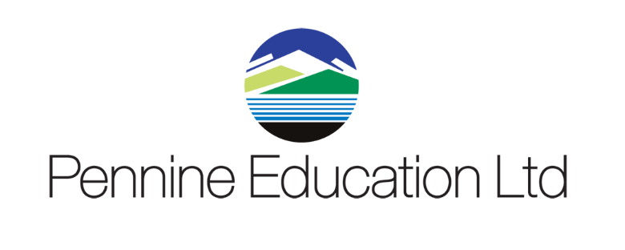

Helpdesk Support calls KPI monitoring report Sept 2023 to August 2024
Month | Total No Calls | Resolved in SLA | Resolved on 1st Contact
September | 672 | 100% | 88%
October | 474 | 100% | 86%
November | 457 | 100% | 90%
December | 163 | 100% | 95%
January | 473 | 100% | 90%
February | 286 | 100% | 87%
March | 295 | 100% | 94%
April
May
June
July
August

