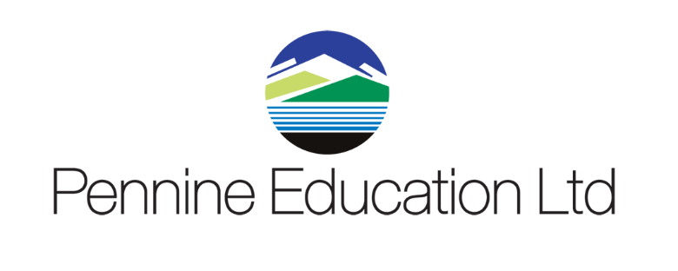

Helpdesk Support calls KPI monitoring report Sept 2021 to August 2022
Month | Total No Calls | Resolved in SLA | Resolved on 1st Contact
September | 606 | 100% | 97.4%
October | 444 | 100% | 98%
November | 461 | 100% | 98.2%
December | 237 | 100% | 98.6%
January | 493 | 100% | 95.4%
February | 264 | 99.8% | 90.2%
March | 349 | 100% | 95.2%
April | 237 | 100% | 95.8%
May | 409 | 100% | 96.4%
June | 539 | 100% | 93.8%
July | 477 | 100% | 96.2%
August

